Talend Job: TEST_Avita_Monthly_Report_Extract

Overview
This is a test/debug variant of a monthly extract for the "Avita Health" client: it queries a fixed list of client codes (2156AI, 2156M, 2156SP, 2157, 2157AI, 2157M, 2157SP, 2158, 2158AI, 2158M, 2158SP, 2159, 2159AI, 2159M, 2159SP) from DW.DIMDEBTOR, decrypts each debtor's SSN, filters out rows with a blank SSN, and writes the result to a CSV — but nearly every component with a real-world side effect (tSendMail_1, tSendMail_2, tFileDelete_1, tFileRowCount_2, tJava_1) is explicitly deactivated (ACTIVATE=false), and the output file only contains 3 raw debtor columns rather than the full ~15-column report layout referenced in tJava_1's (also deactivated) header-building code. This strongly suggests it is a scaled-down test harness for the real Avita_Monthly_Report_Extract job rather than a production report.

Detail table
Field | Value
Job name | TEST_Avita_Monthly_Report_Extract
Version | 0.1
Project | EDW2SF
Author | jmach@harriscollect.com
Created | 2025-06-17T10:11:30.591-0700
Last Modified | 2025-09-24T11:00:33.135-0700

Step-by-step data flow
Setup subjob: tPrejob_1 → tJava_2 opens a per-run log file → on success, tDBConnection_1 opens the Snowflake connection.
Main subjob (a second, disconnected chain gates the query): tFileDelete_1 (deactivated) → tJava_1 (deactivated, builds a CSV header string and file path but is never activated) → on success, tDBInput_1 runs the fixed client-list query against DW.DIMDEBTOR.
- tDBInput_1 (SELECT DEBTOR_IDX, CLIENT, SSN FROM DW.DIMDEBTOR WHERE CLIENT IN (...)) feeds two branches: the MAIN row flow to tDataDecrypt_1, and on SUBJOB_OK, tFileRowCount_2 (deactivated).
- tDataDecrypt_1 decrypts the SSN column using a job-level crypto key/file at context.cryptoPath + "dimdbtr.crypt" (DIE_ON_ERROR=false).
- tFilterRow_4 keeps only rows where SSN.trim().compareTo("") > 0 (i.e., a non-blank SSN after decryption).
- tFlowMeter_2 counts the filtered rows.
- tFileOutputDelimited_1 writes the 3-column result (DEBTOR_IDX, CLIENT, SSN) to context.outputDir + "TEST_Avita_Monthly_Report_" + <date> + ".csv" (comma-delimited, header included).
Deactivated branch (would-be row-count-based emailing): tFileRowCount_2 (deactivated) would count rows in a differently-named file (Avita_Monthly_Report_...csv, not the TEST_ file this job actually writes) and branch via RUN_IF to tSendMail_1 (deactivated, "rows_gt_1") or tSendMail_2 (deactivated, "rows_le_1") — neither email actually fires since both tSendMail components and the counting step itself are deactivated.
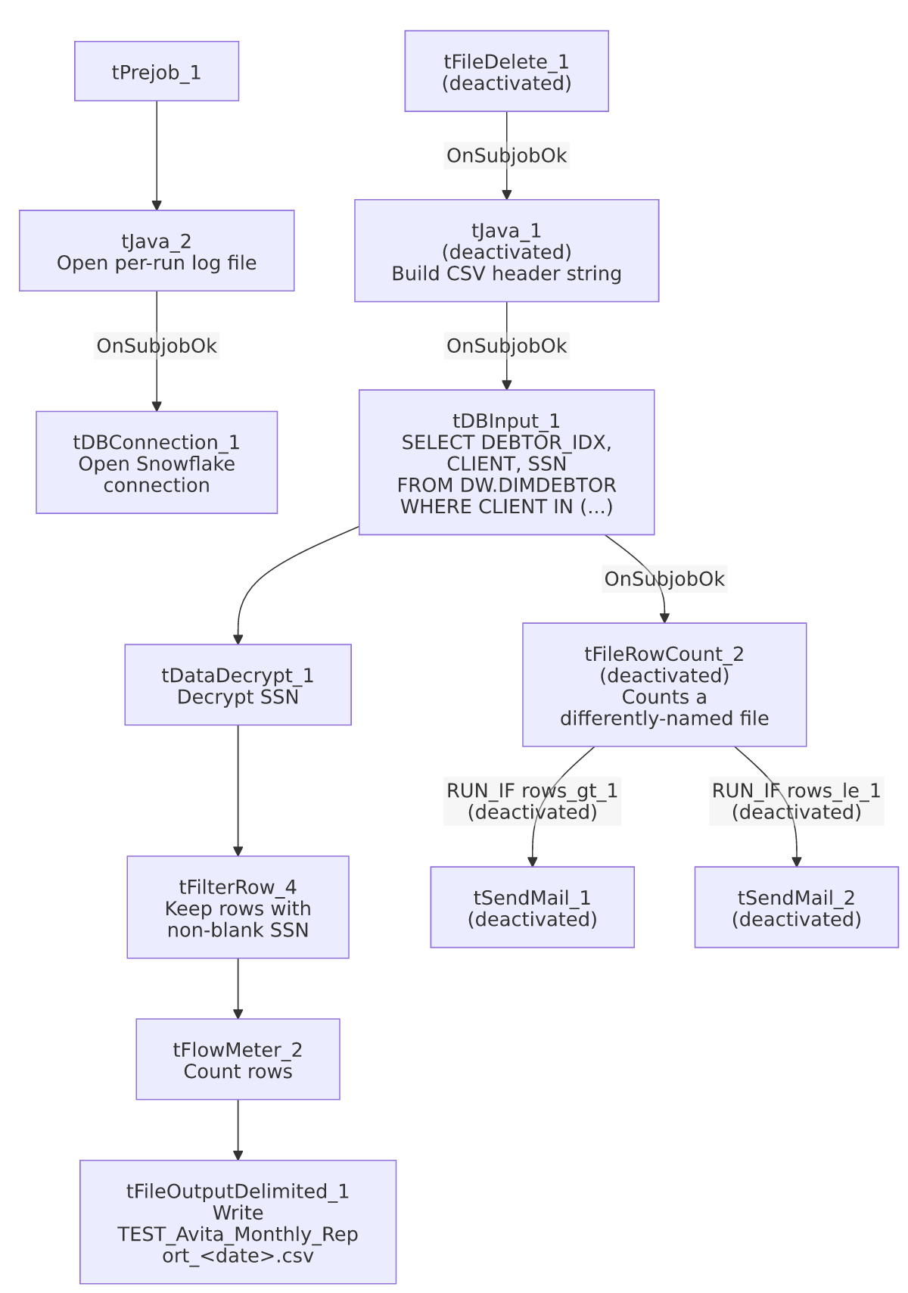

Settings tables

Source: `tDBInput_1` (`tSnowflakeInput`)
Setting | Value | What it means
Query | SELECT d.DEBTOR_IDX, d.CLIENT, d.SSN FROM DW.DIMDEBTOR d WHERE CLIENT IN ('2156AI', '2156M', '2156SP', '2157', '2157AI', '2157M', '2157SP', '2158', '2158AI', '2158M', '2158SP', '2159', '2159AI', '2159M', '2159SP') ORDER BY d.CLIENT, d.DEBTOR_IDX; | A fixed, hardcoded list of client codes tied to Avita Health, embedded directly in the query rather than parameterized via context.

Decrypt: `tDataDecrypt_1`
Setting | Value | What it means
CRYPTO_METHOD / ALGO_VERSION | AES / 2 | Decrypts the SSN column at read time.
CRYPTO_FILE_PATH | context.cryptoPath + "dimdbtr.crypt" | Points to a shared crypto key file, not job-specific.
SECRET_TYPE / SECRET_KEY / PASSWORD_M1 | ***REDACTED*** | Encryption key material — preserved as redacted, not guessed.
DIE_ON_ERROR | false | A decryption failure on a given row does not fail the job.

Output: `tFileOutputDelimited_1`
Setting | Value | What it means
FILENAME | context.outputDir + "TEST_Avita_Monthly_Report_" + <date> + ".csv" | Note the TEST_ prefix baked into the actual output filename — this job writes a visibly test-named file, not the production report name.
Columns | DEBTOR_IDX, CLIENT, SSN only | 3 raw identifier/SSN columns — no name, address, balance, or other report fields, unlike the ~15-column header string built (but never used, since tJava_1 is deactivated) elsewhere in the job.

Deactivated components (present but not wired to run)
Component | What it would do if activated
tFileDelete_1 | Delete a prior Avita_Monthly_Report_<date>.csv file before starting.
tJava_1 | Build a ~15-column CSV header string (CLIENT,NAME1,ADD1,CITY,ST,ZIP,PACKET,DOB,"C.D.#", SSNUM,STATUS,ASGN_AMT,ASGN_COLL,TOTAL_BA... — truncated in metadata) for a differently-shaped, full report file.
tFileRowCount_2 | Count rows in Avita_Monthly_Report_<date>.csv (not the file this job actually produces) to decide which email to send.
tSendMail_1 / tSendMail_2 | Email context.mailRecipients with subject "Avita Health Monthly Report" — either confirming the attached report or noting no valid records this month.

Dependencies & configuration
- Triggers/depends on other jobs: none — no tRunJob links found.
- Context variables used: cryptoPath, logDir, mailRecipients, outputDir.
- 2 hardcoded developer-workstation paths: tFileDelete_1.DIRECTORY and tFileDelete_1.PATH (both C:/Talend-Studio-20211109_1610-V8.0.1/...) — moot in practice since tFileDelete_1 itself is deactivated.
- Per 05_operational_runbook.md, this job is one of the 12 project-wide jobs configured to send email — but in this TEST_ variant, both tSendMail components are deactivated, so no email would actually be sent by this specific job as configured.

Glossary
Component type | Plain-English meaning
tDataDecrypt | Decrypts a column's value using a shared key/crypto file — used here to recover a plaintext SSN from an encrypted-at-rest column.
tFilterRow | Keeps only rows matching a condition, discarding the rest.
tFlowMeter | Counts rows passing a point in the flow, for logging/monitoring.
tFileOutputDelimited | Writes rows to a delimited (CSV-style) text file.
tFileRowCount | Counts the rows in an existing file (used here, when active, to decide which email branch to take).
tSendMail | Sends an email.
tFileDelete | Deletes a file or folder from disk.

Issues observed
- Nearly every component with a real side effect in this job is deactivated (tFileDelete_1, tJava_1, tFileRowCount_2, tSendMail_1, tSendMail_2) — only the query, decrypt, filter, and CSV-write steps actually run. This is strong, concrete evidence (not just the TEST_ name) that this is a debug/scaled-down harness rather than a job meant to run as configured in production.
- The deactivated `tFileRowCount_2` and `tSendMail` branch reference a completely different output filename (Avita_Monthly_Report_<date>.csv) than the one this job's active branch actually writes (TEST_Avita_Monthly_Report_<date>.csv). Even if someone re-activated those components without also fixing the filename, the row-count check would look at the wrong (likely nonexistent) file.
- The active output schema (`DEBTOR_IDX`, `CLIENT`, `SSN`) is a small subset of the ~15-column report header string built (but unused) in the deactivated `tJava_1`. This test job validates the client-list query, decryption, and blank-SSN filter, but does not exercise the full report layout that the production job presumably produces — verify against Avita_Monthly_Report_Extract's own metadata for the full picture.
- This job decrypts and writes SSNs to a local CSV file (context.outputDir) with DIE_ON_ERROR=false on the decrypt step, meaning a decryption failure on any given row would not stop the job — the resulting row would carry whatever tDataDecrypt_1 produces on failure (unable to determine from metadata what that value is; verify in Talend Studio) rather than a hard error.

