Talend Job: TEST_Date_Params

Overview
This is a minimal test/utility job, not a production data-mover: it contains a single tJava component that parses a string context variable (context.strStartDate) into a proper date (context.dtStartDate), with a fallback branch for handling bad or missing input. It moves no data between systems and has no source, target, or connection components at all — it appears to exist purely to test or demonstrate the date-parsing logic used elsewhere in the project (likely copy-pasted into other jobs that need to convert a string context parameter into a Date).

Detail table
Field | Value
Job name | TEST_Date_Params
Version | 0.1
Project | EDW2SF
Author | jmach@harriscollect.com
Created | 2022-06-13T10:10:08.442-0700
Last Modified | 2025-08-28T08:57:24.390-0700

Step-by-step data flow
This job has exactly one component and no connections at all — it is a standalone snippet, not a wired pipeline.
- tJava_1 runs a try/catch block: it attempts context.dtStartDate = TalendDate.TO_DATE(context.strStartDate, "yyyy-MM-dd") and prints the resulting date. The `catch` block's logic is truncated in this job's own metadata — the captured code cuts off mid-statement inside a conditional that appears to check whether context.strStartDate is null or blank (Relational.ISNULL(...) || StringHandling.TRIM(co...), so the fallback behavior when parsing fails (or the input is empty) cannot be confirmed from this extraction. See Issues observed.
There is no tPrejob/tPostjob, no database or file component, and the connections array in this job's metadata is empty — tJava_1 is not wired to anything else.
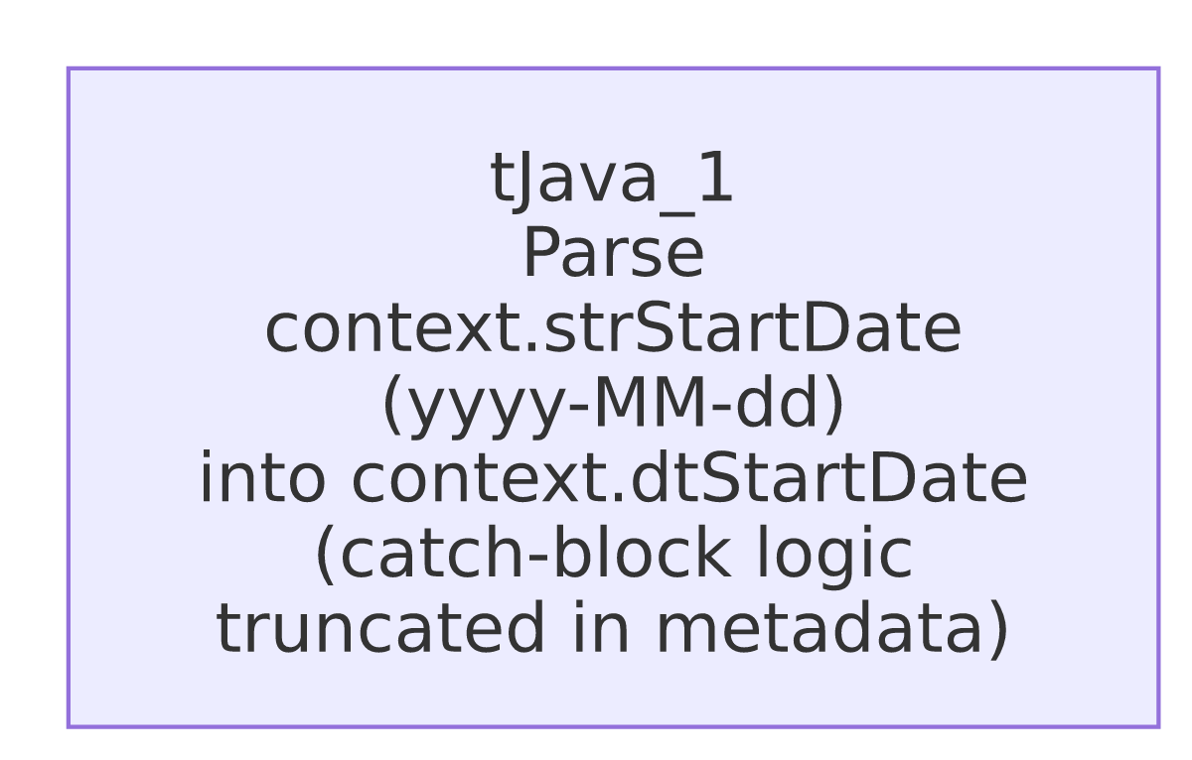

Settings tables

`tJava_1`
Setting | Value | What it means
CODE (try block) | context.dtStartDate = TalendDate.TO_DATE(context.strStartDate,"yyyy-MM-dd"); System.out.println("Start date is: " + context.dtStartDate.toString()); | Parses a yyyy-MM-dd-formatted string context variable into a Date context variable and logs the result.
CODE (catch block) | Truncated in metadata: `if (Relational.ISNULL(context.strStartDate)

Dependencies & configuration
- Triggers/depends on other jobs: none — no tRunJob links found, and this job does not appear in 06_dependency_matrix.md's orchestration table (unsurprising, since nothing calls a bare test snippet like this).
- Context variables used: strStartDate (input, a string expected in yyyy-MM-dd format), dtStartDate (output, set on successful parse).
- No hardcoded developer-workstation paths found in this job (it has no file/path-related components at all).

Glossary
Component type | Plain-English meaning
tJava | Runs arbitrary Java code once, outside of any per-row data flow — used here purely to test a date-parsing expression.

Issues observed
- This job has no connections, no `tPrejob`/`tPostjob`, and no source or target of any kind — it is a self-contained code snippet rather than a runnable ETL pipeline. Given the TEST_ prefix on its name and its lack of any real data flow, this strongly suggests a scratch/test job used to validate the TalendDate.TO_DATE parsing pattern before it was used elsewhere, rather than a job that is itself scheduled to run in production. Unable to confirm its actual usage/status from metadata — verify with the team whether it is still needed or safe to retire.
- The `catch` block's fallback logic is truncated in this metadata, cutting off inside a null/blank check on context.strStartDate. What context.dtStartDate ends up being when the input is missing or malformed (left unset, defaulted to a specific date, etc.) cannot be determined from this extraction — verify directly in Talend Studio before assuming any particular fallback behavior.
- No other findings beyond the project-wide patterns already documented in 05_operational_runbook.md (not applicable here in any case, since this job has no hardcoded paths, connections, or file operations to which those patterns would apply).

