Talend Job: TEST_Email_Alerts

Overview
This is a minimal test/utility job: it contains a single tSendMail component that sends a generic "Talend Open Studio notification" email with the body "Hello" to one recipient. It moves no business data at all — it appears to exist purely to verify that the project's SMTP relay (harriscollect-com.mail.protection.outlook.com) and mail-authentication settings work from this Talend environment, likely used as a template or connectivity check when building the project's other alerting jobs (e.g. Semaphore_Check, the LW_* scrub jobs).

Detail table
Field | Value
Job name | TEST_Email_Alerts
Version | 0.1
Project | EDW2SF
Author | jmach@harriscollect.com
Created | 2023-11-30T11:32:33.852-0800
Last Modified | 2025-08-28T08:57:24.422-0700

Step-by-step data flow
The job has exactly one component and no wiring to any other component — tSendMail_1 runs as the job's entire body, with no prejob/postjob subjobs, no connections list, and no other components present in this metadata.
- tSendMail_1 sends a plain-text email to jmach@harriscollect.com, from svc_analytics@harriscollect.com, subject "Talend Open Studio notification", body "Hello", via SMTP host harriscollect-com.mail.protection.outlook.com on port 25 (no SSL/STARTTLS). DIE_ON_ERROR is true, so a failed send would fail the job.
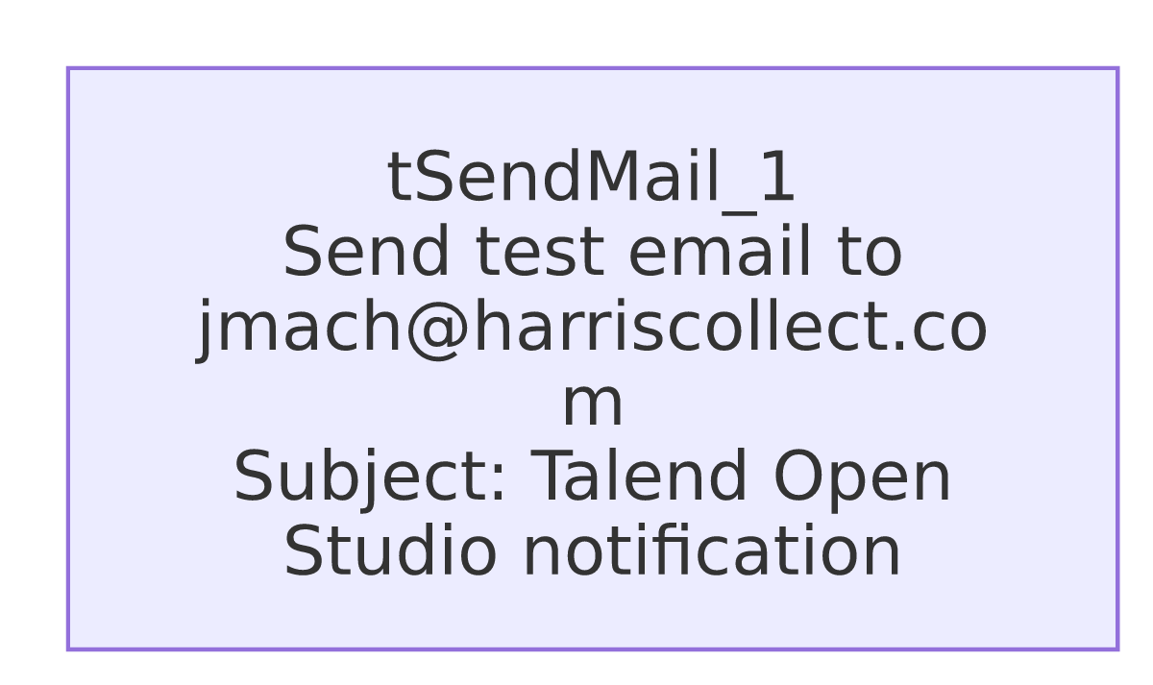

Settings tables

`tSendMail_1`
Setting | Value | What it means
TO / FROM | jmach@harriscollect.com / svc_analytics@harriscollect.com | Single hardcoded recipient — the job's author's own address, not a shared team inbox.
SUBJECT / MESSAGE | "Talend Open Studio notification" / "Hello" | Generic placeholder content, consistent with a connectivity test rather than a real business alert.
SMTP_HOST / SMTP_PORT | harriscollect-com.mail.protection.outlook.com / 25 | The project's outbound mail relay.
SSL / STARTTLS | false / false | No transport encryption configured on this connection.
AUTH_MODE / AUTH_USERNAME / AUTH_PASSWORD / TOKEN / USE_TWO_LINE_TOKEN | ***REDACTED*** (all) | Authentication details are redacted in the source metadata — preserved as-is here.
DIE_ON_ERROR | true | A failed send fails the job outright — there is no fallback logging.
CHECK_ATTACHMENT | true | Talend will validate any configured attachment exists before sending (none is configured here).

Dependencies & configuration
- Triggers/depends on other jobs: none — no tRunJob links found (runjob_targets: []), and it does not appear as a target in 06_dependency_matrix.md.
- Context variables used: none — context_vars_referenced is empty; every setting on tSendMail_1 is a literal, hardcoded value rather than a context variable.
- No hardcoded developer-workstation paths found in this job (hardcoded_path_findings: []) — it has no file-system components at all.

Glossary
Component type | Plain-English meaning
tSendMail | Sends an email via a configured SMTP server — used here to send a single fixed test message.

Issues observed
- This job is almost certainly a test artifact, not a production alert job — its name (TEST_), generic subject/body ("Talend Open Studio notification" / "Hello"), and single hardcoded personal recipient (the job's author) all point to a connectivity check rather than a real business notification. It is listed in 05_operational_runbook.md's "12 jobs send email on failure or completion" table alongside genuine alerting jobs like Semaphore_Check — worth confirming with the team whether it is still scheduled/run anywhere, since if it is, it would only ever notify one individual with a message that carries no operational information.
- No context variables are used anywhere in this job — every value (recipient, SMTP host, subject, body) is hardcoded directly on the component, unlike the project's other tSendMail-using jobs (e.g. Semaphore_Check, which parameterizes its recipients via literal strings but at least routes through a shared IT support inbox). If this job were ever repurposed for a real alert, none of its settings could be changed without editing the job itself.
- No other findings beyond what's already covered above; this job is too minimal to exhibit most of the project-wide patterns documented in 05_operational_runbook.md.

