Talend Job: Test_Decryption

Overview
This is a small, standalone utility/test job: it reads a fixed local file of debtor SSNs (DEBTOR_IDX, encrypted SSN), decrypts the SSN column using Talend's built-in decryption component and a local key file, and writes the decrypted result to a second fixed local file. There is no database connection, no context variables, and no wiring to any other job — everything about this job (its hardcoded C:/Data/... paths and generic "Test" name) indicates it is a one-off developer test of the decryption mechanism used elsewhere in the project (e.g., for SSNs loaded from CUBS extract files), not a production data-movement job.

Detail table
Field | Value
Job name | Test_Decryption
Version | 0.1
Project | EDW2SF
Author | jmach@harriscollect.com
Created | 2022-03-09T09:06:43.859-0800
Last Modified | 2025-08-28T08:57:24.455-0700

Step-by-step data flow
This job has no tPrejob/tPostjob, no database connection, and only a single linear chain:
- tFileInputDelimited_1 reads C:/Data/out.txt (tab-delimited, no header, DIE_ON_ERROR=false), producing two columns: DEBTOR_IDX and an encrypted SSN.
- tDataDecrypt_1 decrypts the SSN column using a key file at C:/Data/cryptest.fil (PASSWORD_M1 and SECRET_TYPE both ***REDACTED***), passing DEBTOR_IDX through unchanged.
- tFileOutputDelimited_1 writes both columns (now with a decrypted SSN) to C:/Data/decrypted.txt (tab-delimited, no header).
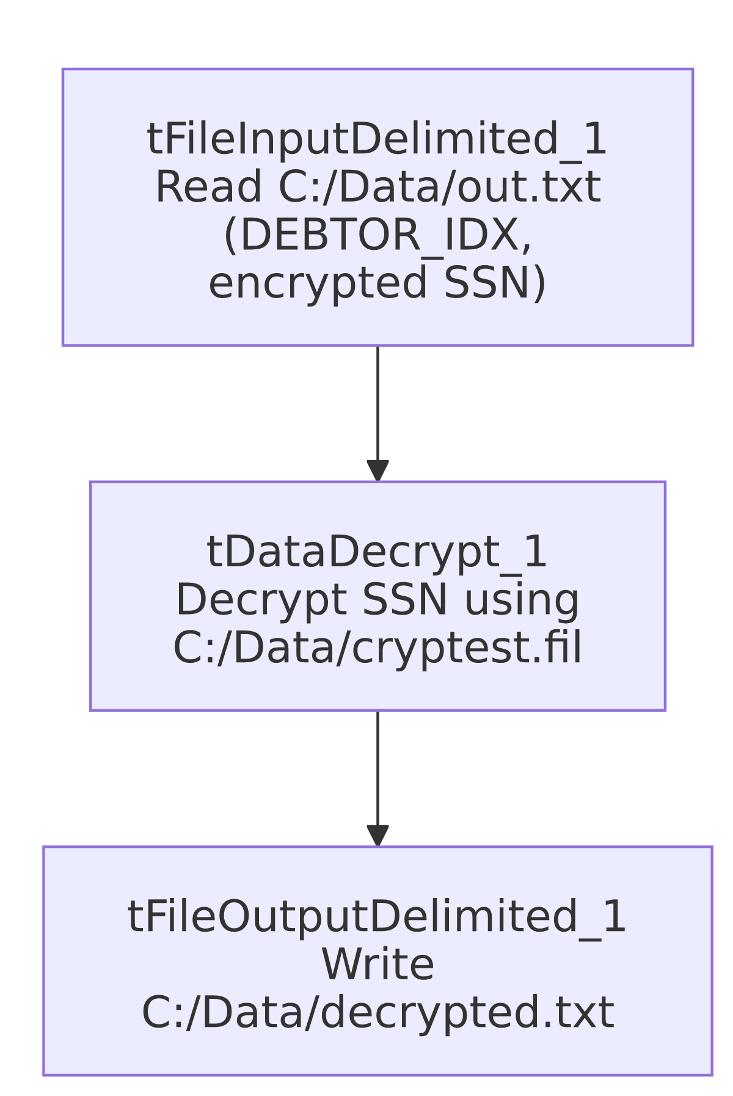

Settings tables

Source: `tFileInputDelimited_1`
Setting | Value | What it means
FILENAME | "C:/Data/out.txt" | A fixed local file, not context-driven — no context.sourceDir or similar is used anywhere in this job.
FIELDSEPARATOR / HEADER | \t / 0 (no header) | Tab-delimited, no header row expected.
DIE_ON_ERROR | false | Malformed rows don't fail the job; no reject flow is wired, so any bad rows are silently dropped.
TEMP_DIR | "C:/Talend-Studio-20211109_1610-V8.0.1/workspace" | Developer workstation path — see Issues observed.

Transform: `tDataDecrypt_1`
Setting | Value | What it means
CRYPTO_FILE_PATH | "C:/Data/cryptest.fil" | Local key/certificate file used to decrypt the SSN column.
PASSWORD_M1 | ***REDACTED*** | Preserved as redacted in source metadata — never guessed or reconstructed here.
SECRET_TYPE | ***REDACTED*** | Same — redacted in source metadata.
ALGO_VERSION | 1 | Decryption algorithm version used by the component.

Target: `tFileOutputDelimited_1`
Setting | Value | What it means
FILENAME | "C:/Data/decrypted.txt" | Fixed local output path for the decrypted result.
APPEND | false | Output file is overwritten each run, not appended to.

Dependencies & configuration
- Triggers/depends on other jobs: none — no tRunJob links found, and no other job in this batch or the reference docs appears to call this one.
- Context variables used: none — every path in this job is a literal string, not a context.* reference (unusual for this project; see Issues observed).
- Hardcoded paths: the job's core file paths (C:/Data/out.txt, C:/Data/cryptest.fil, C:/Data/decrypted.txt) are all hardcoded local paths outside the standard context.sourceDir/archiveDir pattern used elsewhere in EDW2SF; the extractor separately flagged tFileInputDelimited_1.TEMP_DIR (C:/Talend-Studio-20211109_1610-V8.0.1/workspace) as a developer-workstation path per the project-wide pattern in 05_operational_runbook.md.

Glossary
Component type | Plain-English meaning
tFileInputDelimited / tFileOutputDelimited | Read/write a delimited (tab- or comma-separated) text file according to a schema.
tDataDecrypt | Decrypts one or more columns using a Talend cryptographic key file, the counterpart to a tDataEncrypt used elsewhere to protect sensitive fields like SSN.

Issues observed
- This job has no database connection, no `context.*` variables, and no `tPrejob`/`tPostjob` structure — every other job in this batch (and the four reference docs) follows the project's standard log-file-open/connection-open/connection-close scaffolding. Its complete absence here, combined with the generic "Test" name and hardcoded C:/Data/... paths, strongly suggests this is a developer's local proof-of-concept for the decryption mechanism (used to decrypt SSNs loaded from CUBS extracts elsewhere in the project) rather than a job intended to run in a scheduled production pipeline. Whether it is still deployed/scheduled anywhere is unable to determine from metadata — verify with the team before assuming it's dormant.
- No reject flow is wired from `tFileInputDelimited_1`, and DIE_ON_ERROR=false, so any row that fails to parse is silently dropped with no record of it — consistent with the project-wide unwired-reject-flow pattern noted in other jobs' docs, but here with no downstream consequence since the job appears to be a test harness rather than a production load.
- `PASSWORD_M1` and `SECRET_TYPE` on `tDataDecrypt_1` are both `*REDACTED*` in the source metadata and are preserved as such here — the actual key/algorithm values are not available from this extraction and must not be guessed.

