Talend Job: Test_Encryption

Overview
This is a small, standalone utility job — not part of the production load pipeline — that reads up to 1,000 debtor Social Security Numbers from the EDWProdHH MSSQL DIMDEBTOR table for logon HH (excluding rows already masked with an XXX-prefixed SSN), runs them through Talend's tDataEncrypt component, and writes the result to a local flat file. Its name and minimal structure (no logging setup, no connection-close teardown, no downstream consumer of the output file) strongly suggest it exists to test/validate the encryption component and its key file, not to run on a schedule as part of the warehouse load.

Detail table
Field | Value
Job name | Test_Encryption
Version | 0.1
Project | EDW2SF
Author | jmach@harriscollect.com
Created | 2022-03-09T08:15:08.049-0800
Last Modified | 2025-08-28T08:57:24.491-0700

Step-by-step data flow
This job has no tPrejob/tPostjob, no explicit connection-open/-close components, and only a single linear chain:
- tDBInput_1 (tMSSqlInput) connects directly to EDWProdHH (context.EDWProdHH_Server/Port/Schema/Database/Login, password redacted) and runs SELECT TOP 1000 [DEBTOR_IDX], SSN FROM DIMDEBTOR WHERE LOGON='HH' AND LEN(TRIM(SSN))=9 AND SSN NOT LIKE 'XXX%' — a fixed, hardcoded logon ('HH') and row limit, and a filter meant to exclude SSNs that have already been redacted/masked upstream ('XXX%').
- tDataEncrypt_1 encrypts the SSN column using a password-protected crypto key file at "C:/Data/cryptest.fil" (PASSWORD_M1 and SECRET_TYPE both redacted; GEN_CRYPTO_FILE_CONTROLLER=false, meaning it uses an existing key file rather than generating a new one).
- tFileOutputDelimited_1 writes the two-column result (DEBTOR_IDX, encrypted SSN) to a fixed local path "C:/Data/out.txt", tab-delimited, no header.
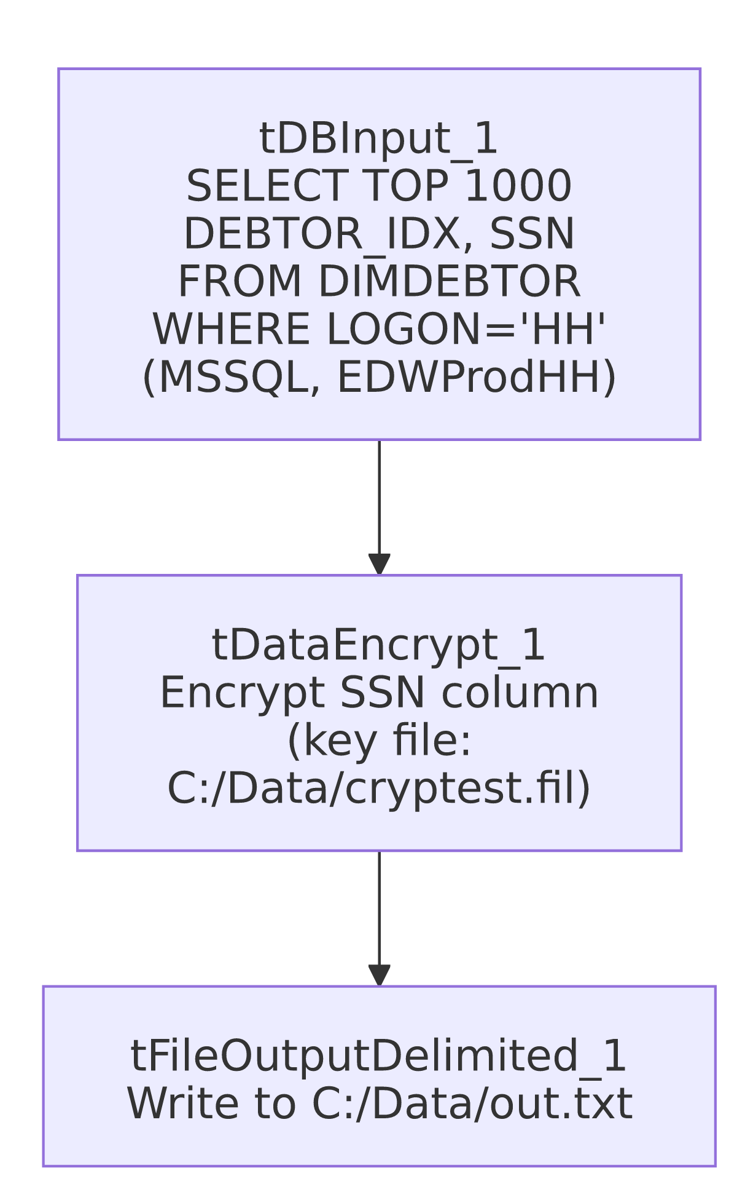

Settings tables

Source: `tDBInput_1` (`tMSSqlInput`)
Setting | Value | What it means
Connection | context.EDWProdHH_Server/Port/Schema/Database/Login (password ***REDACTED***) | Connects directly to the EDWProdHH MSSQL database — the same operational database referenced by name throughout this project (see 01_system_architecture.md).
Query | SELECT TOP 1000 [DEBTOR_IDX], SSN FROM DIMDEBTOR WHERE LOGON='HH' AND LEN(TRIM(SSN))=9 AND SSN NOT LIKE 'XXX%' | Pulls a bounded sample (1,000 rows) of un-masked, well-formed (9-character) SSNs for logon HH only — hardcoded, not parameterized by context.

Transform: `tDataEncrypt_1`
Setting | Value | What it means
PASSWORD_M1 | ***REDACTED*** | Password protecting the encryption key/algorithm — preserved as redacted, not guessed.
CRYPTO_FILE_PATH | "C:/Data/cryptest.fil" | Local path to the crypto key file used to encrypt the SSN column.
GEN_CRYPTO_FILE_CONTROLLER | false | Uses the existing key file rather than generating a new one — consistent with a test job validating a pre-existing key, not provisioning one.
SECRET_TYPE | ***REDACTED*** | Encryption/secret type setting — redacted value preserved as-is.

Target: `tFileOutputDelimited_1`
Setting | Value | What it means
FILENAME | "C:/Data/out.txt" | Fixed local output path — not driven by any context variable.
FIELDSEPARATOR / INCLUDEHEADER | \t / false | Tab-delimited, no header row.
APPEND | false | Overwrites the file on each run rather than appending.

Dependencies & configuration
- Triggers/depends on other jobs: none — no tRunJob links found, and this job is not called by (nor does it call) any other job in 06_dependency_matrix.md.
- Context variables used: EDWProdHH_Database, EDWProdHH_Login, EDWProdHH_Port, EDWProdHH_Schema, EDWProdHH_Server — the standard EDWProdHH_0.1 context group (see 01_system_architecture.md/06_dependency_matrix.md).
- No hardcoded-path findings were flagged by the metadata extraction for this job — but see Issues observed; the job in fact contains several hardcoded local paths that simply weren't captured by the extractor's specific pattern-matching.

Glossary
Component type | Plain-English meaning
tMSSqlInput | Runs a query against a Microsoft SQL Server database and returns the result rows.
tDataEncrypt | Encrypts one or more columns of a row using a password-protected key file, producing an encrypted value in place of the original.
tFileOutputDelimited | Writes rows to a delimited (e.g., tab- or comma-separated) local text file.

Issues observed
- This job's `hardcoded_path_findings` list came back empty from the metadata extraction, but it clearly contains hardcoded local Windows paths: tDataEncrypt_1.CRYPTO_FILE_PATH ("C:/Data/cryptest.fil") and tFileOutputDelimited_1.FILENAME ("C:/Data/out.txt") are both literal, non-context-driven paths. These simply weren't flagged by whatever pattern the extractor used to detect hardcoded paths elsewhere in this project (typically the C:/Talend-Studio-... workspace path) — worth noting so this job isn't assumed path-clean just because the automated finding list is empty.
- No `tPrejob`/`tPostjob`, no explicit connection-close, and the query is entirely hardcoded (fixed TOP 1000, fixed LOGON='HH') rather than driven by context variables the way production load jobs in this project are. Combined with the job's name (Test_Encryption), this strongly suggests it is a one-off validation/test utility for the tDataEncrypt component rather than a job intended to run on a production schedule — but this is an inference from structure, not something stated anywhere in the metadata; confirm with the team before assuming it's safe to delete or ignore in scheduling audits.
- The output file (`C:/Data/out.txt`) has no documented downstream consumer in this job or any other job's metadata reviewed in this batch — if this job is in fact still scheduled, it's worth asking why, since nothing appears to read its output.

