Talend Job: Top_N_Accounts_Extract

Overview
Extracts a pre-built "Top 20 clients by high balance" report — client name, debtor/packet identifiers, industry, assigned amount, current balance, and a set of contact-channel activity counters (dialer/agent calls, texts, letters, emails, VoApps, last contact date) — from a Snowflake view (EDWPRODHH.PUB_JCHANG.REPORT_TOP_20_CLIENTS_HIGH_BALANCE) and writes it straight to a dated CSV file. Despite the job's generic name ("Top N Accounts"), the underlying query and its target table name are hardcoded to a specific "Top 20 Clients" report, and its schema is per-client rather than per-account.

Detail table
Field | Value
Job name | Top_N_Accounts_Extract
Version | 0.1
Project | EDW2SF
Author | jmach@harriscollect.com
Created | 2023-07-18T14:17:01.903-0700
Last Modified | 2025-11-16T21:27:58.022-0800

Step-by-step data flow
Setup subjob: tPrejob_1 → tSetKeystore_1 configures SSL trust/keystore (SSL_KEYSTORE from context.keystorePath, truststore path hardcoded, passwords redacted) → on success, tDBConnection_1 opens the Snowflake connection.
Main subjob (runs independently of the setup subjob — there is no visible connection tying tDBInput_1 to the connection setup chain, meaning it implicitly relies on Talend's shared/default Snowflake connection rather than being explicitly wired to tDBConnection_1):
- tDBInput_1 runs a fixed SELECT of 18 named columns (CLIENT_NAME, DEBTOR_IDX, PACKET_IDX, PL_GROUP, PARTY, INDUSTRY, BATCH_DATE, ASSIGNED_AMOUNT, BALANCE_DIMDEBTOR, and a set of contact-channel counters: DIALER_AGENT_CALLS, OUTBOUND_MANUAL_CALLS, TEXT_MESSAGES, LETTERS, DIALER_AGENTLESS_CALLS, INBOUND_AGENT_CALLS, EMAILS, VOAPPS, LAST_CONTACT) FROM EDWPRODHH.PUB_JCHANG.REPORT_TOP_20_CLIENTS_HIGH_BALANCE; — a fully qualified, three-part Snowflake object reference, reading from a view/table in a PUB_JCHANG schema (see 01_system_architecture.md's note that PUB_JCHANG looks like an individually-owned schema, not shared platform infrastructure).
- tFileOutputDelimited_1 writes the rows straight through, unmapped, to context.targetDir + "TOP_20_CLIENTS_HIGH_BALANCES_" + TalendDate.getDate("CCYYMMDD") + ".csv" — comma-delimited, header included, ISO-8859-15 encoding.
Teardown subjob: tPostjob_1 → tDBClose_1 closes the Snowflake connection.
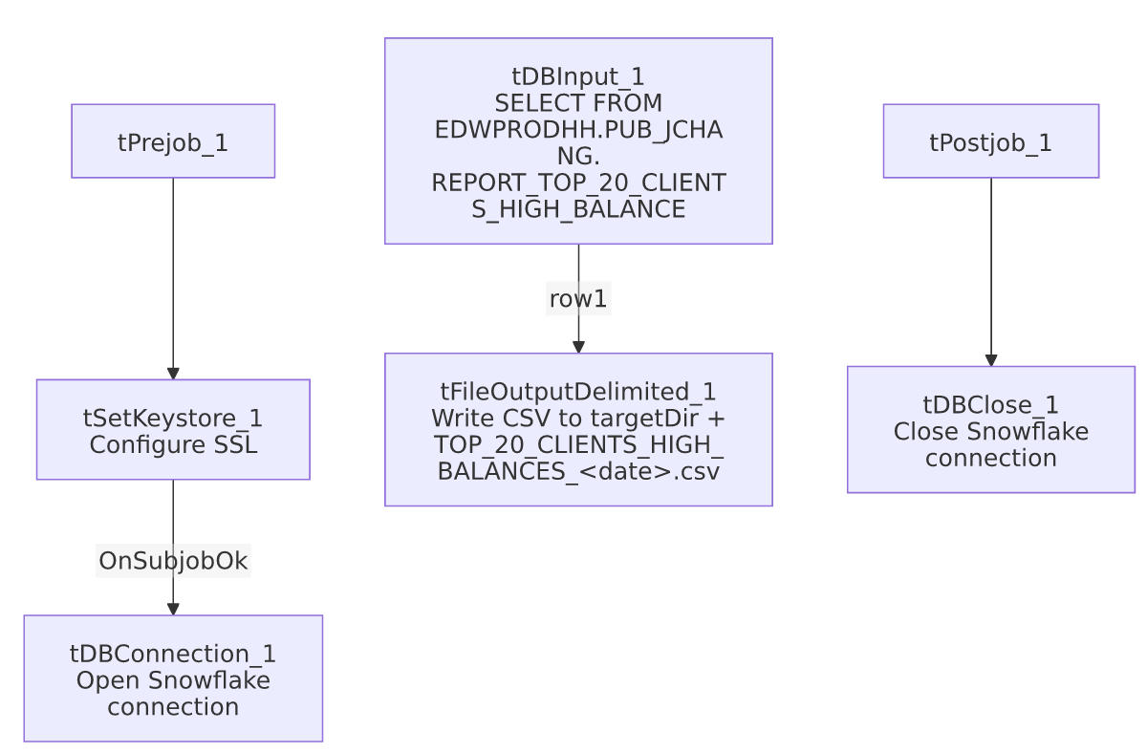

Settings tables

Source: `tDBInput_1` (`tSnowflakeInput`)
Setting | Value | What it means
Query | SELECT ... FROM EDWPRODHH.PUB_JCHANG.REPORT_TOP_20_CLIENTS_HIGH_BALANCE; | A fixed, fully qualified read of a pre-built report object — no filtering, joins, or parameters visible in this job. All logic (the "top 20" selection and balance/activity aggregation) lives in that Snowflake object, not in this Talend job.
Columns | 18 client-level and contact-activity columns | See Overview for the full list; all typed as strings/dates/decimals matching the source view's own column types.

Target: `tFileOutputDelimited_1`
Setting | Value | What it means
FILENAME | context.targetDir + "TOP_20_CLIENTS_HIGH_BALANCES_" + TalendDate.getDate("CCYYMMDD") + ".csv" | Produces a new, dated file on every run rather than overwriting a fixed name — old extracts are not automatically cleaned up by this job.
FIELDSEPARATOR / INCLUDEHEADER | , / true | Standard comma-delimited CSV with a header row.
ENCODING | ISO-8859-15 | Non-UTF-8 encoding, consistent with other legacy-source extract jobs in this project.
APPEND | false | Each run creates a fresh file rather than appending to a prior day's extract.

Dependencies & configuration
- Triggers/depends on other jobs: none — no tRunJob links found, and this job does not appear in 06_dependency_matrix.md's orchestration table.
- Context variables used: keystorePath (SSL/keystore configuration), targetDir (output directory for the CSV — not confirmed against StandardFolders_0.1 or any other documented context group in _shared_context.json; likely a job-specific or ad hoc variable).
- 1 hardcoded developer-workstation path: tSetKeystore_1.SSL_TRUSTSERVER_TRUSTSTORE ("C:/clientTrustStore.trustStore") — same project-wide risk pattern documented in 05_operational_runbook.md.
- Reads from `EDWPRODHH.PUB_JCHANG`, a schema flagged in 01_system_architecture.md as looking individually owned (the "JCHANG" initials suggest a specific person) rather than shared platform infrastructure — worth confirming who owns this schema/view and what happens to this extract if that person or their access changes.

Glossary
Component type | Plain-English meaning
tSnowflakeInput | Runs a query against Snowflake and returns its result rows.
tFileOutputDelimited | Writes rows to a delimited (CSV-style) text file.
tSnowflakeConnection / tSnowflakeClose | Open/close the Snowflake connection used by the job.
tSetKeystore | Configures SSL trust/keystore settings used by the Snowflake connection.

Issues observed
- `tDBInput_1` has no visible connection to `tDBConnection_1` in this job's connections metadata — the setup subjob (keystore → connection) and the main subjob (query → file write) are two separate, unconnected chains. This is common in Talend when a query component implicitly uses the single open/shared connection rather than being explicitly wired to it, so it's likely not a functional problem, but it does mean this job's own metadata alone doesn't prove the query actually runs against the connection the job deliberately configured (with its keystore/SSL settings) rather than some other default. Verify directly in Talend Studio if this job's connection behavior is ever in question.
- The job's name ("Top N Accounts Extract") is more generic than what it actually does — it runs one fixed query against a specifically-named "Top 20 Clients High Balance" report object, with no parameter controlling "N" or the ranking criteria visible anywhere in this job. Anyone expecting a configurable top-N account extract based on the job name alone would be misled; the actual selection logic lives entirely in the Snowflake view/table this job reads from, not in Talend.
- `context.targetDir` is not a variable name found in any of the documented context groups in _shared_context.json (unlike StandardFolders_0.1's sourceDir/archiveDir/logDir). Unable to determine from this job's own metadata which context group supplies it or what path it resolves to; verify with the team.
- No other findings beyond the project-wide hardcoded-path pattern already documented in 05_operational_runbook.md.

