Talend Job: Touchstar_DNC_Load

Overview
Loads "Do Not Call" phone-number files from the Touchstar dialer system into Snowflake: it reads every file in a source directory (tab-delimited, one phone number per relevant row), tags each row with its source file name and the file's own last-modified timestamp, inserts the results into a TOUCHSTAR_DONOTCALL_STAGING table, then calls a stored procedure to merge them into a downstream do-not-call table. This gives the collections platform an up-to-date list of numbers it must not dial, sourced from the Touchstar system rather than the I3 dialer platform used elsewhere in this project.

Detail table
Field | Value
Job name | Touchstar_DNC_Load
Version | 0.2
Project | EDW2SF
Author | jmach@harriscollect.com
Created | 2025-01-17T08:44:05.198-0800
Last Modified | 2025-09-24T11:09:22.403-0700

Step-by-step data flow
Setup subjob: tPrejob_1 → tDBConnection_1 opens the Snowflake connection (OnComponentOk). No SSL/keystore step, no MSSQL connection — this job only ever talks to Snowflake and the local file system.
Main subjob — starts independently at tDBRow_1 (no incoming trigger link, so it begins as soon as the job starts):
- tDBRow_1 runs TRUNCATE TABLE TOUCHSTAR_DONOTCALL_STAGING; against Snowflake (no explicit schema prefix — see Issues observed).
- On success (OnSubjobOk), tFileList_1 lists files in context.dncSourceDir (EXCLUDEFILEMASK of *.txt is set but IFEXCLUDE=false, so the exclusion is configured but never actually applied).
- For each file, tJava_1 sets context.dncFilePath/context.dncFileName from the current file-list iteration values.
- tFileInputDelimited_1 reads the file (tab-delimited, header row present, DIE_ON_ERROR=false) into a schema of PHONE_NUMBER, FILE_DATE, JAVA_TIMESTAMP, PHONE — reading a repository reject schema whose stored label is a bare metadata GUID (_3w2w4LQEEe-PfNW_65jztA - metadata), not a descriptive name.
- tJavaRow_1 derives FILE_DATE and JAVA_TIMESTAMP from the source file's own OS-level last-modified timestamp (via Files.readAttributes), not from any value inside the file, and passes PHONE through.
- tMap_1 adds SOURCE and FILE_NAME (presumably populated from context.dncFileName, not directly visible in the captured mapping expressions) and UPLOAD_DATE, producing the final 6-column shape: FILE_DATE, JAVA_TIMESTAMP, PHONE, SOURCE, FILE_NAME, UPLOAD_DATE.
- tDBOutput_1 inserts the mapped rows into Snowflake table TOUCHSTAR_DONOTCALL_STAGING (INSERT, no table-recreate action).
- Once the tFileList_1 iteration subjob completes (OnSubjobOk), tDBRow_2 runs CALL MERGE_TOUCHSTAR_INTO_DONOTCALL(); — with no result-checking downstream (no tJavaRow/tWarn/tDie after this call).
No teardown subjob — no tPostjob/tDBClose component exists in this job's metadata, so the Snowflake connection opened in setup is never explicitly closed by this job.
There is also no archive/delete step for the source files after loading — this job never removes or archives what it reads from context.dncSourceDir.
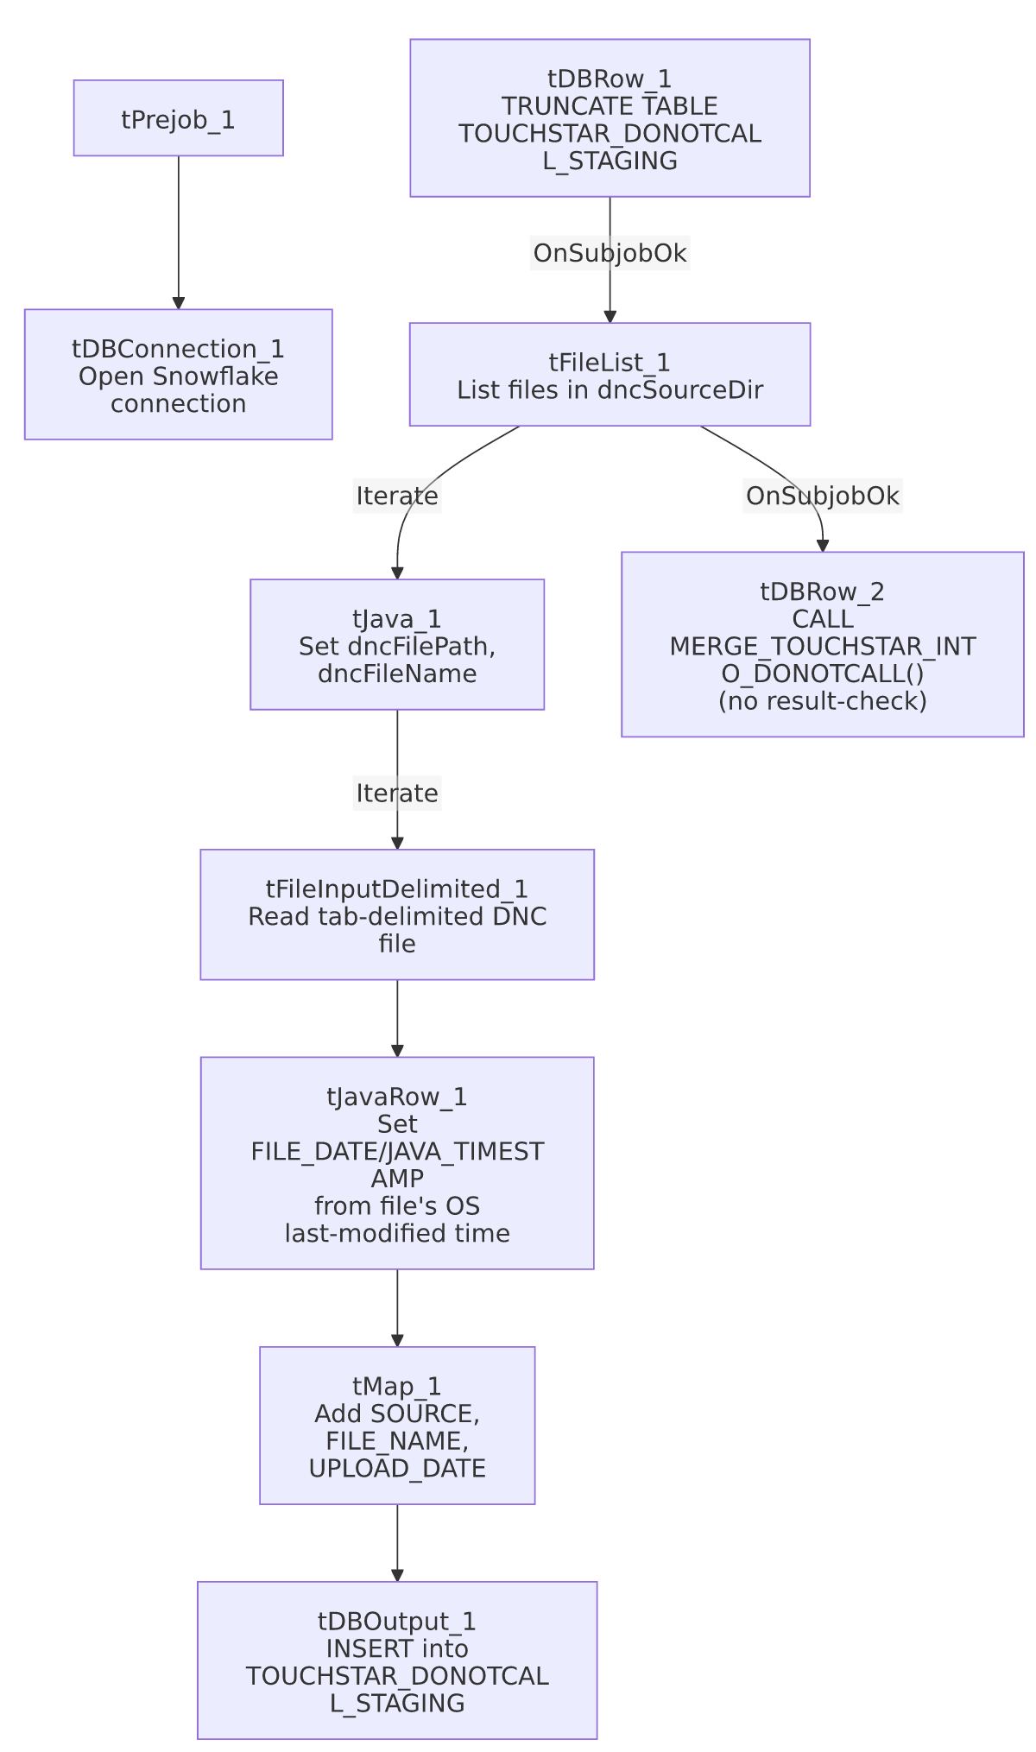

Settings tables

Source: `tFileInputDelimited_1`
Setting | Value | What it means
FILENAME | context.dncFilePath | The current file from tFileList_1's iteration.
FIELDSEPARATOR / HEADER | \t / 1 header row | Tab-delimited with a header row skipped.
SCHEMA (main) | PHONE_NUMBER, FILE_DATE, JAVA_TIMESTAMP, PHONE (plus errorCode/errorMessage reject columns) | PHONE_NUMBER is read from the file but not carried forward past tJavaRow_1 — only PHONE (a separately-named column) continues into the map and output. See Issues observed.
SCHEMA_REJECT | Repository schema ID _3w2w4LQEEe-PfNW_65jztA - metadata | Generic GUID-based label, not a descriptive name — unable to determine from metadata what this reject schema's actual columns are.
DIE_ON_ERROR | false | Malformed rows do not fail the job...
Reject flow | Not wired | ...but no connection carries rejected rows anywhere in this job — they are silently dropped with no record of how many, or which, rows failed to parse.
TEMP_DIR | "C:/Talend-Studio-20211109_1610-V8.0.1/workspace" | Hardcoded developer-workstation path.

Date derivation: `tJavaRow_1`
Setting | Value | What it means
Logic | Reads the source file's OS-level last-modified timestamp (Files.readAttributes(...).lastModifiedTime()) and uses it to populate FILE_DATE/JAVA_TIMESTAMP | The "file date" recorded against every DNC number is when the file was last touched on disk, not any date encoded in the file's own content — if the file's OS timestamp is altered by a copy/transfer step before Talend reads it, the recorded date would reflect that instead of the file's true origin date.

Target: `tDBOutput_1` (`tSnowflakeOutput`)
Setting | Value | What it means
Table | TOUCHSTAR_DONOTCALL_STAGING | Destination staging table for the raw DNC rows.
Output action | INSERT | Appends rows; relies on the earlier TRUNCATE (step 1) to prevent duplicate accumulation across runs.

Truncate & merge: `tDBRow_1` / `tDBRow_2`
Setting | Value | What it means
Query (tDBRow_1) | TRUNCATE TABLE TOUCHSTAR_DONOTCALL_STAGING; | No explicit schema prefix (e.g. STAGING.) — see Issues observed.
Query (tDBRow_2) | CALL MERGE_TOUCHSTAR_INTO_DONOTCALL(); | Calls a stored procedure (not shown in this metadata) presumably merging the staged numbers into a final do-not-call table. No RETVALUE/result capture follows this call.

Dependencies & configuration
- Triggers/depends on other jobs: none — no tRunJob links found, and this job is not listed as a target in 06_dependency_matrix.md.
- Context variables used: dncFileName, dncFilePath, dncSourceDir. None of these are documented context groups in _shared_context.json — this job appears to use its own dedicated (undocumented in the shared context extract) variable set rather than the shared StandardFolders_0.1 group used by most of the project.
- 1 hardcoded developer-workstation path: tFileInputDelimited_1.TEMP_DIR — same project-wide risk documented in 05_operational_runbook.md.

Glossary
Component type | Plain-English meaning
tFileList | Lists files in a directory for the job to iterate over one at a time.
tFileInputDelimited | Reads a delimited (tab/comma-style) text file according to a schema.
tJavaRow | Runs custom Java code once per input row — here used to stamp each row with the source file's OS last-modified date.
tMap | Maps/transforms columns from one schema to another.
tSnowflakeOutput / tSnowflakeRow / tSnowflakeConnection | Write rows to a Snowflake table / run an arbitrary SQL statement or stored-procedure call against Snowflake / open the Snowflake connection used elsewhere in the job.

Issues observed
- No teardown subjob exists — there is no tPostjob/tDBClose anywhere in this job's metadata, so the Snowflake connection opened by tDBConnection_1 is never explicitly closed within the job itself (it would only close when the JVM exits). This is a gap relative to most other jobs in this project, which pair every tDBConnection with a matching tDBClose in a tPostjob subjob.
- No archive or delete step for the source files — after a DNC file is loaded, it is left in place in context.dncSourceDir with no record of having been processed. Unlike file-load jobs elsewhere in this project (e.g. ADP_Payroll_Load, which archives-then-deletes), a rerun of this job would reprocess every file in the directory again, potentially reloading numbers already staged (mitigated only by the preceding TRUNCATE, which clears the whole staging table each run regardless of which files are "new").
- No result-checking on the `MERGE_TOUCHSTAR_INTO_DONOTCALL()` call — a failure in the merge stored procedure would only surface as a generic Talend execution error, with no job-specific tWarn/tDie message to distinguish it, unlike jobs such as ADP_Payroll_Load that capture and branch on the procedure's return code.
- No reject flow wired from `tFileInputDelimited_1`, and its reject schema is a bare GUID-labeled repository schema (_3w2w4LQEEe-PfNW_65jztA - metadata) rather than a descriptively-named one — malformed rows are silently dropped with no diagnostic trail, matching the project-wide pattern already documented in 05_operational_runbook.md.
- `TRUNCATE TABLE TOUCHSTAR_DONOTCALL_STAGING;` has no explicit schema prefix, unlike some other jobs in this project that qualify their truncate/merge targets with STAGING.. Unable to determine from this metadata whether TOUCHSTAR_DONOTCALL_STAGING resolves to the intended staging schema via the connection's default schema, or whether this is a portability risk if that default ever changes — verify with the team.
- The source schema reads a `PHONE_NUMBER` column that is then dropped — tFileInputDelimited_1's schema includes both PHONE_NUMBER and PHONE, but only PHONE survives into tJavaRow_1's output and everything downstream. Unable to determine from this metadata whether PHONE_NUMBER and PHONE are expected to always hold the same value (making the drop harmless) or whether this indicates a leftover/unused column from an earlier version of the file format; verify with the team.

