Talend Job: Trans_History_Load

Overview
Reads transaction-history export files (the "transhistory" repository schema: transaction ID, debtor, transaction code/amount/date, statement and posting fields, letter/campaign references) from a fixed Linux path (/mnt/cubs/TransHistory/) and loads them into a Snowflake table named TEMP_TRANS. Unlike every other job in this batch, this job has no visible connection-open/close, prejob/postjob, log-file setup, merge step, or file archive/delete step — see Issues observed, which flags several structural anomalies significant enough that this job's actual production readiness should be verified directly with the team before relying on this documentation alone.

Detail table
Field | Value
Job name | Trans_History_Load
Version | 0.1
Project | EDW2SF
Author | jmach@harriscollect.com
Created | 2023-06-02T10:12:23.102-0700
Last Modified | 2025-09-24T11:08:20.984-0700

Step-by-step data flow
This job's metadata contains only 6 components — no tPrejob/tPostjob, no tDBConnection/tDBClose, no log-file setup, and no archive/delete step. The entire flow is:
- tFileList_1 lists files in the hardcoded, non-context-driven directory /mnt/cubs/TransHistory/ (an EXCLUDEFILEMASK of *.txt is configured but IFEXCLUDE=false, so no files are actually excluded).
- For each file (ITERATE), tJava_1 sets context.sourceFilePath and context.fileName.
- tFileInputDelimited_1 reads the file (tab-delimited, header row, DIE_ON_ERROR=false) using the repository schema "transhistory" — roughly 80 columns covering transaction ID/code/amount/date, statement fields (STMT_DATE, STMT_CODE, STMT_GRP), posting fields (POST_DATE, POST_BATCH), NSF/cancellation/judgment payment fields, and letter/campaign references (LTR_ID, CAMPID).
- tMap_1 maps the source columns to a target schema, renaming a few columns along the way (e.g. source DEBTOR → target DEBTOR_NUMBER, source SOURCE/COMMENT → target TRANS_SOURCE/TRANS_COMMENT) and adding a FILENAME column.
- tFlowMeter_2 counts rows passing through (labeled "MyLabel", not renamed for this job; also flagged in the metadata as having a "not synchronized" reference to a LEGACY_DIMDEBTOR repository schema — see Issues observed).
- tDBOutput_1 inserts the rows into Snowflake table TEMP_TRANS (INSERT, no table-recreate action) — but see Issues observed regarding a serious schema mismatch on this final component.
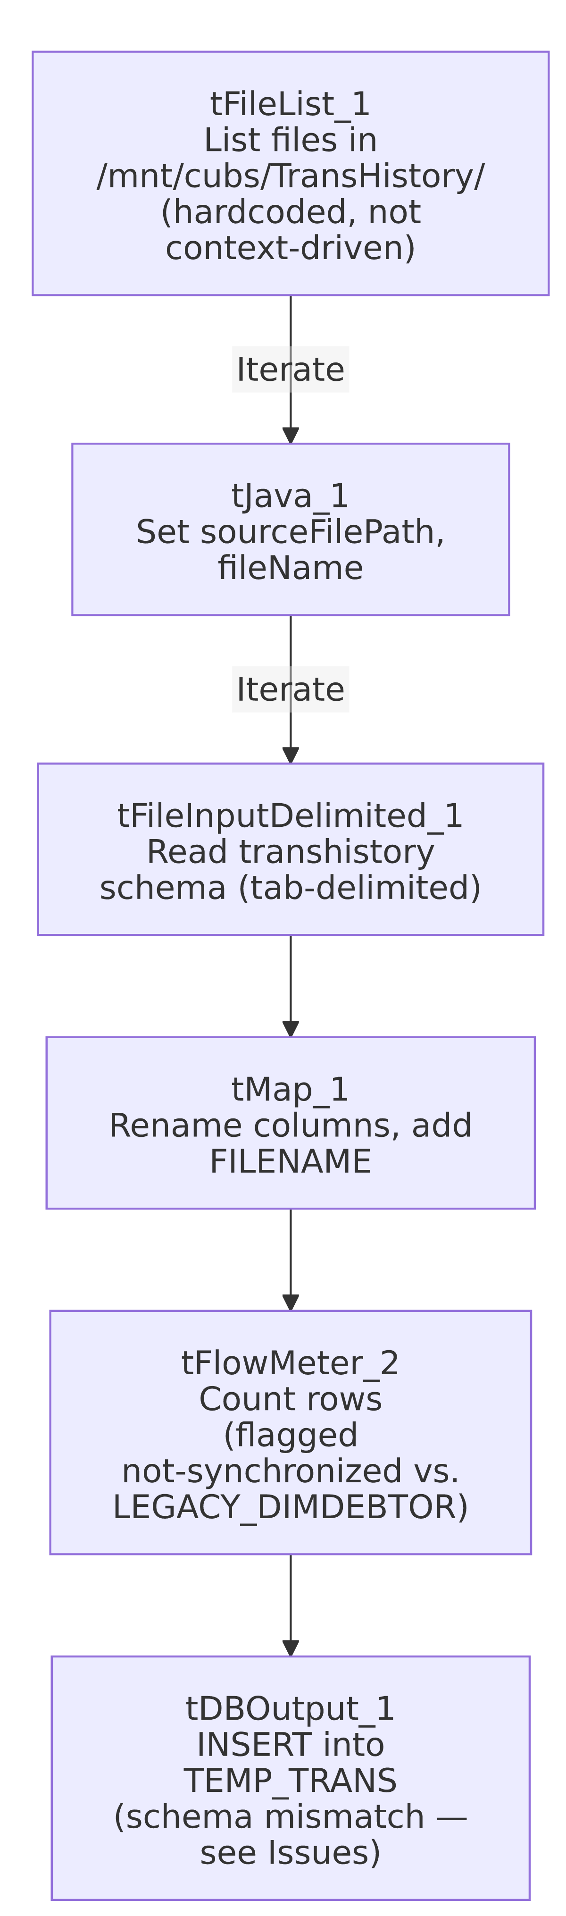

Settings tables

Source: `tFileList_1` / `tFileInputDelimited_1`
Setting | Value | What it means
DIRECTORY (tFileList_1) | "/mnt/cubs/TransHistory/" | Hardcoded literal path, not built from context.sourceDir as most other file-source jobs in this project do — see Issues observed.
FILENAME (tFileInputDelimited_1) | context.sourceFilePath | Set per-iteration by tJava_1.
SCHEMA | Repository schema "transhistory" | ~80-column transaction-history layout (transaction ID/code/amount, statement/posting fields, letter/campaign references).
FIELDSEPARATOR / HEADER | \t / 1 header row | Tab-delimited with a header row skipped.
DIE_ON_ERROR | false | Malformed rows don't fail the job; no reject flow is wired downstream (rejects are silently dropped).
TEMP_DIR | "C:/Talend-Studio-20211109_1610-V8.0.1/workspace" | Developer-workstation path — see Issues observed.

Target: `tDBOutput_1` (`tSnowflakeOutput`)
Setting | Value | What it means
Table | TEMP_TRANS | Destination table name — the "TEMP" prefix and this job's overall thin/incomplete structure both suggest a staging or in-progress table rather than a finished production target.
Schema label | table.main.schema:REPOSITORY_SCHEMA_TYPE = "... - LEGACY_DIMDEBTOR" | The target component's own schema reference is labeled `LEGACY_DIMDEBTOR`, and its actual captured column list (DEBTOR, DEBTOR_IDX, NAME1, NAME2, ADD1, ADD2, CITY, ST, ZIP, DOB, SSN, TOTAL_BAL, ASGN_AMT, PROM_DT, UPDATEKEY, etc.) is a debtor-dimension-shaped schema, not a transaction-shaped one — it does not match the transaction-shaped columns (LOGON, TRANS_ID, TRANS_IDX, TCODE, TRANS_AMT, TRANS_DATE, etc.) that tMap_1 actually outputs. See Issues observed — this is the most significant finding in this job.
Output action | INSERT | No truncate/merge step precedes or follows this insert anywhere in the job.

Dependencies & configuration
- Triggers/depends on other jobs: none — no tRunJob links found, and this job is not listed as a tRunJob target anywhere in 06_dependency_matrix.md. Note this is a distinct job from CUBS_Raw_Trans_Load (which CO_Master_Load does call) — the two should not be confused.
- Context variables used: only fileName and sourceFilePath — no context.sourceDir, logDir, archiveDir, or database-connection context variables appear anywhere in this job's metadata, consistent with the missing connection/log/archive components noted above.
- 1 hardcoded path flagged by the extractor: tFileInputDelimited_1.TEMP_DIR (C:/Talend-Studio-20211109_1610-V8.0.1/workspace). In addition, tFileList_1.DIRECTORY (/mnt/cubs/TransHistory/) is a hardcoded literal path not built from a context variable — not flagged by the automated extractor (it only pattern-matches the C:/Talend-Studio... developer path), but worth noting here since it means this job's source directory cannot be changed without editing the job itself.

Glossary
Component type | Plain-English meaning
tFileList | Lists files in a directory for the job to iterate over one at a time.
tFileInputDelimited | Reads a delimited (tab- or comma-separated) text file according to a schema.
tMap | Maps/transforms columns from one schema to another, including renames.
tFlowMeter | Counts rows passing through a point in the flow, for logging/monitoring.
tSnowflakeOutput | Writes rows to a Snowflake table.

Issues observed
- `tDBOutput_1`'s captured schema is debtor-shaped (`LEGACY_DIMDEBTOR`-labeled), not transaction-shaped, while `tMap_1` immediately upstream outputs transaction-shaped columns. The columns captured on tDBOutput_1 (DEBTOR, DEBTOR_IDX, NAME1, ADD1, CITY, SSN, TOTAL_BAL, PROM_DT, UPDATEKEY, etc.) do not resemble the transaction-shaped columns produced by tMap_1 (LOGON, TRANS_ID, TRANS_IDX, DEBTOR_NUMBER, TCODE, TRANS_AMT, TRANS_DATE, CLIENT, etc.), and tDBOutput_1's own schema parameter is explicitly labeled with the repository schema name LEGACY_DIMDEBTOR rather than anything transaction- or TEMP_TRANS-related. This is either (a) a job built by copying a debtor-dimension-load job and never fully repointing its output schema to match the actual transaction data flowing into it, or (b) a metadata-extraction artifact. Given how strictly this documentation must trace to source metadata, this cannot be resolved without opening the job directly in Talend Studio — but as captured, this looks like a broken or unfinished job that would very likely fail at runtime with a column-count/type mismatch, or silently write transaction data into columns meant for debtor demographics. This is the most consequential finding in this batch and should be verified with the team before this job is assumed to be production-ready.
- This job has no `tPrejob`/`tPostjob`, no `tDBConnection`/`tDBClose`, and no log-file-open step, unlike every other job examined in this batch and both file-load reference docs (ADP_Payroll_Load, Raw_PCI_Letter_Load). The Snowflake connection tDBOutput_1 uses must therefore be either an embedded/inline connection configuration not captured separately in this extraction, or a genuinely missing piece of the job. Unable to determine from metadata; if this job is actually scheduled to run, verify how (and whether) it successfully connects to Snowflake at all.
- No truncate or merge step accompanies the `INSERT` into `TEMP_TRANS`. Given the "TEMP" naming and the schema mismatch noted above, this reinforces the impression that TEMP_TRANS is an intermediate/staging table this job was never finished wiring into the rest of the warehouse (no downstream merge into a DW-schema fact table, unlike the CUBS_Raw_Trans_Load/FACTTRANS merge pattern documented in CO_Master_Load).
- No archive or delete step processes the source file after loading — unlike the majority of file-load jobs in this project (which zip/copy the file to archiveDir and delete the original), this job leaves every processed file in place in /mnt/cubs/TransHistory/. Combined with the hardcoded, unfiltered tFileList_1 directory listing, repeated runs would very likely reprocess the same files indefinitely unless some external process (not visible in this metadata) removes them.
- `tFileList_1.DIRECTORY` is a hardcoded literal Linux path (`/mnt/cubs/TransHistory/`) rather than being built from context.sourceDir (as StandardFolders_0.1 and most other file-load jobs in this project do). This means the source location cannot be reconfigured via context/environment without editing the job directly.

