Talend Job: VAT_1394_Load

Overview
A small, single-purpose file-load job that reads a fixed local flat file (VAT_1394.txt — three columns: a debtor number, a client code, and a value) and inserts it as-is into the Snowflake VAT_1394 table. Everything about the source location is hardcoded rather than context-driven, and there is no merge, truncate, or archive step — this looks like a narrow, purpose-built load for a specific one-off or recurring reference dataset (the name suggests a specific legal/regulatory data point, "VAT" and a case or docket number, "1394") rather than a general per-site pipeline.

Detail table
Field | Value
Job name | VAT_1394_Load
Version | 0.1
Project | EDW2SF
Author | jmach@harriscollect.com
Created | 2023-02-22T09:53:55.674-0800
Last Modified | 2025-08-28T08:57:24.530-0700

Step-by-step data flow
Setup subjob: tPrejob_1 → tDBConnection_1 opens the Snowflake connection (OnComponentOk).
Main subjob (not explicitly linked to the setup subjob — runs as its own subjob, same pattern noted in other jobs in this project):
- tFileInputDelimited_1 reads "C:/Data/VAT_1394.txt" (tab-delimited, header row present, DIE_ON_ERROR=false) into a 3-column schema (D_NUM, CLIENT, VALUE).
- tMap_1 passes the row through unchanged to the same 3-column target schema (DIE_ON_ERROR=true, so a mapping failure fails the job).
- tDBOutput_1 inserts the rows into Snowflake table VAT_1394 (INSERT, no table-recreate action, no preceding TRUNCATE).
Teardown subjob: tPostjob_1 → tDBClose_1 closes the Snowflake connection.
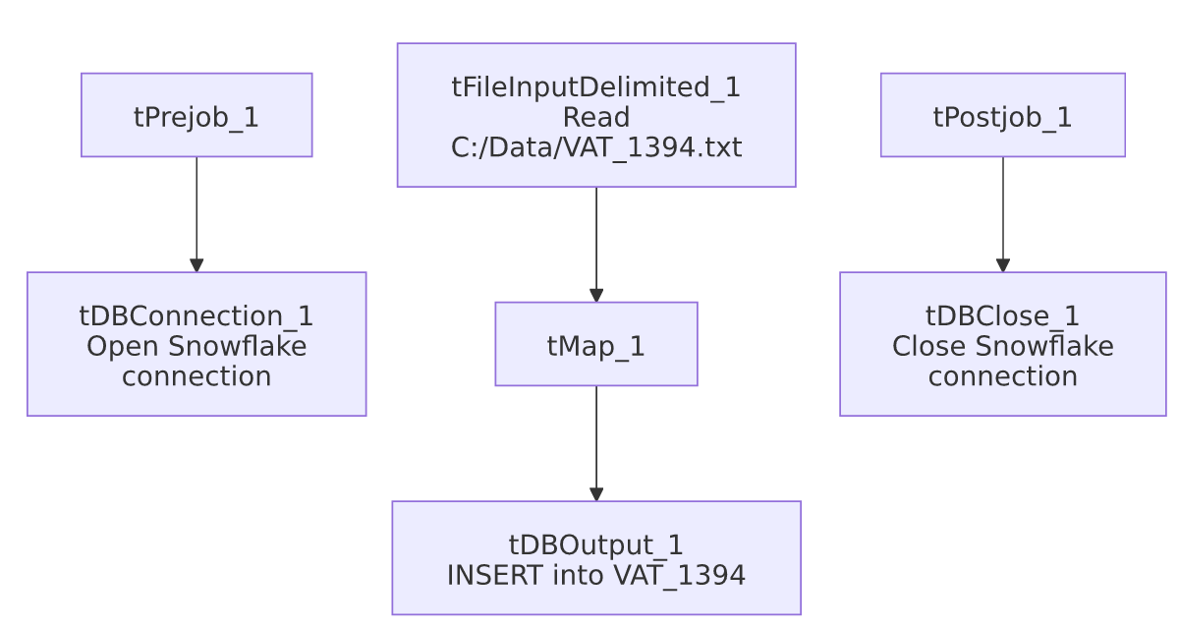

Settings tables

Source: `tFileInputDelimited_1`
Setting | Value | What it means
FILENAME | "C:/Data/VAT_1394.txt" | Fixed, hardcoded local path — not driven by any context variable (unlike the context.sourceDir-based pattern used by most other jobs in this project).
FIELDSEPARATOR / HEADER | \t / 1 header row | Tab-delimited with a header row skipped.
Schema | D_NUM, CLIENT, VALUE (3 columns) | A narrow, fixed record shape — a debtor/document number, a client code, and a single value field.
DIE_ON_ERROR | false | Malformed rows do not fail the job...
Reject flow | Not wired | ...but there is also no connection carrying rejected rows anywhere — same silently-dropped-rejects pattern seen elsewhere in this project (e.g. ADP_Payroll_Load).
TEMP_DIR | "C:/Talend-Studio-20211109_1610-V8.0.1/workspace" | Hardcoded developer-workstation path — see 05_operational_runbook.md.

Target: `tDBOutput_1` (`tSnowflakeOutput`)
Setting | Value | What it means
Table | VAT_1394 | Destination table.
Output action | INSERT | Appends rows; there is no TRUNCATE before this step, so rerunning the job against the same source file would duplicate all its rows in the target table.
Table action | NONE | Table is not recreated/altered by this job.

Dependencies & configuration
- Triggers/depends on other jobs: none — no tRunJob links found, and this job is not called by (nor calls) any other job in 06_dependency_matrix.md.
- Context variables used: none — context_vars_referenced is empty for this job. Every setting (file path, table name) is a literal value.
- 1 hardcoded developer-workstation path in tFileInputDelimited_1.TEMP_DIR (C:/Talend-Studio-20211109_1610-V8.0.1/workspace) — same risk pattern documented project-wide in 05_operational_runbook.md.

Glossary
Component type | Plain-English meaning
tFileInputDelimited | Reads a delimited (CSV/TSV-style) text file according to a schema.
tMap | Maps/transforms columns from one schema to another.
tSnowflakeOutput / tSnowflakeConnection / tSnowflakeClose | Write rows to a Snowflake table / open and close the Snowflake connection used in the job.

Issues observed
- No `TRUNCATE` before the `INSERT`, and no context-variable-driven file path — unlike the file-list-and-archive pattern used elsewhere (e.g. SMS_IC_Outbound_Load, ADP_Payroll_Load), this job reads the exact same fixed file path every run with no archiving or deletion step visible in this metadata. If it's actually scheduled to run repeatedly against a file that isn't replaced or cleared between runs, every run would re-insert the same rows into VAT_1394, duplicating them indefinitely. Unable to determine from metadata whether an external process replaces or clears C:/Data/VAT_1394.txt between runs — verify with the team.
- This job has zero context variables, which is unusual for this project (most jobs reference at least logDir/sourceDir/archiveDir from StandardFolders_0.1, per 06_dependency_matrix.md) — reinforcing that this is likely a narrowly-scoped, possibly one-off or manually-triggered load rather than part of the regular scheduled pipeline. This is an inference from structure, not stated in the metadata; confirm with the team before assuming it runs unattended.
- No reject flow wired from `tFileInputDelimited_1` (DIE_ON_ERROR=false, no downstream reject connection) — malformed rows are silently dropped with no record of how many or which ones failed to parse, same pattern flagged in other file-load jobs in this project.
- No logging setup (`tJava`/log-file redirection), no `tDie`/`tWarn`, and no keystore/SSL configuration in this job, unlike most other jobs reviewed in this batch — a load failure here would only produce a generic Talend execution error with no job-specific diagnostic message.

