Talend Job: VA_Tax_Inventory_Report

Overview
Produces a bi-monthly "VA Tax Inventory" report: it extracts debtor account records with PII (name, address, SSN, employer name/address, packet/collector-rank and balance fields) from a Snowflake source, decrypts protected columns, writes the decrypted rows to a dated CSV with a manually-built header line, and emails the finished report to a distribution list. The source table lives in EDWPRODHH.PUB_LWASHINGTON.VA_TAX_INVENTORY_REPORT — a schema name that, like PUB_JCHANG flagged elsewhere in this project's architecture documentation, reads as an individual's name rather than shared platform infrastructure (see Issues observed).

Detail table
Field | Value
Job name | VA_Tax_Inventory_Report
Version | 0.1
Project | EDW2SF
Author | jmach@harriscollect.com
Created | 2026-05-04T14:41:45.643-0700
Last Modified | 2026-06-04T17:06:34.623-0700

Step-by-step data flow
Setup subjob: tPrejob_1 → tSetKeystore_1 configures SSL trust/keystore settings from context.keystorePath (passwords redacted) → on success, tDBConnection_1 opens the Snowflake connection.
Main subjob:
- tFileExist_1 checks whether today's dated output file (context.outputDir+"VATAX_BiMonthly_Inventory_Report_"+<date>+".csv") already exists.
- If it does (RUN_IF), tFileDelete_1 deletes it — with FAILON=true, so if the delete fails (e.g., the file is locked open elsewhere), the whole job fails at that point.
- Regardless of whether the file existed (tFileExist_1's SUBJOB_OK), the job continues: tSleep_2 pauses 30 seconds, then tJava_1 builds context.outputDir + fileName and a custom header string using the raw, human-readable column names from the SQL query (e.g., "PACKET NBR", not the normalized schema name PACKET_NBR) — the statement that actually writes this header line to the file is truncated in this metadata, but the surrounding wiring (tFileOutputDelimited_1 has APPEND=true and INCLUDEHEADER=false) strongly implies tJava_1 writes the header before any data rows are appended.
- tSleep_1 pauses another 30 seconds, then tDBInput_1 runs the source query against EDWPRODHH.PUB_LWASHINGTON.VA_TAX_INVENTORY_REPORT (28 columns).
- tDBInput_1 → tDataDecrypt_1 (MAIN) decrypts protected columns using a key file at context.cryptoPath+"dimdbtr.crypt" (secret type, secret key, and password all redacted; DIE_ON_ERROR=true, so a decryption failure — e.g., a missing or wrong key file — fails the entire job rather than letting undecrypted or garbled PII through).
- tDataDecrypt_1 → tFileOutputDelimited_1 (FLOW) appends the decrypted rows to the same dated CSV, without a header (the header was already written by tJava_1 in step 3).
- Once tDBInput_1's subjob completes (SUBJOB_OK), tSendMail_1 emails the finished report (subject "VA Tax Inventory Report", body "The bi-monthly VA Tax Inventory report is attached.") from svc_analytics@harriscollect.com to context.mailRecipients, with CHECK_ATTACHMENT=true and DIE_ON_ERROR=true — no attachment-file parameter is visible in this job's captured metadata (see Issues observed).
No teardown subjob is present in this job's metadata — there is no tPostjob/tDBClose pair, unlike every other job in this batch (see Issues observed).
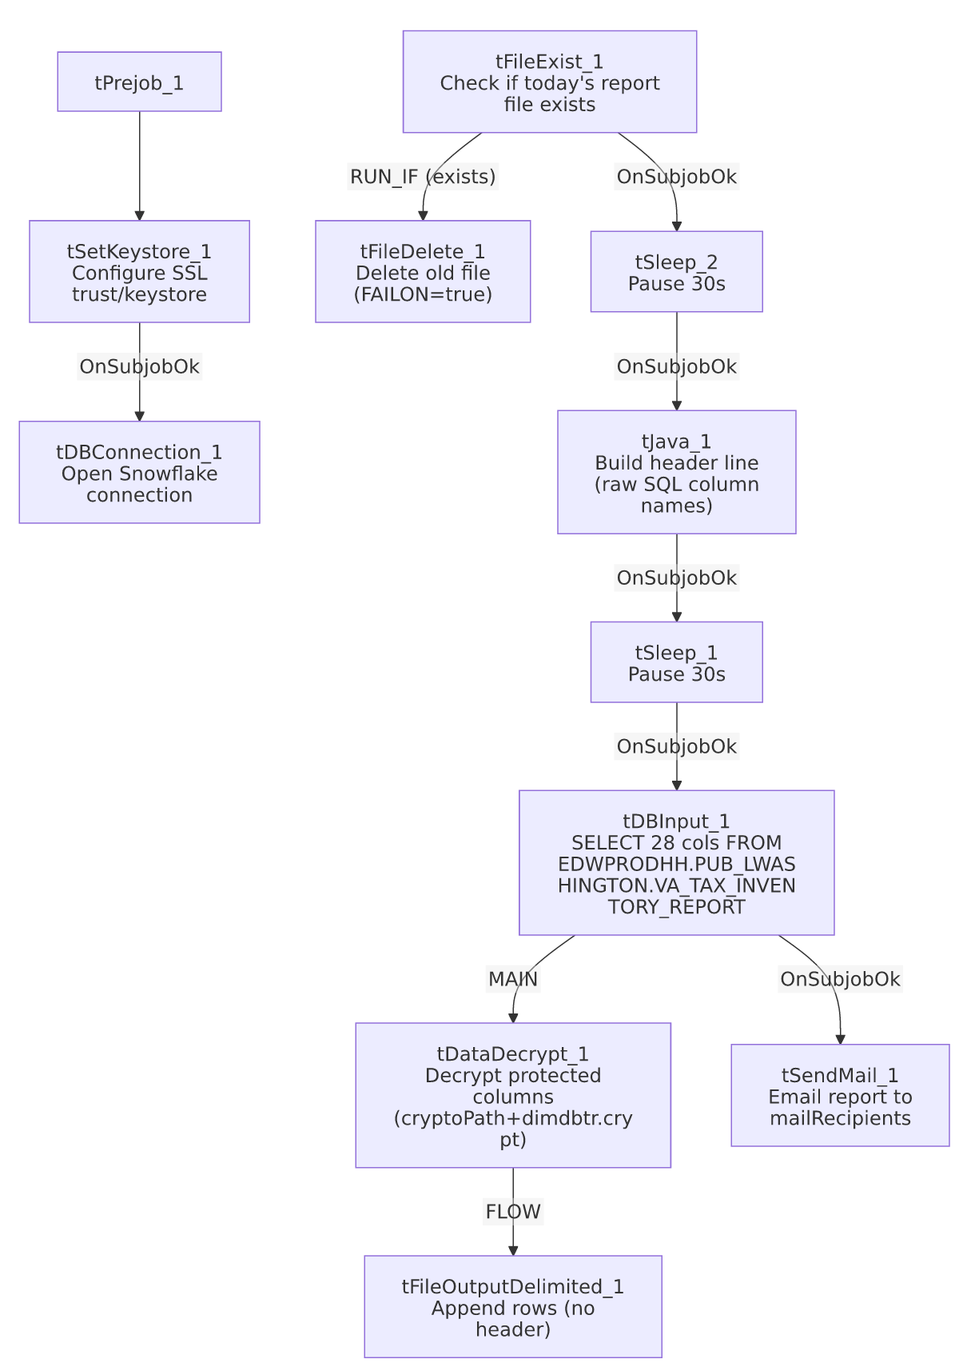

Settings tables

Gate / cleanup: `tFileExist_1` / `tFileDelete_1`
Setting | Value | What it means
FILE_NAME (tFileExist_1) | context.outputDir+"VATAX_BiMonthly_Inventory_Report_"+<date>+".csv" | Checks for today's dated report file before rebuilding it.
FAILON (tFileDelete_1) | true | Unlike the FAILON=false default seen on equivalent tFileDelete components elsewhere in this project, a failed delete here fails the job outright.

Source: `tDBInput_1` (`tSnowflakeInput`)
Setting | Value | What it means
Query | SELECT "ACCOUNT", CLIENT, NAME, ADDRESS, CITY, ST, ZIP, "PACKET NBR", DOB, DSK, CDN, "PN-ASSIGN", "PRIN COL", SSN, "MISC COST", "MISC COST REC ", "ST CD", "EMP1 NAME", "EMP1 ADDR", "28.TEC_SSN", "MISC.3", "NOTE2 TYPE", "PKT-BAL", LST_PAY_DT, "PKT-AGN", "PKT-COL", "PACKET LOCAL RANK ESX 4", "KDOR BANK" FROM EDWPRODHH.PUB_LWASHINGTON.VA_TAX_INVENTORY_REPORT; | Reads a fully-qualified EDWPRODHH.PUB_LWASHINGTON.* object, with several quoted column aliases containing spaces/punctuation that Talend's schema mechanically normalizes (e.g. "28.TEC_SSN" becomes schema column _8_TEC_SSN, dropping the leading 2 — see Issues observed).

Decrypt: `tDataDecrypt_1`
Setting | Value | What it means
CRYPTO_FILE_PATH | context.cryptoPath+"dimdbtr.crypt" | Key/config file used to decrypt protected columns (e.g. SSN).
CRYPTO_METHOD / ALGO_VERSION | AES / 2 | Algorithm details.
SECRET_TYPE / SECRET_KEY / PASSWORD_M1 | ***REDACTED*** | Preserved as redacted in the source metadata.
DIE_ON_ERROR | true | A decryption failure fails the whole job rather than allowing undecrypted/garbled PII to pass through.

Target: `tFileOutputDelimited_1`
Setting | Value | What it means
FILENAME | context.outputDir+"VATAX_BiMonthly_Inventory_Report_"+<date>+".csv" | Same dated file whose header tJava_1 wrote earlier in the flow.
APPEND / INCLUDEHEADER | true / false | Rows are appended below the header line written separately by tJava_1, not by this component.

Notification: `tSendMail_1`
Setting | Value | What it means
TO / FROM | context.mailRecipients / "svc_analytics@harriscollect.com" | Recipient list is context-driven; sender is a shared analytics service account.
SUBJECT / MESSAGE | "VA Tax Inventory Report" / "The bi-monthly VA Tax Inventory report is attached."
CHECK_ATTACHMENT | true | The component expects an attachment — but no attachment-file path parameter appears anywhere in this job's captured metadata (see Issues observed).
DIE_ON_ERROR | true | A failed send fails the job.
SMTP_HOST / PORT / SSL / STARTTLS | "harriscollect-com.mail.protection.outlook.com" / 25 / false / false | Unencrypted SMTP relay, consistent with an internal mail relay setup.

Dependencies & configuration
- Triggers/depends on other jobs: none — no tRunJob links found, and this job does not appear as a call target in 06_dependency_matrix.md's 65-link orchestration table.
- Context variables used: cryptoPath, keystorePath, mailRecipients, outputDir.
- 3 hardcoded path findings: tSetKeystore_1.SSL_TRUSTSERVER_TRUSTSTORE ("C:/clientTrustStore.trustStore") and tFileDelete_1.DIRECTORY/PATH (both C:/Talend-Studio-20211109_1610-V8.0.1/workspace/delete_folder...) — same project-wide portability risk documented in 05_operational_runbook.md.

Glossary
Component type | Plain-English meaning
tFileExist | Checks whether a specific file exists on disk.
tFileDelete | Deletes a file or folder.
tSleep | Pauses job execution for a fixed number of seconds.
tJava | Runs custom Java code — here used to build a filename and a custom CSV header string.
tSnowflakeInput | Runs a query against Snowflake and returns its result rows.
tDataDecrypt | Decrypts data previously encrypted with a matching key/algorithm — used here to restore protected PII columns (e.g. SSN) before they're written to the output file.
tFileOutputDelimited | Writes rows to a delimited (CSV-style) text file.
tSendMail | Sends an email, optionally with an attachment.
tSetKeystore / tSnowflakeConnection | Configure SSL trust/keystore settings and open the Snowflake connection used by the job.

Issues observed
- `tSendMail_1` has `CHECK_ATTACHMENT=true` but no attachment-file path parameter is visible anywhere in this job's captured metadata. The email almost certainly is meant to attach the CSV file just written (context.outputDir+"VATAX_BiMonthly_Inventory_Report_"+<date>+".csv"), but this cannot be confirmed from the extracted metadata alone — verify directly in Talend Studio.
- This job has no `tPostjob`/`tDBClose` teardown at all — unlike every other job documented in this batch. The Snowflake connection opened by tDBConnection_1 is never explicitly closed in this job's own component list, which could leave connections open longer than necessary depending on how the Talend runtime handles job-end cleanup in this case.
- The source query hardcodes quoted column aliases containing spaces and punctuation (e.g. "PACKET NBR", "PN-ASSIGN", "28.TEC_SSN"), which Talend's schema mechanically normalizes into different names (e.g. "28.TEC_SSN" becomes the schema column _8_TEC_SSN, silently dropping the leading 2). Anyone tracing this job's output columns back to source definitions should refer to the raw SQL text captured above, not the normalized schema column names, to avoid misidentifying a field.
- Two 30-second `tSleep` pauses (`tSleep_1`, `tSleep_2`) are wired into the main flow with no comment or explanation captured in the metadata. Unable to determine their purpose (e.g., waiting for a file-system operation to settle, or deliberately throttling) from this job's own data — verify with the team before assuming they can be shortened or removed.
- `tFileDelete_1.FAILON=true`, unlike the FAILON=false seen on equivalent tFileDelete components elsewhere in this project's file-load jobs — if the prior day's report file can't be deleted (e.g., locked open by another process, such as someone viewing it), this job fails outright rather than continuing.
- The source schema (`PUB_LWASHINGTON`) reads as an individual's name, similar to PUB_JCHANG (flagged in 01_system_architecture.md as likely individually owned). PUB_LWASHINGTON is not itself listed among that document's named connection labels, so it may be a schema reached through an already-documented connection rather than a distinct one — but the same governance question (what happens if the underlying person/relationship changes) applies here too. Verify ownership with the team.

