Talend Job: VA_Tax_Report_Split

Overview
Splits an existing Virginia tax-reconciliation report (VA_TAX_RECON_REPORT in Snowflake — debtor tax-account balances, agency/collection fields, and a computed ERROR_MESSAGE) into one Excel workbook per distinct error message. It reads the list of distinct error messages already present in the table, then for each one re-queries the full report filtered to that message and writes the matching rows to their own .xlsx file, so each category of reconciliation error can be reviewed as a separate spreadsheet. This job does not compute or populate ERROR_MESSAGE itself — it only reads and re-splits a report some other job (not present in this batch) has already produced.

Detail table
Field | Value
Job name | VA_Tax_Report_Split
Version | 0.1
Project | EDW2SF
Author | jmach@harriscollect.com
Created | 2022-11-18T10:25:37.774-0800
Last Modified | 2025-09-24T11:07:11.543-0700

Step-by-step data flow
Setup subjob: tPrejob_1 → tDBConnection_1 opens the Snowflake connection.
Main subjob — starts independently at tDBInput_1 (no incoming trigger, runs as soon as the job starts):
- tDBInput_1 runs SELECT DISTINCT RTRIM(ERROR_MESSAGE) AS ERROR_MESSAGE FROM VA_TAX_RECON_REPORT; against Snowflake, producing the distinct list of error messages currently in the report.
- tFlowToIterate_1 converts that result set into an iteration loop — one pass per distinct error message.
- For each message, tJava_1 sets context.errMsg from the current row's ERROR_MESSAGE, sanitizing it for use in a filename: commas are stripped, "<+" is replaced with "LT", > with "GT", and spaces with underscores.
- tDBRow_1 re-queries VA_TAX_RECON_REPORT with a full ~22-column SELECT (debtor, client, agency dates, last-payment info, multiple H_H_*/FILE_*/DIFF_* balance-and-difference columns, COLL_AGENCY) filtered WHERE ERROR_MESSAGE=? — bound to the current iteration's raw (unsanitized) error message value.
- tMap_1 passes the 22 columns straight through with no transformation.
- tFileOutputExcel_1 writes the matching rows to context.outputDir+"VA_TAX_RECON_"+context.errMsg+"_"+TalendDate.getDate("CCYYMMDD")+".xlsx", with the sheet named after context.errMsg and APPEND_FILE/APPEND_SHEET both true (append rather than overwrite, in case the job runs more than once against the same date).
Teardown subjob: tPostjob_1 → tDBClose_1 (close Snowflake).
A second output component, tFileOutputDelimited_1 (would write a .txt version of the same rows to context.outputDir+"VA_TAX_RECON_"+context.errMsg+"_"+TalendDate.getDate("CCYYMMDD")+".txt"), exists in the job but has ACTIVATE=false and no connection wired to it in this metadata — see Issues observed.
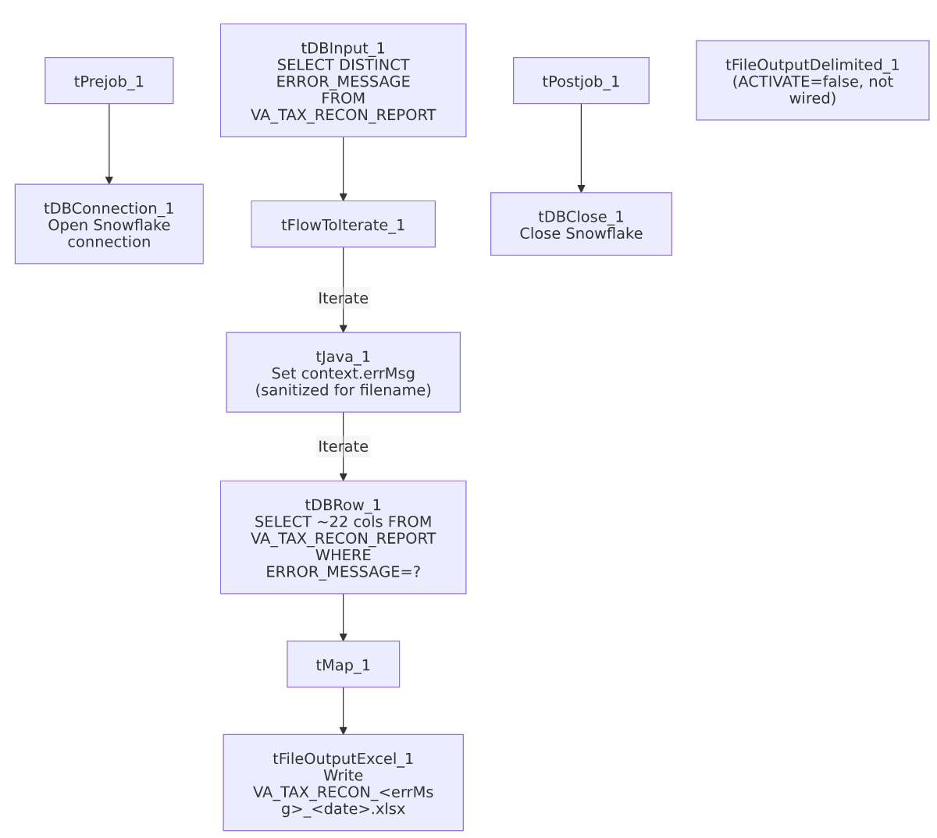

Settings tables

Distinct-value driver: `tDBInput_1`
Setting | Value | What it means
Query | SELECT DISTINCT RTRIM(ERROR_MESSAGE) AS ERROR_MESSAGE FROM VA_TAX_RECON_REPORT; | Trailing whitespace is trimmed from the error message before it's used to drive the loop — but see Issues observed regarding the re-query step, which does not apply the same trim.

Per-message re-query: `tDBRow_1` (`tSnowflakeRow`)
Setting | Value | What it means
Query | SELECT LEFT(DEBTOR,50) AS DEBTOR, ..., LEFT(ERROR_MESSAGE,100) AS ERROR_MESSAGE, ... FROM VA_TAX_RECON_REPORT WHERE ERROR_MESSAGE=? | Re-pulls the full report a second time per distinct message rather than splitting the first result set in-memory — for a report with many distinct error messages, this means the table is scanned once per message. Several numeric fields use TRY_TO_NUMERIC/TRY_TO_DATE (non-throwing conversions), so a malformed value becomes NULL rather than failing the row.
Bind parameter | ? = the current iteration's ERROR_MESSAGE value from tDBInput_1 (not the context.errMsg-sanitized version) | The filter uses the original, un-sanitized message text — appropriate, since it must match what's actually stored in the table; only the *filename* uses the sanitized context.errMsg.

Output: `tFileOutputExcel_1`
Setting | Value | What it means
FILENAME | context.outputDir+"VA_TAX_RECON_"+context.errMsg+"_"+TalendDate.getDate("CCYYMMDD")+".xlsx" | One file per distinct error message, dated by run date (not by any date column in the data).
SHEETNAME | context.errMsg | Names the worksheet after the (sanitized) error message.
APPEND_FILE / APPEND_SHEET | true / true | If the job is run more than once on the same calendar date, new rows are appended to the existing file/sheet rather than overwriting it — worth knowing if a rerun is expected to produce a clean file.
PASSWORD | ***REDACTED*** | Workbook protection password, redacted in source metadata — preserved as-is.

Inactive output: `tFileOutputDelimited_1`
Setting | Value | What it means
ACTIVATE | false | This component is present in the job design but disabled — it does not run.
FILENAME (configured) | context.outputDir+"VA_TAX_RECON_"+context.errMsg+"_"+TalendDate.getDate("CCYYMMDD")+".txt" | Would write a tab-delimited .txt twin of the Excel output, if enabled.
Wiring | Not connected to any other component in this job's connections list | Even if re-activated, it currently has no incoming data flow — see Issues observed.

Dependencies & configuration
- Triggers/depends on other jobs: none — no tRunJob links found, and this job does not appear in 06_dependency_matrix.md's orchestration table. It depends on VA_TAX_RECON_REPORT already being populated by some other, unidentified job or process not present in this batch.
- Context variables used: errMsg (set internally per iteration), outputDir.
- No hardcoded developer-workstation paths found in this job (hardcoded_path_findings: []).
- Possible relation to other VA_Tax jobs: the project is known to include VA_Tax_Report_Load and VA_Tax_Inventory_Report (the latter listed in 05_operational_runbook.md's email-alert job list). This job's own metadata does not reference either by name, and neither appears in its runjob_targets — unable to determine from this job's own metadata whether it runs downstream of VA_Tax_Report_Load (which one would guess populates VA_TAX_RECON_REPORT) or independently; verify with the team, and cross-check those jobs' own docs if available.

Glossary
Component type | Plain-English meaning
tSnowflakeConnection / tSnowflakeInput / tSnowflakeRow / tSnowflakeClose | Open a Snowflake connection, run a query and return its rows, run an arbitrary SQL statement, and close the connection.
tFlowToIterate | Converts a set of query result rows into a loop, running downstream components once per row/value.
tMap | Maps/transforms columns from one schema to another — here, a straight pass-through with no changes.
tFileOutputExcel | Writes rows to an Excel (.xlsx) workbook, one sheet (or appended sheet) per configured name.
tFileOutputDelimited | Writes rows to a delimited (CSV/TSV-style) text file — present in this job but disabled.

Issues observed
- The distinct-message query trims the error message (`RTRIM`), but the per-message re-query's `WHERE ERROR_MESSAGE=?` filters against the untrimmed value passed through the iteration, and the tJava_1 filename-sanitizing logic operates on that same untrimmed value. If any row in VA_TAX_RECON_REPORT has trailing whitespace variance in ERROR_MESSAGE (which is exactly why the distinct-list query bothers to RTRIM at all), the re-query in step 4 binds against a value that was only trimmed for *deduplication purposes* upstream — unable to fully determine from this metadata whether this could cause a message with trailing whitespace to match zero rows in the re-query (producing an empty/missing Excel file for that category) or whether RTRIM in the distinct query is enough to guarantee an exact match downstream; verify directly against the data before relying on every error category producing a populated file.
- The report is re-queried once per distinct error message rather than the first query's result set being split in memory — for a report with many distinct categories, this means a full scan of VA_TAX_RECON_REPORT per category. Not a correctness issue, but worth knowing if the report is large and this job's runtime becomes a concern.
- `tFileOutputDelimited_1` is present but inactive (`ACTIVATE=false`) and has no wiring in this job's connections list. It appears to be a leftover or planned-but-unfinished alternate output format (a .txt twin of the .xlsx file) rather than something currently in use — confirm with the team whether a text-file version of this report is still needed before assuming it can be safely deleted.
- `APPEND_FILE`/`APPEND_SHEET` are both `true` on the Excel output, meaning a second run on the same calendar date appends to the existing workbook/sheet rather than replacing it. If this job is ever re-run to correct a bad output (rather than only running once per day), the corrected data would sit alongside the original bad rows in the same file rather than replacing them — verify whether that's the intended operational behavior.
- This job's relationship to `VA_Tax_Report_Load`/`VA_Tax_Inventory_Report` (which populate or consume similar Virginia tax-reconciliation data, per 05_operational_runbook.md) is unable to determine from this job's own metadata — no tRunJob link or shared context variable ties them together in what was extracted here; verify with the team or cross-reference those jobs' own documentation if available in this or another batch.

