Talend Job: i3_AgentActivityLog_Load

Overview
Loads call-center agent status/activity events (login/logout, ACD status changes, hold/DND/ACW state transitions, per-state durations, timestamps) from the I3 (Interactive Intelligence) telephony platform's MSSQL database into the Snowflake I3_AGENTACTIVITYLOG table. Like i3_CallDetail_40_Load, it computes the latest timestamp already loaded before pulling from the source — but whether that value is actually applied as a filter on the source query can't be confirmed from this metadata (see Issues observed).

Detail table
Field | Value
Job name | i3_AgentActivityLog_Load
Version | 0.1
Project | EDW2SF
Author | jmach@harriscollect.com
Created | 2022-02-09T15:39:10.010-0800
Last Modified | 2025-11-04T11:36:33.855-0800

Step-by-step data flow
Setup subjob: tPrejob_1 → tJava_1 opens a per-run log file → on success, tSetKeystore_1 configures SSL trust/keystore from context.keystorePath → tDBConnection_1 opens the Snowflake connection → on success, tDBConnection_2 opens the MSSQL connection to context.I3_IC_40_Server/Port/Schema/Database/Login (password redacted) — correctly using the I3_IC_40 context group for an I3 telephony job, unlike the naming mismatch flagged in i3_CallDetail_40_Load.
Main subjob:
- tDBRow_1 runs SELECT COALESCE(TO_VARCHAR(MAX(I3TIMESTAMPGMT)),'2015-01-01') AS MAX_DT FROM DW.I3_AGENTACTIVITYLOG; against Snowflake to find the latest event timestamp already loaded (defaulting to 2015-01-01 if the table is empty).
- tJavaRow_1 captures that value into context.maxI3Date.
- On success, tDBInput_1 runs a fixed SELECT (using the shared MSSQL connection) against the source agent-status table, pulling UserId, StatusDateTime/StatusDateTimeGMT, several Changed* status flags, hold/ACW/DND durations, SeqNo, I3TimeStampGMT, SiteId/SubSiteId, etc. (~19 columns). The captured query text is truncated in this metadata after the initial column list and does not visibly reference `context.maxI3Date` — see Issues observed.
- tMap_1 passes the ~19 source columns through to a same-shaped uppercase-named target schema.
- tFlowMeter_3 counts rows passing through (labeled "MyLabel", not renamed for this job).
- tDBOutputBulkExec_1 bulk-inserts the rows into Snowflake table I3_AGENTACTIVITYLOG (INSERT, no table-recreate action) — this job uses the bulk-exec variant of the Snowflake output component rather than the plain tSnowflakeOutput used in i3_CallDetail_40_Load.
Separately, tStatCatcher_1 and tFlowMeterCatcher_1 feed two tLogRow components that print job statistics and flow-meter counts to the log — standard Talend internal instrumentation, not part of the business data path.
Teardown subjob: tPostjob_1 → tDBClose_1 (close Snowflake) → tDBClose_2 (close MSSQL).
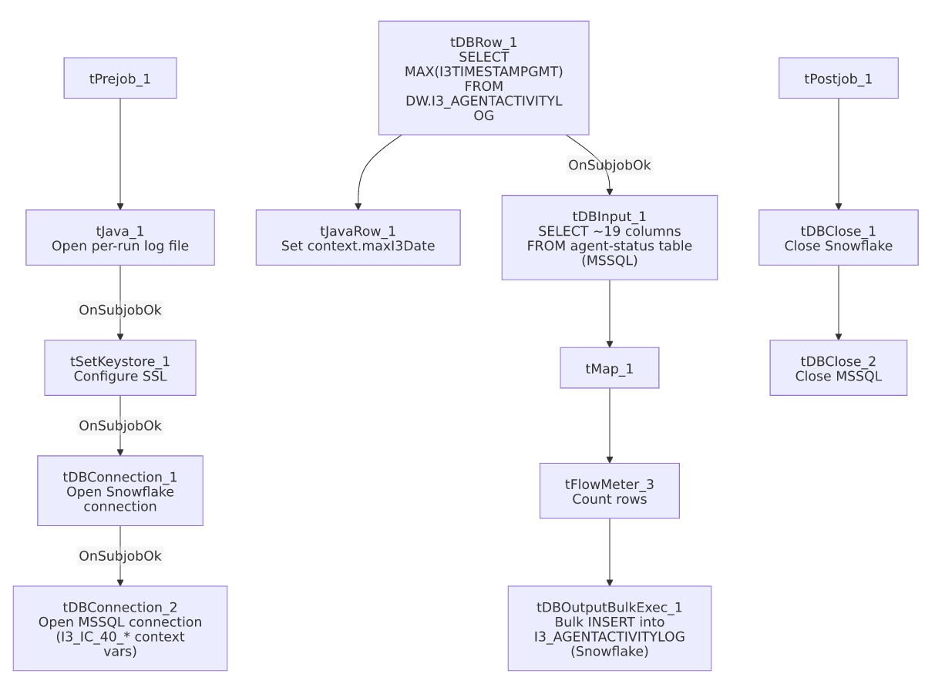

Settings tables

Source: `tDBInput_1` (`tMSSqlInput`)
Setting | Value | What it means
Connection | Shared tDBConnection_2 | Reuses the job's single MSSQL connection.
Query | Fixed SELECT of ~19 named columns (agent status change flags, hold/ACW/DND durations, SeqNo, I3TimeStampGMT, SiteId/SubSiteId) | The visible portion does not reference context.maxI3Date — see Issues observed.

Aggregate check: `tDBRow_1` (`tSnowflakeRow`)
Setting | Value | What it means
Query | SELECT COALESCE(TO_VARCHAR(MAX(I3TIMESTAMPGMT)),'2015-01-01') AS MAX_DT FROM DW.I3_AGENTACTIVITYLOG; | Finds the latest event timestamp already loaded, defaulting to 2015-01-01 for a first/empty run. Result captured into context.maxI3Date by tJavaRow_1.

Target: `tDBOutputBulkExec_1` (`tSnowflakeOutputBulkExec`)
Setting | Value | What it means
Table | I3_AGENTACTIVITYLOG | Destination table in Snowflake.
Output action | INSERT | Appends rows — there is no TRUNCATE/staging step, consistent with an incremental-append design, assuming the max-date check is actually applied upstream.

Dependencies & configuration
- Triggers/depends on other jobs: none — no tRunJob links found.
- Context variables used: I3_IC_40_Server, I3_IC_40_Port, I3_IC_40_Schema, I3_IC_40_Database, I3_IC_40_Login (MSSQL connection details), keystorePath, logDir, maxI3Date (computed internally from the Snowflake max-date query).
- 1 hardcoded developer-workstation path in tSetKeystore_1.SSL_TRUSTSERVER_TRUSTSTORE ("C:/clientTrustStore.trustStore") — same pattern documented project-wide in 05_operational_runbook.md.

Glossary
Component type | Plain-English meaning
tSnowflakeConnection / tSnowflakeClose | Open/close a Snowflake database connection shared by other components in the job.
tMSSqlConnection / tMSSqlInput / tMSSqlClose | Open a Microsoft SQL Server connection, run a query against it, and close it.
tSnowflakeRow | Runs an arbitrary SQL statement or stored-procedure call against Snowflake — here, used for a single aggregate SELECT.
tSnowflakeOutputBulkExec | A bulk-loading variant of the Snowflake output component, typically faster for larger row volumes than the plain tSnowflakeOutput.
tJavaRow | Runs custom Java code once per input row — here used to unpack a single query result into a context variable.
tFlowMeter | Counts rows passing a point in the flow for logging/monitoring.
tSetKeystore | Configures SSL trust/keystore settings for the job's secure connections.
tStatCatcher / tFlowMeterCatcher / tLogRow | Talend's built-in job-statistics and flow-meter capture components, which print execution stats to the log; not part of the business data flow.

Issues observed
- The incremental-load logic may not actually be applied, the same open question flagged in i3_CallDetail_40_Load. The job computes context.maxI3Date from Snowflake before reading the MSSQL source, but the tDBInput_1.QUERY text captured in this metadata is truncated after the initial column list and does not show a WHERE I3TimeStampGMT > ...-style clause referencing context.maxI3Date in the visible portion. Unable to determine from this metadata whether the query is actually filtered — if it isn't, every run re-reads and re-inserts the entire source table, duplicating all previously loaded rows in Snowflake (there is no TRUNCATE before the bulk INSERT). Verify directly in Talend Studio before assuming the incremental design works as intended.
- Unlike `i3_CallDetail_40_Load`, this job's MSSQL connection is correctly labeled with `I3_IC_40_*` context variables for an I3 telephony source — worth calling out as a positive contrast, since the sibling i3_CallDetail_40_Load job instead uses EDWProdHH_* variables for what is also I3 data.
- No error/row-count logging specific to this job's business outcome (no tWarn/tDie/tSendMail) — a load failure here would only surface as a generic Talend execution error, with no job-specific message to distinguish it in a shared log, consistent with most of the 289 jobs per 05_operational_runbook.md.

