Talend Job: i3_AgentQueueStats_Load

Overview
Loads Interactive Intelligence (I3) contact-center agent/queue interval statistics (entered/abandoned/answered ACD call counts, hold/talk/after-call-work durations, agent status timers, service-level buckets, and custom values, per statistics set/site/sub-site/interval) from the I3 IC system's i3_AgentQueueStats MSSQL table into the Snowflake I3_AGENTQUEUESTATS table. Follows the same incremental-load *shape* as i3_CallDetail_40_Load — it first computes the maximum timestamp already loaded — though (as with that job) the captured source query is truncated and does not show a filter referencing that value in the visible portion.

Detail table
Field | Value
Job name | i3_AgentQueueStats_Load
Version | 0.1
Project | EDW2SF
Author | jmach@harriscollect.com
Created | 2022-03-23T09:28:24.001-0700
Last Modified | 2025-11-05T10:32:11.057-0800

Step-by-step data flow
Setup subjob: tPrejob_1 → tJava_1 opens a per-run log file (context.logDir+jobName+"_"+<timestamp>+".log") → on success, tSetKeystore_1 configures SSL trust/keystore settings → on success, tDBConnection_1 opens the Snowflake connection → on success, tDBConnection_2 opens the MSSQL connection using context.I3_IC_40_Server/Port/Schema/Database/Login (password redacted).
Main subjob:
- tDBRow_1 runs SELECT COALESCE(TO_VARCHAR(MAX(I3TIMESTAMPGMT)),'2010-01-01') AS MAX_DT FROM DW.I3_AGENTQUEUESTATS; against Snowflake to find the latest interval timestamp already loaded.
- tJavaRow_1 captures that value into context.maxI3Date.
- On success, tDBInput_1 runs a fixed SELECT (using the shared MSSQL connection) against the source i3_AgentQueueStats table, pulling roughly 90 columns of ACD queue-statistics data (statistics set, call-handling counters and durations, agent-status timers, service-level bucket counts, custom values, site/sub-site IDs, I3TimeStampGMT, schema version). The captured query text is truncated in this metadata and does not visibly reference `context.maxI3Date` — see Issues observed.
- tMap_1 passes the ~90 source columns through to a same-shaped uppercase-named target schema.
- tFlowMeter_2 counts rows passing through (labeled "MyLabel" internally but wired with link label "QStats").
- tDBOutput_1 inserts the rows into Snowflake table I3_AGENTQUEUESTATS (INSERT, no table-recreate action).
Teardown subjob: tPostjob_1 → tDBClose_1 (close Snowflake) → tDBClose_2 (close MSSQL).
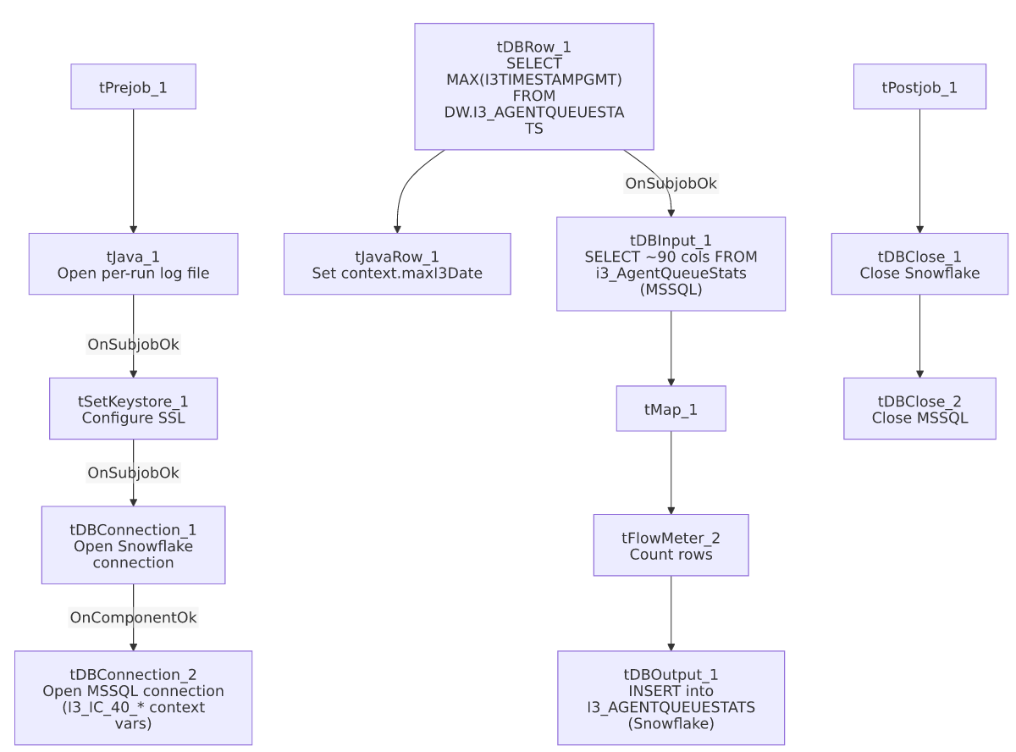

Settings tables

Max-date check: `tDBRow_1` (`tSnowflakeRow`)
Setting | Value | What it means
Query | SELECT COALESCE(TO_VARCHAR(MAX(I3TIMESTAMPGMT)),'2010-01-01') AS MAX_DT FROM DW.I3_AGENTQUEUESTATS; | Finds the newest interval timestamp already in Snowflake, defaulting to 2010-01-01 if the table is empty.
Result handling | MAX_DT → context.maxI3Date via tJavaRow_1 | Intended to drive an incremental filter on the source query — see Issues observed on whether that filter is actually applied.

Source: `tDBInput_1` (`tMSSqlInput`)
Setting | Value | What it means
Connection | Shared tDBConnection_2 | Reuses the job's single MSSQL connection.
Table | i3_AgentQueueStats | Source I3 queue-statistics table.
Query | Fixed SELECT of ~90 named columns (statistics set, call-handling counters/durations, agent-status timers, service-level buckets, custom values, site/sub-site IDs, I3TimeStampGMT, schema version) | The visible portion of the query does not reference context.maxI3Date — see Issues observed.

Setup: `tDBConnection_2` (`tMSSqlConnection`)
Setting | Value | What it means
HOST / PORT / SCHEMA_DB / DBNAME / USER | context.I3_IC_40_Server / context.I3_IC_40_Port / context.I3_IC_40_Schema / context.I3_IC_40_Database / context.I3_IC_40_Login | Correctly uses the I3_IC_40 context group for this I3-system source — unlike i3_CallDetail_40_Load, whose MSSQL connection is (per that job's own metadata) configured with EDWProdHH_* context variables despite also reading I3 telephony data.

Target: `tDBOutput_1` (`tSnowflakeOutput`)
Setting | Value | What it means
Table | I3_AGENTQUEUESTATS | Destination table in Snowflake.
Output action | INSERT | Appends rows — there is no TRUNCATE/staging step in this job, consistent with an incremental-append design, assuming the max-date check is actually applied upstream.

Dependencies & configuration
- Triggers/depends on other jobs: none — no tRunJob links found.
- Context variables used: I3_IC_40_Database, I3_IC_40_Login, I3_IC_40_Port, I3_IC_40_Schema, I3_IC_40_Server (MSSQL connection details), keystorePath, logDir, maxI3Date (computed internally from the Snowflake max-date query).
- 1 hardcoded path finding: tSetKeystore_1.SSL_TRUSTSERVER_TRUSTSTORE = "C:/clientTrustStore.trustStore" — same project-wide portability risk documented in 05_operational_runbook.md.

Glossary
Component type | Plain-English meaning
tSnowflakeConnection / tSnowflakeClose | Open/close a Snowflake database connection shared by other components in the job.
tMSSqlConnection / tMSSqlInput / tMSSqlClose | Open a Microsoft SQL Server connection, run a query against it, and close it.
tSnowflakeRow | Runs an arbitrary SQL statement or query against Snowflake — here used once for a single aggregate value.
tJavaRow | Runs custom Java code once per input row — here used to unpack a single query result into a context variable.
tMap | Maps/transforms columns from one schema to another.
tFlowMeter | Counts rows passing a point in the flow for logging/monitoring.
tSetKeystore | Configures SSL/TLS keystore and truststore settings used by the job's database connections.
tJava | Runs custom Java code — here used to open a log file.

Issues observed
- The incremental-load logic may not actually be applied. The job computes context.maxI3Date from Snowflake before reading the MSSQL source, strongly suggesting the intent is to pull only rows with a newer I3TimeStampGMT than what's already loaded. However, the tDBInput_1.QUERY text captured in this metadata is truncated after the column list and does not show a WHERE clause referencing context.maxI3Date anywhere in the visible portion. Unable to determine from this metadata whether the query is actually filtered — if it isn't, every run re-reads and re-inserts the entire source table, duplicating all previously loaded rows in Snowflake (there is no TRUNCATE step before the INSERT). This is the same open question flagged in i3_CallDetail_40_Load's documentation and should be verified directly in Talend Studio before assuming the incremental design works as intended.
- This job's MSSQL connection is correctly configured with `I3_IC_40_*` context variables, matching the I3 IC system it actually reads from. This is a useful positive contrast to i3_CallDetail_40_Load, whose otherwise-similar MSSQL connection uses EDWProdHH_* variables despite reading the same class of I3 telephony data — confirming the mislabeling flagged in that job's doc is not a universal project convention, and should be checked case-by-case rather than assumed.
- No error/row-count logging specific to this job's business outcome (no tWarn/tDie/tSendMail) — a load failure here would only surface as a generic Talend execution error, with no job-specific message to distinguish it in a shared log.

