Talend Job: i3_AgentStats

Overview
Loads agent-level call-center activity records (campaign, site, agent ID, call/stage identifiers, a property name/value pair, and an internal agentstats_id) from the I3 (Interactive Intelligence) telephony system's AgentStats MSSQL table into the Snowflake I3_AGENTSTATS table, joined against a DIMLOGON-style lookup query computed from the current Snowflake data. It follows a "compute watermark, then pull and upsert" incremental pattern similar to i3_CallDetail_40_Load, but here the two watermark values it computes (maxAgentDate, maxPullDate) are only ever logged, not visibly used to filter the source query — see Issues observed.

Detail table
Field | Value
Job name | i3_AgentStats
Version | 0.1
Project | EDW2SF
Author | jmach@harriscollect.com
Created | 2023-06-06T14:27:21.680-0700
Last Modified | 2025-11-05T10:47:35.966-0800

Step-by-step data flow
Setup subjob: tPrejob_1 → tJava_1 opens a per-run log file at context.logDir + jobName + "_" + <timestamp> + ".log" → on success (OnSubjobOk), tDBConnection_1 (tMSSqlConnection) opens the MSSQL connection using context.I3_IC_40_* variables (Server/Port/Schema/Database/Login, password redacted) → on success, tSetKeystore_1 configures SSL trust/keystore from context.keystorePath → on success, tDBConnection_2 opens the Snowflake connection.
Main subjob (runs independently of the setup chain until it needs each connection):
- tDBRow_1 (tSnowflakeRow) runs a query against DW.I3_AGENTSTATS computing MAX_AGENT_DATE (COALESCE(CAST(DATEADD(min,-30,MAX(agenttimeUTC)) AS VARCHAR(30)), '2019-01-01')) and MAX_PULL_DATE (current time converted to the session's timezone via CONVERT_TIMEZONE/GET_CURRENT_TIMEZONE).
- tDBRow_1 feeds two branches simultaneously: (a) MAIN → tJavaRow_1 captures the two computed values into context.maxAgentDate and context.maxPullDate; (b) SUBJOB_OK (which in Talend fires only once the whole row-processing subjob, including the tJavaRow_1 branch, has finished) → tJava_2 prints both values to the log.
- tJava_2 then fires SUBJOB_OK → tDBInput_1 (tMSSqlInput, reusing the shared MSSQL connection tDBConnection_1) runs a fixed SELECT of 11 columns (campaignname, siteid, odsoffset, agenttimeUTC, agentid, stageid, callid, callidkey, propertyname, propertyvalue, agentstats_id) FROM I3_IC_40.ININ_DIALER_40.AgentStats WHERE [agenttimeUT... — the query text is truncated in this metadata immediately after the `WHERE` clause begins, so whether it actually filters using context.maxAgentDate/context.maxPullDate cannot be confirmed. See Issues observed.
- tMap_1 passes the 11 columns through unchanged to a same-shaped target schema.
- tFlowMeter_5 counts rows passing through (labeled "MyLabel", not renamed for this job).
- tDBOutput_1 upserts the rows into Snowflake table I3_AGENTSTATS (UPSERT, tableAction: NONE — no TRUNCATE, consistent with an incremental design).
Teardown subjob: tPostjob_1 → tDBClose_1 (close MSSQL) → tDBClose_2 (close Snowflake).
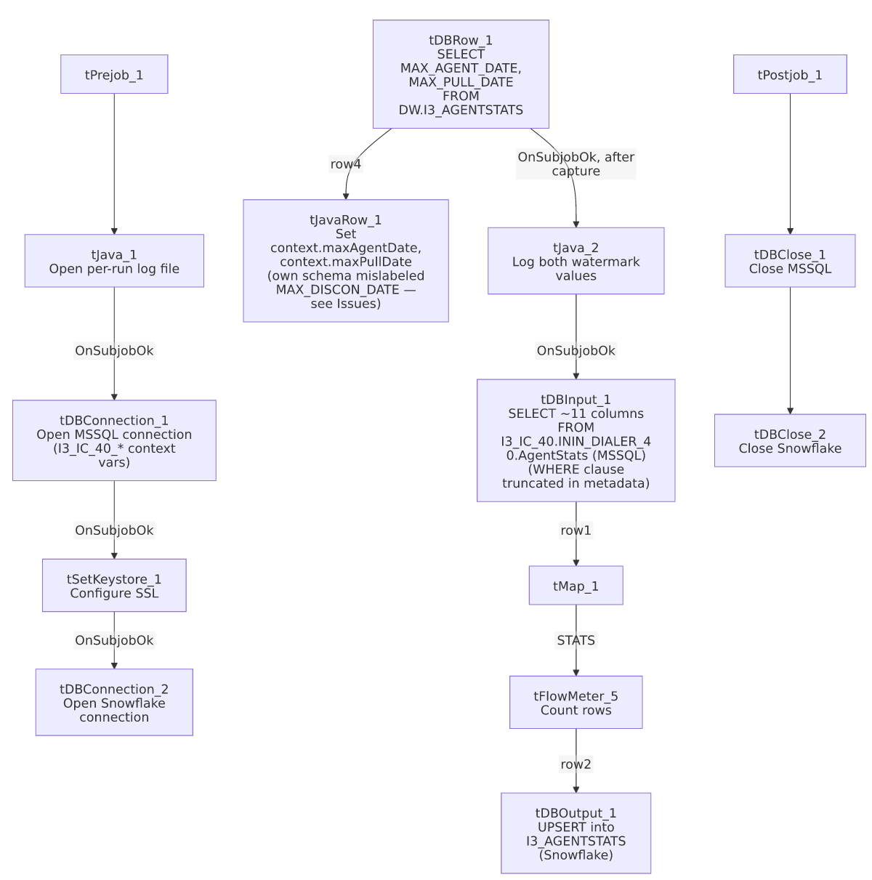

Settings tables

Watermark query: `tDBRow_1` (`tSnowflakeRow`) / `tJavaRow_1`
Setting | Value | What it means
Query | SELECT COALESCE(CAST(DATEADD(min,-30,MAX(agenttimeUTC)) AS VARCHAR(30)), '2019-01-01') AS MAX_AGENT_DATE, CAST(CONVERT_TIMEZONE(GET_CURRENT_TIMEZONE(),'UTC',CURRENT_TIMESTAMP) AS VARCHAR(30)) AS MAX_PULL_DATE FROM DW.I3_AGENTSTATS; | Computes the latest agent-activity timestamp already loaded (minus a 30-minute safety buffer, defaulting to 2019-01-01 if the table is empty) and the current pull time.
Result handling | tJavaRow_1: context.maxAgentDate = input_row.MAX_AGENT_DATE; context.maxPullDate = input_row.MAX_PULL_DATE; | Captures both values for use (in principle) as an incremental-load filter downstream. `tJavaRow_1`'s own declared schema columns are `MAX_DISCON_DATE`/`MAX_PULL_DATE`, not `MAX_AGENT_DATE`/`MAX_PULL_DATE` — a naming mismatch with the actual code and with tDBRow_1's own output columns; see Issues observed.

Source: `tDBInput_1` (`tMSSqlInput`)
Setting | Value | What it means
Connection | Shared tDBConnection_1 (USE_EXISTING_CONNECTION=true) | Reuses the job's single MSSQL connection.
HOST / PORT / DB_SCHEMA / DBNAME / USER (component's own params) | context.EDWProdHH_Server / _Port / _Schema / _Database / _Login | These are dead/unused values — since USE_EXISTING_CONNECTION=true, the component actually connects via tDBConnection_1, which is configured with context.I3_IC_40_* variables, not EDWProdHH_*. See Issues observed.
Query | SELECT campaignname, siteid, CONVERT(NUMERIC,odsoffset), agenttimeUTC, agentid, stageid, callid, callidkey, propertyname, propertyvalue, CONVERT(NUMERIC,agentstats_id) FROM I3_IC_40.ININ_DIALER_40.AgentStats WHERE [agenttimeUT... (truncated) | Reads from a fully qualified I3_IC_40.ININ_DIALER_40.AgentStats MSSQL table. The visible portion of the query does not show whether the WHERE clause actually filters using context.maxAgentDate — see Issues observed.
TRIM_ALL_COLUMN | true | Whitespace is trimmed from all extracted columns.

Connection: `tDBConnection_1` (`tMSSqlConnection`)
Setting | Value | What it means
HOST / PORT / SCHEMA / DBNAME / USER | context.I3_IC_40_Server / _Port / _Schema / _Database / _Login | The job's real MSSQL connection is configured for the "I3_IC_40" telephony database context group (see _shared_context.json), correctly matching the table it reads (I3_IC_40.ININ_DIALER_40.AgentStats).
DRIVER | JTDS | Standard JTDS driver for this connection.

Target: `tDBOutput_1` (`tSnowflakeOutput`)
Setting | Value | What it means
Table | I3_AGENTSTATS | Destination table in Snowflake.
Output action | UPSERT | Inserts new rows and updates existing ones on match — no separate TRUNCATE/staging step, consistent with an incremental-append/update design (assuming the watermark filter is actually applied upstream).

Dependencies & configuration
- Triggers/depends on other jobs: none — no tRunJob links found.
- Context variables used: EDWProdHH_Database, EDWProdHH_Login, EDWProdHH_Port, EDWProdHH_Schema, EDWProdHH_Server (referenced only in tDBInput_1's own dead/unused parameters — see Issues observed), I3_IC_40_Database, I3_IC_40_Login, I3_IC_40_Port, I3_IC_40_Schema, I3_IC_40_Server (the connection actually used), keystorePath, logDir, maxAgentDate, maxPullDate (both set internally from the watermark query).
- 1 hardcoded path: tSetKeystore_1.SSL_TRUSTSERVER_TRUSTSTORE ("C:/clientTrustStore.trustStore") — same project-wide risk pattern documented in 05_operational_runbook.md.

Glossary
Component type | Plain-English meaning
tMSSqlConnection / tMSSqlInput / tMSSqlClose | Open a Microsoft SQL Server connection, run a query against it, and close it.
tSnowflakeConnection / tSnowflakeRow / tSnowflakeOutput / tSnowflakeClose | Open a Snowflake connection, run an arbitrary SQL statement or stored-procedure call against it, write rows to a table, and close it.
tMap | Maps/transforms columns from one schema to another.
tFlowMeter | Counts rows passing a point in the flow for logging/monitoring.
tJavaRow | Runs custom Java code once per input row — here used to unpack query results into context variables.
tSetKeystore | Configures SSL trust/keystore settings used by subsequent secure connections.

Issues observed
- `tDBInput_1`'s own (unused) connection parameters reference `context.EDWProdHH_*` variables, even though the actual shared connection it uses (`tDBConnection_1`) is configured with `context.I3_IC_40_*` variables pointing at the I3 telephony database. Because USE_EXISTING_CONNECTION=true, the HOST/PORT/DB_SCHEMA/DBNAME/USER values stored directly on tDBInput_1 are dead configuration that Talend ignores at runtime — but their presence strongly suggests this component was copied from an EDWProdHH-sourced job template and not fully cleaned up, similar to other cross-job naming/copy-paste artifacts documented elsewhere in this project (e.g. ADP_Payroll_Load's mislabeled reject schema). Not a functional bug since the dead values are never used, but it could mislead anyone reading this component's configuration in Talend Studio into thinking it connects to EDWProdHH.
- The incremental-load logic may not actually be applied. The job computes context.maxAgentDate (latest loaded agenttimeUTC, minus a 30-minute buffer) before reading the MSSQL source, strongly suggesting an incremental design — but tDBInput_1's QUERY text is truncated in this metadata immediately after WHERE [agenttimeUT, so whether the query actually filters using context.maxAgentDate cannot be confirmed. If it isn't filtered, and given the target uses UPSERT (not INSERT+TRUNCATE), every run would re-pull the full source history and upsert it — functionally safe against duplicates (thanks to UPSERT), but potentially a large and unnecessary read against the source MSSQL table on every run. Verify directly in Talend Studio before assuming the incremental filter works as intended. This is the same category of gap flagged in i3_CallDetail_40_Load's own doc.
- `tJavaRow_1`'s own declared output schema uses the column name `MAX_DISCON_DATE`, not `MAX_AGENT_DATE`, even though its actual code (context.maxAgentDate = input_row.MAX_AGENT_DATE;) and its upstream source (tDBRow_1's MAX_AGENT_DATE column) both use "AGENT," not "DISCON." This is very likely a copy-paste artifact from a different job (a "disconnect date" watermark job elsewhere in the project) whose schema was never renamed to match this job's own use case. Since the actual generated code correctly references input_row.MAX_AGENT_DATE, this appears to be a cosmetic/schema-metadata inconsistency rather than a functional bug — but it's worth a cleanup pass so the repository schema doesn't mislead someone reading it later, similar to the LEGACY_DIMDEBTOR artifact documented in the ProInsight_*_Scorecard_Load jobs.
- No error/row-count logging specific to this job's business outcome (no tWarn/tDie/tSendMail tied to the load itself) — a load failure here would only surface as a generic Talend execution error, with no job-specific message to distinguish it in a shared log. Same gap documented in i3_CallDetail_40_Load's own doc.

