Talend Job: i3_CRC_Load

Overview
Loads call-result-code (CRC) reference data — the lookup table that translates the I3 dialer's numeric call-disposition codes (e.g. success/contact/revenue flags, a "final CRC" and CRC-type classification) into human-readable descriptions — from the I3 telephony MSSQL database into the Snowflake I3_CRC table. This is a small reference/dimension-style load rather than a transactional one: it upserts (rather than truncates-and-reloads) so existing CRC codes are updated in place and new ones are added, with no data removed.

Detail table
Field | Value
Job name | i3_CRC_Load
Version | 0.1
Project | EDW2SF
Author | jmach@harriscollect.com
Created | 2022-01-25T14:56:54.779-0800
Last Modified | 2022-05-24T09:48:38.280-0700

Step-by-step data flow
Setup subjob: tPrejob_1 → tDBConnection_1 opens the Snowflake connection → on success, tDBConnection_2 opens the MSSQL connection to context.EDWProdHH_Server/Port/Schema/Database/Login (password redacted; as in i3_CallDetail_40_Load, this connection is configured using EDWProdHH_* context variables even though it reads I3 telephony reference data — see Issues observed).
Main subjob:
- tDBInput_1 runs a fixed SELECT (with explicit CASTs to numeric) against the source CRC table via MSSQL, pulling CRCID, CRC, CrcDescription, Success, Contact, Revenue, FinalCrc, CrcType. The captured query text is truncated in this metadata after the visible column list (cuts off mid-SELECT), so the exact source table name and any WHERE/ORDER BY clause are not confirmed.
- tMap_1 passes the 8 columns through to a same-shaped, uppercase-named target schema (CRCID, CRC, CRCDESCRIPTION, SUCCESS, CONTACT, REVENUE, FINALCRC, CRCTYPE).
- tFlowMeter_3 counts rows passing through (labeled "MyLabel", not renamed for this job — same generic-label pattern seen elsewhere in the project).
- tDBOutput_1 writes the rows into Snowflake table I3_CRC using outputAction: UPSERT — unlike the truncate-then-insert pattern used by most other load jobs in this project, this job updates matching rows and inserts new ones without ever clearing the table first.
Separately, tStatCatcher_1 and tFlowMeterCatcher_1 (Talend's built-in statistics/flow-meter catchers) feed two tLogRow components that print job statistics and flow-meter counts to the log — these run automatically alongside the main flow and aren't part of the business data path.
Teardown subjob: tPostjob_1 → tDBClose_1 (close Snowflake) → tDBClose_2 (close MSSQL).
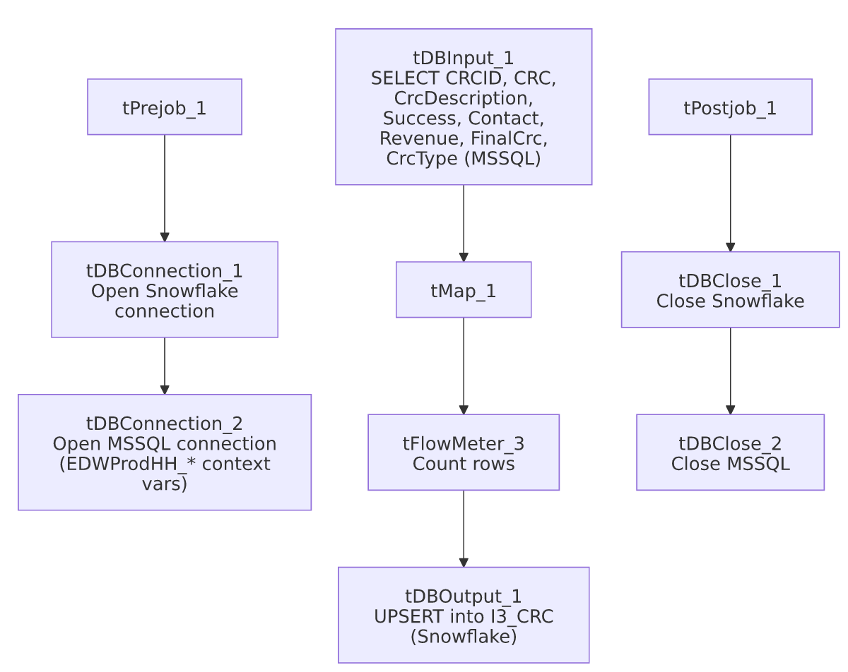

Settings tables

Source: `tDBInput_1` (`tMSSqlInput`)
Setting | Value | What it means
Connection | Shared tDBConnection_2 | Reuses the job's single MSSQL connection.
Query | SELECT CAST([CRCID] AS numeric(10,0)) AS CRCID, [CRC], [CrcDescription], CAST([Success] AS numeric(4,0)) AS [Success], CAST([Contact] AS numeric(4,0)) AS [Contact], CAST([Revenue] AS numeric(4,0)) AS [Revenue], ... (truncated in metadata) | Explicit numeric casts suggest the source columns may be stored as a looser type (e.g. varchar/bit) in MSSQL and are being normalized on the way in. The visible portion doesn't show a FROM/WHERE clause.

Target: `tDBOutput_1` (`tSnowflakeOutput`)
Setting | Value | What it means
Table | I3_CRC | Destination reference table in Snowflake.
Output action | UPSERT | Updates existing rows (matched presumably on CRCID, though the match key is not itself visible in this component's captured parameters) and inserts new ones — no rows are ever deleted by this job, appropriate for a slowly-changing reference table.

Dependencies & configuration
- Triggers/depends on other jobs: none — no tRunJob links found, and this job does not appear in 06_dependency_matrix.md's orchestration table.
- Context variables used: EDWProdHH_Database, EDWProdHH_Login, EDWProdHH_Port, EDWProdHH_Schema, EDWProdHH_Server (MSSQL connection details — see Issues observed on naming, same pattern as i3_CallDetail_40_Load).
- No hardcoded developer-workstation paths found in this job (hardcoded_path_findings: []).

Glossary
Component type | Plain-English meaning
tSnowflakeConnection / tSnowflakeClose | Open/close a Snowflake database connection shared by other components in the job.
tMSSqlConnection / tMSSqlInput / tMSSqlClose | Open a Microsoft SQL Server connection, run a query against it, and close it.
tMap | Maps/transforms columns from one schema to another.
tFlowMeter | Counts rows passing a point in the flow, for logging/monitoring.
tSnowflakeOutput | Writes rows to a Snowflake table — here configured to UPSERT (update-or-insert) rather than plain INSERT.
tStatCatcher / tFlowMeterCatcher / tLogRow | Talend's built-in job-statistics and flow-meter capture components, which print execution stats to the log; not part of the business data flow.

Issues observed
- The MSSQL source query is truncated in this metadata, cutting off after the visible column-cast list. The actual source table name (presumably CRC based on the columns being selected, but not directly confirmed) and any filtering clause are not visible — unable to determine from this metadata whether the query pulls the full reference table every run (consistent with a small lookup table and the UPSERT target behavior) or applies some filter; verify directly in Talend Studio.
- The MSSQL connection is configured using `context.EDWProdHH_*` variables, the same naming convention documented in i3_CallDetail_40_Load for the "EDWProdHH" operational database, even though this job loads I3 telephony CRC reference data, not EDWProdHH data. As with that job, this may mean the I3 database shares a physical SQL Server with EDWProdHH, or it may be a mislabeled/reused context group — unable to determine from metadata; verify with the team.
- No error/row-count logging specific to this job's business outcome (no tWarn/tDie/tSendMail) — a load failure here would only surface as a generic Talend execution error, with no job-specific message to distinguish it in a shared log. This matches the project-wide pattern documented in 05_operational_runbook.md for the majority of jobs that lack explicit tDie/tWarn logic.
- No other findings — this is a small, self-contained reference-data load with no file handling, no hardcoded paths, and a straightforward UPSERT target pattern.

