Talend Job: i3_CallDetail_40_Load_Copy

Overview
This job is a modified copy of i3_CallDetail_40_Load (same source table i3_CallDetail_40 on the I3 telephony MSSQL database, same target I3_CALLDETAIL_40 in Snowflake), but at version 0.3 it has diverged in several concrete ways: its incremental-key calculation components are disabled, its Snowflake output now truncates the target table before every load (a full-reload pattern rather than an append), and it adds a merge-procedure call and a per-run log file that the original job doesn't have. It is not a byte-for-byte duplicate — see Issues observed for exactly what changed.

Detail table
Field | Value
Job name | i3_CallDetail_40_Load_Copy
Version | 0.3
Project | EDW2SF
Author | jmach@harriscollect.com
Created | 2024-03-13T08:59:54.762-0700
Last Modified | 2025-08-28T08:57:24.666-0700

Step-by-step data flow
Setup subjob: tPrejob_1 → tJava_1 opens a per-run log file at context.logDir + jobName + "_" + <timestamp> + ".log" and redirects System.out/System.err to it (a pattern the original i3_CallDetail_40_Load does not have) → on success, tDBConnection_1 opens the Snowflake connection → tDBConnection_2 opens the MSSQL connection using context.EDWProdHH_* variables (same naming-mismatch pattern already flagged in the original job's doc).
Main subjob:
- tDBInput_1 (Snowflake, SELECT ... FROM DW.I3_CALLDETAIL_40 computing a lookback window off callplacedtime and context.lookBack) is present but `ACTIVATE=false` — this component is disabled and does not run.
- tJavaRow_1, which would capture that result into context.maxInsertKey, is also disabled (ACTIVATE=false).
- tDBInput_2 runs a fixed SELECT of ~50 named columns (same column list as the original job) against the source i3_CallDetail_40 table on MSSQL. The captured query text is truncated after the column list, same limitation as the original job — whether a WHERE clause exists is unable to determine from this metadata.
- tMap_1 passes the columns through to the same uppercase-named target schema as the original job (DIE_ON_ERROR=true).
- tFlowMeter_3 counts rows passing through (labeled "MyLabel").
- tDBOutput_1 writes to Snowflake table I3_CALLDETAIL_40 with `tableAction=TRUNCATE` (the original job uses tableAction=NONE/plain append) — every run now clears the table before reloading it.
- On the main subjob's success (tDBInput_2 → tDBRow_1, SUBJOB_OK), tDBRow_1 runs CALL STAGING.MERGE_INTO_I3_CALLDETAIL_40(); — a merge-procedure call the original job does not have.
A disabled, unwired tFileOutputExcel_1 component (ACTIVATE=false, no incoming or outgoing connections) also exists in this job, configured to write to C:/Data/inboundcalls.xlsx with a full ~53-column schema matching the call-detail data — it never runs and is not part of any data path. This job also has no `tStatCatcher`/`tLogRow`/`tFlowMeterCatcher` components, unlike the original job, which does.
Teardown subjob: tPostjob_1 → tDBClose_1 (close Snowflake) → tDBClose_2 (close MSSQL).
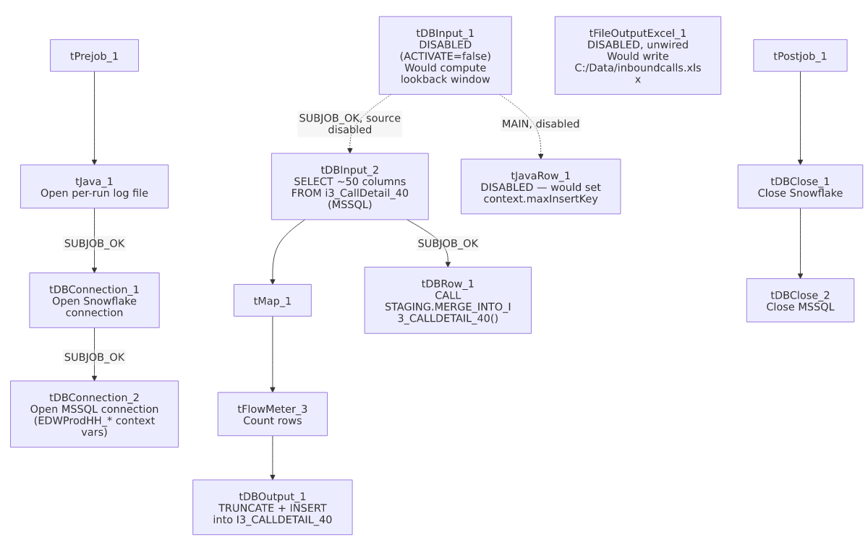

Settings tables

Disabled incremental-key components: `tDBInput_1` / `tJavaRow_1`
Setting | Value | What it means
ACTIVATE (tDBInput_1) | false | This component is turned off in the job design — it does not execute at run time.
Query (tDBInput_1, if it were enabled) | SELECT CAST(DATEADD(DAY,-"+context.lookBack+",COALESCE(MAX(callplacedtime),'2014-01-01')) AS VARCHAR(30)) AS MAX_INSERT_KEY FROM DW.I3_CALLDETAIL_40; | A different incremental strategy than the original job (date-lookback off callplacedtime rather than MAX(INSERTKEY)), but moot since the component is disabled.
ACTIVATE (tJavaRow_1) | false | Also disabled; the context.maxInsertKey assignment it would perform never runs.

Source: `tDBInput_2` (`tMSSqlInput`)
Setting | Value | What it means
Connection | Shared tDBConnection_2 | Reuses the job's MSSQL connection.
Table | i3_CallDetail_40 | Source telephony call-detail table, same as the original job.
Query | Fixed SELECT of ~50 named columns; truncated before any WHERE clause in this metadata | Same truncation limitation as i3_CallDetail_40_Load — whether this is filtered by any date/key window is unable to determine from metadata.

Target: `tDBOutput_1` (`tSnowflakeOutput`)
Setting | Value | What it means
Table | I3_CALLDETAIL_40 | Destination table in Snowflake — same table the original job writes to.
Output action | INSERT | Appends rows.
Table action | `TRUNCATE` | Clears the entire table before every load — a full-reload behavior, different from the original job's `NONE` (plain append). Combined with the disabled max-key logic, this job now behaves as a full truncate-and-reload rather than an incremental append.

Merge step: `tDBRow_1` (`tSnowflakeRow`)
Setting | Value | What it means
Query | CALL STAGING.MERGE_INTO_I3_CALLDETAIL_40(); | Calls a stored procedure after the load subjob completes — a step the original i3_CallDetail_40_Load does not have at all.

Dead component: `tFileOutputExcel_1`
Setting | Value | What it means
ACTIVATE | false | Disabled; not part of any data path (no incoming/outgoing connections in this metadata).
FILENAME | "C:/Data/inboundcalls.xlsx" | A hardcoded, unrelated-looking output path ("inboundcalls") that was never wired up — likely leftover from an unrelated experiment or copy-paste.
PASSWORD | ***REDACTED*** | File-protection password is set but redacted in this metadata; preserved as-is.

Dependencies & configuration
- Triggers/depends on other jobs: none — no tRunJob links found.
- Context variables used: EDWProdHH_Server, EDWProdHH_Port, EDWProdHH_Schema, EDWProdHH_Database, EDWProdHH_Login (MSSQL connection details), logDir (new in this version, for the per-run log file), maxInsertKey (only meaningful if the disabled components were re-enabled). Note: context.lookBack, referenced in the disabled tDBInput_1 query text, does not appear in this job's own context_vars_referenced list — likely because the extraction only tracks variables on active components; unable to confirm from metadata.
- No hardcoded developer-workstation paths found in this job's own components (the tFileOutputExcel_1 path is a fixed literal, not a workspace path, and the component is disabled).

Glossary
Component type | Plain-English meaning
tSnowflakeConnection / tSnowflakeClose | Open/close a Snowflake database connection shared by other components in the job.
tMSSqlConnection / tMSSqlInput / tMSSqlClose | Open a Microsoft SQL Server connection, run a query against it, and close it.
tSnowflakeInput | Runs a query against Snowflake and returns its result rows.
tSnowflakeRow | Runs an arbitrary SQL statement or stored-procedure call against Snowflake.
tJavaRow | Runs custom Java code once per input row — here intended to unpack a query result into a context variable (disabled in this job).
tJava | Runs a block of custom Java code once — here used to redirect the job's console output to a per-run log file.
tFlowMeter | Counts rows passing a point in the flow for logging/monitoring.
tFileOutputExcel | Writes rows to an Excel (.xlsx) file — present but disabled and unwired in this job.

Issues observed
- The incremental-load logic is explicitly disabled, and the output now truncates the table on every run. Both tDBInput_1 (the max-key/lookback query) and tJavaRow_1 (which would capture that value into context.maxInsertKey) have ACTIVATE=false. Combined with tDBOutput_1.tableAction now being TRUNCATE instead of the original job's NONE, this version behaves as a full truncate-and-reload of I3_CALLDETAIL_40 from the entire MSSQL source table every run, not an incremental append. Whether this was an intentional simplification (moving incremental logic into the new MERGE_INTO_I3_CALLDETAIL_40() stored procedure instead) or an unfinished change is unable to determine from metadata — verify with the team, especially since the disabled components' query logic (date-lookback off callplacedtime, using an as-yet-undocumented context.lookBack) suggests a different incremental approach was being tried and abandoned mid-edit.
- Whether `tDBInput_2` still runs at all is ambiguous. Its only trigger link in this metadata is tDBInput_1 -> tDBInput_2 (SUBJOB_OK), but tDBInput_1 is disabled. Depending on how this specific Talend version handles a disabled trigger component, the downstream SUBJOB_OK link may or may not still fire. Unable to determine from metadata alone whether this job's main load path actually executes at run time; this should be verified directly in Talend Studio before assuming the job runs as designed.
- A disabled, unwired `tFileOutputExcel_1` component is left in the job, targeting C:/Data/inboundcalls.xlsx with a full call-detail-shaped schema and a redacted protection password. It has no connections in or out and does not affect the job's behavior, but it is dead design-time clutter that could confuse anyone reviewing the job in Talend Studio.
- No `tStatCatcher`/`tLogRow`/`tFlowMeterCatcher` components exist in this job, unlike the original i3_CallDetail_40_Load, so this copy loses the standard Talend job-statistics logging the original has (though it gains the per-run log file via tJava_1 instead, which the original lacks).
- The same `EDWProdHH_*`-named MSSQL connection mislabeling flagged in `i3_CallDetail_40_Load` is inherited here — this job reads I3 telephony data but its connection variables are named for the "EDWProdHH" operational database context group. See that job's doc for the same caveat.

