Talend Job: i3_CallDetail_viw_Load

Overview
Loads call-detail-view records from the I3 telephony MSSQL view i3_Calldetail_viw into the Snowflake I3_CALLDETAIL_VIW table, using an incremental pattern keyed on InitiatedDate: it first computes the latest InitiatedDate already loaded into Snowflake, then reads only newer source rows (the source query's WHERE clause is visible in this metadata, unlike the sibling i3_CallDetail_40_Load job, though it is still cut off before its full condition can be confirmed). It moves a small set of call-linkage fields (call ID, direction, local/remote party, initiation time, event log, and three custom string fields) rather than full call-duration/outcome detail.

Detail table
Field | Value
Job name | i3_CallDetail_viw_Load
Version | 0.1
Project | EDW2SF
Author | jmach@harriscollect.com
Created | 2022-02-07T10:41:05.209-0800
Last Modified | 2022-05-24T09:48:53.412-0700

Step-by-step data flow
Setup subjob: tPrejob_1 → tDBConnection_1 opens the Snowflake connection → tDBConnection_2 opens the MSSQL connection to context.EDWProdHH_Server/Port/Schema/Database/Login (password redacted; same "EDWProdHH"-named connection used for I3 telephony data as in i3_CallDetail_40_Load).
Main subjob:
- tDBRow_1 runs SELECT COALESCE(CAST(MAX(INITIATEDDATE) AS VARCHAR(30)), '2014-12-31') AS MAX_INIT_DATE FROM DW.I3_CALLDETAIL_VIW; against Snowflake to find the latest InitiatedDate already loaded (defaulting to 2014-12-31 if the table is empty).
- tJavaRow_1 captures that value into context.maxInitDate.
- On success (SUBJOB_OK), tDBInput_1 runs a fixed SELECT against the source i3_Calldetail_viw view (using the shared MSSQL connection), pulling CallId, CallDirection, LocalUserId, RemoteNumber, InitiatedDate, CallEventLog, and three CustomString fields, with a visible `WHERE Initiate...` clause — the metadata cuts off right after the keyword, so whether it actually compares against context.maxInitDate cannot be confirmed, but the presence of a WHERE fragment referencing the same column used for the max-date calculation is a stronger signal of an actually-applied incremental filter than in i3_CallDetail_40_Load.
- tMap_1 passes the 9 source columns through to a same-shaped target schema (DIE_ON_ERROR=true).
- tFlowMeter_4 counts rows passing through (labeled "MyLabel").
- tDBOutputBulkExec_1 bulk-loads the rows into Snowflake table I3_CALLDETAIL_VIW (INSERT, no table-recreate action) — this job uses the bulk-exec variant of the Snowflake output component, unlike the plain tSnowflakeOutput used in most sibling I3 jobs.
Separately, tStatCatcher_1 and tFlowMeterCatcher_1 feed two tLogRow components that print job statistics and flow-meter counts to the log — standard Talend instrumentation, not part of the business data path.
Teardown subjob: tPostjob_1 → tDBClose_1 (close Snowflake) → tDBClose_2 (close MSSQL).
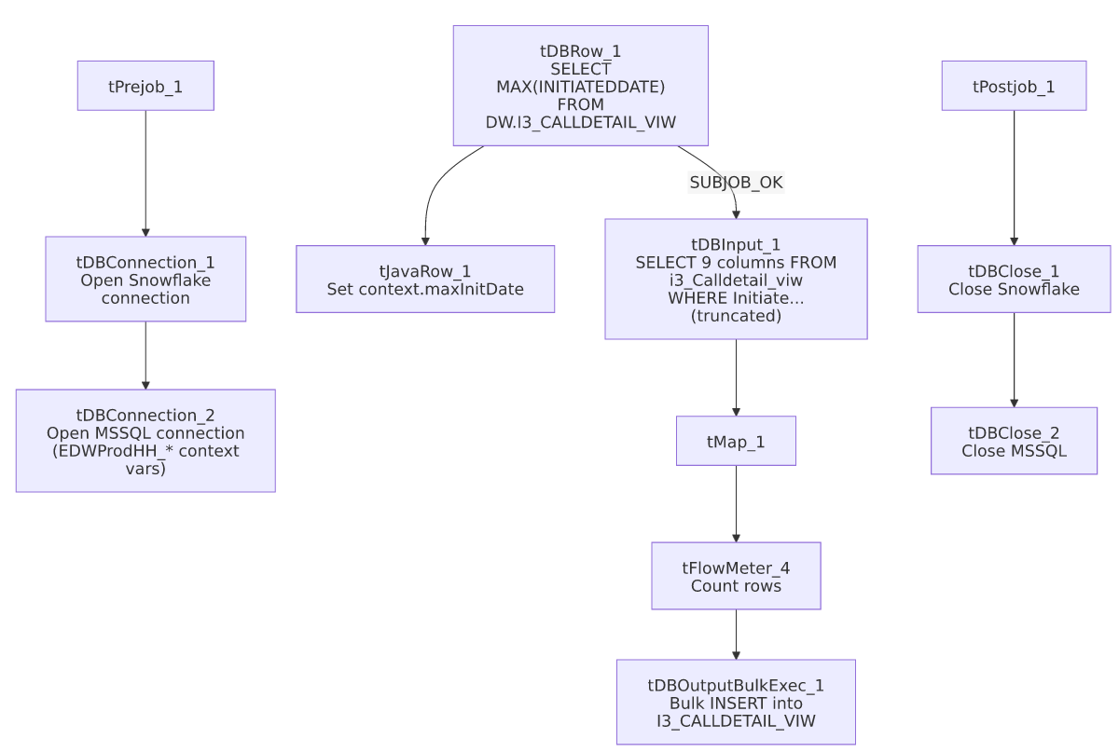

Settings tables

Incremental key: `tDBRow_1` / `tJavaRow_1`
Setting | Value | What it means
Query (tDBRow_1) | SELECT COALESCE(CAST(MAX(INITIATEDDATE) AS VARCHAR(30)), '2014-12-31') AS MAX_INIT_DATE FROM DW.I3_CALLDETAIL_VIW; | Finds the latest InitiatedDate already in Snowflake, defaulting to 2014-12-31 for an empty table.
Code (tJavaRow_1) | context.maxInitDate = input_row.MAX_INIT_DATE; | Stores the result for use in the source query.

Source: `tDBInput_1` (`tMSSqlInput`)
Setting | Value | What it means
Connection | Shared tDBConnection_2 | Reuses the job's single MSSQL connection.
View | i3_Calldetail_viw | Source telephony call-linkage view.
Query | Fixed SELECT of 9 named columns with a WHERE Initiate... clause (cut off in this metadata) | The visible fragment suggests filtering on InitiatedDate, presumably against context.maxInitDate, but the full condition is unable to be confirmed from this metadata.

Target: `tDBOutputBulkExec_1` (`tSnowflakeOutputBulkExec`)
Setting | Value | What it means
Table | I3_CALLDETAIL_VIW | Destination table in Snowflake.
Output action | INSERT | Appends rows — there is no TRUNCATE/staging step, consistent with an incremental-append design (assuming the WHERE clause does what it appears to).
Table action | NONE | Table is not recreated by this job.
Component variant | tSnowflakeOutputBulkExec (bulk load) | Uses Snowflake's bulk-loading mechanism rather than row-by-row inserts — more efficient for larger volumes, and different from the plain tSnowflakeOutput used elsewhere in this project's I3 jobs.

Dependencies & configuration
- Triggers/depends on other jobs: none — no tRunJob links found.
- Context variables used: EDWProdHH_Server, EDWProdHH_Port, EDWProdHH_Schema, EDWProdHH_Database, EDWProdHH_Login (MSSQL connection details — same naming convention concern as i3_CallDetail_40_Load), maxInitDate (computed internally from the Snowflake max-date query).
- No hardcoded developer-workstation paths found in this job.

Glossary
Component type | Plain-English meaning
tSnowflakeConnection / tSnowflakeClose | Open/close a Snowflake database connection shared by other components in the job.
tMSSqlConnection / tMSSqlInput / tMSSqlClose | Open a Microsoft SQL Server connection, run a query against it, and close it.
tSnowflakeRow | Runs an arbitrary SQL statement against Snowflake and returns its result — here used just once for a single aggregate value.
tSnowflakeOutputBulkExec | Loads rows into Snowflake using its bulk-load mechanism rather than row-by-row inserts.
tJavaRow | Runs custom Java code once per input row — here used to unpack a single query result into a context variable.
tFlowMeter | Counts rows passing a point in the flow for logging/monitoring.
tStatCatcher / tFlowMeterCatcher / tLogRow | Talend's built-in job-statistics and flow-meter capture components, which print execution stats to the log; not part of the business data flow.

Issues observed
- The source query's `WHERE` clause is visible but still truncated in this metadata (WHERE Initiate...), so it is not possible to confirm with certainty that it actually references context.maxInitDate rather than some other fixed condition. Unlike i3_CallDetail_40_Load (whose captured query shows no WHERE fragment at all), this job's partial fragment is at least suggestive that the incremental design is applied — but this should still be verified directly in Talend Studio before relying on it.
- This job uses `tSnowflakeOutputBulkExec` while most sibling I3 load jobs use plain `tSnowflakeOutput`. Not a functional problem on its own, but worth knowing this project does not use one consistent Snowflake-write component across similar jobs — verify per job rather than assuming a uniform loading mechanism.
- The same `EDWProdHH_*`-named MSSQL connection is used to read I3 telephony data, the same naming/labeling concern already flagged in i3_CallDetail_40_Load's doc — see that doc for the full discussion.
- No error/row-count logging specific to this job's business outcome (no tWarn/tDie/tSendMail) — a load failure here would only surface as a generic Talend execution error.

