Talend Job: i3_Call_Detail_View_Init_Load

Overview
This job's extracted metadata contains a single component and nothing else — no connections, no tPrejob/tPostjob, no output, no downstream flow of any kind. It is configured to read from an MSSQL table/view named calldetail_viw (a "call detail view," presumably related to the I3 telephony platform's call-detail data covered by i3_CallDetail_40_Load) using the I3_IC_40 connection context, but as captured it does not move data anywhere or perform any complete extract-load cycle. Based purely on what this metadata shows, this reads as an incomplete or scratch/test job rather than a functioning part of the pipeline — see Issues observed.

Detail table
Field | Value
Job name | i3_Call_Detail_View_Init_Load
Version | 0.1
Project | EDW2SF
Author | jmach@harriscollect.com
Created | 2023-05-12T10:48:14.000-0700
Last Modified | 2025-08-28T08:57:22.188-0700

Step-by-step data flow
The job's components list contains exactly one entry, tDBInput_1, and its connections list is empty — there is no wiring to any other component, no setup/teardown subjob, and no captured schema for what this component would actually return. Unable to determine from metadata whether this component is left completely disconnected on the canvas, or whether downstream components exist in the job but were not captured by this extraction.
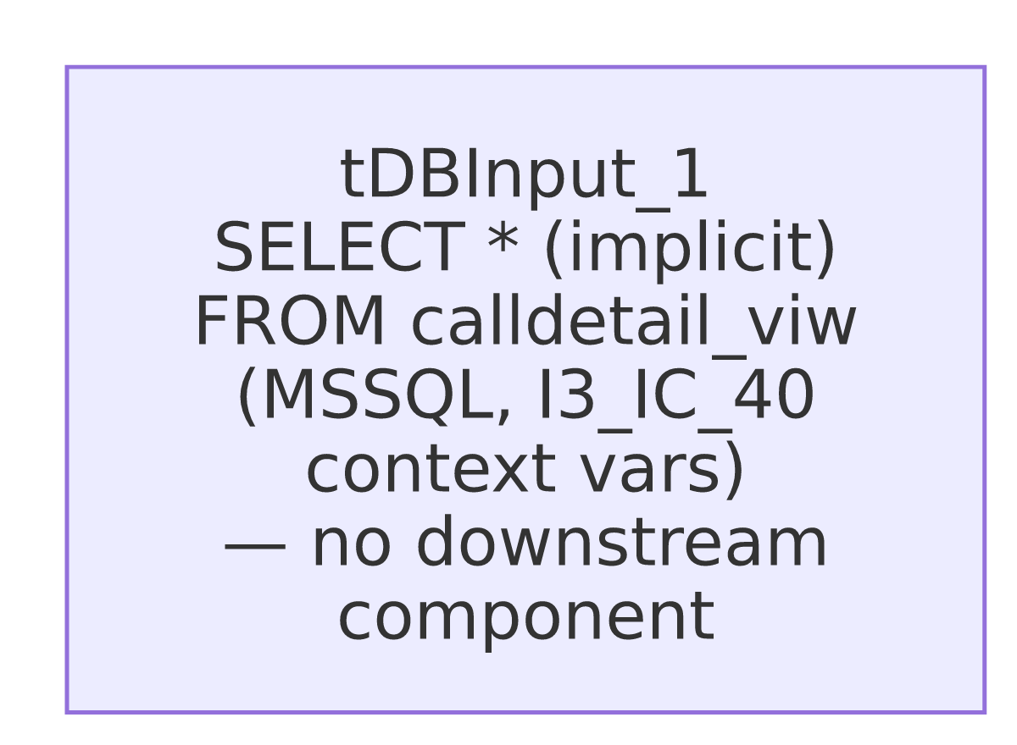

Settings tables

Source: `tDBInput_1` (`tMSSqlInput`)
Setting | Value | What it means
Connection | context.I3_IC_40_Server/Port/Schema/Database/Login (password ***REDACTED***) | Same I3 telephony connection context used by other i3_* jobs in this project (e.g. i3_AgentActivityLog_Load, i3_InteractionWrapup_Load).
TABLE | "calldetail_viw" | Reads from a table or view named "call detail view" — presumably a source-side view over call-detail data, distinct from the i3_CallDetail_40 table read by i3_CallDetail_40_Load.
QUERY | "" (empty) | No custom query is set — the component would default to selecting from the TABLE value directly, whatever columns that view exposes.
USE_EXISTING_CONNECTION | false | This component opens its own ad hoc MSSQL connection rather than sharing one — there is no separate tMSSqlConnection component in this job's metadata for it to share.
No schema_columns were captured for this component, so the actual column layout of calldetail_viw is not visible in this metadata.

Dependencies & configuration
- Triggers/depends on other jobs: none — no tRunJob links found, and this job does not appear as a caller or target in 06_dependency_matrix.md.
- Context variables used: I3_IC_40_Database, I3_IC_40_Login, I3_IC_40_Port, I3_IC_40_Schema, I3_IC_40_Server (the standard I3_IC_40_0.1 context group).
- No hardcoded paths found in this job's single component.

Glossary
Component type | Plain-English meaning
tMSSqlInput | Runs a query (or, with no query set, an implicit select) against a Microsoft SQL Server table/view and returns the result rows.

Issues observed
- This job does not perform a complete data flow as captured. It has exactly one component, no tPrejob/tPostjob, no connection-open/-close pair, no output destination (file or database), and no logging or error-handling components — in contrast to every other job reviewed in this batch, all of which have at minimum a source, transform, and destination. Running this job as-is would query calldetail_viw and discard the result with nothing consuming it.
- No schema was captured for `tDBInput_1`, so even the shape of calldetail_viw (what columns it exposes) is not visible in this metadata — unable to determine from metadata what this job would actually retrieve if run.
- The job name ("Init_Load") and its minimal, disconnected structure suggest this is a development scratch job or an abandoned starting point — possibly created to explore the calldetail_viw source ahead of building a real load job, and left in the repository unfinished. This is an inference from structure, not stated anywhere in the metadata. Recommend confirming with the team whether this job is actually scheduled/deployed; if it is, that would be worth flagging as an operational gap (a job that runs but accomplishes nothing), and if it isn't, it's a candidate for cleanup so it doesn't get mistaken for a working i3_CallDetail-family load in future audits.

