Talend Job: i3_Campaign_Type_Load

Overview
Loads a small reference table of I3 dialer campaign name/type pairs (i3_Campaign_Type) from the source SQL Server database into the Snowflake I3_CAMPAIGN_TYPE table, using a full truncate-and-reload pattern appropriate for a small, slowly-changing lookup table. Like i3_CallDetail_40_Load, this job's MSSQL connection is configured with EDWProdHH_* context variables even though the table itself is I3-named — but here the query text literally schema-qualifies the table using context.EDWProdHH_Schema, which is stronger evidence that the I3 tables genuinely live inside the same SQL Server database/schema as EDWProdHH data (see Issues observed).

Detail table
Field | Value
Job name | i3_Campaign_Type_Load
Version | 0.1
Project | EDW2SF
Author | jmach@harriscollect.com
Created | 2022-01-25T15:19:09.044-0800
Last Modified | 2025-09-24T10:59:42.536-0700

Step-by-step data flow
Setup subjob: tPrejob_1 → tDBConnection_1 opens the Snowflake connection → on success, tDBConnection_2 opens the MSSQL connection using context.EDWProdHH_Server/Port/Schema/Database/Login (password redacted).
Main subjob:
- tDBInput_1 runs SELECT "<EDWProdHH_Schema>".i3_Campaign_Type.campaignname, "<EDWProdHH_Schema>".i3_Campaign_Type.campaigntype FROM "<EDWProdHH_Schema>".i3_Campaign_Type — the query text is built dynamically at design time using context.EDWProdHH_Schema as the schema qualifier for the i3_Campaign_Type table.
- tMap_1 passes the 2 source columns through to an uppercase-named target schema (CAMPAIGNNAME, CAMPAIGNTYPE).
- tFlowMeter_3 counts rows passing through (labeled "MyLabel").
- tDBOutput_1 truncates and reloads Snowflake table I3_CAMPAIGN_TYPE (outputAction=INSERT, tableAction=TRUNCATE) — a full-refresh pattern, unlike the incremental-append design used by this project's larger I3 fact-style loads (i3_CallDetail_40_Load, i3_AgentQueueStats_Load).
Separately, tStatCatcher_1 and tFlowMeterCatcher_1 (standard Talend internal statistics/flow-meter catchers) feed two tLogRow components that print job statistics and flow-meter counts to the log — these run automatically alongside the main flow and aren't part of the business data path.
Teardown subjob: tPostjob_1 → tDBClose_1 (close Snowflake) → tDBClose_2 (close MSSQL).
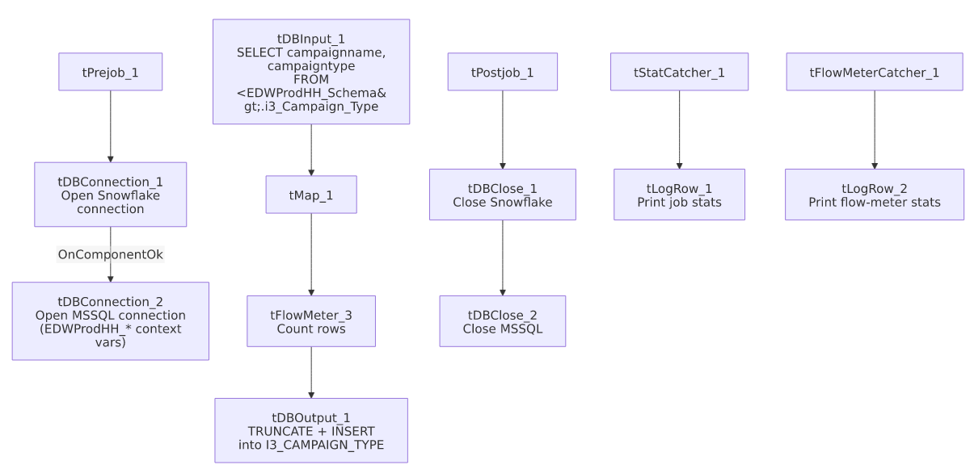

Settings tables

Source: `tDBInput_1` (`tMSSqlInput`)
Setting | Value | What it means
Table | i3_Campaign_Type | Source lookup table of campaign name/type pairs.
Query | SELECT "<EDWProdHH_Schema>".i3_Campaign_Type.campaignname, "<EDWProdHH_Schema>".i3_Campaign_Type.campaigntype FROM "<EDWProdHH_Schema>".i3_Campaign_Type | Dynamically schema-qualifies the table using context.EDWProdHH_Schema — direct evidence that this i3-named table lives inside the same SQL Server schema as EDWProdHH data.

Target: `tDBOutput_1` (`tSnowflakeOutput`)
Setting | Value | What it means
Table | I3_CAMPAIGN_TYPE | Destination table in Snowflake.
Output action | INSERT | Loads all current source rows.
Table action | TRUNCATE | Clears the table before loading — a full reload every run, appropriate for a small reference/lookup table.

Setup: `tDBConnection_2` (`tMSSqlConnection`)
Setting | Value | What it means
HOST / PORT / SCHEMA_DB / DBNAME / USER | context.EDWProdHH_Server / context.EDWProdHH_Port / context.EDWProdHH_Schema / context.EDWProdHH_Database / context.EDWProdHH_Login | Same EDWProdHH context group used for the operational database elsewhere in the project — see Issues observed for what this implies about where I3 tables physically live.

Dependencies & configuration
- Triggers/depends on other jobs: none — no tRunJob links found.
- Context variables used: EDWProdHH_Database, EDWProdHH_Login, EDWProdHH_Port, EDWProdHH_Schema, EDWProdHH_Server.
- No hardcoded developer-workstation paths found in this job — notably cleaner than most of the 210 jobs flagged project-wide in 05_operational_runbook.md, though this job's simplicity (no file I/O, no keystore configuration) likely explains the absence rather than any deliberate cleanup.

Glossary
Component type | Plain-English meaning
tSnowflakeConnection / tSnowflakeClose | Open/close a Snowflake database connection shared by other components in the job.
tMSSqlConnection / tMSSqlInput / tMSSqlClose | Open a Microsoft SQL Server connection, run a query against it, and close it.
tMap | Maps/transforms columns from one schema to another.
tFlowMeter | Counts rows passing a point in the flow for logging/monitoring.
tSnowflakeOutput | Writes rows to a Snowflake table — here with TRUNCATE table action, meaning the table is cleared before each load.
tStatCatcher / tFlowMeterCatcher / tLogRow | Talend's built-in job-statistics and flow-meter capture components, which print execution stats to the log; not part of the business data flow.

Issues observed
- This job's MSSQL connection uses `EDWProdHH_*` context variables for a table named `i3_Campaign_Type` — the same pattern flagged as ambiguous in i3_CallDetail_40_Load's documentation. Here, though, the query text itself schema-qualifies the table with context.EDWProdHH_Schema, which is direct evidence that the I3 tables genuinely live in the same SQL Server database/schema as EDWProdHH data (rather than the connection label simply being reused/mislabeled). This job's own metadata supports resolving that open question — worth cross-referencing when reviewing i3_CallDetail_40_Load's equivalent finding.
- Full truncate-and-reload (`tableAction=TRUNCATE`) means a query failure mid-run could leave `I3_CAMPAIGN_TYPE` empty or partially loaded until the next successful run — there is no staging table or two-step swap in this job. Anything actively querying I3_CAMPAIGN_TYPE during a run window could see a transient empty or partial table.
- No error/row-count-specific logging (no tWarn/tDie/tSendMail) — the same absence noted in this project's other I3 load jobs; a failure here would only surface as a generic Talend execution error.

