Talend Job: i3_DialerCallListCHI_Load

Overview
Refreshes the "CHI" site's dialer call-list table (I3_DIALERCALLLIST_CHI) in Snowflake directly from MSSQL: it computes the current maximum I3_UPLOAD_ID already in Snowflake, extracts debtor/campaign/phone/call-attempt data (roughly 60 columns, including HH-style skip-trace columns SKPPHN1/SKPPHN2/PHO1) from the MSSQL DialerCalllist_* source, joins it against a Snowflake DIMLOGON lookup, and directly UPSERTs the mapped rows into the final Snowflake table — with no separate staging table, no TRUNCATE, and no downstream MERGE call. This is a third distinct load pattern within the i3_DialerCallList* job family (alongside i3_DialerCallListHH_Load's truncate-staging-then-watermark-append pattern and the key-based MERGE pattern used by CO_Load/DC_Load_Backup/TOL_Load, per that job's own doc) — the simplest of the three, relying entirely on Snowflake's native UPSERT to avoid duplicates.

Detail table
Field | Value
Job name | i3_DialerCallListCHI_Load
Version | 0.2
Project | EDW2SF
Author | jmach@harriscollect.com
Created | 2023-06-01T10:33:42.092-0700
Last Modified | 2025-11-16T19:32:33.058-0800

Step-by-step data flow
Setup subjob: tPrejob_1 → tJava_1 opens a per-run log file at context.logDir + jobName + "_" + <timestamp> + ".log" → on success (OnSubjobOk), tSetKeystore_1 configures SSL trust/keystore from context.keystorePath (passwords redacted) → on success, tDBConnection_1 opens the Snowflake connection → on success (OnComponentOk), tDBConnection_2 (tMSSqlConnection, hardcoded HOST="MP-ININSQL-V01", DBNAME="DIALER_40", driver JTDS, user svc_ssa_snflk) opens the MSSQL connection.
Main subjob:
- tDBInput_3 (tSnowflakeInput) runs SELECT CAST(COALESCE(MAX(i3_UPLOAD_ID),1) AS VARCHAR(20)) AS MAXUPLOADID FROM I3_DIALERCALLLIST_CHI to find the highest upload ID already loaded.
- tDBInput_3 feeds two branches: MAIN → tJavaRow_1 captures the value into context.maxUploadID; SUBJOB_OK (fires only once that capture completes) → tDBInput_1 (tMSSqlInput, reusing the shared MSSQL connection) runs a fixed SELECT of ~60 named columns (I3_IDENTITY, ACCOUNT AS DEBTORNUMBER, LOGON, a derived DEBTOR_IDX, CAMPAIGN, DEBTORNAME, address/phone fields, SKPPHN1/SKPPHN2/PHO1, call-attempt counters, I3_UPLOAD_ID, etc.) against the source dialer table. The component's own `TABLE` parameter is hardcoded to `"DialerCalllist_HH"` — not _CHI — even though this is the CHI job (see Issues observed); the actual QUERY text is truncated in this metadata after the column list, so the real FROM/WHERE clause (and whether it filters using context.maxUploadID) cannot be confirmed.
- tMap_1 joins the MSSQL flow (row1) against tDBInput_2 (tSnowflakeInput reading Snowflake table DIMLOGON, row3), adding a DIMLOGON surrogate key column.
- tFlowMeter_3 counts rows passing through.
- tDBOutput_1 upserts the mapped rows directly into Snowflake table I3_DIALERCALLLIST_CHI (UPSERT, tableAction: NONE — no truncate, no staging table).
Teardown subjob: tPostjob_1 → tDBClose_1 (close Snowflake) → tDBClose_2 (close MSSQL).
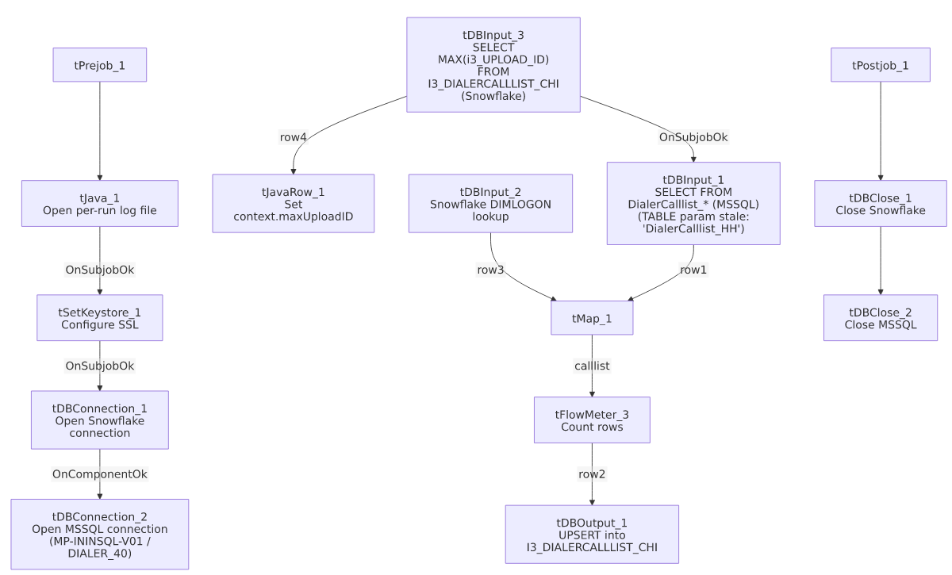

Settings tables

Source: `tDBInput_1` (`tMSSqlInput`)
Setting | Value | What it means
Connection | Shared tDBConnection_2 | Reuses the job's single MSSQL connection.
TABLE (component's own parameter) | "DialerCalllist_HH" | Stale/incorrect for this job — this is the CHI job, but the dead TABLE field still reads "HH." See Issues observed.
Query | Fixed SELECT of ~60 named columns (identity, debtor/campaign identifiers, address, SKPPHN1/SKPPHN2/PHO1, call-history flags, I3_UPLOAD_ID) — captured text truncated after the visible column list | The actual FROM/WHERE clause, and whether it filters on context.maxUploadID, is not visible in this metadata.
ENCODING | ISO-8859-15 | Non-UTF-8 encoding, consistent with other legacy-source jobs in this project.
TRIM_ALL_COLUMN | false | No whitespace trimming applied to extracted columns.

MSSQL connection: `tDBConnection_2` (`tMSSqlConnection`)
Setting | Value | What it means
DRIVER | JTDS | Matches i3_DialerCallListPRE_Load's connection, not HH_Load's (MSSQL_PROP).
HOST | "MP-ININSQL-V01" (hardcoded) | Same physical server as PRE_Load/TOL_Load per that job family's documentation.
DBNAME | "DIALER_40" (hardcoded) | Same database as PRE_Load/TOL_Load — unlike HH_Load, which hits a differently-named EDWPRODHH database on a different server.
USER | "svc_ssa_snflk" | Hardcoded service account name.

Lookup: `tDBInput_2` (`tSnowflakeInput`)
Setting | Value | What it means
Table | DIMLOGON | Small dimension table joined in tMap_1 to attach a DIMLOGON surrogate key based on LOGON.

Watermark query: `tDBInput_3` / `tJavaRow_1`
Setting | Value | What it means
Query | SELECT CAST(COALESCE(MAX(i3_UPLOAD_ID),1) AS VARCHAR(20)) AS MAXUPLOADID FROM I3_DIALERCALLLIST_CHI | Computes the highest upload ID already loaded into the CHI Snowflake table.
Result handling | context.maxUploadID = input_row.MAXUPLOADID; | Captured into context, but not visibly referenced in tDBInput_1's (truncated) query text — see Issues observed.

Target: `tDBOutput_1` (`tSnowflakeOutput`)
Setting | Value | What it means
Table | I3_DIALERCALLLIST_CHI | Destination table in Snowflake.
Output action | UPSERT | Inserts new rows and updates existing rows on match — no TRUNCATE/staging step, so this design tolerates re-running without needing the maxUploadID filter to work correctly (unlike HH_Load's append-only INSERT ... WHERE LOAD_DTTM > MAX(...) pattern, which can produce duplicates if its watermark logic misfires).

Dependencies & configuration
- Triggers/depends on other jobs: none — no tRunJob links found (runjob_targets: []); not listed as a target in 06_dependency_matrix.md either.
- Context variables used: keystorePath, logDir, maxUploadID (computed internally, but not confirmed to be actually applied as a filter — see Issues observed). This job does not use context.EDWProdHH_* or any StandardFolders_0.1 variable; its MSSQL host/database/driver are all hardcoded.
- 1 hardcoded path: tSetKeystore_1.SSL_TRUSTSERVER_TRUSTSTORE ("C:/clientTrustStore.trustStore") — same project-wide risk documented in 05_operational_runbook.md.

Glossary
Component type | Plain-English meaning
tMSSqlConnection / tMSSqlInput / tMSSqlClose | Open a Microsoft SQL Server connection, run a query against it, and close it.
tSnowflakeConnection / tSnowflakeInput / tSnowflakeOutput / tSnowflakeClose | Open/close a Snowflake connection, read a table, and write rows to a table.
tMap | Maps/transforms and optionally joins (lookup) columns from one or more input schemas to an output schema.
tFlowMeter | Counts rows passing a point in the flow for logging/monitoring.
tJavaRow | Runs custom Java code once per input row — here used to unpack a single query result into a context variable.
tSetKeystore | Configures SSL trust/keystore settings used by subsequent secure connections.

Issues observed
- `tDBInput_1`'s own `TABLE` parameter is hardcoded to `"DialerCalllist_HH"`, not `"DialerCalllist_CHI"`, even though this job is i3_DialerCallListCHI_Load and its actual QUERY (not the TABLE field) is what really drives the extraction. This is almost certainly dead/unused configuration left over from copying this job from the HH sibling (or a shared template), since tMSSqlInput uses the free-form QUERY text, not TABLE, when a custom query is present — but its presence here is worth flagging directly, since if anyone (or any future automation) ever switches this component from "query mode" to "guess query from table," it would silently start reading the wrong site's table. Unable to confirm from this truncated metadata what the actual QUERY's FROM clause names; verify directly in Talend Studio.
- The incremental-load logic (`context.maxUploadID`) may not actually be applied. The job computes the current max I3_UPLOAD_ID from Snowflake before reading MSSQL, suggesting an incremental design, but tDBInput_1's QUERY text is truncated in this metadata after the column list, so whether a WHERE ... > context.maxUploadID-style filter actually exists cannot be confirmed. Unlike HH_Load's append-only design, this job's UPSERT target action means even an unfiltered full re-read would not create duplicate rows — but it could mean every run unnecessarily re-reads the entire source table. Verify directly in Talend Studio. Same category of gap documented in i3_CallDetail_40_Load's and i3_AgentStats' own docs.
- This job's MSSQL connection (`MP-ININSQL-V01` / `DIALER_40`, driver `JTDS`) matches `i3_DialerCallListPRE_Load`'s connection (see that job's own doc) but differs from HH_Load's (MP-BI-V01 / EDWPRODHH, driver MSSQL_PROP) — reinforcing HH_Load's own finding that these "site" jobs are not all pointed at one shared dialer database.
- This job's source schema includes `SKPPHN1`/`SKPPHN2`/`PHO1` (skip-trace/directory-assistance-style columns), which i3_DialerCallListHH_Load's own doc described as "HH-specific" relative to the DC/TOL/CO/PRE siblings it was directly compared against at the time. Seeing the same columns present in CHI's own source schema here suggests those columns are not actually unique to HH — they may simply not have been present in whichever specific siblings that comparison covered. Worth a follow-up comparison across the full i3_DialerCallList* family rather than assuming any one column set is site-specific without checking each job's own metadata.
- No other findings beyond the project-wide hardcoded-path pattern already documented in 05_operational_runbook.md.

