Talend Job: i3_DialerCallListCO_Load

Overview
Refreshes the "CO" site's dialer call-list table in Snowflake (I3_DIALERCALLLIST_CO) from the I3 telephony MSSQL system: it extracts debtor/campaign/phone/call-attempt data from MSSQL table DialerCalllist_CO, joins it against a Snowflake DIMLOGON lookup, writes the enriched result to an intermediate CSV file, then re-reads that same file to load a Snowflake staging table and finally merges the staged rows into the DW warehouse table keyed on I3_IDENTITY. Unlike its i3_DialerCallListHH_Load sibling (which loads MSSQL straight into Snowflake with no file round-trip), this job goes through a full extract-to-file-and-back cycle before landing in staging, and — like CO_Load/CO_Load_Backup more generally — uses a proper key-based MERGE into the warehouse rather than a simple append.

Detail table
Field | Value
Job name | i3_DialerCallListCO_Load
Version | 0.2
Project | EDW2SF
Author | jmach@harriscollect.com
Created | 2023-07-06T09:51:28.197-0700
Last Modified | 2025-11-10T15:43:45.237-0800

Step-by-step data flow
Setup subjob: tPrejob_1 → tJava_1 opens a per-run log file at context.logDir + jobName + "_" + <timestamp> + ".log" → on success (OnSubjobOk), tDBConnection_2 opens the MSSQL connection (hardcoded host/database — see Settings tables) → on success, tSetKeystore_1 configures SSL trust/keystore from context.keystorePath (passwords redacted) → on success, tDBConnection_1 opens the Snowflake connection.
Main subjob, phase 1 — extract MSSQL to CSV:
- tDBRow_1 runs TRUNCATE TABLE STAGING.I3_DIALERCALLLIST_CO; on Snowflake (starts independently, with no incoming trigger link, as soon as the job's main subjob begins).
- On success (OnSubjobOk), tDBInput_1 runs a fixed SELECT against MSSQL table DialerCalllist_CO, pulling I3_IDENTITY, ACCOUNT AS DEBTORNUMBER, LOGON, a derived DEBTOR_IDX, CAMPAIGN, DEBTORNAME, address/phone fields (PHONE1–PHONE7), call-attempt counters (I3_ATTEMPTS*, 8 columns), I3_UPLOAD_ID, campaign-owner fields, and more (~60 columns total). The captured query text is truncated in this metadata after the initial column list, so any WHERE clause is not visible.
- tDBInput_1's output flows (FLOW) into tMap_1, which also receives a lookup input (MAIN) from tDBInput_2 (tSnowflakeInput reading Snowflake table DIMLOGON), adding a DIMLOGON surrogate key column based on LOGON.
- tMap_1 → tFlowMeter_3 (row count) → tFileOutputDelimited_1, which writes the enriched list to a fixed path /output/i3_dialercalllistCO.csv (comma-delimited, no header, split every 10,000 rows).
Main subjob, phase 2 — reload CSV into Snowflake staging:
- Once phase 1's flow subjob completes, tDBInput_1 also fires OnSubjobOk into tFileList_1, which lists every file in /output/ (hardcoded, not a context variable — EXCLUDEFILEMASK="*.txt" with IFEXCLUDE=false, so the exclusion is configured but never applied).
- tFileList_1 ITERATEs into tFileInputDelimited_1, which re-reads each listed file (same ~60-column schema) → tFlowMeter_8 (row count) → tDBOutput_1, which INSERTs the rows into Snowflake table I3_DIALERCALLLIST_CO (presumed to be the STAGING-schema copy given the earlier explicit truncate of STAGING.I3_DIALERCALLLIST_CO, though the component's own db.table field does not itself show a schema prefix).
Main subjob, phase 3 — merge and cleanup (parallel):
- Once tFileList_1's iteration subjob completes (OnSubjobOk), tParallelize_1 starts two branches concurrently:
- tDBRow_2 runs a MERGE INTO DW.I3_DIALERCALLLIST_CO AS tgt USING STAGING.I3_DIALERCALLLIST_CO AS src ON (tgt.I3_IDENTITY = src.I3_IDENTITY) — updating all ~60 columns on match, inserting new rows on no match, with I3_UPLOAD_ID coalesced to 0 if null on both branches.
- tFileList_2 re-lists /output/ and ITERATEs into tFileDelete_1, which attempts to delete each file found there.
Teardown subjob: tPostjob_1 → tDBClose_1 (close Snowflake) → tDBClose_2 (close MSSQL).
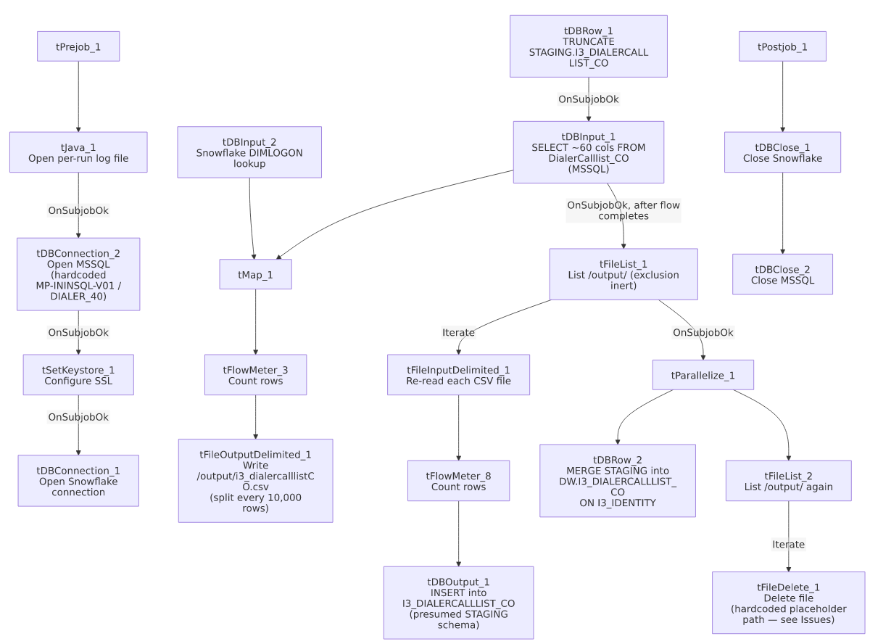

Settings tables

Source: `tDBInput_1` (`tMSSqlInput`)
Setting | Value | What it means
Connection | Shared tDBConnection_2 | Reuses the job's single hardcoded MSSQL connection.
TABLE | "DialerCalllist_CO" | Correctly named for the CO site.
Query | Fixed SELECT of ~60 named columns — captured text truncated after the initial column list | Any WHERE clause is not visible in this metadata.
TRIM_ALL_COLUMN | true | Whitespace trimmed from all extracted columns.

MSSQL connection: `tDBConnection_2` (`tMSSqlConnection`)
Setting | Value | What it means
DRIVER | JTDS
HOST | "MP-ININSQL-V01" (hardcoded) | Same physical server as i3_DialerCallListTOL_Load (this batch) — both CO and TOL point at the same dialer SQL Server.
DBNAME | "DIALER_40" (hardcoded) | Same source database as the TOL sibling.
USER | "svc_ssa_snflk" | Hardcoded service account.

Intermediate file: `tFileOutputDelimited_1` / `tFileInputDelimited_1`
Setting | Value | What it means
FILENAME (write) | "/output/i3_dialercalllistCO.csv" | Hardcoded path, not driven by any context variable (contrast with context.sourceDir/context.fileDir patterns used elsewhere in the project).
SPLIT / SPLIT_EVERY | true / 10000 | Large lists are split into multiple numbered files rather than one large file.
DIRECTORY (tFileList_1/tFileList_2) | "/output/" (hardcoded) | Same hardcoded output directory is listed twice — once to reload the file into Snowflake, once to delete it afterward.
TEMP_DIR (tFileInputDelimited_1) | "C:/Talend-Studio-20211109_1610-V8.0.1/workspace" | Hardcoded developer-workstation path.

Lookup: `tDBInput_2` (`tSnowflakeInput`)
Setting | Value | What it means
Table | DIMLOGON | Small dimension table (DIMLOGON, LOGON, DESCRIPTION) joined in tMap_1 to attach a DIMLOGON surrogate key based on LOGON.

Target (staging): `tDBOutput_1` (`tSnowflakeOutput`)
Setting | Value | What it means
Table | I3_DIALERCALLLIST_CO | INSERT, tableAction: NONE — relies entirely on tDBRow_1's earlier explicit TRUNCATE TABLE STAGING.I3_DIALERCALLLIST_CO to keep this idempotent; the component's own db.table field shows no schema prefix, so the assumption that this lands in STAGING (not some other schema) is inferred from the truncate step, not directly confirmed.

Warehouse merge: `tDBRow_2` (`tSnowflakeRow`)
Setting | Value | What it means
Query | MERGE INTO DW.I3_DIALERCALLLIST_CO AS tgt USING STAGING.I3_DIALERCALLLIST_CO AS src ON (tgt.I3_IDENTITY = src.I3_IDENTITY) WHEN MATCHED THEN UPDATE SET ... WHEN NOT MATCHED THEN INSERT (...) | Full column-by-column update on match, insert on no match — a proper key-based merge, not a simple append. I3_UPLOAD_ID is coalesced to 0 if null on both the update and insert branches.

Cleanup: `tFileDelete_1`
Setting | Value | What it means
FILENAME | globalMap.get("tFileList_2_CURRENT_FILEPATH") | The current file from tFileList_2's iteration — dynamically the right file.
DIRECTORY / PATH | "C:/Talend-Studio-20211109_1610-V8.0.1/workspace/delete_folder" / "C:/Talend-Studio-20211109_1610-V8.0.1/workspace/delete_folder or delete_file" | Hardcoded, template-placeholder-looking values (the literal text "delete_folder or delete_file" strongly suggests these were never actually configured) — see Issues observed regarding whether cleanup functions at all.
FAILON | true | Unlike some other jobs' tFileDelete components in this project, a failed delete here does fail the job.

Dependencies & configuration
- Triggers/depends on other jobs: none — no tRunJob links found, and this job does not appear in 06_dependency_matrix.md's orchestration table.
- Context variables used: keystorePath, logDir only — this job's MSSQL host/database, output CSV path, and file-list directories are all hardcoded rather than driven by StandardFolders_0.1 or any other context group.
- 4 hardcoded paths found: tSetKeystore_1.SSL_TRUSTSERVER_TRUSTSTORE (C:/clientTrustStore.trustStore), tFileInputDelimited_1.TEMP_DIR, and tFileDelete_1.DIRECTORY/PATH — same project-wide risk documented in 05_operational_runbook.md. The /output/ directory itself and the CSV filename are also hardcoded, though not flagged in hardcoded_path_findings (they are Unix-style paths, not the Windows developer-workstation pattern that finding set specifically targets).

Glossary
Component type | Plain-English meaning
tMSSqlConnection / tMSSqlInput / tMSSqlClose | Open a Microsoft SQL Server connection, run a query against it, and close it.
tSnowflakeConnection / tSnowflakeInput / tSnowflakeOutput / tSnowflakeRow / tSnowflakeClose | Open/close a Snowflake connection, read a table, write rows to a table, or run an arbitrary SQL statement against Snowflake.
tMap | Maps/transforms and optionally joins (lookup) columns from one or more input schemas to an output schema.
tFlowMeter | Counts rows passing a point in the flow for logging/monitoring.
tFileList | Lists files in a directory for the job to iterate over one at a time.
tFileInputDelimited / tFileOutputDelimited | Read/write a delimited (CSV-style) text file.
tFileDelete | Deletes a specific file from disk.
tParallelize | Runs its downstream branches at the same time instead of one after another.
tSetKeystore | Configures SSL trust/keystore settings used by subsequent secure connections.

Issues observed
- The cleanup step's `tFileDelete_1.DIRECTORY`/`PATH` values look like unconfigured template placeholders ("...delete_folder" / "...delete_folder or delete_file"), not a real path pointing at /output/. Combined with FAILON=true, this raises a real operational question: if tFileDelete_1 actually attempts to delete against these literal Windows paths rather than the dynamic FILENAME (globalMap.get("tFileList_2_CURRENT_FILEPATH")), either the delete silently targets the wrong location, or — if FILENAME does take precedence at runtime over DIRECTORY/PATH (which is plausible; FILENAME is Talend's actual delete-target field, with DIRECTORY/PATH typically only relevant for folder-deletion mode) — cleanup may work correctly despite these placeholder-looking values. Unable to fully determine from this metadata which parameter Talend actually honors here; verify directly in Talend Studio, since if cleanup silently fails, every run leaves its intermediate CSV files behind in /output/.
- The MSSQL source query in `tDBInput_1` is truncated in this metadata, cutting off after the initial column list — any WHERE clause (e.g. a date or upload-ID filter limiting the extract to new/changed rows) is not visible, so it's unable to be determined from this metadata whether this is a full-table extract every run or an incrementally filtered one.
- The output CSV path (`/output/i3_dialercalllistCO.csv`) and both `tFileList` directories (`/output/`) are hardcoded rather than driven by a context variable, unlike most file-handling jobs elsewhere in this project that use context.sourceDir/context.archiveDir/etc. from StandardFolders_0.1. Moving this job to a different environment or output location would require editing the job directly.
- No reject-row handling, no `tWarn`/`tDie` on the merge result — a bad row from the MSSQL extract or a failed MERGE would only surface as a generic Talend execution error, with no job-specific diagnostic message, unlike ADP_Payroll_Load's explicit merge-result branching.
- No other findings beyond the project-wide hardcoded-path pattern already documented in 05_operational_runbook.md.

