Talend Job: i3_DialerCallListCO_Load_Backup

Overview
Builds an outbound "dialer call list" for the CO site: it reads debtor/account records from the MSSQL DialerCalllist_CO table, enriches them with a logon-to-DIMLOGON lookup from Snowflake, and writes the result as a CSV file (/output/i3_dialercalllistCO.csv) intended for the I3 telephony/dialer system. In the same run, it also lists every file currently sitting in that same /output/ directory, reads each one back with an expanded schema that adds dialer-response/attempt-tracking fields (call attempts, disposition status, campaign-owner info), loads that into Snowflake staging, merges it into the DW.I3_DIALERCALLLIST_CO warehouse table, and then deletes every file from /output/. The _Backup suffix in the job name, its blank author field, and its very recent/narrow create-modify window (created and modified one day apart in November 2025) all suggest this is a snapshot or working copy rather than the long-standing production version of this job — see Issues observed.

Detail table
Field | Value
Job name | i3_DialerCallListCO_Load_Backup
Version | 0.2
Project | EDW2SF
Author | *(blank in source metadata)*
Created | 2025-11-10T15:14:37.779-0800
Last Modified | 2025-11-11T10:32:00.005-0800

Step-by-step data flow
Setup subjob: tPrejob_1 → tJava_1 opens a per-run log file → on success (OnSubjobOk), tDBConnection_2 opens the MSSQL connection (context.EDWProdHH_* variables, password redacted) → on success, tSetKeystore_1 configures SSL trust/keystore from context.keystorePath → on success, tDBConnection_1 opens the Snowflake connection.
Main subjob — outbound call-list generation:
- tDBRow_1 runs TRUNCATE TABLE STAGING.I3_DIALERCALLLIST_CO;.
- On success (OnSubjobOk), tDBInput_1 (tMSSqlInput, reusing the shared tDBConnection_2) runs a query against DialerCalllist_CO, building I3_IDENTITY, DEBTORNUMBER (aliased from ACCOUNT), LOGON, a computed DEBTOR_IDX (LOGON + '-' + ACCOUNT), CAMPAIGN, DEBTORNAME, address fields, CLIENTNAME, BALANCE, multiple phone-number columns (PHONERES, EMP1PHN, EMP2PHN, APPHONE, PHONE1–PHONE7), last-payment/letter-notice fields, SSN, desk/status codes, a promise-to-pay date (PLDATE), a dialer SCORE/MEDIAN, and load-tracking fields (CSVFILENAME, DATELOADED, TIMELOADED, ZONE).
- tMap_1 joins that against tDBInput_2 (a tSnowflakeInput reading the DIMLOGON table: DIMLOGON, LOGON, DESCRIPTION), adding a DIMLOGON surrogate-key column keyed on LOGON.
- tFlowMeter_3 counts rows, then tFileOutputDelimited_1 writes the result as a headerless, comma-delimited CSV to /output/i3_dialercalllistCO.csv (split every 10,000 rows).
Main subjob — read-back, load, and merge (runs after the MSSQL read completes):
- On success (OnSubjobOk from tDBInput_1), tFileList_1 lists every file in /output/ (no filename filter is applied — EXCLUDEFILEMASK="*.txt" but IFEXCLUDE=false).
- For each file (ITERATE), tFileInputDelimited_1 reads it back (headerless CSV, DIE_ON_ERROR=true — unlike most file reads in this project, a malformed row here does fail the job) using the same base column layout as step 2/3.
- tMap_2 adds a substantially larger set of columns not present in the outbound file's own generation logic: LOAD_DTTM, STATUS, ATTEMPTS, HHCUSTVAR1–3, HHCUSTINT1, several I3_ATTEMPTS* counters (remote hangup, system hangup, abandoned, busy, fax, no-answer, machine, rescheduled, sit-callable, daily), I3_SITEID, I3_ACTIVECAMPAIGNID, I3_LASTCALLED_UTC, I3_UPLOAD_ID, SUCCESSRESULT, and I3_CAMPAIGNOWNERID/NAME/EXPIRATION. This set of dialer-attempt/tracking fields is consistent with a dialer response/results file rather than the original outbound call-list content — see Issues observed regarding which specific file(s) actually populate these columns at runtime.
- tDBOutput_1 inserts the enriched rows into Snowflake (I3_DIALERCALLLIST_CO, INSERT, no table-recreate — presumably landing in the STAGING schema truncated in step 1, though this component's own db.table parameter shows only the bare table name, not a schema-qualified one).
- After the entire file-list loop in step 5–8 completes (tFileList_1 → tParallelize_1, OnSubjobOk), tParallelize_1 runs two branches at once:
- tDBRow_2 runs an inline MERGE INTO DW.I3_DIALERCALLLIST_CO AS tgt USING STAGING.I3_DIALERCALLLIST_CO AS src ON (tgt.I3_IDENTITY = src.I3_IDENTITY) — a full-column WHEN MATCHED THEN UPDATE / WHEN NOT MATCHED THEN INSERT upsert (including COALESCE(src.I3_UPLOAD_ID,0) to default a null upload ID to zero).
- tFileList_2 lists /output/ again → for each file (ITERATE), tFileDelete_1 deletes it (FAILON=true — unlike most delete steps in this project, a failed delete here does fail the job).
Teardown subjob: tPostjob_1 → tDBClose_1 (close Snowflake) → tDBClose_2 (close MSSQL).
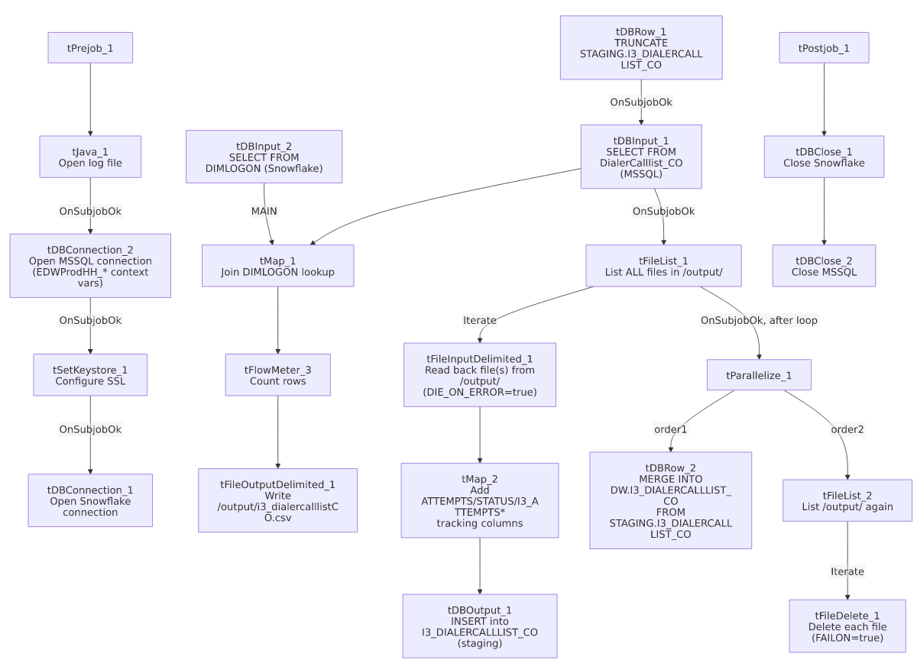

Settings tables

Source: `tDBInput_1` (`tMSSqlInput`)
Setting | Value | What it means
Table | DialerCalllist_CO | Source table of debtor/account records eligible for outbound dialing at the CO site.
Connection | Shared tDBConnection_2 | Reuses the job's single MSSQL connection.
Key derived column | DEBTOR_IDX = COALESCE(LOGON,'')+'-'+COALESCE(ACCOUNT,'') | Composite key built in-query, matching the DEBTOR_IDX pattern used for dialer-family tables elsewhere in this project.

Lookup: `tDBInput_2` (`tSnowflakeInput`)
Setting | Value | What it means
Table | DIMLOGON | A logon-name-to-surrogate-key dimension table in Snowflake, joined in tMap_1 to attach a DIMLOGON ID to each row.

Outbound file: `tFileOutputDelimited_1`
Setting | Value | What it means
FILENAME | "/output/i3_dialercalllistCO.csv" | Hardcoded absolute path, not built from a context.* variable.
HEADER | Not included (INCLUDEHEADER=false) | Output file has no header row, matching the headerless read-back step.
SPLIT / SPLIT_EVERY | true / 10000 | Splits the output into multiple files if the row count exceeds 10,000 per file — meaning tFileList_1/tFileList_2 could pick up more than one generated file per run.

Read-back and enrichment: `tFileInputDelimited_1` / `tMap_2`
Setting | Value | What it means
FILENAME | Current file from tFileList_1 | Lists every file in `/output/`, not just the one just written — see Issues observed.
DIE_ON_ERROR | true | Unlike most file reads in this project, a malformed row here fails the job outright rather than being silently dropped.
Added columns (tMap_2) | ATTEMPTS, STATUS, I3_ATTEMPTS* counters, I3_SITEID, I3_LASTCALLED_UTC, I3_CAMPAIGNOWNERID/NAME/EXPIRATION, etc. | These fields describe dial-attempt outcomes and campaign ownership — content that would not exist in the file at the moment this job itself generates it, implying these values are expected to come from a dialer-produced response file also landing in /output/. Which exact file supplies them is not shown in this metadata.

Target: `tDBOutput_1` (`tSnowflakeOutput`)
Setting | Value | What it means
Table | I3_DIALERCALLLIST_CO | No explicit schema in this component's own parameters; presumably resolves to STAGING via the connection's default schema, consistent with the TRUNCATE TABLE STAGING.I3_DIALERCALLLIST_CO that precedes it.
Output action | INSERT | Relies on the earlier truncate to avoid duplicate accumulation.

Merge step: `tDBRow_2` (`tSnowflakeRow`)
Setting | Value | What it means
Query | Inline MERGE INTO DW.I3_DIALERCALLLIST_CO ... USING STAGING.I3_DIALERCALLLIST_CO ... ON (tgt.I3_IDENTITY = src.I3_IDENTITY) with a full-column UPDATE/INSERT | Unlike most CUBS/dialer jobs in this project, which call a MERGE_INTO_<table>() stored procedure, this job embeds the entire MERGE statement directly in the Talend job — see Issues observed.

Cleanup: `tFileDelete_1`
Setting | Value | What it means
FAILON | true | A failed delete fails the job — the opposite of the FAILON=false pattern used in most other file-load jobs in this project (e.g. Voapp_File_Load).
DIRECTORY / PATH | "C:/Talend-Studio-20211109_1610-V8.0.1/workspace/delete_folder" / similar | These parameters (used only as Talend's internal placeholders when FILENAME is set directly) are still developer-workstation paths — see Issues observed.

Dependencies & configuration
- Triggers/depends on other jobs: none — no tRunJob links found, and this job is not listed as a tRunJob target anywhere in 06_dependency_matrix.md. This job's job-name pattern (i3_DialerCallListCO_Load) resembles the i3_DialerCallList<Site>_Load family referenced in this batch's instructions as having sibling docs elsewhere in the project — but this is the _Backup variant specifically, which should not be assumed identical to a canonical i3_DialerCallListCO_Load job unless one is confirmed to exist separately.
- Context variables used: EDWProdHH_Database, EDWProdHH_Login, EDWProdHH_Port, EDWProdHH_Schema, EDWProdHH_Server, keystorePath, logDir.
- 4 hardcoded paths: tSetKeystore_1.SSL_TRUSTSERVER_TRUSTSTORE (C:/clientTrustStore.trustStore), tFileInputDelimited_1.TEMP_DIR, and tFileDelete_1.DIRECTORY/PATH (both C:/Talend-Studio-20211109_1610-V8.0.1/workspace/delete_folder...) — the same project-wide developer-workstation portability risk. In addition, /output/ itself (used by tFileList_1, tFileList_2, and tFileOutputDelimited_1) is a hardcoded absolute path not built from any context.* variable — not flagged by the automated extractor, but notable since it means this job's file exchange location cannot be reconfigured without editing the job.

Glossary
Component type | Plain-English meaning
tMSSqlConnection / tMSSqlInput / tMSSqlClose | Open a Microsoft SQL Server connection, run a query against it, and close it.
tSnowflakeConnection / tSnowflakeInput / tSnowflakeOutput / tSnowflakeRow / tSnowflakeClose | Open a Snowflake connection, read/write rows, run arbitrary SQL, and close the connection.
tMap | Maps/transforms columns from one schema to another, and can join a second input as a lookup.
tFlowMeter | Counts rows passing a point in the flow, for logging/monitoring.
tFileList | Lists files in a directory for the job to iterate over one at a time.
tFileInputDelimited / tFileOutputDelimited | Read/write a delimited text file according to a schema.
tFileDelete | Deletes a file from disk.
tParallelize | Runs its downstream branches at the same time instead of one after another.
tSetKeystore | Configures the SSL trust store/keystore used for the job's encrypted database connections.

Issues observed
- `tFileList_1` and `tFileList_2` both list every file in `/output/` with no name filter matching just this job's own CSV. Since EXCLUDEFILEMASK="*.txt" is set but IFEXCLUDE=false (the exclusion is never actually applied), any file present in /output/ — a leftover from a prior failed run, a file dropped by another job or process sharing that directory, or an unrelated dialer response file — would be read into I3_DIALERCALLLIST_CO and then deleted by tFileDelete_1. Given /output/ is a generic, non-job-specific directory name, this is a real risk of cross-contamination if any other process writes to the same path. Unable to confirm from metadata whether /output/ is in practice dedicated solely to this job; verify with the team.
- The job's own generation step (steps 1–4) does not populate the dial-attempt/tracking columns that `tMap_2` adds in step 7 (ATTEMPTS, STATUS, I3_ATTEMPTS* counters, I3_LASTCALLED_UTC, campaign-owner fields). This strongly suggests the read-back step is meant to process a *different* file — a response file from the I3 dialer system reporting call outcomes — that is expected to also land in /output/ sometime during or after this job's own file-write. However, because both file-list steps scan the same directory indiscriminately (see previous point), there is no way from this metadata to confirm that only the intended response file is processed, or that the job even waits for one to arrive before its file-list steps run.
- The `_Backup` suffix, blank `author` field, and one-day-apart create/modify timestamps (2025-11-10 to 2025-11-11) together suggest this is a snapshot, working copy, or experiment, not the long-standing production job for CO dialer call-list processing. Whether a separate, canonical i3_DialerCallListCO_Load (without _Backup) also exists and is the one actually scheduled is unable to determine from this job's own metadata — verify with the team so this backup copy isn't mistaken for (or accidentally scheduled as) the production job.
- `tFileDelete_1.FAILON=true` is the opposite of the FAILON=false pattern used by delete steps in other file-processing jobs in this project (e.g. Voapp_File_Load). Combined with the unfiltered directory listing above, if any file in /output/ cannot be deleted (permissions, file lock, etc.), this job fails outright — which is arguably safer than silently leaving files behind, but is inconsistent with the rest of the project's convention.
- The merge step (`tDBRow_2`) embeds a full inline `MERGE` statement directly in the Talend job rather than calling a `MERGE_INTO_<table>()` stored procedure, unlike the CUBS/ADP/PCI-letter jobs documented elsewhere in this batch and in the reference docs. This is not necessarily wrong, but it means a future change to the merge logic must be made inside this Talend job itself rather than in a centrally-maintained Snowflake procedure — worth flagging as an inconsistency in how this project manages its merge logic.

