Talend Job: i3_DialerCallListDC_Load

Overview
Loads the DC (site code) dialer call list — debtor contact and campaign-dialing data (name, address, phone numbers, balance, campaign, per-outcome attempt counters, upload/campaign-owner metadata) — from the I3 dialer platform's MSSQL DialerCalllist_dc table into the Snowflake I3_DIALERCALLLIST_DC table, enriching each row with a DIMLOGON dimension-key lookup along the way. Unlike most other jobs in this batch, the final write uses UPSERT rather than plain INSERT, so re-running the job does not risk duplicating rows even if the source query re-reads more than just the newest records.

Detail table
Field | Value
Job name | i3_DialerCallListDC_Load
Version | 0.2
Project | EDW2SF
Author | jmach@harriscollect.com
Created | 2023-10-18T11:51:51.702-0700
Last Modified | 2025-11-06T14:02:15.701-0800

Step-by-step data flow
Setup subjob: tPrejob_1 → tJava_1 opens a per-run log file → on success, tSetKeystore_1 configures SSL trust/keystore from context.keystorePath → tDBConnection_1 opens the Snowflake connection → on success, tDBConnection_2 opens the MSSQL connection — but see Issues observed regarding how this connection is configured.
Main subjob:
- tDBInput_3 (tSnowflakeInput) runs SELECT CAST(COALESCE(MAX(i3_UPLOAD_ID),1) AS VARCHAR(20)) AS MAXUPLOADID FROM I3_DIALERCALLLIST_DC; to find the highest upload ID already loaded (defaulting to 1).
- tJavaRow_1 captures that value into context.maxUploadID.
- On success, tDBInput_1 runs a fixed SELECT against the source DialerCalllist_dc table (shared tDBConnection_2), pulling I3_IDENTITY, DEBTORNAME, ACCOUNT AS DEBTORNUMBER, ADDRESS, APPHONE, BALANCE, a computed DEBTOR_IDX (LOGON + '-' + ACCOUNT), CAMPAIGN, and more (~50 columns total per this component's schema). The captured query text is truncated after the initial columns and does not visibly reference `context.maxUploadID` — see Issues observed.
- In parallel, tDBInput_2 (tSnowflakeInput) reads the DIMLOGON dimension table (DIMLOGON surrogate key, LOGON, DESCRIPTION) from Snowflake.
- tMap_1 joins the MSSQL row flow with the DIMLOGON lookup (adding a DIMLOGON surrogate-key column to the output) and passes ~53 columns through to an uppercase-named target schema.
- tFlowMeter_3 counts rows passing through (labeled "MyLabel", not renamed for this job).
- tDBOutput_1 upserts the rows into Snowflake table I3_DIALERCALLLIST_DC.
Teardown subjob: tPostjob_1 → tDBClose_1 (close Snowflake) → tDBClose_2 (close MSSQL).
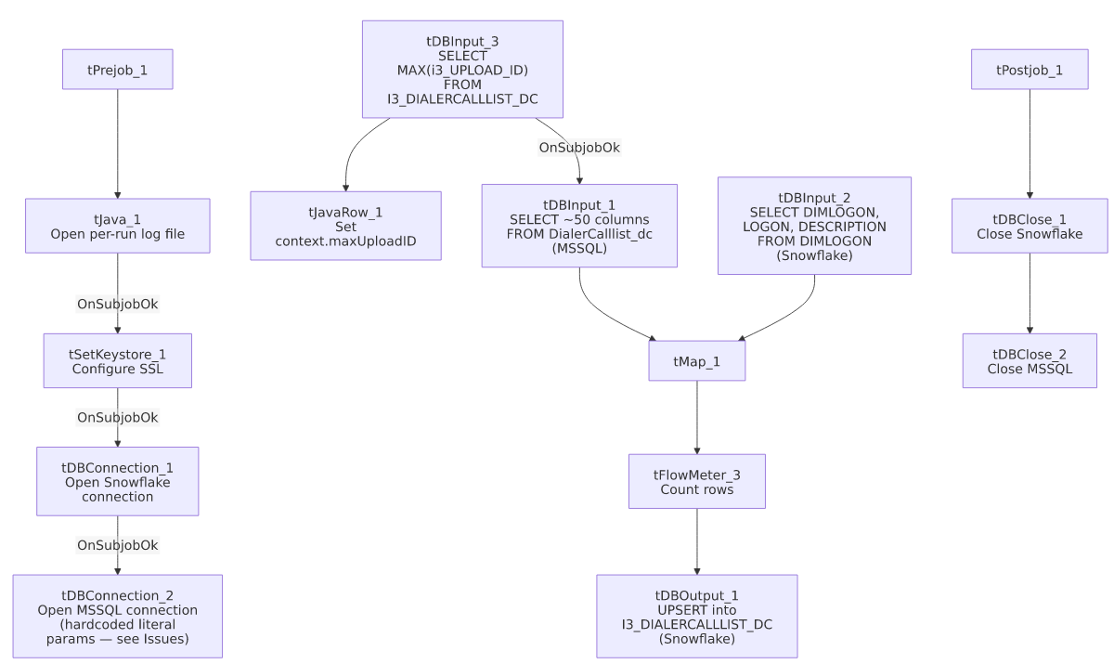

Settings tables

Setup: `tDBConnection_2` (`tMSSqlConnection`)
Setting | Value | What it means
HOST | "MP-ININSQL-V01" (literal) | Hardcoded server name, not a context variable — see Issues observed.
DBNAME | "DIALER_40" (literal) | Hardcoded database name.
SCHEMA_DB | "dbo" (literal) | Hardcoded schema.
USER | "svc_ssa_snflk" (literal) | Hardcoded service-account username; password ***REDACTED***.

Source: `tDBInput_1` (`tMSSqlInput`)
Setting | Value | What it means
Connection | Shared tDBConnection_2 | Reuses the job's hardcoded-parameter MSSQL connection.
TABLE | "DialerCalllist_dc" | Source dialer call-list table for the DC site.
Query | Fixed SELECT computing DEBTOR_IDX as COALESCE(LOGON,'')+'-'+COALESCE(ACCOUNT,''), casting I3_IDENTITY and BALANCE to numeric types, plus ~50 named columns (campaign, contact attempts by outcome, campaign-owner metadata) | The visible portion does not reference context.maxUploadID — see Issues observed.

Lookup: `tDBInput_2` (`tSnowflakeInput`)
Setting | Value | What it means
Table | DIMLOGON | Dimension table mapping LOGON text codes to a DIMLOGON surrogate key and description — joined into the main flow via tMap_1 to enrich each dialer record with its logon dimension key.

Target: `tDBOutput_1` (`tSnowflakeOutput`)
Setting | Value | What it means
Table | I3_DIALERCALLLIST_DC | Destination table for the DC site's dialer call list.
Output action | UPSERT | Inserts new rows and updates existing ones by key rather than appending duplicates — unlike the plain INSERT pattern used in most other jobs reviewed in this batch.
Table action | NONE | Table is not recreated/altered by this job.

Dependencies & configuration
- Triggers/depends on other jobs: none — no tRunJob links found, and this job does not appear as a caller or target in 06_dependency_matrix.md.
- Context variables used: keystorePath, logDir, maxUploadID (computed internally from the Snowflake max-upload-ID query). Notably, no `I3_*` context variables are referenced — see Issues observed regarding the hardcoded MSSQL connection.
- 1 hardcoded developer-workstation path in tSetKeystore_1.SSL_TRUSTSERVER_TRUSTSTORE ("C:/clientTrustStore.trustStore") — same pattern documented project-wide in 05_operational_runbook.md.

Glossary
Component type | Plain-English meaning
tSnowflakeConnection / tSnowflakeClose | Open/close a Snowflake database connection shared by other components in the job.
tMSSqlConnection / tMSSqlInput / tMSSqlClose | Open a Microsoft SQL Server connection, run a query against it, and close it.
tSnowflakeInput | Runs a query against Snowflake and returns its result rows — used here both for a lookup dimension (DIMLOGON) and a single aggregate value (max upload ID).
tMap | Maps/transforms columns from one schema to another, and here also performs the DIMLOGON lookup join.
tFlowMeter | Counts rows passing a point in the flow for logging/monitoring.
tSnowflakeOutput | Writes rows to a Snowflake table — here configured for UPSERT rather than plain INSERT.
tSetKeystore | Configures SSL trust/keystore settings for the job's secure connections.

Issues observed
- This job's MSSQL connection (`tDBConnection_2`) uses hardcoded literal values (`"MP-ININSQL-V01"`, `"DIALER_40"`, `"dbo"`, `"svc_ssa_snflk"`) instead of context variables, unlike every other MSSQL-sourced job reviewed in this batch (i3_AgentActivityLog_Load, i3_InteractionWrapup_Load, i3_Call_Detail_View_Init_Load, Test_Encryption), which all reference context.I3_IC_40_* or context.EDWProdHH_* variables for the equivalent settings. This means changing the DC dialer database's host, name, or service account would require editing this job directly, rather than updating a shared context group — a real deviation from this project's otherwise consistent connection-configuration pattern, and worth flagging for consistency/maintainability.
- The incremental-load logic may not actually be applied. The job computes context.maxUploadID from Snowflake before reading the MSSQL source, but the tDBInput_1.QUERY text captured in this metadata is truncated after the initial column list and does not show a WHERE ... i3_UPLOAD_ID > ...-style clause referencing context.maxUploadID in the visible portion. Unable to determine from this metadata whether the query is actually filtered. Unlike the plain-INSERT jobs in this batch, the risk here is more about unnecessary full-table re-reads/performance than duplicate rows, since the target write is an UPSERT — but it's still worth confirming directly in Talend Studio.
- `i3_UPLOAD_ID` in the Snowflake max-ID query is lowercase (`i3_UPLOAD_ID`) while the equivalent target column elsewhere in this job's own schema is `I3_UPLOAD_ID` (all-caps) — Snowflake identifiers are typically case-insensitive unless quoted, so this is likely harmless, but it's a naming inconsistency worth being aware of if anyone is grepping this project's source for the column name.
- Job version is 0.2, unlike the 0.1 seen on most other jobs in this batch — indicating at least one revision since its initial creation, though the specific changes aren't captured in this metadata.

