Talend Job: i3_DialerCallListDC_Load_Backup

Overview
This job rebuilds the "DC" site's dialer call-list table (I3_DIALERCALLLIST_DC) in Snowflake: it extracts debtor/campaign/phone/call-attempt data from an MSSQL table via a context-parameterized EDWProdHH_* connection, writes the extract to a local CSV, immediately re-reads that same CSV, stages it into Snowflake, and merges the staged rows into the DW warehouse table keyed on I3_IDENTITY. It is structurally the DC-site sibling of Copy_of_i3_DialerCallListTOL_Load_Backup (already documented) and i3_DialerCallListCO_Load_Backup — same export→reimport→stage→merge→cleanup template — but its MSSQL source table parameter literally says `DialerCalllist_CO`, not a DC-named table, which is the central issue with this job (see Issues observed).

Detail table
Field | Value
Job name | i3_DialerCallListDC_Load_Backup
Version | 0.2
Project | EDW2SF
Author | jmach@harriscollect.com
Created | 2025-11-17T11:12:56.537-0800
Last Modified | 2025-11-17T11:42:21.805-0800 (~30 minutes after creation)

Step-by-step data flow
Setup subjob: tPrejob_1 → tJava_1 opens a per-run log file at context.logDir + jobName + "_" + <timestamp> + ".log" → on success, tDBConnection_2 opens the MSSQL connection using context.EDWProdHH_* variables (password and Active Directory auth redacted) → on success, tSetKeystore_1 configures SSL trust/keystore from context.keystorePath (all passwords redacted) → on success, tDBConnection_1 opens the Snowflake connection.
Main subjob:
- tDBRow_1 runs TRUNCATE TABLE STAGING.I3_DIALERCALLLIST_DC; on Snowflake.
- On success, tDBInput_1 runs a fixed SELECT against MSSQL table `DialerCalllist_CO` (not a DC table — see Issues observed), pulling I3_IDENTITY, ACCOUNT AS DEBTORNUMBER, LOGON, a derived DEBTOR_IDX, CAMPAIGN, DEBTORNAME, address fields, and phone/call-history fields — 37 columns total (the captured query text is truncated after the visible column list, so any WHERE clause is not visible in this metadata).
- tMap_1 joins that MSSQL flow against tDBInput_2 (tSnowflakeInput reading Snowflake table DIMLOGON, columns DIMLOGON/LOGON/DESCRIPTION) as a lookup, adding a DIMLOGON surrogate key column.
- tFlowMeter_3 counts rows passing through (labeled "MyLabel", not customized for this job).
- tFileOutputDelimited_1 writes the enriched rows to a hardcoded local file /output/i3_dialercalllistDC.csv (comma-delimited, no header, split every 10,000 rows).
- On tDBInput_1's subjob success, tFileList_1 lists files in the hardcoded directory /output/; for each, tFileInputDelimited_1 re-reads the just-written CSV (DIE_ON_ERROR=true).
- tMap_2 passes the re-read rows through to a wider 61-column target schema, adding LOAD_DTTM, STATUS, ATTEMPTS, HHCUSTVAR1-3, HHCUSTINT1, a dozen I3_ATTEMPTS*/I3_* call-detail counters, and SUCCESS_RESULT (note the underscore — see Issues observed) not present in the original 37-column extract.
- tDBOutput_1 inserts the rows into Snowflake table I3_DIALERCALLLIST_DC (INSERT, tableAction: NONE) — lands in the STAGING schema per the preceding truncate in step 1.
- On tFileList_1's subjob success, tParallelize_1 starts two branches concurrently:
- tDBRow_2 runs MERGE INTO DW.I3_DIALERCALLLIST_DC from STAGING.I3_DIALERCALLLIST_DC, keyed on I3_IDENTITY, casting BALANCE through TRY_TO_NUMERIC(src.BALANCE,16,2) on insert.
- tFileList_2 lists files in /output/ again and tFileDelete_1 deletes each one found.
Teardown subjob: tPostjob_1 → tDBClose_1 (close Snowflake) → tDBClose_2 (close MSSQL).
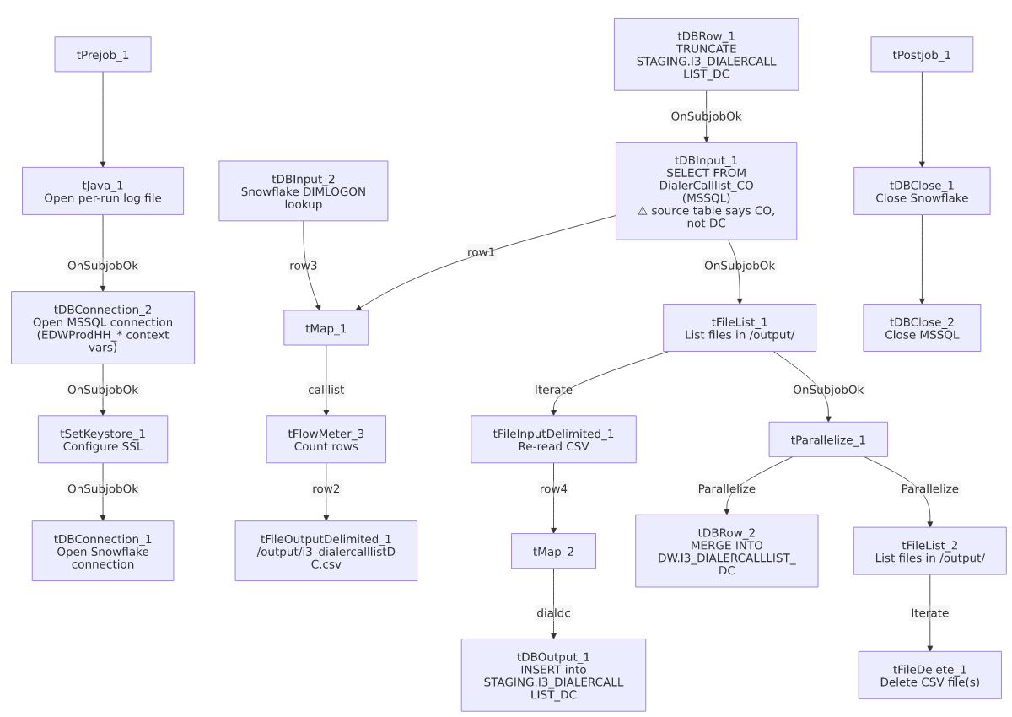

Settings tables

Source: `tDBInput_1` (`tMSSqlInput`)
Setting | Value | What it means
Connection | Shared tDBConnection_2 (EDWProdHH_* context vars) | Reuses the job's single MSSQL connection, driven entirely by context variables rather than hardcoded host/db.
Table | "DialerCalllist_CO" | Says CO, but this job is named/targets DC end-to-end otherwise — see Issues observed.
Query | Fixed 37-column SELECT (identity, debtor/campaign identifiers, address, phone fields, call-history flags) — captured text truncated after the visible column list | Any WHERE clause filtering to a specific site is not visible in this metadata.
ENCODING | ISO-8859-15 | Non-UTF-8 encoding, consistent with other legacy-source jobs in this project.

Lookup: `tDBInput_2` (`tSnowflakeInput`)
Setting | Value | What it means
Table | DIMLOGON | Small dimension table (DIMLOGON, LOGON, DESCRIPTION) joined in tMap_1 to attach a DIMLOGON surrogate key based on LOGON.

Intermediate file: `tFileOutputDelimited_1` / `tFileInputDelimited_1`
Setting | Value | What it means
FILENAME (write) | "/output/i3_dialercalllistDC.csv" | Hardcoded literal path — correctly named for DC, unlike the source table above.
SPLIT / SPLIT_EVERY | true / 10000 | Output may split into multiple part-files past 10,000 rows.
FILENAME (read) | globalMap.get("tFileList_1_CURRENT_FILEPATH") | Re-reads whatever file(s) tFileList_1 found in /output/ — not guaranteed to be only the file just written.
DIE_ON_ERROR (read) | true | A malformed row in the re-read step fails the job outright.

Target: `tDBOutput_1` (`tSnowflakeOutput`)
Setting | Value | What it means
Table | I3_DIALERCALLLIST_DC | INSERT, tableAction: NONE; lands in STAGING per the preceding TRUNCATE STAGING.I3_DIALERCALLLIST_DC.

Merge step: `tDBRow_2` (`tSnowflakeRow`)
Setting | Value | What it means
Query | MERGE INTO DW.I3_DIALERCALLLIST_DC AS tgt USING STAGING.I3_DIALERCALLLIST_DC AS src ON (tgt.I3_IDENTITY = src.I3_IDENTITY) — updates all columns on match, inserts on no-match | Standard staging→warehouse upsert, keyed on I3_IDENTITY.
BALANCE cast | TRY_TO_NUMERIC(src.BALANCE,16,2) on insert | Source BALANCE is carried as a string through the whole pipeline; this defensively converts it to a numeric on write.
Column name | SUCCESS_RESULT (with underscore) | Differs from the SUCCESSRESULT (no underscore) column name used by every sibling job in this family — see Issues observed.

Cleanup: `tFileDelete_1`
Setting | Value | What it means
FILENAME | globalMap.get("tFileList_2_CURRENT_FILEPATH") | Actual file(s) deleted are whatever tFileList_2 iterates in /output/.
DIRECTORY | "C:/Talend-Studio-20211109_1610-V8.0.1/workspace/delete_folder" | Hardcoded developer-workstation path, unused since FILENAME drives the actual delete.
PATH | "C:/Talend-Studio-20211109_1610-V8.0.1/workspace/delete_folder or delete_file" | Same unedited placeholder text found verbatim in Copy_of_i3_DialerCallListTOL_Load_Backup — confirms this whole family was built from one shared template.

Dependencies & configuration
- Triggers/depends on other jobs: none — no tRunJob links found (runjob_targets: []); not listed as a target in 06_dependency_matrix.md either.
- Context variables used: EDWProdHH_Database, EDWProdHH_Login, EDWProdHH_Port, EDWProdHH_Schema, EDWProdHH_Server (MSSQL connection), keystorePath, logDir.
- 4 hardcoded paths found: tSetKeystore_1.SSL_TRUSTSERVER_TRUSTSTORE (C:/clientTrustStore.trustStore), tFileInputDelimited_1.TEMP_DIR, and tFileDelete_1.DIRECTORY/PATH (all C:/Talend-Studio-20211109_1610-V8.0.1/workspace/...) — same project-wide portability risk documented in 05_operational_runbook.md.

Glossary
Component type | Plain-English meaning
tMSSqlConnection / tMSSqlInput / tMSSqlClose | Open a Microsoft SQL Server connection, run a query against it, and close it.
tSnowflakeConnection / tSnowflakeInput / tSnowflakeOutput / tSnowflakeRow / tSnowflakeClose | Open/close a Snowflake connection, read a table, write rows to a table, or run an arbitrary SQL/merge statement against Snowflake.
tMap | Maps/transforms and optionally joins (lookup) columns from one or more input schemas to an output schema.
tFlowMeter | Counts rows passing a point in the flow for logging/monitoring.
tFileOutputDelimited / tFileInputDelimited | Write or read a delimited (CSV-style) text file according to a schema.
tFileList | Lists files in a directory for the job to iterate over one at a time.
tFileDelete | Deletes a file (or, per its own config fields, potentially a folder) from disk.
tParallelize | Runs its downstream branches at the same time rather than one after another.
tSetKeystore | Configures SSL trust/keystore settings used by subsequent secure connections.

Issues observed
- The MSSQL source table (`tDBInput_1.TABLE`) is `"DialerCalllist_CO"`, not a DC-named table, while every other part of this job — the output CSV (i3_dialercalllistDC.csv), the Snowflake target (STAGING.I3_DIALERCALLLIST_DC / DW.I3_DIALERCALLLIST_DC), and the job name itself — consistently says DC. Unlike Copy_of_i3_DialerCallListTOL_Load_Backup (where *everything* said CO, making it look like an obviously-inert leftover copy), this job is internally self-consistent as "DC" except for the one line that actually decides what data gets pulled. If this job runs under its current name, it would load CO's raw dialer records into the DC warehouse table. Verify with the team whether DialerCalllist_CO is genuinely the correct/shared MSSQL source for DC, or whether this is a copy-paste error from a CO-based template job that was never corrected.
- The target column name `SUCCESS_RESULT` (with an underscore) appears in this job's tMap_2/tDBOutput_1 schema and its own MERGE SQL, whereas every sibling in this job family reviewed (HH_Load, HH_Load_Backup, PRE_Load, TOL_Load, and the already-documented CO_Load/CO_Load_Backup) uses SUCCESSRESULT (no underscore). Whether DW.I3_DIALERCALLLIST_DC actually has a differently-named column (intentional drift) or this is itself a typo relative to the rest of the family is unable to determine from metadata — verify with team.
- The MSSQL connection is parameterized via `context.EDWProdHH_*` variables even though the table being queried (DialerCalllist_CO) is I3 dialer/telephony data, not EDWProdHH operational data — the same naming ambiguity already flagged in i3_CallDetail_40_Load's doc and in Copy_of_i3_DialerCallListTOL_Load_Backup's doc. Confirm which physical database context.EDWProdHH_Database resolves to here, and whether a table literally named DialerCalllist_CO exists in it.
- The export→reimport round trip (write /output/i3_dialercalllistDC.csv, then immediately have tFileList_1/tFileInputDelimited_1 re-read whatever is in /output/) is the same pattern already flagged as a risk in Copy_of_i3_DialerCallListTOL_Load_Backup's doc — the re-read step isn't guaranteed to pick up only the file just written if other files are present in /output/ at run time.
- `tFileDelete_1`'s `DIRECTORY` and `PATH` parameters are the same unedited placeholder text (".../delete_folder" and ".../delete_folder or delete_file") found verbatim in the already-documented Copy_of_i3_DialerCallListTOL_Load_Backup — strong evidence this entire job family was cloned from one shared template without those fields ever being customized. The actual delete target is driven by FILENAME, not these fields.
- Beyond the items above, this job follows the same hardcoded-path and unconfigured-connection-entry patterns already documented project-wide in 05_operational_runbook.md.

