Talend Job: i3_DialerCallListHH_Load

Overview
This job refreshes the "HH" site's dialer call-list table (I3_DIALERCALLLIST_HH) in Snowflake directly from MSSQL, with no CSV round trip: it extracts debtor/campaign/phone/call-attempt data from MSSQL table DialerCalllist_HH, joins it against a Snowflake DIMLOGON lookup, truncates and reloads a STAGING copy of the table, then incrementally appends any newer rows into the DW warehouse table based on a LOAD_DTTM watermark. It is the simplest member of the i3_DialerCallList* family reviewed in this batch — no file export/reimport, no tParallelize, no key-based MERGE — and its DW-load logic is meaningfully different from its MERGE-based siblings (see Issues observed).

Detail table
Field | Value
Job name | i3_DialerCallListHH_Load
Version | 0.2
Project | EDW2SF
Author | jmach@harriscollect.com
Created | 2023-05-31T09:10:38.919-0700
Last Modified | 2026-02-18T10:29:57.236-0800

Step-by-step data flow
Setup subjob: tPrejob_1 → tJava_1 opens a per-run log file at context.logDir + jobName + "_" + <timestamp> + ".log" → on success, tSetKeystore_1 configures SSL trust/keystore from context.keystorePath (passwords redacted) → on success, tDBConnection_1 opens the Snowflake connection, which on success opens tDBConnection_2 (MSSQL, hardcoded host — see Settings tables).
Main subjob:
- tDBRow_1 runs TRUNCATE TABLE STAGING.I3_DIALERCALLLIST_HH; on Snowflake.
- On success, tDBInput_1 runs a fixed SELECT against MSSQL table DialerCalllist_HH, pulling I3_IDENTITY, ACCOUNT AS DEBTORNUMBER, LOGON, a derived DEBTOR_IDX, CAMPAIGN, DEBTORNAME, address/phone fields, call-history fields, SKPPHN1/SKPPHN2/PHO1/DIRASS1 (HH-specific skip-trace/directory-assistance columns not present in the DC/TOL/CO source query), call-attempt counters, and — notably — I3_UPLOAD_ID already sourced directly from MSSQL (unlike PRE_Load, which separately re-derives an upload-ID watermark; see that job's doc).
- tMap_1 joins the MSSQL flow against tDBInput_2 (tSnowflakeInput reading Snowflake table DIMLOGON), adding a DIMLOGON surrogate key column.
- tFlowMeter_3 counts rows passing through.
- tDBOutput_1 inserts the mapped rows into Snowflake table I3_DIALERCALLLIST_HH with tableAction: TRUNCATE — i.e., it truncates and reloads this table itself as part of the insert (the STAGING copy, per step 1's explicit truncate immediately before this branch runs).
- In parallel (triggered directly by tDBInput_1's subjob success, which in Talend fires only once the whole flow subjob — including tDBOutput_1 — has finished), tDBRow_2 runs an INSERT INTO DW.I3_DIALERCALLLIST_HH (...) SELECT ... FROM STAGING.I3_DIALERCALLLIST_HH src WHERE src.LOAD_DTTM > (SELECT MAX(LOAD_DTTM) FROM DW.I3_DIALERCALLLIST_HH) — an append-only, watermark-based copy of newly-staged rows into the warehouse table.
Teardown subjob: tPostjob_1 → tDBClose_1 (close Snowflake) → tDBClose_2 (close MSSQL).
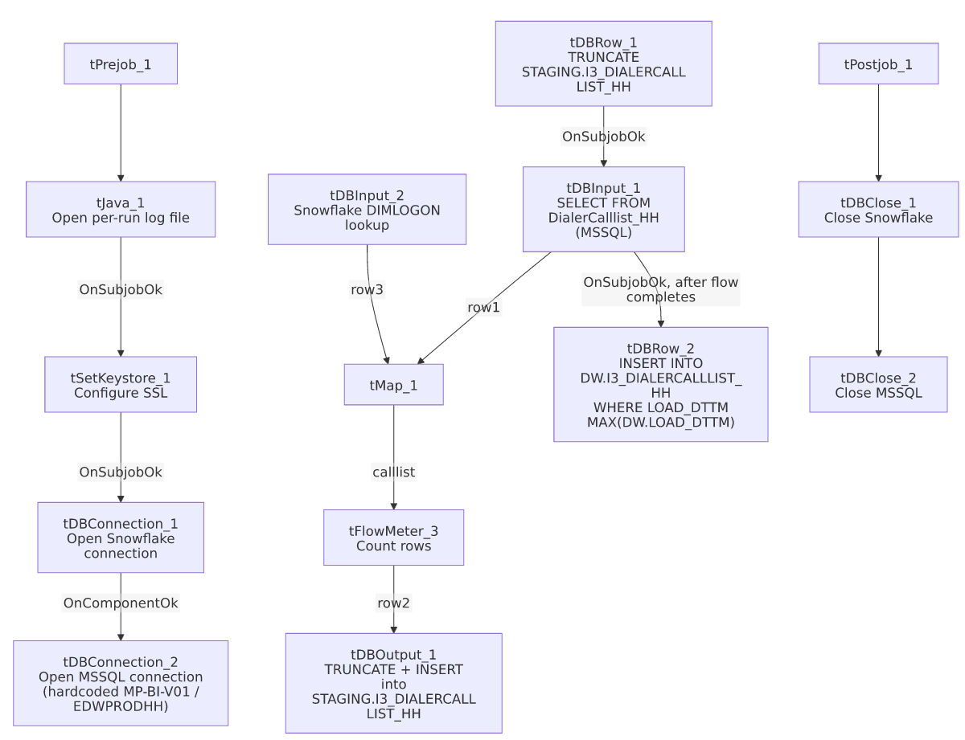

Settings tables

Source: `tDBInput_1` (`tMSSqlInput`)
Setting | Value | What it means
Connection | Shared tDBConnection_2 | Reuses the job's single hardcoded MSSQL connection.
Table | "DialerCalllist_HH" | Correctly named for the HH site.
Query | Fixed SELECT of ~60 named columns (identity, debtor/campaign identifiers, address, SKPPHN1/SKPPHN2/PHO1/DIRASS1, call-history flags, I3_UPLOAD_ID) — captured text truncated after the visible column list | Any WHERE clause is not visible in this metadata.
ENCODING | ISO-8859-15 | Non-UTF-8 encoding, consistent with other legacy-source jobs in this project.
TRIM_ALL_COLUMN | false | Unlike DC_Load_Backup/TOL_Load (both true), this job does not trim whitespace from all extracted columns.

MSSQL connection: `tDBConnection_2` (`tMSSqlConnection`)
Setting | Value | What it means
DRIVER | MSSQL_PROP | Different driver than the JTDS driver used by TOL_Load/PRE_Load/DC_Load_Backup's MSSQL connections.
HOST | "MP-BI-V01" (hardcoded) | Different physical server than PRE_Load/TOL_Load, which hit "MP-ININSQL-V01".
DBNAME | "EDWPRODHH" (hardcoded) | Different database name than PRE_Load/TOL_Load's "DIALER_40" — this job's dialer call-list source lives in a differently-named database from its siblings'.
USER | "dwuser" | Hardcoded service account name.

Lookup: `tDBInput_2` (`tSnowflakeInput`)
Setting | Value | What it means
Table | DIMLOGON | Small dimension table (DIMLOGON, LOGON, DESCRIPTION) joined in tMap_1 to attach a DIMLOGON surrogate key based on LOGON.

Target (staging): `tDBOutput_1` (`tSnowflakeOutput`)
Setting | Value | What it means
Table | I3_DIALERCALLLIST_HH | INSERT with tableAction: TRUNCATE — this component itself truncates and reloads the table (redundant with tDBRow_1's explicit truncate one step earlier, unless they target different schemas — see Issues observed).

Warehouse append: `tDBRow_2` (`tSnowflakeRow`)
Setting | Value | What it means
Query | INSERT INTO DW.I3_DIALERCALLLIST_HH (...) SELECT ... FROM STAGING.I3_DIALERCALLLIST_HH src WHERE src.LOAD_DTTM > (SELECT MAX(LOAD_DTTM) FROM DW.I3_DIALERCALLLIST_HH) | Append-only, watermark-based load — not a key-based MERGE. Any row in STAGING whose LOAD_DTTM is not newer than the current DW maximum is silently skipped; any existing DW row is never updated. See Issues observed.

Dependencies & configuration
- Triggers/depends on other jobs: none — no tRunJob links found (runjob_targets: []); not listed as a target in 06_dependency_matrix.md either.
- Context variables used: keystorePath, logDir only — this job does not use context.EDWProdHH_* or any StandardFolders_0.1 variable; its MSSQL host/database/driver are all hardcoded (see Settings tables).
- 1 hardcoded path found: tSetKeystore_1.SSL_TRUSTSERVER_TRUSTSTORE (C:/clientTrustStore.trustStore) — same project-wide risk documented in 05_operational_runbook.md.

Glossary
Component type | Plain-English meaning
tMSSqlConnection / tMSSqlInput / tMSSqlClose | Open a Microsoft SQL Server connection, run a query against it, and close it.
tSnowflakeConnection / tSnowflakeInput / tSnowflakeOutput / tSnowflakeRow / tSnowflakeClose | Open/close a Snowflake connection, read a table, write rows to a table, or run an arbitrary SQL statement against Snowflake.
tMap | Maps/transforms and optionally joins (lookup) columns from one or more input schemas to an output schema.
tFlowMeter | Counts rows passing a point in the flow for logging/monitoring.
tSetKeystore | Configures SSL trust/keystore settings used by subsequent secure connections.

Issues observed
- This job's warehouse load (`tDBRow_2`) is an append-only `INSERT ... WHERE LOAD_DTTM > MAX(DW.LOAD_DTTM)`, not a key-based `MERGE`, unlike its CO_Load/CO_Load_Backup, DC_Load_Backup, and TOL_Load siblings, all of which run a MERGE INTO DW... ON (tgt.I3_IDENTITY = src.I3_IDENTITY) that updates existing rows on match. Under this job's logic, if a previously-loaded debtor record's data changes but its LOAD_DTTM in STAGING is not newer than the current DW maximum, the update is silently never applied to DW — and if the same LOAD_DTTM is reused across every row of a staging load (as is common with a single "as-of" timestamp column), a correction reprocessed on the same run would still exceed the *previous* run's max and get inserted, potentially producing duplicate `I3_IDENTITY` rows in `DW` rather than a clean overwrite. Verify with the team whether this divergence from the sibling jobs' MERGE pattern is intentional.
- `tDBOutput_1` truncates via `tableAction: TRUNCATE` on the same run that `tDBRow_1` already explicitly runs `TRUNCATE TABLE STAGING.I3_DIALERCALLLIST_HH`. If both target the same STAGING.I3_DIALERCALLLIST_HH table, the second truncate is redundant; if tDBOutput_1's implicit schema differs from STAGING (not specified in this component's own metadata), the two truncates are targeting different tables and neither documentation nor this metadata makes that unambiguous — verify with team.
- This job's MSSQL connection (`MP-BI-V01` / `EDWPRODHH`, driver `MSSQL_PROP`) differs from `PRE_Load`/`TOL_Load`'s (`MP-ININSQL-V01` / `DIALER_40`, driver `JTDS`) despite all being members of the same i3_DialerCallList* family pulling dialer call-list data — confirms these "site" jobs are not all pointed at one shared dialer database; verify with team which source is authoritative for which site.
- No other findings beyond the project-wide hardcoded-path pattern already documented in 05_operational_runbook.md.

