Talend Job: i3_DialerCallListHH_Load_Backup

Overview
This is a "backup"/manual-reload variant of i3_DialerCallListHH_Load. Its designed live-extraction path (MSSQL DialerCalllist_HH → Snowflake DIMLOGON lookup → CSV export) is present in the job but entirely deactivated (ACTIVATE=false on every component in that chain). What actually runs today is a much simpler active path: it lists whatever CSV file(s) already exist in a hardcoded /output/ directory and inserts them straight into the Snowflake I3_DIALERCALLLIST_HH table, with no truncate, no staging table, and no deduplication — a materially different (and simpler, riskier) load than the primary i3_DialerCallListHH_Load job's truncate-STAGING-then-watermark-append-to-DW design.

Detail table
Field | Value
Job name | i3_DialerCallListHH_Load_Backup
Version | 0.2
Project | EDW2SF
Author | jmach@harriscollect.com
Created | 2025-11-06T14:47:54.278-0800
Last Modified | 2025-11-09T22:17:45.053-0800

Step-by-step data flow
Setup subjob: tPrejob_1 → tJava_1 opens a per-run log file (context.logDir+jobName+"_"+<timestamp>+".log") → on success, tSetKeystore_1 configures SSL trust/keystore settings → on success, tDBConnection_1 opens the Snowflake connection → on success, tDBConnection_2 opens the MSSQL connection using hardcoded values (HOST="MP-BI-V01", DBNAME="EDWPRODHH", SCHEMA_DB="dbo", USER="dwuser", DRIVER=MSSQL_PROP) — the same hardcoded connection details used by the non-backup i3_DialerCallListHH_Load job.
Disabled subtree (`ACTIVATE=false` on every component — does not execute in this job's current state):
- tDBInput_1 would run a fixed SELECT of ~40 columns (I3_IDENTITY, DEBTORNUMBER, LOGON, a derived DEBTOR_IDX, CAMPAIGN, DEBTORNAME, address fields, SSN, phone fields including HH-specific SKPPHN1/SKPPHN2/PHO1/DIRASS1, call-history fields, LOAD_DTTM) against MSSQL table DialerCalllist_HH — matching the live-extraction query used by i3_DialerCallListHH_Load.
- tDBInput_2 (tSnowflakeInput, disabled) would read the Snowflake DIMLOGON lookup table.
- tMap_1 (disabled) would join the two, adding a DIMLOGON surrogate key.
- tFlowMeter_3 (disabled) would count rows.
- tFileOutputDelimited_1 (disabled) would write the rows to a hardcoded file, "/output/i3_dialercalllistHH.csv" (SPLIT=true, SPLIT_EVERY=10000, no header).
Active path: because tDBInput_1 (and everything downstream of it in the disabled subtree) is switched off, Talend's standard deactivation behavior skips that subtree and passes its OnSubjobOk trigger straight through, so `tFileList_1` fires unconditionally:
- tFileList_1 lists files in a hardcoded "/output/" directory (not context-driven).
- For each file found (ITERATE), tFileInputDelimited_1 reads it (HEADER=0, no header row expected — consistent with files matching the disabled tFileOutputDelimited_1's INCLUDEHEADER=false setting; DIE_ON_ERROR=true) using the same ~40-column schema as the disabled MSSQL extraction.
- tFlowMeter_12 counts rows passing through.
- tDBOutput_1 inserts the rows into Snowflake table I3_DIALERCALLLIST_HH (INSERT, tableAction=NONE — no truncate, no staging/DW split).
Teardown subjob: tPostjob_1 → tDBClose_1 (close Snowflake) → tDBClose_2 (close MSSQL).
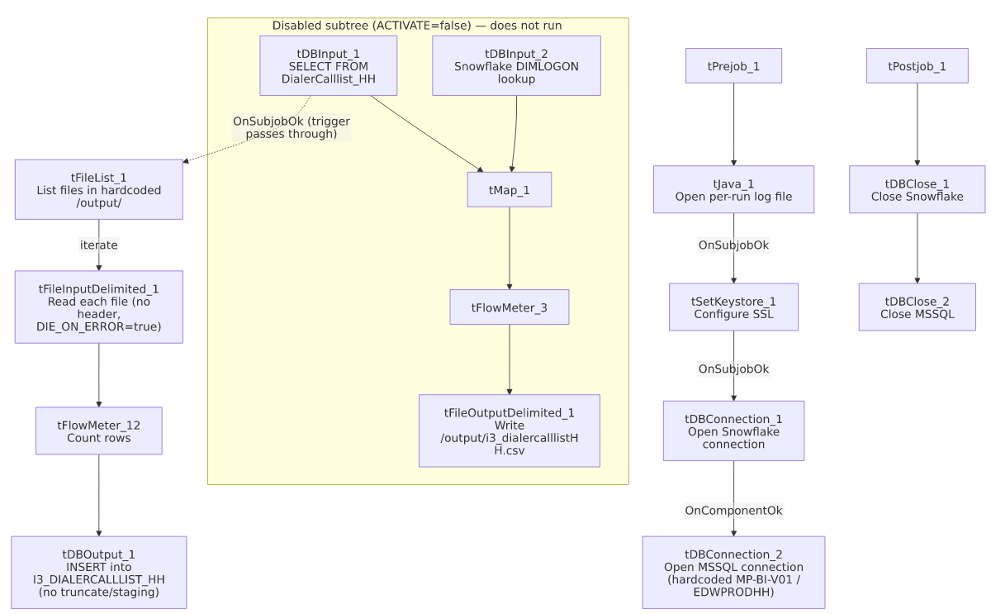

Settings tables

Disabled extraction (kept in the job but not executed): `tDBInput_1` / `tFileOutputDelimited_1`
Setting | Value | What it means
ACTIVATE (tDBInput_1, tMap_1, tFlowMeter_3, tDBInput_2, tFileOutputDelimited_1) | false | This entire branch is switched off; none of it runs in the job's current configuration.
Table / Query (tDBInput_1) | DialerCalllist_HH / fixed SELECT of ~40 columns incl. I3_IDENTITY, DEBTOR_IDX, SSN, phone fields, LOAD_DTTM | Matches the live-extraction query used by the non-backup i3_DialerCallListHH_Load job.
FILENAME (tFileOutputDelimited_1) | "/output/i3_dialercalllistHH.csv" (hardcoded) | Would be the output file if this branch were active — matches the directory the active tFileList_1 reads from.

Active source: `tFileList_1`
Setting | Value | What it means
DIRECTORY | "/output/" (hardcoded, not context-driven) | Lists whatever file(s) already exist there — presumably CSVs dropped in manually or produced by a prior run of the (now-disabled) extraction branch.

Active source: `tFileInputDelimited_1`
Setting | Value | What it means
FILENAME | ((String)globalMap.get("tFileList_1_CURRENT_FILEPATH")) | Current file from tFileList_1's iteration.
HEADER | 0 | No header row expected.
DIE_ON_ERROR | true | Unlike most file-load jobs in this project (which set this false and route bad rows to a reject flow), a single malformed row here fails the entire job.

Active target: `tDBOutput_1` (`tSnowflakeOutput`)
Setting | Value | What it means
Table | I3_DIALERCALLLIST_HH | Same table name the primary job's STAGING/DW design ultimately serves, but reached with a single flat INSERT.
Output action | INSERT | Appends rows.
Table action | NONE | No truncate — rows are appended directly with no staging table and no DW-vs-STAGING split, unlike i3_DialerCallListHH_Load's two-tier design.

Dependencies & configuration
- Triggers/depends on other jobs: none — no tRunJob links found, and this job does not appear as a call target in 06_dependency_matrix.md's 65-link orchestration table.
- Context variables used: keystorePath, logDir only — the MSSQL host/database/driver/user are all hardcoded (matching the primary job's pattern of not using EDWProdHH_* or any StandardFolders_0.1 variable).
- 2 hardcoded path findings captured by the extraction: tSetKeystore_1.SSL_TRUSTSERVER_TRUSTSTORE ("C:/clientTrustStore.trustStore") and tFileInputDelimited_1.TEMP_DIR ("C:/Talend-Studio-20211109_1610-V8.0.1/workspace") — same project-wide portability risk documented in 05_operational_runbook.md. Additionally, tFileList_1.DIRECTORY ("/output/") and the disabled tFileOutputDelimited_1.FILENAME ("/output/i3_dialercalllistHH.csv") are also hardcoded absolute paths in this job's own parameters, though they weren't captured in the standard hardcoded-path findings list (which appears scoped to Windows-style C:/... developer paths).

Glossary
Component type | Plain-English meaning
tFileList | Lists files in a directory for the job to iterate over one at a time.
tFileInputDelimited | Reads a delimited (CSV-style) text file according to a schema.
tFlowMeter | Counts rows passing a point in the flow for logging/monitoring.
tMSSqlConnection / tMSSqlInput / tMSSqlClose | Open a Microsoft SQL Server connection, run a query against it, and close it.
tSnowflakeConnection / tSnowflakeInput / tSnowflakeOutput / tSnowflakeClose | Open a Snowflake connection, read a table, write rows to a table, and close the connection.
tMap | Maps/transforms and optionally joins (lookup) columns from one or more input schemas to an output schema.
tSetKeystore | Configures SSL trust/keystore settings used by subsequent secure connections.
tJava | Runs custom Java code — here used to open a log file.

Issues observed
- The job's currently-active data source is whatever CSV file(s) already sit in a hardcoded `/output/` directory — not a live database extraction. The MSSQL-extraction-to-CSV branch that would normally populate that directory (tDBInput_1 → tMap_1 → tFlowMeter_3 → tFileOutputDelimited_1) is entirely deactivated (ACTIVATE=false on all four components). Standard Talend behavior propagates the OnSubjobOk trigger through a deactivated component without running it, so tFileList_1 still fires — but this means the job's real current behavior (load pre-existing files) is substantially different from what its still-present, disabled components describe. Confirm with the team whether this is a deliberate "backup/manual-reload" mode (e.g., for recovering from a failed primary run using a manually-supplied extract) or an accidentally-left-disabled path.
- `tDBOutput_1` has `tableAction=NONE` (no truncate) and there is no companion `STAGING`/`DW` split or `MERGE` step, unlike the primary i3_DialerCallListHH_Load job (which truncates STAGING, reloads it, then appends newer rows into DW by a LOAD_DTTM watermark). Re-running this backup job against the same file(s) more than once would insert duplicate rows into I3_DIALERCALLLIST_HH, since nothing in this job's own metadata deduplicates or checks for previously-loaded I3_IDENTITY values.
- `tFileInputDelimited_1.DIE_ON_ERROR=true` — unlike most file-load jobs in this project (which typically set this false and route bad rows to a reject flow), a single malformed row in whatever file is sitting in /output/ would fail this entire backup/reload job outright, with no reject-row capture.
- `tFileList_1.DIRECTORY` and the disabled `tFileOutputDelimited_1.FILENAME` are hardcoded to `/output/` rather than being context-driven — if this job is ever run somewhere the /output/ path doesn't exist or doesn't hold the intended file, it would either find nothing to load or (worse) pick up an unrelated file left there by another process.

