Talend Job: i3_DialerCallListPRE_Load

Overview
Refreshes the "PRE" site's dialer call-list table (I3_DIALERCALLLIST_PRE) in Snowflake directly from MSSQL: it computes the current maximum I3_UPLOAD_ID already in Snowflake, extracts debtor/campaign/phone/call-attempt data (roughly 60 columns, including PRE-specific columns CALLIDCAP, CBC1/CBC2/CBC3, and PHONE5/PHONE6/PHONE7) from the MSSQL DialerCalllist_* source, joins it against a Snowflake DIMLOGON lookup, and directly UPSERTs the mapped rows into the final Snowflake table — with no separate staging table, no TRUNCATE, and no downstream MERGE call. This job is structurally almost identical to i3_DialerCallListCHI_Load (same component wiring, same watermark-then-read-then-upsert shape, same MSSQL server/database), differing mainly in its own site-specific source column set.

Detail table
Field | Value
Job name | i3_DialerCallListPRE_Load
Version | 0.2
Project | EDW2SF
Author | jmach@harriscollect.com
Created | 2023-06-01T10:51:18.411-0700
Last Modified | 2025-11-06T14:15:45.400-0800

Step-by-step data flow
Setup subjob: tPrejob_1 → tJava_1 opens a per-run log file at context.logDir + jobName + "_" + <timestamp> + ".log" → on success (OnSubjobOk), tSetKeystore_1 configures SSL trust/keystore from context.keystorePath (passwords redacted) → on success, tDBConnection_1 opens the Snowflake connection → on success (OnSubjobOk), tDBConnection_2 (tMSSqlConnection, hardcoded HOST="MP-ININSQL-V01", DBNAME="DIALER_40", driver JTDS, user svc_ssa_snflk) opens the MSSQL connection. (Note this last link uses OnSubjobOk, whereas the equivalent link in i3_DialerCallListCHI_Load uses OnComponentOk — a minor wiring difference between the two otherwise near-identical jobs.)
Main subjob:
- tDBInput_3 (tSnowflakeInput) runs SELECT CAST(COALESCE(MAX(i3_UPLOAD_ID),1) AS VARCHAR(20)) AS MAXUPLOADID FROM I3_DIALERCALLLIST_PRE to find the highest upload ID already loaded.
- tDBInput_3 feeds two branches: MAIN → tJavaRow_1 captures the value into context.maxUploadID; SUBJOB_OK (fires only once that capture completes) → tDBInput_1 (tMSSqlInput, reusing the shared MSSQL connection) runs a fixed SELECT of ~60 named columns (I3_IDENTITY, DEBTORNAME, ACCOUNT AS DEBTORNUMBER, ADDRESS, APPHONE, BALANCE cast to NUMERIC(16,2), a derived DEBTOR_IDX, and further columns including CALLIDCAP, CAMPAIGN, CBC1/CBC2/CBC3, city/state/zip, PHONE5/PHONE6/PHONE7, call-attempt counters, I3_UPLOAD_ID, etc.). The component's own `TABLE` parameter is hardcoded to `"DialerCalllist_HH"` — not _PRE — even though this is the PRE job, the same stale value found in i3_DialerCallListCHI_Load's equivalent component (see Issues observed); the actual QUERY text is truncated in this metadata after the initial columns, so the real FROM/WHERE clause cannot be confirmed.
- tMap_1 joins the MSSQL flow (row1) against tDBInput_2 (tSnowflakeInput reading Snowflake table DIMLOGON, row3), adding a DIMLOGON surrogate key column.
- tFlowMeter_3 counts rows passing through (labeled "precallst").
- tDBOutput_1 upserts the mapped rows directly into Snowflake table I3_DIALERCALLLIST_PRE (UPSERT, tableAction: NONE — no truncate, no staging table).
Teardown subjob: tPostjob_1 → tDBClose_1 (close Snowflake) → tDBClose_2 (close MSSQL).
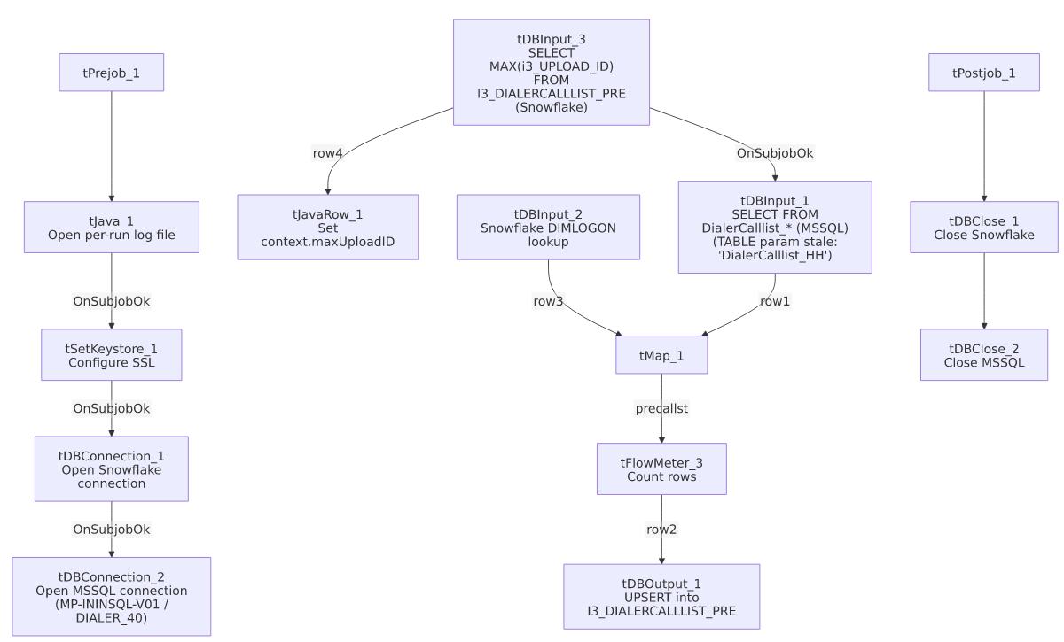

Settings tables

Source: `tDBInput_1` (`tMSSqlInput`)
Setting | Value | What it means
Connection | Shared tDBConnection_2 | Reuses the job's single MSSQL connection.
TABLE (component's own parameter) | "DialerCalllist_HH" | Stale/incorrect for this job — this is the PRE job, but the dead TABLE field still reads "HH," the same copy-paste artifact found in i3_DialerCallListCHI_Load's equivalent component. See Issues observed.
Query | Fixed SELECT beginning with I3_IDENTITY, DEBTORNAME, ACCOUNT AS DEBTORNUMBER, ADDRESS, APPHONE, BALANCE, derived DEBTOR_IDX — captured text truncated shortly after | Includes PRE-specific columns (CALLIDCAP, CBC1/CBC2/CBC3, PHONE5/PHONE6/PHONE7) not present in i3_DialerCallListCHI_Load's or i3_DialerCallListHH_Load's own source schemas — confirms each site's job pulls a genuinely different column set from the shared DIALER_40 source database, not just a differently-named table.
ENCODING | ISO-8859-15 | Non-UTF-8 encoding, consistent with other legacy-source jobs in this project.
TRIM_ALL_COLUMN | false | No whitespace trimming applied to extracted columns.

MSSQL connection: `tDBConnection_2` (`tMSSqlConnection`)
Setting | Value | What it means
DRIVER | JTDS | Same as i3_DialerCallListCHI_Load's connection, different from HH_Load's (MSSQL_PROP).
HOST | "MP-ININSQL-V01" (hardcoded) | Same physical server as CHI_Load.
DBNAME | "DIALER_40" (hardcoded) | Same database as CHI_Load — unlike HH_Load's differently-named EDWPRODHH database on a different server.
USER | "svc_ssa_snflk" | Hardcoded service account name.

Lookup: `tDBInput_2` (`tSnowflakeInput`)
Setting | Value | What it means
Table | DIMLOGON | Small dimension table joined in tMap_1 to attach a DIMLOGON surrogate key based on LOGON.

Watermark query: `tDBInput_3` / `tJavaRow_1`
Setting | Value | What it means
Query | SELECT CAST(COALESCE(MAX(i3_UPLOAD_ID),1) AS VARCHAR(20)) AS MAXUPLOADID FROM I3_DIALERCALLLIST_PRE | Computes the highest upload ID already loaded into the PRE Snowflake table.
Result handling | context.maxUploadID = input_row.MAXUPLOADID; | Captured into context, but not visibly referenced in tDBInput_1's (truncated) query text — see Issues observed.

Target: `tDBOutput_1` (`tSnowflakeOutput`)
Setting | Value | What it means
Table | I3_DIALERCALLLIST_PRE | Destination table in Snowflake.
Output action | UPSERT | Inserts new rows and updates existing rows on match — no TRUNCATE/staging step, tolerating re-runs without depending on the maxUploadID filter working correctly.

Dependencies & configuration
- Triggers/depends on other jobs: none — no tRunJob links found (runjob_targets: []); not listed as a target in 06_dependency_matrix.md either.
- Context variables used: keystorePath, logDir, maxUploadID (computed internally, but not confirmed to be actually applied as a filter — see Issues observed). This job does not use context.EDWProdHH_* or any StandardFolders_0.1 variable; its MSSQL host/database/driver are all hardcoded.
- 1 hardcoded path: tSetKeystore_1.SSL_TRUSTSERVER_TRUSTSTORE ("C:/clientTrustStore.trustStore") — same project-wide risk documented in 05_operational_runbook.md.

Glossary
Component type | Plain-English meaning
tMSSqlConnection / tMSSqlInput / tMSSqlClose | Open a Microsoft SQL Server connection, run a query against it, and close it.
tSnowflakeConnection / tSnowflakeInput / tSnowflakeOutput / tSnowflakeClose | Open/close a Snowflake connection, read a table, and write rows to a table.
tMap | Maps/transforms and optionally joins (lookup) columns from one or more input schemas to an output schema.
tFlowMeter | Counts rows passing a point in the flow for logging/monitoring.
tJavaRow | Runs custom Java code once per input row — here used to unpack a single query result into a context variable.
tSetKeystore | Configures SSL trust/keystore settings used by subsequent secure connections.

Issues observed
- `tDBInput_1`'s own `TABLE` parameter is hardcoded to `"DialerCalllist_HH"`, not `"DialerCalllist_PRE"`, the same stale-copy-paste value also found in i3_DialerCallListCHI_Load's equivalent component. Seeing this exact same wrong value in two different sibling jobs (CHI and PRE) confirms it isn't a one-off typo — it's very likely a fixed value copied forward from a shared job template (perhaps originally built from the HH job) and never updated in either downstream copy. Since tMSSqlInput uses the free-form QUERY text (not the TABLE field) when a custom query is present, this is almost certainly dead/unused configuration rather than a functional bug today — but it means the TABLE field cannot be trusted as documentation of what this job actually reads, and it would become a real bug if the component were ever switched out of "query mode." Unable to confirm the real FROM clause from this truncated metadata; verify directly in Talend Studio.
- The incremental-load logic (`context.maxUploadID`) may not actually be applied. As with i3_DialerCallListCHI_Load, the job computes the current max I3_UPLOAD_ID from Snowflake before reading MSSQL, but tDBInput_1's QUERY text is truncated after the initial columns, so whether it actually filters on context.maxUploadID cannot be confirmed. The UPSERT output action means this wouldn't create duplicates even if unfiltered, but it could mean unnecessary full re-reads of the source table on every run. Verify directly in Talend Studio.
- This job's source schema differs meaningfully from both `CHI_Load`'s and `HH_Load`'s — it includes CALLIDCAP, CBC1/CBC2/CBC3, and PHONE5/PHONE6/PHONE7 that don't appear in either sibling's own schema, and it does *not* include SKPPHN1/SKPPHN2/PHO1 (present in both HH and CHI). This reinforces that each site's job in this family queries a genuinely different column set from the shared DIALER_40 MSSQL database — useful to know before assuming any two site jobs in this family are interchangeable beyond their shared component wiring.
- No other findings beyond the project-wide hardcoded-path pattern already documented in 05_operational_runbook.md.

