Talend Job: i3_DialerCallListTOL_Load

Overview
Refreshes the "TOL" site's dialer call-list table in Snowflake (I3_DIALERCALLLIST_TOL) from the I3 telephony MSSQL system, following the exact same extract-to-CSV-and-back, truncate/stage/merge pattern as its i3_DialerCallListCO_Load sibling (this batch): read from MSSQL, join a DIMLOGON lookup, write an intermediate CSV, reload it into a Snowflake staging table, then MERGE into the DW warehouse table keyed on I3_IDENTITY. The two jobs share the same MSSQL server/database and nearly identical component wiring — but this job's source-table parameter is configured as DialerCalllist_CO, not a TOL-named table (see Issues observed), distinct from (though similar in kind to) the mismatch already documented in the separate i3_DialerCallListTOL_Load_Backup job.

Detail table
Field | Value
Job name | i3_DialerCallListTOL_Load
Version | 0.2
Project | EDW2SF
Author | jmach@harriscollect.com
Created | 2023-07-06T09:51:28.197-0700
Last Modified | 2025-11-10T15:43:45.237-0800

Step-by-step data flow
Setup subjob: tPrejob_1 → tJava_1 opens a per-run log file at context.logDir + jobName + "_" + <timestamp> + ".log" → on success (OnSubjobOk), tDBConnection_2 opens the MSSQL connection (hardcoded host/database — see Settings tables) → on success, tSetKeystore_1 configures SSL trust/keystore from context.keystorePath (passwords redacted) → on success, tDBConnection_1 opens the Snowflake connection.
Main subjob, phase 1 — extract MSSQL to CSV:
- tDBRow_1 runs TRUNCATE TABLE STAGING.I3_DIALERCALLLIST_TOL; on Snowflake (starts independently as soon as the main subjob begins).
- On success (OnSubjobOk), tDBInput_1 runs a fixed SELECT configured with TABLE = "DialerCalllist_CO" — not a TOL-named table (see Issues observed) — pulling I3_IDENTITY, ACCOUNT AS DEBTORNUMBER, LOGON, a derived DEBTOR_IDX, CAMPAIGN, DEBTORNAME, address/phone fields (PHONE1–PHONE7), call-attempt counters (I3_ATTEMPTS*, 8 columns), I3_UPLOAD_ID, campaign-owner fields, and more (~60 columns total). The captured query text is truncated in this metadata after the initial column list, so the query's actual FROM clause (and thus which physical table is really queried at runtime) cannot be confirmed beyond the TABLE parameter.
- tDBInput_1's output flows (FLOW) into tMap_1, which also receives a lookup input (MAIN) from tDBInput_2 (tSnowflakeInput reading Snowflake table DIMLOGON), adding a DIMLOGON surrogate key column based on LOGON.
- tMap_1 → tFlowMeter_3 (row count) → tFileOutputDelimited_1, which writes the enriched list to a fixed path /output/i3_dialercalllistTOL.csv (correctly TOL-named, comma-delimited, no header, split every 10,000 rows).
Main subjob, phase 2 — reload CSV into Snowflake staging:
- Once phase 1's flow subjob completes, tDBInput_1 also fires OnSubjobOk into tFileList_1, which lists every file in /output/ (hardcoded — EXCLUDEFILEMASK="*.txt" with IFEXCLUDE=false, so the exclusion is configured but never applied).
- tFileList_1 ITERATEs into tFileInputDelimited_1, which re-reads each listed file (same ~60-column schema) → tFlowMeter_8 (row count) → tDBOutput_1, which INSERTs the rows into Snowflake table I3_DIALERCALLLIST_TOL (presumed STAGING-schema, per the earlier explicit truncate — the component's own db.table field shows no schema prefix).
Main subjob, phase 3 — merge and cleanup (parallel):
- Once tFileList_1's iteration subjob completes (OnSubjobOk), tParallelize_1 starts two branches concurrently:
- tDBRow_2 runs MERGE INTO DW.I3_DIALERCALLLIST_TOL AS tgt USING STAGING.I3_DIALERCALLLIST_TOL AS src ON (tgt.I3_IDENTITY = src.I3_IDENTITY) — correctly TOL-named throughout, updating all ~60 columns on match, inserting new rows on no match, with I3_UPLOAD_ID coalesced to 0 if null.
- tFileList_2 re-lists /output/ and ITERATEs into tFileDelete_1, which attempts to delete each file found there.
Teardown subjob: tPostjob_1 → tDBClose_1 (close Snowflake) → tDBClose_2 (close MSSQL).
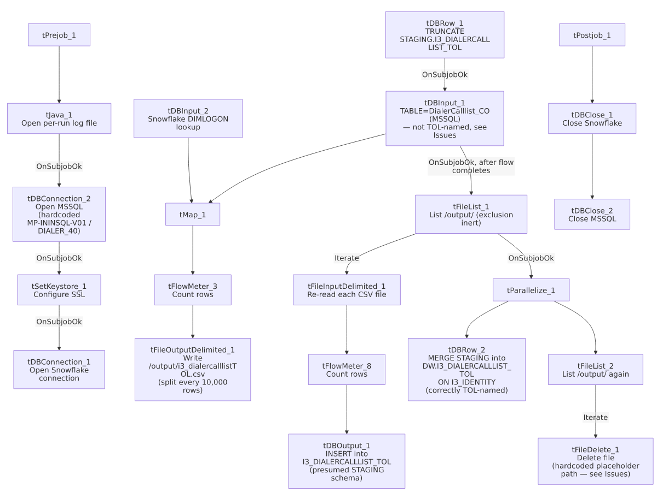

Settings tables

Source: `tDBInput_1` (`tMSSqlInput`)
Setting | Value | What it means
Connection | Shared tDBConnection_2 | Reuses the job's single hardcoded MSSQL connection.
TABLE | "DialerCalllist_CO" | Not TOL-named — see Issues observed. This is the exact same value configured on the sibling i3_DialerCallListCO_Load job's tDBInput_1.TABLE.
Query | Fixed SELECT of ~60 named columns, identical in structure to the CO job's query — captured text truncated after the initial column list | The visible portion does not show a FROM clause, so it cannot be confirmed from this metadata whether the underlying query text (as opposed to the TABLE parameter) actually targets a CO or TOL source table.
TRIM_ALL_COLUMN | true | Whitespace trimmed from all extracted columns.

MSSQL connection: `tDBConnection_2` (`tMSSqlConnection`)
Setting | Value | What it means
DRIVER | JTDS
HOST | "MP-ININSQL-V01" (hardcoded) | Same physical server as i3_DialerCallListCO_Load.
DBNAME | "DIALER_40" (hardcoded) | Same source database as the CO sibling — both CO and TOL call-list data lives in the same MSSQL database, differentiated only by table name (in principle).
USER | "svc_ssa_snflk" | Hardcoded service account.

Intermediate file: `tFileOutputDelimited_1` / `tFileInputDelimited_1`
Setting | Value | What it means
FILENAME (write) | "/output/i3_dialercalllistTOL.csv" | Correctly TOL-named, hardcoded path (not context-variable-driven).
SPLIT / SPLIT_EVERY | true / 10000 | Large lists are split into multiple numbered files rather than one large file.
DIRECTORY (tFileList_1/tFileList_2) | "/output/" (hardcoded) | Same shared hardcoded output directory used by the CO job — both jobs' intermediate CSVs and any leftover files from either site would sit in this same directory, subject to the same inert-exclusion-mask issue (see Issues observed).
TEMP_DIR (tFileInputDelimited_1) | "C:/Talend-Studio-20211109_1610-V8.0.1/workspace" | Hardcoded developer-workstation path.

Lookup: `tDBInput_2` (`tSnowflakeInput`)
Setting | Value | What it means
Table | DIMLOGON | Small dimension table joined in tMap_1 to attach a DIMLOGON surrogate key based on LOGON.

Target (staging): `tDBOutput_1` (`tSnowflakeOutput`)
Setting | Value | What it means
Table | I3_DIALERCALLLIST_TOL | INSERT, tableAction: NONE — correctly TOL-named, relies on tDBRow_1's earlier TRUNCATE TABLE STAGING.I3_DIALERCALLLIST_TOL for idempotency.

Warehouse merge: `tDBRow_2` (`tSnowflakeRow`)
Setting | Value | What it means
Query | MERGE INTO DW.I3_DIALERCALLLIST_TOL AS tgt USING STAGING.I3_DIALERCALLLIST_TOL AS src ON (tgt.I3_IDENTITY = src.I3_IDENTITY) WHEN MATCHED THEN UPDATE SET ... WHEN NOT MATCHED THEN INSERT (...) | Correctly TOL-named throughout (unlike the source-side TABLE parameter) — full column-by-column update on match, insert on no match, I3_UPLOAD_ID coalesced to 0 if null.

Cleanup: `tFileDelete_1`
Setting | Value | What it means
DIRECTORY / PATH | "C:/Talend-Studio-20211109_1610-V8.0.1/workspace/delete_folder" / "...delete_folder or delete_file" | Same placeholder-looking hardcoded values as the CO sibling — see that job's Issues section for the same open question about whether cleanup actually functions.

Dependencies & configuration
- Triggers/depends on other jobs: none — no tRunJob links found, and this job does not appear in 06_dependency_matrix.md's orchestration table.
- Context variables used: keystorePath, logDir only.
- 4 hardcoded paths found: tSetKeystore_1.SSL_TRUSTSERVER_TRUSTSTORE (C:/clientTrustStore.trustStore), tFileInputDelimited_1.TEMP_DIR, and tFileDelete_1.DIRECTORY/PATH — same project-wide risk documented in 05_operational_runbook.md.
- Relationship to `i3_DialerCallListTOL_Load_Backup`: a separate, already-documented job with the same TOL naming, also configured with TABLE = "DialerCalllist_CO" on its own MSSQL read step, but a structurally different pipeline (uses EDWProdHH_* context-variable connections rather than this job's hardcoded MP-ININSQL-V01/DIALER_40, and adds outcome columns via a second tMap_2 after re-reading its CSV rather than carrying the full schema through in one pass). The two jobs are not the same design reused twice — they independently share the same CO/TOL table-name mismatch, which may point to a common root cause (e.g. both copied from the same CO-site template) rather than one job's mistake being copied into the other.

Glossary
Component type | Plain-English meaning
tMSSqlConnection / tMSSqlInput / tMSSqlClose | Open a Microsoft SQL Server connection, run a query against it, and close it.
tSnowflakeConnection / tSnowflakeInput / tSnowflakeOutput / tSnowflakeRow / tSnowflakeClose | Open/close a Snowflake connection, read a table, write rows to a table, or run an arbitrary SQL statement against Snowflake.
tMap | Maps/transforms and optionally joins (lookup) columns from one or more input schemas to an output schema.
tFlowMeter | Counts rows passing a point in the flow for logging/monitoring.
tFileList | Lists files in a directory for the job to iterate over one at a time.
tFileInputDelimited / tFileOutputDelimited | Read/write a delimited (CSV-style) text file.
tFileDelete | Deletes a specific file from disk.
tParallelize | Runs its downstream branches at the same time instead of one after another.
tSetKeystore | Configures SSL trust/keystore settings used by subsequent secure connections.

Issues observed
- `tDBInput_1`'s `TABLE` parameter is configured as `"DialerCalllist_CO"`, not a TOL-named table, even though this job is i3_DialerCallListTOL_Load, truncates/loads/merges exclusively TOL-named Snowflake tables (STAGING.I3_DIALERCALLLIST_TOL, DW.I3_DIALERCALLLIST_TOL), and writes its intermediate file to i3_dialercalllistTOL.csv. This is the single clearest anomaly in this job. Two things keep this from being a certain functional bug: (1) in Talend's tMSSqlInput, when a custom QUERY is supplied (as it is here), the TABLE field is typically a vestigial leftover from whenever the query was last auto-generated via "Guess Query" and is not necessarily what actually executes — the real table reference would live in the QUERY text's FROM clause; and (2) that QUERY text is truncated in this metadata after the column list, so the actual FROM clause is not visible either way. Unable to determine from this metadata whether this job actually pulls CO-site data into a TOL-labeled warehouse table, or whether the `TABLE` field is simply stale UI metadata with no runtime effect. This should be verified directly in Talend Studio (or by comparing a sample of loaded I3_DIALERCALLLIST_TOL rows' CAMPAIGN/DEBTORNAME values against known CO vs. TOL debtor populations) before assuming this job's data is correct.
- The identical `DialerCalllist_CO` value also appears on the separate `i3_DialerCallListTOL_Load_Backup` job's own MSSQL read step (see that job's own documentation). The two jobs are structurally different otherwise, so this is not simply one job's config copied wholesale into the other — but it does suggest a shared CO-site template was the starting point for building out TOL support project-wide, with this leftover field never corrected in either descendant. Worth a single cleanup pass across both jobs rather than treating them as unrelated incidents.
- The cleanup step's `tFileDelete_1.DIRECTORY`/`PATH` values look like unconfigured template placeholders, identical to the CO sibling's — see that job's Issues section for the same open question about whether the delete step actually targets /output/ or these literal placeholder paths.
- The MSSQL source query is truncated in this metadata, cutting off after the initial column list — any WHERE clause is not visible, so it's unable to be determined whether this is a full-table extract every run or an incrementally filtered one.
- The output CSV path and both `tFileList` directories are hardcoded to `/output/`, shared with the CO sibling job, rather than driven by a context variable — moving either job to a different environment would require direct edits, and running both jobs against the same /output/ directory concurrently could mean one job's tFileList iteration picks up the other's leftover files (mitigated only by each file's TOL/CO-specific filename, since the exclusion mask on both jobs is inert).
- No other findings beyond the project-wide hardcoded-path pattern already documented in 05_operational_runbook.md.

