Talend Job: i3_DialerCallListTOL_Load_Backup

Overview
This job builds a dialer call list for the "TOL" site and loads a record of it into Snowflake. It reads collections-account records from a SQL Server table via the EDWProdHH-labeled connection, attaches a DIMLOGON surrogate key from Snowflake, writes the enriched list out as a CSV file (presumably the actual file the I3 dialer system consumes), then re-reads that file together with a set of dialer outcome/tracking columns and merges it into the Snowflake I3_DIALERCALLLIST_TOL table using the project's standard truncate-staging → load → merge-into-DW pattern. However, the source table configured on the read step is literally named DialerCalllist_CO — a different site's table — which, combined with this job's own _Load_Backup name and its version 0.2 being created and last modified within the same second, strongly suggests this is an unfinished or leftover copy of a CO-site job rather than a verified TOL pipeline (see Issues observed).

Detail table
Field | Value
Job name | i3_DialerCallListTOL_Load_Backup
Version | 0.2
Project | EDW2SF
Author | jmach@harriscollect.com
Created | 2025-11-11T10:29:15.117-0800
Last Modified | 2025-11-11T10:29:15.283-0800

Step-by-step data flow
Setup subjob: tPrejob_1 → tJava_1 opens a per-run log file at context.logDir + jobName + "_" + <timestamp> + ".log" → on success, tDBConnection_2 opens the MSSQL connection using context.EDWProdHH_Server/Port/Schema/Database/Login (password redacted) → on success, tSetKeystore_1 configures SSL/keystore settings from context.keystorePath (all passwords redacted) → on success, tDBConnection_1 opens the Snowflake connection (no connection-label parameters were captured for this component).
Main subjob — starts independently at tDBRow_1:
- tDBRow_1 runs TRUNCATE TABLE STAGING.I3_DIALERCALLLIST_TOL; against Snowflake.
- On success, tDBInput_1 (reusing the shared tDBConnection_2 MSSQL connection) runs a fixed SELECT of ~38 columns — account/debtor identifiers, campaign, name/address, multiple phone numbers, balance, last-payment/letter fields, SSN, desk code, score — configured with TABLE = "DialerCalllist_CO". This does not match the job's own TOL naming — see Issues observed.
- tDBInput_1's output flows (FLOW) into tMap_1, which also receives a MAIN-labeled lookup input from tDBInput_2 (tSnowflakeInput, table DIMLOGON) to attach a DIMLOGON surrogate key based on LOGON.
- tMap_1 → tFlowMeter_3 (row count, labeled "calllist") → tFileOutputDelimited_1, which writes the enriched list to a fixed path /output/i3_dialercalllistTOL.csv (comma-delimited, no header, split every 10,000 rows).
- On tDBInput_1's success, tFileList_1 lists every file in /output/ (EXCLUDEFILEMASK = "*.txt" but IFEXCLUDE = false, so the exclusion is configured but never applied — the same inert-exclusion pattern documented in ADP_Payroll_Load).
- tFileList_1 ITERATEs into tFileInputDelimited_1, which re-reads each listed file using the same base schema. tMap_2 then adds a further set of I3 dialer-outcome columns not present in the file just written (STATUS, ATTEMPTS, HHCUSTVAR1-3, HHCUSTINT1, I3_ATTEMPTS* counters, I3_SITEID, I3_ACTIVECAMPAIGNID, I3_LASTCALLED_UTC, I3_UPLOAD_ID, SUCCESSRESULT, I3_CAMPAIGNOWNERID/NAME/EXPIRATION, LOAD_DTTM) — see Issues observed regarding what values these actually get.
- tMap_2 → tDBOutput_1, which INSERTs the result into Snowflake table I3_DIALERCALLLIST_TOL (in the connection's default/staging schema, consistent with the earlier TRUNCATE TABLE STAGING.I3_DIALERCALLLIST_TOL).
- Separately, tFileList_1 also fires (SUBJOB_OK) into tParallelize_1, which runs two branches concurrently:
- tDBRow_2 runs a MERGE INTO DW.I3_DIALERCALLLIST_TOL from STAGING.I3_DIALERCALLLIST_TOL, keyed on I3_IDENTITY (update on match, insert on no match).
- tFileList_2 re-lists /output/ and ITERATEs into tFileDelete_1, deleting every file found there.
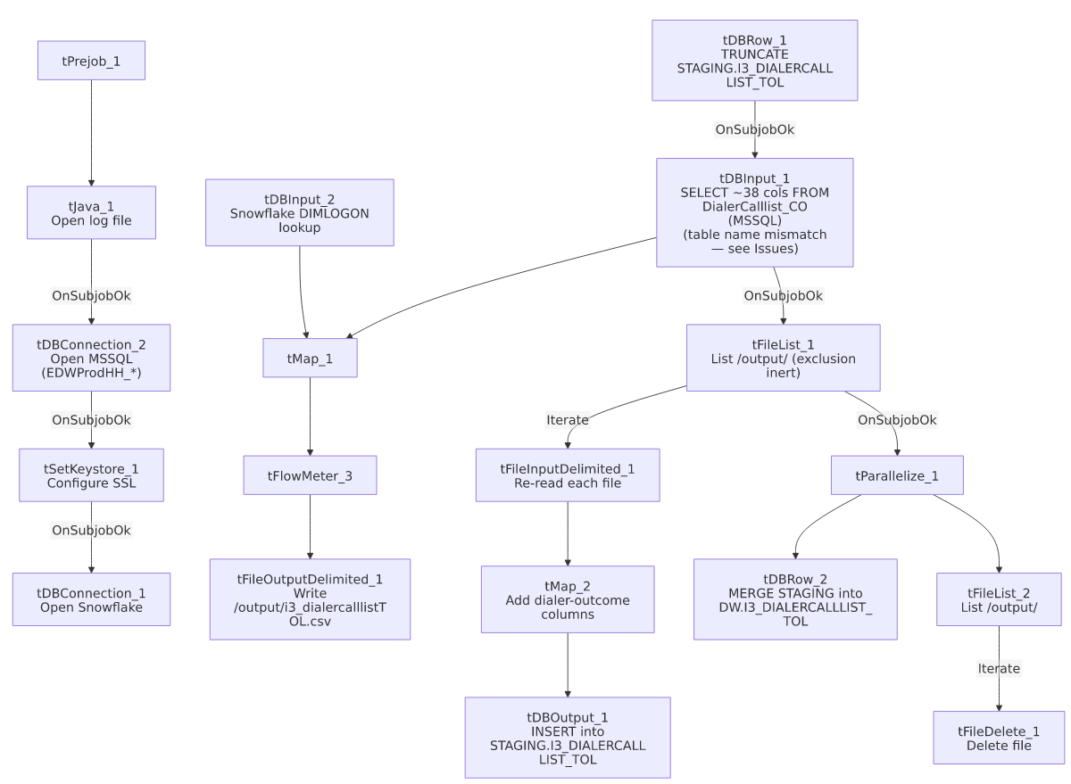

Settings tables

Source: `tDBInput_1` (`tMSSqlInput`)
Setting | Value | What it means
Connection | Shared tDBConnection_2 (EDWProdHH_* context vars) | Reuses the job's MSSQL connection.
TABLE | "DialerCalllist_CO" | Configured against the CO site's call-list table, not TOL — see Issues observed.
QUERY | Fixed SELECT of ~38 named columns (account, campaign, name/address, phones, balance, tax/legal-adjacent fields absent here — this table is collections-focused, not tax) | Query text is truncated in this metadata after the column list; the actual FROM clause (and thus which physical table is really queried) could not be confirmed beyond the TABLE parameter above.

Lookup: `tDBInput_2` (`tSnowflakeInput`)
Setting | Value | What it means
Table | DIMLOGON | A logon-name dimension table, joined in tMap_1 to attach a DIMLOGON surrogate key to each call-list row.

Output file: `tFileOutputDelimited_1`
Setting | Value | What it means
FILENAME | "/output/i3_dialercalllistTOL.csv" | Fixed path — likely the actual file the I3 dialer system picks up.
INCLUDEHEADER / SPLIT | false / every 10,000 rows | No header row; large lists are split into multiple files.

Target: `tDBOutput_1` (`tSnowflakeOutput`) / Merge: `tDBRow_1` / `tDBRow_2`
Setting | Value | What it means
Table (tDBOutput_1) | I3_DIALERCALLLIST_TOL | Loaded via INSERT after tDBRow_1's TRUNCATE TABLE STAGING.I3_DIALERCALLLIST_TOL; — standard truncate-and-reload staging pattern.
Merge (tDBRow_2) | MERGE INTO DW.I3_DIALERCALLLIST_TOL ... ON (tgt.I3_IDENTITY = src.I3_IDENTITY) | Updates matching rows, inserts new ones, keyed on I3_IDENTITY; I3_UPLOAD_ID is coalesced to 0 if null on both the update and insert branches.

Dependencies & configuration
- Triggers/depends on other jobs: none — no tRunJob links found, and no other job in 06_dependency_matrix.md calls this job either.
- Context variables used: EDWProdHH_Database, EDWProdHH_Login, EDWProdHH_Port, EDWProdHH_Schema, EDWProdHH_Server, keystorePath, logDir. Notably, no `I3_IC_40_*` variables are referenced anywhere despite the job name and output table both being I3-branded.
- 4 hardcoded developer-workstation paths: tSetKeystore_1.SSL_TRUSTSERVER_TRUSTSTORE, tFileInputDelimited_1.TEMP_DIR, and tFileDelete_1.DIRECTORY/PATH (all C:/Talend-Studio-20211109_1610-V8.0.1/workspace/... or C:/clientTrustStore.trustStore) — same project-wide risk documented in 05_operational_runbook.md.

Glossary
Component type | Plain-English meaning
tFileList | Lists files in a directory for the job to iterate over one at a time.
tFileInputDelimited / tFileOutputDelimited | Read/write a delimited (CSV-style) text file.
tMap | Maps/transforms columns from one schema to another, optionally joining in lookup data.
tSnowflakeRow | Runs an arbitrary SQL statement (here, a TRUNCATE and a MERGE) against Snowflake.
tSnowflakeOutput / tSnowflakeInput / tSnowflakeConnection / tSnowflakeClose | Write to / read from / open / close a Snowflake connection.
tParallelize | Runs its downstream branches at the same time instead of one after another.
tFileDelete | Deletes a specific file from disk.
tFlowMeter | Counts rows passing a point in the flow, for logging/monitoring.
tSetKeystore | Configures the SSL trust/keystore used for secure connections in the job.

Issues observed
- The source table is configured as `DialerCalllist_CO`, not a TOL-named table, even though this job is i3_DialerCallListTOL_Load_Backup and writes to I3_DIALERCALLLIST_TOL. Combined with the _Load_Backup suffix and the fact that this job's created_date and modified_date are identical to the second (2025-11-11T10:29:15), this looks like an unfinished or accidental copy of a CO-site version of this job, with the TABLE parameter never repointed to a TOL-specific source. Unable to confirm from this metadata whether the job has ever actually run in this state, or whether the truncated QUERY text's FROM clause overrides the TABLE parameter with something else — verify directly in Talend Studio before assuming this job is safe to schedule.
- The job writes a CSV file and then immediately reads it back, adding a set of dialer-outcome columns (STATUS, ATTEMPTS, all I3_ATTEMPTS* counters, I3_UPLOAD_ID, SUCCESSRESULT, campaign-owner fields) that do not exist in the file that was just written. Unless tFileList_1's directory listing is actually picking up a *different*, pre-existing file (e.g., a return/results file the I3 dialer system already dropped in /output/) rather than the one this job just wrote, those columns would load into Snowflake as null/default on every run. tFileList_1's exclusion mask is also inert (see below), so which files actually get processed depends entirely on what else happens to be sitting in /output/ at run time — unable to determine the intended behavior from metadata alone; verify with the team.
- `tFileList_1` and `tFileList_2` both have `EXCLUDEFILEMASK = "*.txt"` with `IFEXCLUDE = false`, meaning the exclusion is configured but never actually applied — every file in /output/ is picked up by both the reload step and the delete step, not just the ones this job produced. Same inert-exclusion pattern already documented in ADP_Payroll_Load.
- A possible race between reading and deleting files in `/output/`: the cleanup branch (tFileList_2 → tFileDelete_1) runs in parallel with the reload branch (tFileList_1 → tFileInputDelimited_1 → ... → tDBOutput_1), both operating on the same shared directory. tParallelize_1 only starts after tFileList_1 has already finished listing, but the reload branch's own file processing may still be in flight when the delete branch's own separate listing (tFileList_2) runs — unable to confirm from metadata whether this creates a "file deleted before it's fully loaded" risk; verify before assuming it's safe.
- 4 hardcoded developer-workstation paths (C:/Talend-Studio-20211109_1610-V8.0.1/workspace/...) — same portability risk documented project-wide in 05_operational_runbook.md.
- This job's own naming and context variables are internally inconsistent: it's branded i3_...TOL and writes to an I3_-prefixed Snowflake table, but every context variable it actually uses is EDWProdHH_* — no I3_IC_40_* telephony-database variables appear anywhere. This is the same kind of connection/naming mismatch flagged in i3_CallDetail_40_Load and i3_Individual_Load; whether EDWProdHH and the I3 systems share a physical SQL Server, or this is simply a mislabeled job, is unable to determine from metadata — verify with the team.
- Given the version number, timestamps, and _Backup suffix, it is unclear whether this job is an active production pipeline at all — verify with the team before assuming it runs on any schedule.

