Talend Job: i3_DialerCallList_DEDOR_Load

Overview
Loads the "DEDOR" outbound dialer call list from the I3 telephony/dialer MSSQL database into the Snowflake I3_DIALERCALLLIST_DEDOR table. The source columns (TAX_PERIOD_BEGIN_DATE, TAX_PERIOD_END_DATE, JUDGEMENT_STATUS, TAX_TYPE, CASE_TYPE/CASE_SUBTYPE) indicate this call list is for a tax/judgment-related collections portfolio rather than a general commercial one. Unlike the i3_Interaction*_Load jobs, this is a straightforward full-refresh UPSERT with no max-key/incremental filtering, no staging truncate, and no merge step.

Detail table
Field | Value
Job name | i3_DialerCallList_DEDOR_Load
Version | 0.1
Project | EDW2SF
Author | jmach@harriscollect.com
Created | 2023-09-15T12:52:14.515-0700
Last Modified | 2025-09-24T11:00:30.144-0700

Step-by-step data flow
Setup subjob: tPrejob_1 → tDBConnection_1 opens the Snowflake connection → on success, tDBConnection_2 opens the MSSQL connection using context.I3_IC_40_Server/Port/Schema/Database/Login (password redacted). Notably, this job has no `tJava` per-run log-file setup and no `tSetKeystore` SSL configuration — both present in most of this job's siblings (see Issues observed).
Main subjob:
- tDBInput_1 (reusing the shared tDBConnection_2 MSSQL connection via USE_EXISTING_CONNECTION=true) runs a fixed SELECT of ~45 columns from the I3 dialer call-list table: identity/zone/attempts/status, a full set of I3_ATTEMPTS* outcome counters, upload/entity/case identifiers, name/address/phone fields, balance, tax-period dates, case type/status, and several HH_* (collections-system) fields (last wrap-up code, last call time, agent ID, custom variables).
- tMap_1 passes the row through to a same-shaped uppercase-named target schema.
- tFlowMeter_8 counts rows passing through (labeled "DLR").
- tDBOutput_1 UPSERTs the rows into Snowflake table I3_DIALERCALLLIST_DEDOR (tableAction=NONE).
Teardown subjob: tPostjob_1 → tDBClose_1 (close Snowflake) → tDBClose_2 (close MSSQL).
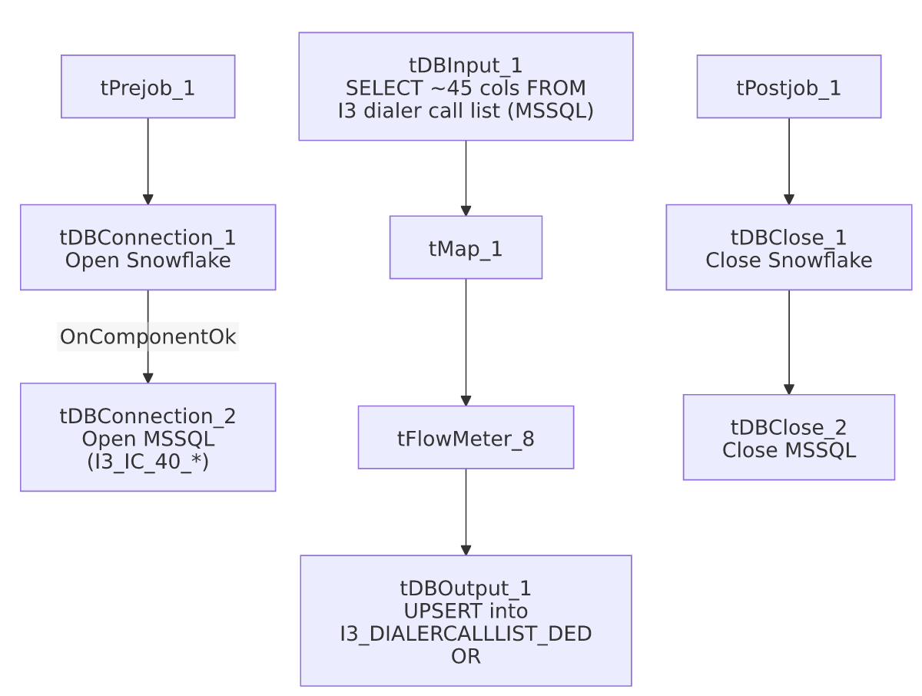

Settings tables

Source: `tDBInput_1` (`tMSSqlInput`)
Setting | Value | What it means
Connection | Shared tDBConnection_2 (I3_IC_40_* context vars) | Reuses the job's single MSSQL connection.
Query | Fixed SELECT of ~45 columns (truncated in this metadata after the initial column list) | No visible WHERE clause — this appears to be a full-table read every run, not an incremental one.

Target: `tDBOutput_1` (`tSnowflakeOutput`)
Setting | Value | What it means
Table | I3_DIALERCALLLIST_DEDOR | Destination table in Snowflake.
Output action | UPSERT | Update-or-insert per row — safe to re-run without duplicating rows, unlike a plain INSERT.
Table action | NONE | Table itself is not recreated/altered.

Dependencies & configuration
- Triggers/depends on other jobs: none — no tRunJob links found, and this job is not called by any other job in 06_dependency_matrix.md.
- Context variables used: I3_IC_40_Database, I3_IC_40_Login, I3_IC_40_Port, I3_IC_40_Schema, I3_IC_40_Server — this job correctly and exclusively uses the I3 telephony connection group, unlike some of its siblings (see i3_Individual_Load and i3_DialerCallListTOL_Load_Backup, which use EDWProdHH_* instead).
- No hardcoded developer-workstation paths found in this job.

Glossary
Component type | Plain-English meaning
tMSSqlConnection / tMSSqlInput / tMSSqlClose | Open a Microsoft SQL Server connection, run a query against it, and close it.
tSnowflakeConnection / tSnowflakeOutput / tSnowflakeClose | Open a Snowflake connection, write rows to a table, and close the connection.
tMap | Maps/transforms columns from one schema to another.
tFlowMeter | Counts rows passing a point in the flow, for logging/monitoring.

Issues observed
- No incremental filter is applied — the source query reads the entire I3 dialer call-list table every run. Because the target uses UPSERT (not INSERT), this is safe from a duplication standpoint, but it does mean every run re-transfers the full table regardless of how much has actually changed, which could be a performance/cost consideration at scale — unable to determine table size or run frequency from this metadata.
- This job has no per-run log-file setup (`tJava`) and no `tSetKeystore` SSL configuration, both of which are present in the structurally similar i3_InteractionSummary_Load, i3_InteractionSummaryEx_Load, i3_InteractionCustomAttributes_Load, and i3_InteractionWrapup_Load jobs. Whether this job's MSSQL connection needs the same SSL trust configuration as its siblings (and is simply missing it) is unable to determine from metadata — verify with the team, particularly if this job has ever failed with a certificate/SSL-related error.
- No error/row-count logging specific to this job's business outcome (no tWarn/tDie/tSendMail) — a load failure here would only surface as a generic Talend execution error. Beyond this, no findings beyond the project-wide patterns already documented in 05_operational_runbook.md.

