Talend Job: i3_Individual_Load

Overview
Loads individual/contact records (name, title, department, company, job title, web login, IC user ID, active/private flags) from a SQL Server table into the Snowflake I3_INDIVIDUAL table. Although the job is named with the i3_ prefix (the I3/Interactive Intelligence telephony system) and its columns (ICUserID, WebLogin, AppIndivID) look like I3 Interaction Center user/contact data, the connection it actually uses is labeled with EDWProdHH_* context variables — the same connection group used by the project's general operational database (see Issues observed). This is a simple full-refresh UPSERT, with no incremental filtering, no staging/merge step, and no per-run logging or SSL setup.

Detail table
Field | Value
Job name | i3_Individual_Load
Version | 0.1
Project | EDW2SF
Author | jmach@harriscollect.com
Created | 2022-03-07T08:52:34.951-0800
Last Modified | 2022-05-24T09:48:39.646-0700

Step-by-step data flow
Setup subjob: tPrejob_1 → tDBConnection_1 opens the Snowflake connection → on success, tDBConnection_2 opens the MSSQL connection using context.EDWProdHH_Server/Port/Schema/Database/Login (password redacted).
Main subjob:
- tDBInput_1 (reusing the shared tDBConnection_2 MSSQL connection via USE_EXISTING_CONNECTION=true) runs a fixed SELECT of 23 columns from the source individual/contact table: IndivID, type/title IDs, name fields, department/company/job title, assistant name, web login, modify timestamp, org/location/site IDs, active/private flags, version, AppIndivID, ICUserID, owner ID, external ID/source.
- tMap_1 passes the row through to a same-shaped uppercase-named target schema.
- tFlowMeter_2 counts rows passing through (labeled "MyLabel", not renamed for this job).
- tDBOutput_1 UPSERTs the rows into Snowflake table I3_INDIVIDUAL (tableAction=NONE).
Teardown subjob: tPostjob_1 → tDBClose_1 (close Snowflake) → tDBClose_2 (close MSSQL).
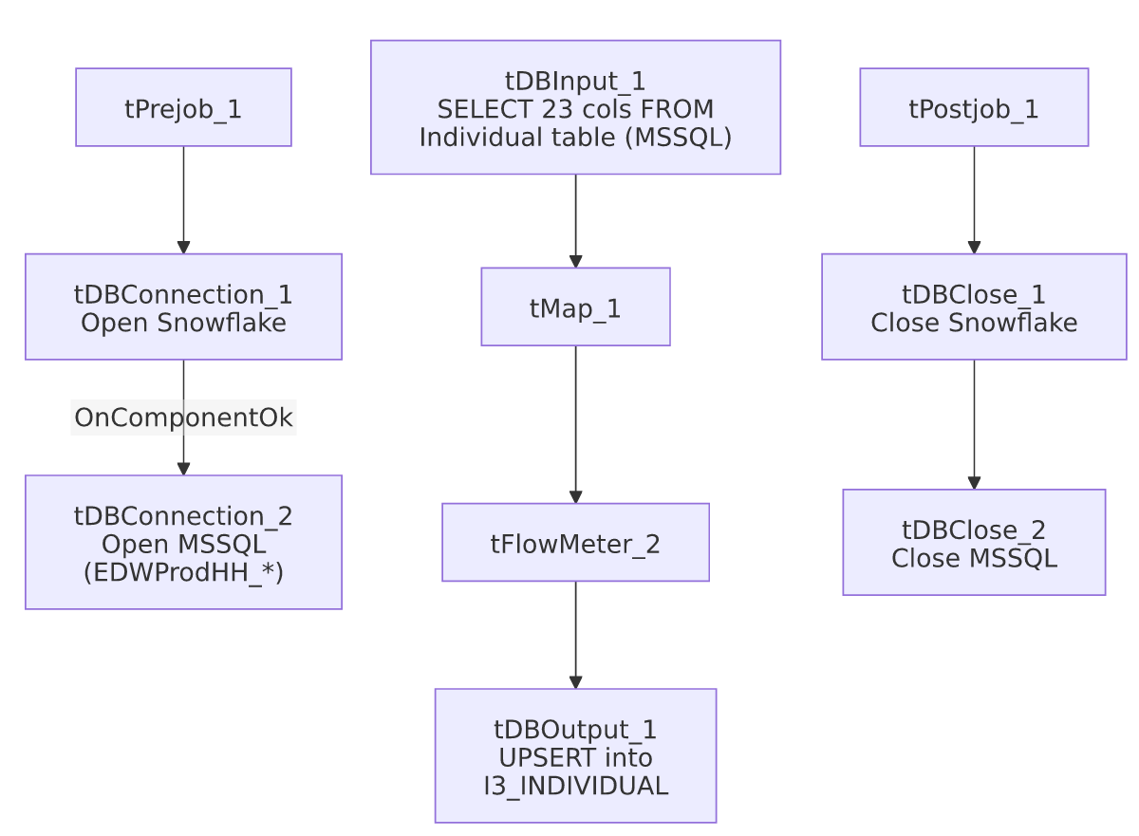

Settings tables

Source: `tDBInput_1` (`tMSSqlInput`)
Setting | Value | What it means
Connection | Shared tDBConnection_2 (EDWProdHH_* context vars) | See Issues observed — this connection group is documented project-wide as the "EDWProdHH" operational database, not I3.
Query | Fixed SELECT of 23 columns (truncated in this metadata after the column list) | No visible WHERE clause — a full-table read every run.

Target: `tDBOutput_1` (`tSnowflakeOutput`)
Setting | Value | What it means
Table | I3_INDIVIDUAL | Destination table in Snowflake.
Output action | UPSERT | Update-or-insert per row, keyed presumably on INDIVID — safe to re-run without duplicating rows.
Table action | NONE | Table itself is not recreated/altered.

Dependencies & configuration
- Triggers/depends on other jobs: none — no tRunJob links found, and this job is not called by any other job in 06_dependency_matrix.md.
- Context variables used: EDWProdHH_Database, EDWProdHH_Login, EDWProdHH_Port, EDWProdHH_Schema, EDWProdHH_Server.
- No hardcoded developer-workstation paths found in this job.

Glossary
Component type | Plain-English meaning
tMSSqlConnection / tMSSqlInput / tMSSqlClose | Open a Microsoft SQL Server connection, run a query against it, and close it.
tSnowflakeConnection / tSnowflakeOutput / tSnowflakeClose | Open a Snowflake connection, write rows to a table, and close the connection.
tMap | Maps/transforms columns from one schema to another.
tFlowMeter | Counts rows passing a point in the flow, for logging/monitoring.

Issues observed
- This job's MSSQL connection is configured using `context.EDWProdHH_*` variables, the naming convention this project uses elsewhere for the general operational "EDWProdHH" database (see 01_system_architecture.md), yet the job is named i3_Individual_Load and its source columns (ICUserID, AppIndivID, WebLogin) look like I3 Interaction Center contact/user data, not general EDWProdHH data. This is the same mismatch pattern flagged in i3_CallDetail_40_Load — either the I3 database is physically hosted on the same SQL Server instance as EDWProdHH (making the shared context appropriate), or this is a mislabeled/reused connection. Unable to determine from metadata; verify with the team which physical database context.EDWProdHH_Database actually points to for this job.
- No incremental filter, no per-run log file, and no SSL/keystore setup — unlike most of this project's other I3-family jobs (e.g. the i3_Interaction*_Load jobs), this one has none of the tJava log-opening or tSetKeystore components. Whether that's because this connection doesn't require SSL, or because this job simply predates that pattern being adopted (it's one of the older jobs in this batch, created 2022-03-07), is unable to determine from metadata.
- No other findings beyond the project-wide patterns already documented in 05_operational_runbook.md — this is otherwise a simple, low-risk full-refresh load.

