Talend Job: i3_InteractionCustomAttributes_Load

Overview
Loads custom-attribute data attached to I3 telephony interactions (up to 9 custom numeric fields, 9 custom string fields, and 2 custom date/time fields per interaction) from the I3 IC MSSQL database into the Snowflake I3_INTERACTIONCUSTOMATTRIBUTES table. Uses a rolling watermark pattern: it first computes the latest timestamp already loaded into Snowflake (minus a 30-minute safety overlap) and captures the current pull time, intending to pull only newer source rows, though the captured metadata does not show the source query's WHERE clause actually applying that filter (see Issues observed — the same open question flagged in this job's i3_InteractionSummary_Load and i3_InteractionSummaryEx_Load siblings).

Detail table
Field | Value
Job name | i3_InteractionCustomAttributes_Load
Version | 0.1
Project | EDW2SF
Author | jmach@harriscollect.com
Created | 2023-05-24T09:42:30.149-0700
Last Modified | 2025-11-06T10:04:49.840-0800

Step-by-step data flow
Setup subjob: tPrejob_1 → tJava_1 opens a per-run log file at context.logDir + jobName + "_" + <timestamp> + ".log" → on success, tDBConnection_1 opens the MSSQL connection using context.I3_IC_40_Server/Port/Schema/Database/Login (password redacted) → on success, tSetKeystore_1 configures SSL/keystore settings from context.keystorePath (all passwords redacted) → on success, tDBConnection_2 opens the Snowflake connection.
Main subjob — starts independently at tDBInput_1:
- tDBInput_1 (tSnowflakeInput) runs SELECT COALESCE(CAST(DATEADD(min,-30,MAX(I3TimeStampGMT)) AS VARCHAR(30)),'2019-01-01') AS MAX_WRAP_DT, CAST(CONVERT_TIMEZONE(...,CURRENT_TIMESTAMP) AS VARCHAR(30)) AS MAX_PULL_DT FROM I3_INTERACTIONCUSTOMATTRIBUTES; against Snowflake to find the latest already-loaded timestamp (with a 30-minute overlap for safety, defaulting to 2019-01-01 if the table is empty).
- tJavaRow_1 captures the two result values into context.maxWrapDt and context.maxPullDt.
- On success, tDBInput_2 (tMSSqlInput) runs a fixed SELECT against the I3 IC source, pulling InteractionIDKey, SiteID, SeqNo, 6 CustomNum fields, 6 CustomString fields, CustomDateTime, CustomDateTimeGMT, I3TimeStampGMT, plus 3 more CustomNum/CustomString pairs (24 columns total). The captured query text is truncated after the column list and does not visibly reference `context.maxWrapDt` — see Issues observed.
- tMap_1 passes the ~24 source columns through to a same-shaped uppercase-named target schema (DIE_ON_ERROR=true).
- tFlowMeter_3 counts rows passing through (labeled "custattr").
- tDBOutput_1 UPSERTs the rows into Snowflake table I3_INTERACTIONCUSTOMATTRIBUTES (tableAction=NONE).
Teardown subjob: tPostjob_1 → tDBClose_1 (close MSSQL) → tDBClose_2 (close Snowflake).
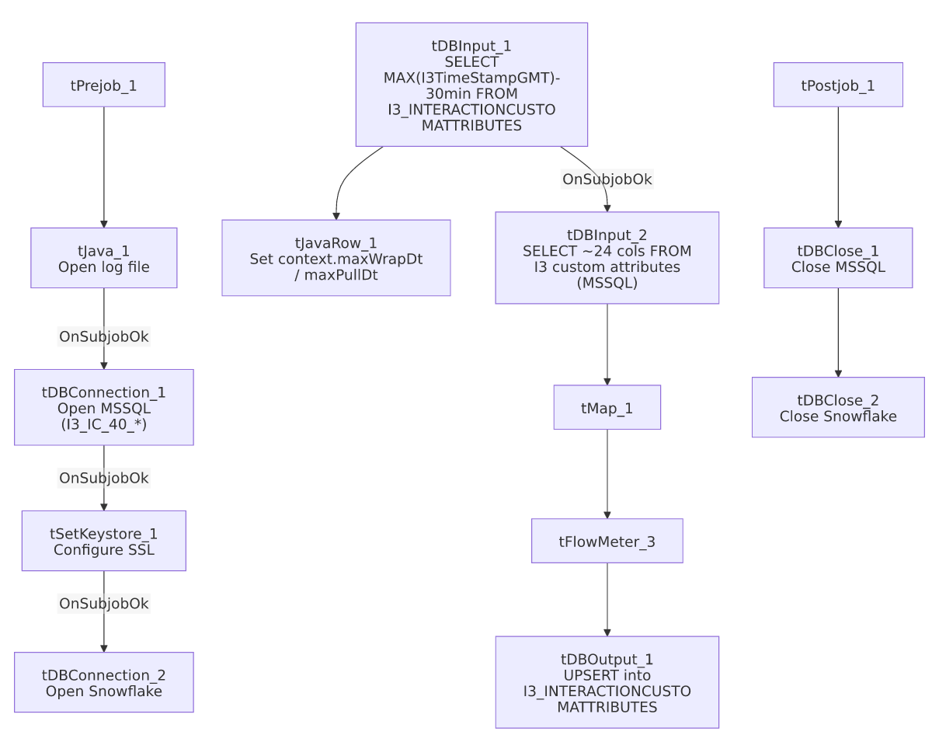

Settings tables

Watermark: `tDBInput_1` (`tSnowflakeInput`)
Setting | Value | What it means
Query | SELECT COALESCE(CAST(DATEADD(min,-30,MAX(I3TimeStampGMT))...),'2019-01-01') AS MAX_WRAP_DT, ... AS MAX_PULL_DT FROM I3_INTERACTIONCUSTOMATTRIBUTES; | Computes the incremental-load starting point (with a 30-minute overlap) and the current pull time, both captured into context for the source query to (presumably) use as filter bounds.

Source: `tDBInput_2` (`tMSSqlInput`)
Setting | Value | What it means
Connection | I3_IC_40_* context vars | Reads from the I3 IC telephony database.
Query | Fixed SELECT of ~24 columns (truncated in this metadata) | Does not visibly reference context.maxWrapDt in the captured portion — see Issues observed.

Target: `tDBOutput_1` (`tSnowflakeOutput`)
Setting | Value | What it means
Table | I3_INTERACTIONCUSTOMATTRIBUTES | Destination table in Snowflake.
Output action | UPSERT | Update-or-insert per row, keyed presumably on INTERACTIONIDKEY/SEQNO — safe against duplication even if the incremental filter re-pulls overlapping rows.
Table action | NONE | Table itself is not recreated/altered.

Dependencies & configuration
- Triggers/depends on other jobs: none — no tRunJob links found.
- Context variables used: I3_IC_40_Database, I3_IC_40_Login, I3_IC_40_Port, I3_IC_40_Schema, I3_IC_40_Server, keystorePath, logDir, maxPullDt, maxWrapDt (the latter two computed internally from the watermark query).
- 1 hardcoded path: tSetKeystore_1.SSL_TRUSTSERVER_TRUSTSTORE = "C:/clientTrustStore.trustStore" — same pattern as other I3 jobs in this project.

Glossary
Component type | Plain-English meaning
tSnowflakeConnection / tSnowflakeInput / tSnowflakeOutput / tSnowflakeClose | Open a Snowflake connection, run a query, write rows, and close it.
tMSSqlConnection / tMSSqlInput / tMSSqlClose | Open a Microsoft SQL Server connection, run a query, and close it.
tJavaRow | Runs custom Java code once per input row — here used to unpack the watermark query's two result values into context variables.
tMap | Maps/transforms columns from one schema to another.
tFlowMeter | Counts rows passing a point in the flow, for logging/monitoring.
tSetKeystore | Configures the SSL trust/keystore used for secure connections in the job.

Issues observed
- The incremental-load logic may not actually be applied — same open question as i3_InteractionSummary_Load/i3_InteractionSummaryEx_Load: the job computes context.maxWrapDt before reading the MSSQL source, but the tDBInput_2.QUERY text captured in this metadata is truncated after the initial column list and does not show a WHERE clause referencing it. Because the target is an UPSERT (not a plain INSERT), a missing filter wouldn't cause duplicate rows, but it would mean every run re-reads and re-transfers the entire source table rather than only new/changed interactions — a performance and cost concern at scale. Verify directly in Talend Studio.
- This job is structurally identical to `i3_InteractionSummary_Load` and `i3_InteractionSummaryEx_Load` (same watermark pattern, same component wiring, same UPSERT target) — the three appear to be built from a shared template, differing only in source columns and target table. Worth keeping in sync as a set if the watermark logic is ever fixed or changed in one of them.
- No other findings beyond the project-wide patterns already documented in 05_operational_runbook.md.

