Talend Job: i3_InteractionSummaryEx_Load

Overview
Loads extended call-event-log data for I3 telephony interactions (interaction key/site/sequence, start time and offset, and a CallEventLog text field) from the I3 IC MSSQL database into the Snowflake I3_INTERACTIONSUMMARYEX table. Uses the same rolling-watermark pattern as its i3_InteractionSummary_Load and i3_InteractionCustomAttributes_Load siblings: it computes the latest already-loaded timestamp from Snowflake (minus a 30-minute safety overlap) before reading the source, though the captured query text does not show that watermark actually being applied as a filter (see Issues observed).

Detail table
Field | Value
Job name | i3_InteractionSummaryEx_Load
Version | 0.1
Project | EDW2SF
Author | jmach@harriscollect.com
Created | 2023-05-23T11:24:16.680-0700
Last Modified | 2025-11-06T10:21:10.425-0800

Step-by-step data flow
Setup subjob: tPrejob_1 → tJava_1 opens a per-run log file → on success, tDBConnection_1 opens the MSSQL connection using context.I3_IC_40_Server/Port/Schema/Database/Login (password redacted) → on success, tSetKeystore_1 configures SSL/keystore settings from context.keystorePath (all passwords redacted) → on success, tDBConnection_2 opens the Snowflake connection.
Main subjob — starts independently at tDBInput_1:
- tDBInput_1 (tSnowflakeInput) runs SELECT COALESCE(CAST(DATEADD(min,-30,MAX(StartDateTimeUTC))...),'2019-01-01') AS MAX_WRAP_DT, ... AS MAX_PULL_DT FROM I3_INTERACTIONSUMMARYEX; against Snowflake to find the incremental-load starting point.
- tJavaRow_1 captures the two result values into context.maxWrapDt and context.maxPullDt.
- On success, tDBInput_2 (tMSSqlInput) runs a fixed SELECT of 6 columns — InteractionIDKey, SiteID, SeqNo, StartDateTimeUTC, StartDTOffset, CallEventLog — from I3_IC_40.dbo.InteractionSummaryEx. The query text visibly includes WHERE StartDateTimeUTC >= '" + context.maxWrapDt + "' AND Start... before being truncated in this metadata — this is the one job in this family where the incremental filter is at least partially visible, though the upper bound of the WHERE clause (presumably using context.maxPullDt) is cut off.
- tMap_1 passes the 6 source columns through to a same-shaped uppercase-named target schema (DIE_ON_ERROR=true).
- tFlowMeter_3 counts rows passing through (labeled "intsumex").
- tDBOutput_1 UPSERTs the rows into Snowflake table I3_INTERACTIONSUMMARYEX (tableAction=NONE).
Teardown subjob: tPostjob_1 → tDBClose_1 (close MSSQL) → tDBClose_2 (close Snowflake).
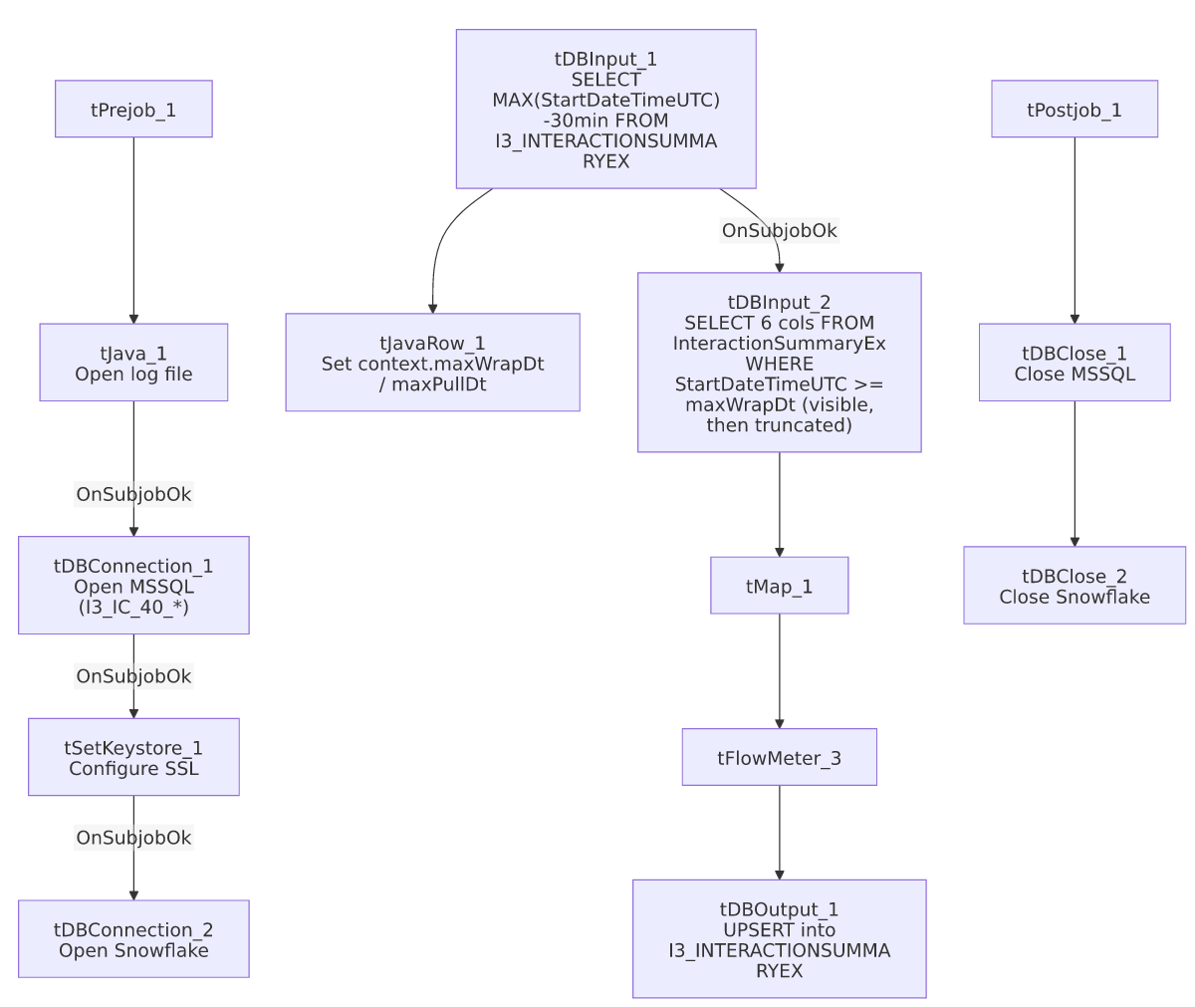

Settings tables

Watermark: `tDBInput_1` (`tSnowflakeInput`)
Setting | Value | What it means
Query | SELECT COALESCE(CAST(DATEADD(min,-30,MAX(StartDateTimeUTC))...),'2019-01-01') AS MAX_WRAP_DT, ... AS MAX_PULL_DT FROM I3_INTERACTIONSUMMARYEX; | Computes the incremental-load starting point (30-minute overlap) and current pull time.

Source: `tDBInput_2` (`tMSSqlInput`)
Setting | Value | What it means
Connection | I3_IC_40_* context vars | Reads from the I3 IC telephony database, table I3_IC_40.dbo.InteractionSummaryEx.
Query | SELECT InteractionIDKey, SiteID, SeqNo, StartDateTimeUTC, StartDTOffset, CallEventLog FROM I3_IC_40.dbo.InteractionSummaryEx WHERE StartDateTimeUTC >= '<maxWrapDt>' AND Start... (truncated) | The visible portion confirms the lower bound of the incremental filter is applied; the upper bound is not visible in this metadata.

Target: `tDBOutput_1` (`tSnowflakeOutput`)
Setting | Value | What it means
Table | I3_INTERACTIONSUMMARYEX | Destination table in Snowflake.
Output action | UPSERT | Update-or-insert per row — safe against duplication from the 30-minute overlap window.
Table action | NONE | Table itself is not recreated/altered.

Dependencies & configuration
- Triggers/depends on other jobs: none — no tRunJob links found.
- Context variables used: I3_IC_40_Database, I3_IC_40_Login, I3_IC_40_Port, I3_IC_40_Schema, I3_IC_40_Server, keystorePath, logDir, maxPullDt, maxWrapDt.
- 1 hardcoded path: tSetKeystore_1.SSL_TRUSTSERVER_TRUSTSTORE = "C:/clientTrustStore.trustStore".

Glossary
Component type | Plain-English meaning
tSnowflakeConnection / tSnowflakeInput / tSnowflakeOutput / tSnowflakeClose | Open a Snowflake connection, run a query, write rows, and close it.
tMSSqlConnection / tMSSqlInput / tMSSqlClose | Open a Microsoft SQL Server connection, run a query, and close it.
tJavaRow | Runs custom Java code once per input row — here used to unpack the watermark query's result into context variables.
tMap | Maps/transforms columns from one schema to another.
tFlowMeter | Counts rows passing a point in the flow, for logging/monitoring.
tSetKeystore | Configures the SSL trust/keystore used for secure connections in the job.

Issues observed
- This is the one job in the `i3_Interaction*_Load` family where the incremental filter is at least partially confirmed — tDBInput_2's query visibly includes WHERE StartDateTimeUTC >= '<maxWrapDt>' AND Start... before truncation, unlike i3_InteractionSummary_Load and i3_InteractionCustomAttributes_Load, whose captured query text cuts off before any WHERE clause becomes visible. This does not fully confirm the upper bound (maxPullDt) is also applied, but it does make this job's incremental design more credible than its siblings' — worth using as the reference point if the team investigates whether the others are actually filtering.
- The `tDBOutput_1` schema in this job's extracted metadata includes a second block of reject-style columns (columnName, rowNumber, category, character, errorMessage, byteOffset, line, sqlState, code) appended after the 6 business columns — this is very likely an artifact of how the extraction captured a combined main/reject schema rather than evidence of an actual reject flow wired in this job (no reject connection appears in the connections list). Unable to fully confirm from metadata; treat the business schema (6 columns) as authoritative.
- No other findings beyond the project-wide patterns already documented in 05_operational_runbook.md.

