Talend Job: i3_InteractionSummary_Load

Overview
Loads interaction-summary records (per-interaction call-center metrics: talk/hold/queue/ACW timing, disposition, wrap-up code, workgroup/agent/line identifiers) from the I3 (Interactive Intelligence) telephony system's MSSQL database into the Snowflake I3_INTERACTIONSUMMARY table, using an UPSERT write keyed presumably on INTERACTIONIDKEY/SITEID/SEQNO so repeated runs update existing rows rather than duplicate them. Like i3_CallHistory_Load, it first computes the latest interaction start time already loaded into Snowflake as an apparent incremental-load marker, though the source query text captured in this metadata is truncated and does not show whether that marker is actually applied as a filter.

Detail table
Field | Value
Job name | i3_InteractionSummary_Load
Version | 0.1
Project | EDW2SF
Author | jmach@harriscollect.com
Created | 2023-05-22T20:28:30.923-0700
Last Modified | 2025-11-06T10:08:18.619-0800

Step-by-step data flow
Setup subjob: tPrejob_1 → tJava_1 opens a per-run log file → on success (OnSubjobOk), tDBConnection_1 opens the MSSQL connection (context.I3_IC_40_* variables — Server/Port/Schema/Database/Login, password redacted) → on success, tSetKeystore_1 configures SSL trust/keystore from context.keystorePath → on success, tDBConnection_2 opens the Snowflake connection.
Main subjob:
- tDBInput_1 (tSnowflakeInput) runs a query against I3_INTERACTIONSUMMARY in Snowflake to compute MAX_WRAP_DT (the latest StartDateTimeUTC already loaded, minus a 30-minute safety buffer, defaulting to '2019-01-01' if empty) and MAX_PULL_DT (current UTC timestamp).
- tJavaRow_1 captures those into context.maxWrapDt and context.maxPullDt (via the MAIN connection, labeled row3).
- On success (OnSubjobOk), tDBInput_2 (tMSSqlInput, its own separate connection — USE_EXISTING_CONNECTION=false, using context.I3_IC_40_* variables consistently with tDBConnection_1) runs a fixed SELECT of ~60 columns against the source interaction-summary table: interaction/site/sequence identifiers, start/connect/terminate timestamps, talk/hold/queue/ACW/park duration metrics, disposition and wrap-up codes, workgroup/agent/line identifiers, and call notes.
- tMap_1 passes the ~60 source columns through to a same-shaped uppercase-named target schema.
- tFlowMeter_3 counts rows passing through (labeled "MyLabel", not renamed for this job).
- tDBOutput_1 upserts the rows into Snowflake table I3_INTERACTIONSUMMARY (UPSERT, no table-recreate action).
Teardown subjob: tPostjob_1 → tDBClose_1 (close MSSQL) → tDBClose_2 (close Snowflake).
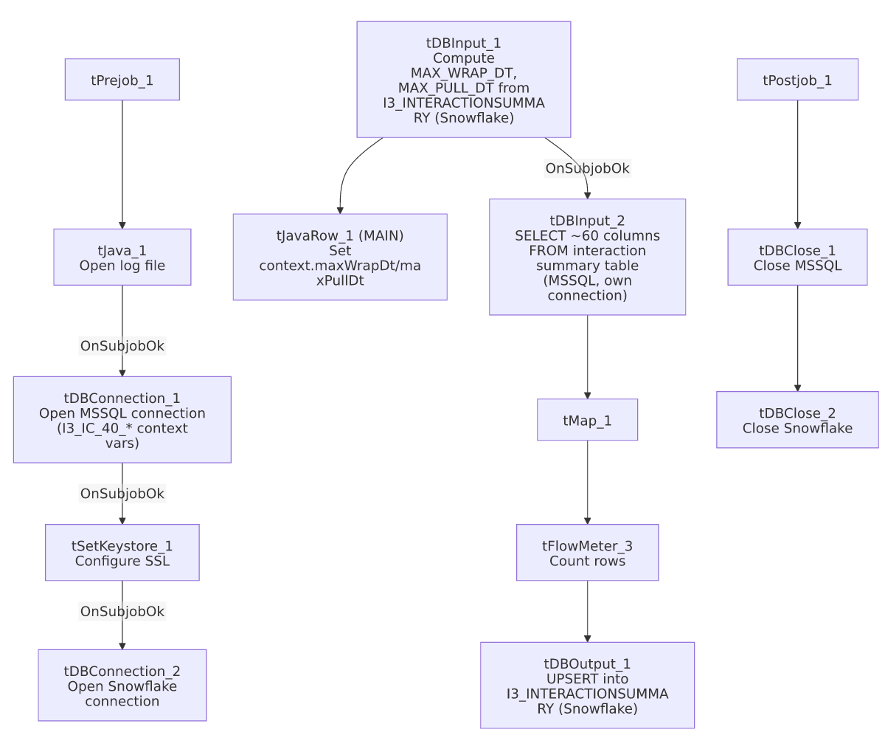

Settings tables

Incremental-marker query: `tDBInput_1` (`tSnowflakeInput`)
Setting | Value | What it means
Query | SELECT COALESCE(CAST(DATEADD(min,-30,MAX(StartDateTimeUTC)) AS VARCHAR(30)),'2019-01-01') AS MAX_WRAP_DT, CAST(CONVERT_TIMEZONE(...,CURRENT_TIMESTAMP) AS VARCHAR(30)) AS MAX_PULL_DT FROM I3_INTERACTIONSUMMARY; | Finds the latest interaction start time already in Snowflake (minus a 30-minute buffer) and the current UTC timestamp, mirroring the same pattern used in i3_CallHistory_Load.
Captured into | context.maxWrapDt, context.maxPullDt | Set by tJavaRow_1 immediately after this query runs, before the MSSQL source read begins.

Source: `tDBInput_2` (`tMSSqlInput`)
Setting | Value | What it means
Connection | USE_EXISTING_CONNECTION=false, own HOST/PORT/etc. set to context.I3_IC_40_* | Opens its own separate MSSQL connection rather than reusing tDBConnection_1 — and unlike i3_CallHistory_Load, this component's own parameters correctly match the I3 IC 40 system it's actually reading from (no naming mismatch here).
Query | SELECT InteractionIDKey, SiteID, SeqNo, InteractionID, StartDateTimeUTC, StartDtOffset, Direction... (truncated) | ~60 columns of interaction-summary metrics; the visible portion does not show a WHERE clause referencing context.maxWrapDt — see Issues observed.

Target: `tDBOutput_1` (`tSnowflakeOutput`)
Setting | Value | What it means
Table | I3_INTERACTIONSUMMARY | Destination table in Snowflake.
Output action | UPSERT | Updates existing rows and inserts new ones, avoiding duplicates on re-run assuming a stable match key (likely INTERACTIONIDKEY/SITEID/SEQNO).
Table action | NONE | No truncate/recreate — consistent with an incremental/upsert design.

Dependencies & configuration
- Triggers/depends on other jobs: none — no tRunJob links found.
- Context variables used: I3_IC_40_Database, I3_IC_40_Login, I3_IC_40_Port, I3_IC_40_Schema, I3_IC_40_Server, keystorePath, logDir, maxPullDt, maxWrapDt.
- 1 hardcoded path: tSetKeystore_1.SSL_TRUSTSERVER_TRUSTSTORE (C:/clientTrustStore.trustStore), the same project-wide SSL truststore path seen in other jobs.

Glossary
Component type | Plain-English meaning
tMSSqlConnection / tMSSqlInput / tMSSqlClose | Open a Microsoft SQL Server connection, run a query against it, and close it.
tSnowflakeConnection / tSnowflakeInput / tSnowflakeOutput / tSnowflakeClose | Open a Snowflake connection, read/write rows, and close the connection.
tJavaRow | Runs custom Java code once per input row — here used to unpack a single query result row into context variables.
tFlowMeter | Counts rows passing a point in the flow, for logging/monitoring.
tSetKeystore | Configures the SSL trust store/keystore used for the job's encrypted database connections.

Issues observed
- Whether this load is actually incremental cannot be confirmed from this metadata. As with i3_CallHistory_Load, the job computes a high-water-mark date (context.maxWrapDt) from Snowflake before reading the MSSQL source, but the captured tDBInput_2.QUERY text is truncated after the initial column list and does not show a WHERE clause referencing context.maxWrapDt. Because the write is an UPSERT (not a plain insert), a non-filtered full-table re-read would not create duplicate rows, but it could still mean the job unnecessarily reprocesses the entire source table every run. Verify directly in Talend Studio.
- Unlike `i3_CallHistory_Load`, this job's MSSQL source component (`tDBInput_2`) does not reuse a shared connection and its own connection parameters correctly reference `I3_IC_40_*` variables — there is no naming mismatch here, which is worth noting precisely because the sibling job in this same batch does have one; the two jobs were evidently built with different care/timing despite their near-identical structure.
- No job-specific error/row-count logging (no tWarn/tDie/tSendMail) — a load failure would surface only as a generic Talend execution error, consistent with the majority of load jobs documented across this project (per 05_operational_runbook.md).

