Talend Job: i3_InteractionWrapup_Load

Overview
Loads call-center interaction wrap-up data (wrap-up code/category, whether wrap-up was required or left incomplete, connected/hold/ACW/suspend timings, supervisor-request counts, per interaction and per user/workgroup) from the I3 platform's MSSQL database into the Snowflake I3_INTERACTIONWRAPUP table, upserting by key. Its incremental-load check is slightly more defensive than similar jobs elsewhere in this project: it looks back 30 minutes before the latest loaded wrap-up start time, presumably to catch records that were still being finalized when the last run captured its watermark.

Detail table
Field | Value
Job name | i3_InteractionWrapup_Load
Version | 0.1
Project | EDW2SF
Author | jmach@harriscollect.com
Created | 2023-04-20T09:48:19.539-0700
Last Modified | 2025-11-06T10:26:48.670-0800

Step-by-step data flow
Setup subjob: tPrejob_1 → tJava_1 opens a per-run log file → on success, tDBConnection_1 opens the MSSQL connection first (context.I3_IC_40_Server/Port/Schema/Database/Login, password redacted) → on success, tSetKeystore_1 configures SSL trust/keystore from context.keystorePath → on success, tDBConnection_2 opens the Snowflake connection. Note the MSSQL-before-Snowflake connection order here is the reverse of the sequence used in sibling jobs like i3_AgentActivityLog_Load (Snowflake opened first there) — not necessarily a problem, just a structural inconsistency worth knowing about.
Main subjob:
- tDBInput_2 (tSnowflakeInput) runs a query computing two values from the target table: MAX_WRAP_DT — the latest WRAPUPSTARTDATETIMEUTC already loaded, minus 30 minutes (DATEADD(min,-30,MAX(...))), defaulting to '2019-01-01' if the table is empty — and MAX_PULL_DT, the current UTC timestamp at query time.
- tJavaRow_1 captures these into context.maxWrapDt and context.maxPullDt.
- On success, tDBInput_1 runs a fixed SELECT (shared tDBConnection_1) against the source wrap-up table, pulling InteractionIDKey, WrapupSegmentID, SourceInteractionIDKey, SiteID, SeqNo, UserID, WorkgroupID, WrapupRequired, WrapupCode/Category/IncompleteReason, WrapupStartDateTimeUTC, connected/hold/ACW/suspend timing counters, and nSupervisorRequest. The captured query text is truncated after the initial columns and does not visibly reference `context.maxWrapDt`/`context.maxPullDt` — see Issues observed.
- tMap_1 passes the ~19 columns through to an uppercase-named target schema.
- tFlowMeter_1 counts rows passing through (labeled "MyLabel", not renamed for this job).
- tDBOutput_1 upserts the rows into Snowflake table I3_INTERACTIONWRAPUP.
Teardown subjob: tPostjob_1 → tDBClose_1 (close MSSQL) → tDBClose_2 (close Snowflake).
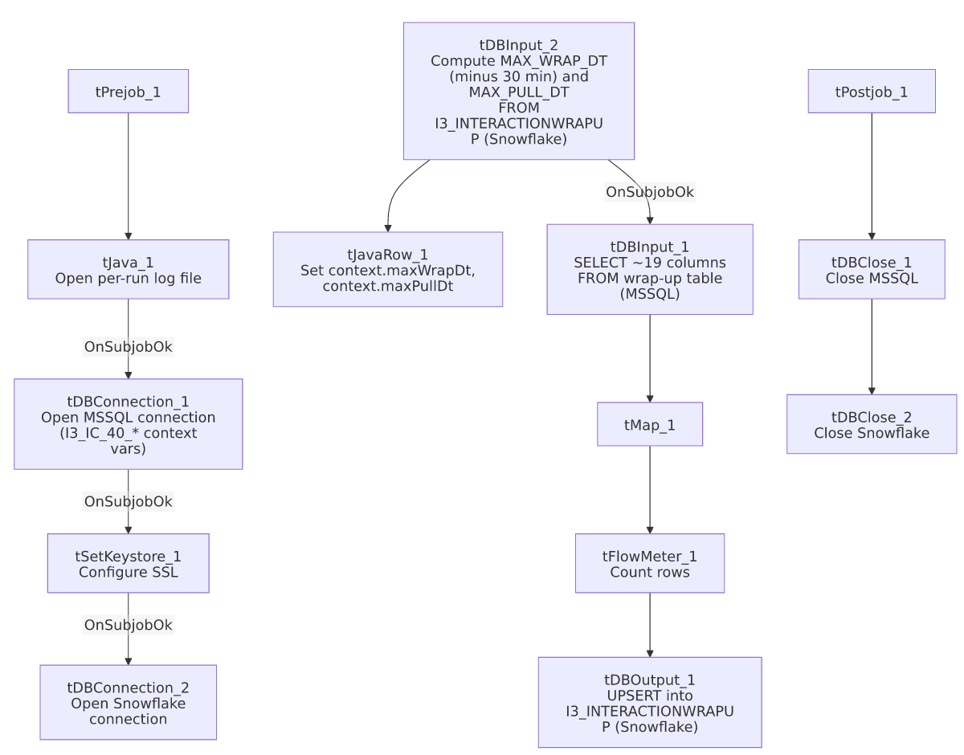

Settings tables

Source: `tDBInput_1` (`tMSSqlInput`)
Setting | Value | What it means
Connection | Shared tDBConnection_1 | Reuses the job's single MSSQL connection.
Query | Fixed SELECT of ~19 named columns (interaction/wrap-up identifiers, wrap-up code/category/incomplete-reason, connected/hold/ACW/suspend timing counters, supervisor-request count) | The visible portion does not reference context.maxWrapDt or context.maxPullDt — see Issues observed.

Watermark computation: `tDBInput_2` (`tSnowflakeInput`)
Setting | Value | What it means
Query | SELECT COALESCE(CAST(DATEADD(min,-30,MAX(WRAPUPSTARTDATETIMEUTC)) AS VARCHAR(30)),'2019-01-01') AS MAX_WRAP_DT, CAST(CONVERT_TIMEZONE(GET_CURRENT_TIMEZONE(),'UTC',CURRENT_TIMESTAMP) AS VARCHAR(30)) AS MAX_PULL_DT FROM I3_INTERACTIONWRAPUP; | Computes a lookback watermark 30 minutes before the latest loaded wrap-up start time (to catch late-finalized records), plus the current UTC pull time — both captured into context by tJavaRow_1.

Target: `tDBOutput_1` (`tSnowflakeOutput`)
Setting | Value | What it means
Table | I3_INTERACTIONWRAPUP | Destination table for call-center wrap-up data.
Output action | UPSERT | Inserts new rows and updates existing ones by key — safer against duplication than plain INSERT if the source query re-reads overlapping rows because of the 30-minute lookback window.
Table action | NONE | Table is not recreated/altered by this job.

Dependencies & configuration
- Triggers/depends on other jobs: none — no tRunJob links found, and this job does not appear as a caller or target in 06_dependency_matrix.md.
- Context variables used: I3_IC_40_Database, I3_IC_40_Login, I3_IC_40_Port, I3_IC_40_Schema, I3_IC_40_Server (MSSQL connection details, correctly labeled for I3 telephony data), keystorePath, logDir, maxPullDt, maxWrapDt (both computed internally from the Snowflake watermark query).
- 1 hardcoded developer-workstation path in tSetKeystore_1.SSL_TRUSTSERVER_TRUSTSTORE ("C:/clientTrustStore.trustStore") — same pattern documented project-wide in 05_operational_runbook.md.

Glossary
Component type | Plain-English meaning
tMSSqlConnection / tMSSqlInput / tMSSqlClose | Open a Microsoft SQL Server connection, run a query against it, and close it.
tSnowflakeConnection / tSnowflakeClose | Open/close a Snowflake database connection shared by other components in the job.
tSnowflakeInput | Runs a query against Snowflake and returns its result rows — here used to compute the incremental-load watermark.
tMap | Maps/transforms columns from one schema to another.
tFlowMeter | Counts rows passing a point in the flow for logging/monitoring.
tSnowflakeOutput | Writes rows to a Snowflake table — here configured for UPSERT.
tJavaRow | Runs custom Java code once per input row — here used to unpack the watermark query's two result values into context variables.
tSetKeystore | Configures SSL trust/keystore settings for the job's secure connections.

Issues observed
- The incremental-load filter may not actually be applied. The job computes both context.maxWrapDt and context.maxPullDt from Snowflake before reading the MSSQL source — and the 30-minute lookback logic strongly suggests a deliberate, thoughtfully-designed incremental window — but the tDBInput_1.QUERY text captured in this metadata is truncated after the initial column list and does not show a WHERE-clause referencing either context variable in the visible portion. Unable to determine from this metadata whether the query is actually filtered by date. Because the target write is an UPSERT (not a plain INSERT), an unfiltered re-read of the whole source table wouldn't create duplicate rows the way it would in i3_CallDetail_40_Load or i3_AgentActivityLog_Load — but it would mean the job re-transfers and re-processes far more data than necessary on every run. Verify directly in Talend Studio.
- The setup subjob opens the MSSQL connection before the Snowflake connection (tDBConnection_1 → tSetKeystore_1 → tDBConnection_2), the reverse order from sibling jobs like i3_AgentActivityLog_Load and i3_DialerCallListDC_Load (which open Snowflake first, then MSSQL). This is likely inconsequential given Talend's connection independence, but it's a structural inconsistency across otherwise very similar jobs in the same i3_* family — worth knowing if debugging connection-order-sensitive issues (e.g., keystore configuration timing relative to either connection).
- No error/row-count logging specific to this job's business outcome (no tWarn/tDie/tSendMail) — a load failure here would only surface as a generic Talend execution error, consistent with most of the 289 jobs per 05_operational_runbook.md.

