Talend Job: master_prediction_proposal_cubs_extract

Overview
Extracts a per-logon "proposed contact channel" prediction dataset (logon, debtor number, and a predicted outreach channel) from a dynamically-named Snowflake table (MASTER_PREDICTION_PROPOSAL_CUBS_<LOGON>) and writes it to a per-logon, dated CSV file. This is a small utility/sub-job — per 06_dependency_matrix.md, it is called via tRunJob 5 times each by Export_Hermes_APC_Master_Prediction and Extract_Hermes_Master_Prediction (10 total invocations project-wide), almost certainly once per site/logon given that its source table name and output filename are both built from context.currentLogon.

Detail table
Field | Value
Job name | master_prediction_proposal_cubs_extract
Version | 0.1
Project | EDW2SF
Author | jmach@harriscollect.com
Created | 2023-05-16T09:15:57.268-0700
Last Modified | 2025-11-05T09:49:06.554-0800

Step-by-step data flow
Setup subjob (chain 1): tPrejob_1 → tJava_1 opens a per-run log file at context.logDir+jobName+"_"+context.currentLogon+"_"+<timestamp>+".log" → on success, tJava_2 sets context.selectQuery = "SELECT LOGON,DEBTORNUMBER,PROPOSED_CHANNEL FROM MASTER_PREDICTION_PROPOSAL_CUBS_"+context.currentLogon.toUpperCase()+";" — dynamically targeting a per-logon Snowflake table.
Extraction subjob (chain 2 — no explicit link from chain 1; see Issues observed): tSetKeystore_1 configures SSL trust/keystore settings from context.keystorePath (passwords redacted) → on success, tDBInput_1 runs the query held in context.selectQuery against Snowflake → tFlowMeter_2 (MAIN) counts rows passing through (labeled "MyLabel") → tFileOutputDelimited_1 (FLOW) writes the rows, with header, to context.importDir+"master_prediction_proposal_cubs_"+context.currentLogon.toLowerCase()+"_"+<date>+".csv".
No `tPostjob`/`tDBClose`, and no `tSnowflakeConnection` component at all, appear anywhere in this job's metadata — see Issues observed regarding how this job actually obtains its Snowflake connection.
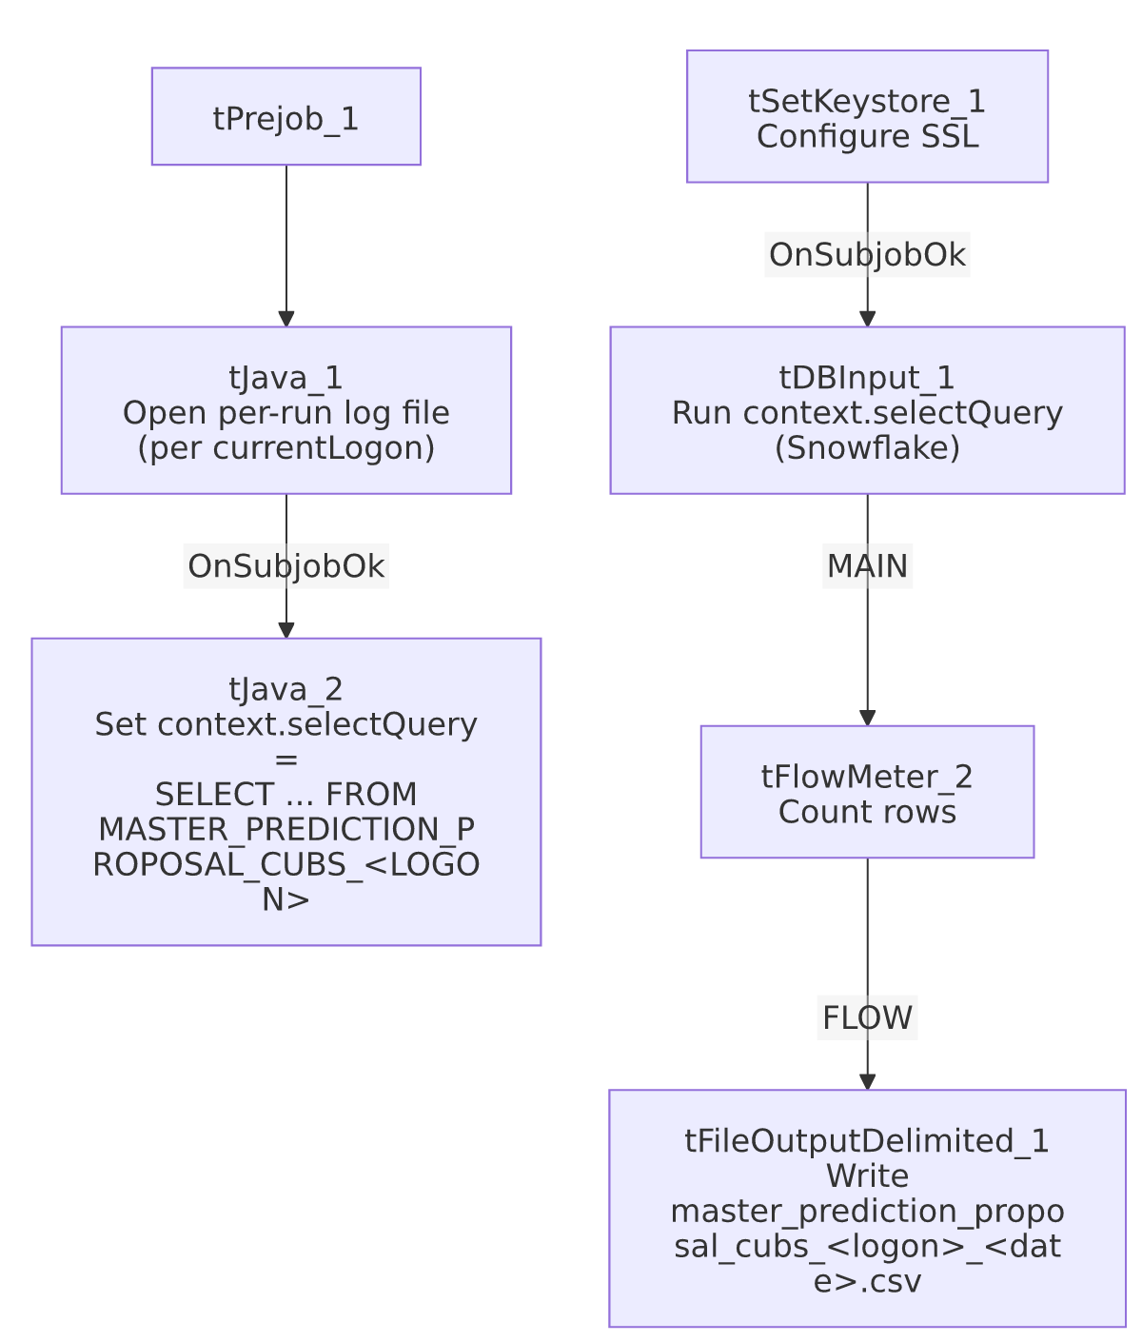
*Note: no connector links the "build query" chain to the "run query" chain in this job's own metadata — see Issues observed.*

Settings tables

Query builder: `tJava_2`
Setting | Value | What it means
CODE | context.selectQuery="SELECT LOGON,DEBTORNUMBER,PROPOSED_CHANNEL FROM MASTER_PREDICTION_PROPOSAL_CUBS_"+context.currentLogon.toUpperCase()+";" | Dynamically builds a query against a per-logon table using context.currentLogon.

Source: `tDBInput_1` (`tSnowflakeInput`)
Setting | Value | What it means
Query | context.selectQuery | The query text itself lives in a context variable set by tJava_2 at runtime, not a literal SQL string on this component.

Target: `tFileOutputDelimited_1`
Setting | Value | What it means
FILENAME | context.importDir+"master_prediction_proposal_cubs_"+context.currentLogon.toLowerCase()+"_"+TalendDate.getDate("CCYYMMDD")+".csv" | Per-logon, dated output file.
INCLUDEHEADER | true | Header row included.

Setup: `tSetKeystore_1`
Setting | Value | What it means
SSL_KEYSTORE | context.keystorePath | Context-driven client keystore.
SSL_TRUSTSERVER_TRUSTSTORE | "C:/clientTrustStore.trustStore" (hardcoded) | Local path — see Dependencies & configuration.

Dependencies & configuration
- Triggers/depends on other jobs: this job's own runjob_targets is empty (it calls nothing), but per 06_dependency_matrix.md it is a call target: Export_Hermes_APC_Master_Prediction and Extract_Hermes_Master_Prediction each call it via tRunJob 5 times (10 invocations total project-wide) — "almost certainly once per site/partner context" per that document, consistent with this job's per-logon design.
- Context variables used: currentLogon, importDir, keystorePath, logDir, selectQuery.
- 1 hardcoded path finding: tSetKeystore_1.SSL_TRUSTSERVER_TRUSTSTORE = "C:/clientTrustStore.trustStore" — same project-wide portability risk documented in 05_operational_runbook.md.

Glossary
Component type | Plain-English meaning
tSnowflakeInput | Runs a query against Snowflake and returns its result rows.
tFileOutputDelimited | Writes rows to a delimited (CSV-style) text file.
tFlowMeter | Counts rows passing a point in the flow for logging/monitoring.
tSetKeystore | Configures SSL/TLS keystore and truststore settings used by the job's database connection.
tJava | Runs custom Java code — here used to open a log file and to build a SQL query string at runtime.

Issues observed
- No `tSnowflakeConnection`/`tSnowflakeClose` component appears anywhere in this job's metadata, and tDBInput_1's captured parameters don't show a USE_EXISTING_CONNECTION setting either. How this job actually establishes its Snowflake connection is not confirmed by this metadata. Since both of its call sites (Export_Hermes_APC_Master_Prediction, Extract_Hermes_Master_Prediction) invoke it via tRunJob, it may rely on a connection shared from the calling parent job — but a child job normally opens its own connection unless explicitly configured otherwise, so this should be verified directly in Talend Studio rather than assumed.
- No explicit trigger link ties `tJava_2` (which sets `context.selectQuery` from `context.currentLogon`) to the `tSetKeystore_1` → `tDBInput_1` chain that consumes it. Both subjob chains exist in the same job with no connector between them in this metadata, so the component graph alone does not guarantee context.selectQuery is set before tDBInput_1 runs it. If the two chains aren't otherwise sequenced correctly at runtime, the query could execute against a stale or blank context.selectQuery. Verify directly in Talend Studio (e.g., an unshown trigger relationship or an inherited default value not captured by this extraction).
- No reject/error handling and no row-count check after the extract (no tWarn/tDie/tSendMail) — a failure, or an unexpectedly-empty result (e.g., if MASTER_PREDICTION_PROPOSAL_CUBS_<LOGON> doesn't exist for a given logon), would only surface as a generic Talend execution error or a near-empty CSV, with nothing in this job's own metadata to flag that condition.
- The source table name is built dynamically from `context.currentLogon.toUpperCase()` — a logon value with no matching MASTER_PREDICTION_PROPOSAL_CUBS_<LOGON> table would fail this job. Which logon values are valid is presumably determined by whatever context each of the two calling jobs passes at each of their 5 invocations — not visible in this job's own metadata; see 06_dependency_matrix.md's note that confirming exactly what differs per call "requires opening each tRunJob component's context settings individually."

