System Architecture Document
**Data-source caveat:** This documentation is generated from metadata extracted from `C:\Users\ven_atilve\Documents\GitHub\compendium\automation\talend-documentation\full-documentation\working\FAMigration`. Signals found in the data suggest it may not represent a real production platform: All 1 defined DB connection(s) have empty host/port/database/schema fields — not configured for real use. The documents below describe exactly what is present in the extracted metadata; treat any "production" framing with that in mind and verify with the team before relying on it operationally.

What actually exists
Layer | Observed state
Talend Studio workspace | 1 project(s) — FAMIGRATION (12 jobs)
Database connections | 1 defined: Frostlake_0.1
Context variables | 1 group(s): Common_0.1 — used by 12/12 jobs

Observed data flow (Mermaid)
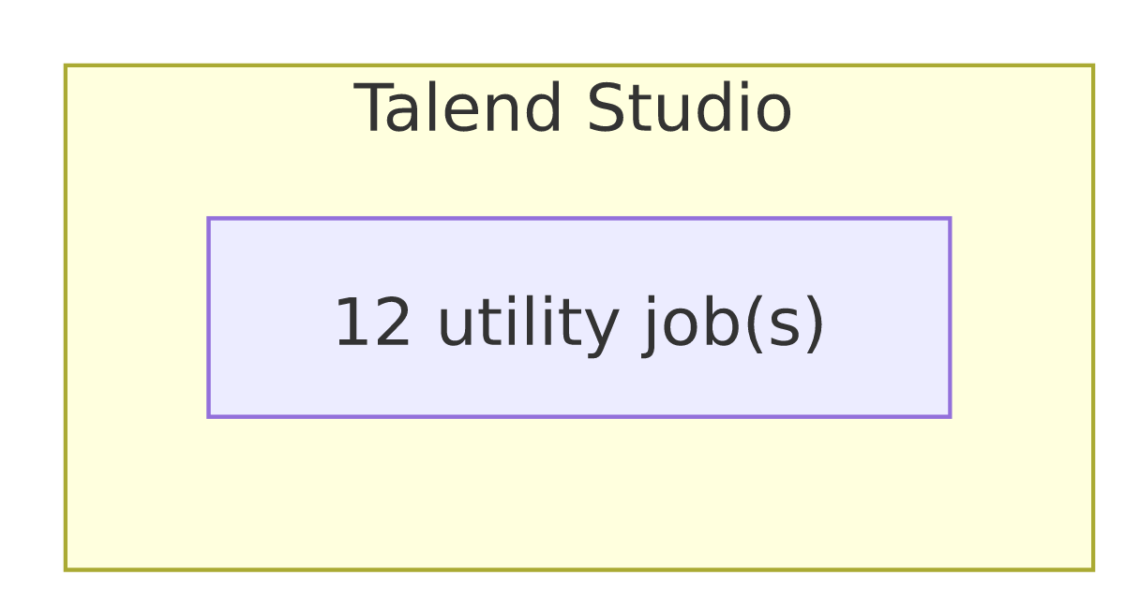
This diagram reflects only what the extracted metadata shows — reload schedules, real connection targets, and any app-to-warehouse linkage must come from re-running the extractors once those are configured.

