System Architecture Document

What actually exists
Layer | Observed state
Talend Studio workspace | 1 project(s) — LATITUDE (56 jobs)
Database connections | 2 defined: Liquid_0.1, TalendLog_0.1
Context variables | 2 group(s): Directories_0.1, LEGACY_DW_0.1 — used by 56/56 jobs

Observed data flow (Mermaid)
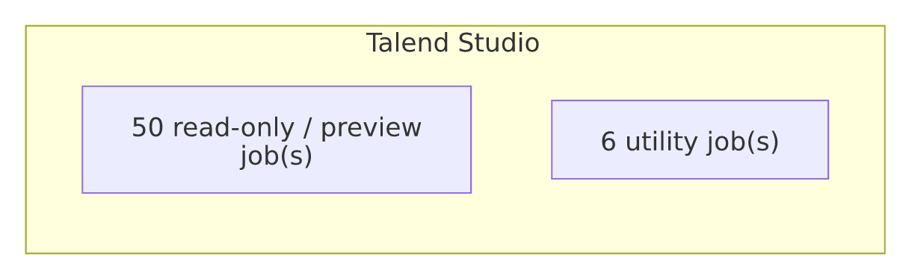
This diagram reflects only what the extracted metadata shows — reload schedules, real connection targets, and any app-to-warehouse linkage must come from re-running the extractors once those are configured.

