Talend Job: Bankruptcy_Text_Load

Overview
This job follows the project's standard "text load" pattern: it watches the shared LATITUDE source folder for a bankruptcy-data file, loads its rows into a Snowflake staging table, merges that staging data into the permanent BANKRUPTCY table via a Snowflake stored procedure, and then archives and deletes the source file. It has no author recorded in its metadata, which is unusual compared to most other jobs in this project.

Detail table
Field | Value
Job name | Bankruptcy_Text_Load
Version | 0.1
Project | LATITUDE
Author | *(blank in metadata — not recorded)*
Created | 2026-06-24T14:37:08.660-0700
Last Modified | 2026-06-25T17:10:44.797-0700

Step-by-step data flow
- Set up. tPrejob_1 runs first; tJava_1 appends today's date to context.archiveDir and opens a log file in context.logDir; tSetKeystore_1 configures the SSL client keystore; tDBConnection_1 opens the Snowflake connection.
- Empty the staging table. tDBRow_1 runs TRUNCATE TABLE LIQUID_STAGING.BANKRUPTCY;.
- Find and read the file. tFileList_1 lists files in context.sourceDir (excluding *.txt, no explicit sort order); tJava_2 captures the found file's path into context.filePath; tFileInputDelimited_1 reads it as a pipe-delimited file (|~| fields, |$| rows, header row present, US-ASCII encoding).
- Transform and load staging. tMap_1 maps the file's ~60 bankruptcy-detail columns (case number, court/trustee details, discharge/dismissal dates, secured/unsecured amounts, etc.) onto the BANKRUPTCY schema and adds LOAD_DT. Rows pass through a row counter (tFlowMeter_2) into tDBOutput_1, which inserts them into the staging table.
- Merge and clean up — in parallel. tFileList_1's success also triggers tParallelize_1, which splits into two branches:
- Merge branch: tDBRow_2 runs CALL LIQUID_STAGING.MERGE_TXT_INTO_BANKRUPTCY(); — a Snowflake stored procedure that folds the staged rows into the permanent table. No result-code check follows it (no tDie/tWarn).
- Cleanup branch: the source folder is listed again (tFileList_2), then in parallel: tJava_3 captures the file path (but not the file name) and tFileArchive_1 zips it into context.archiveDir; separately tFileList_3 → tJava_4 → tFileDelete_1 deletes the original file from the source folder.
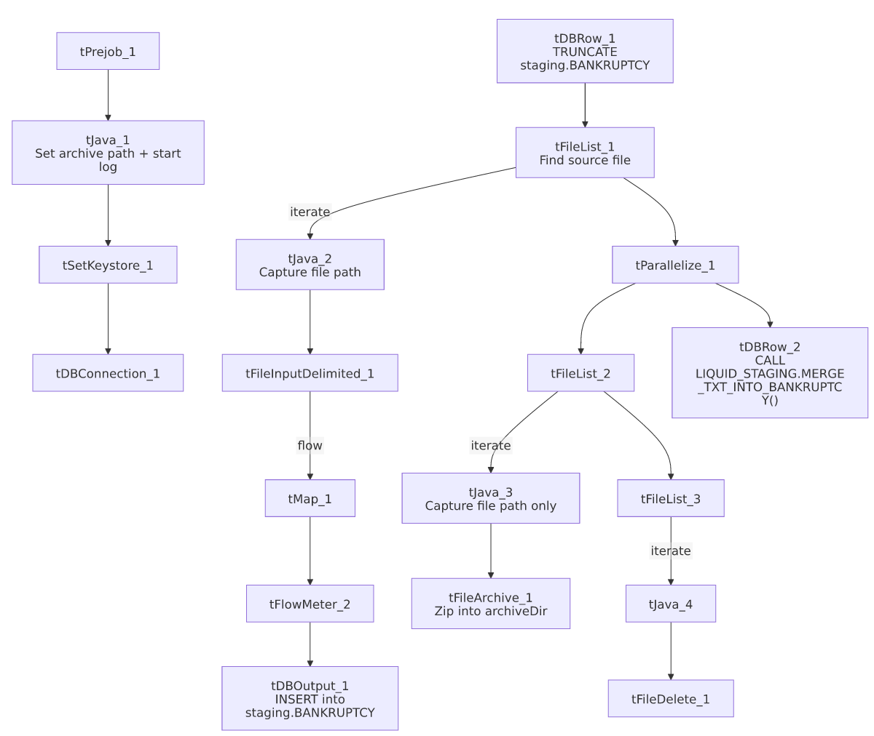

Settings tables

Source: `tFileInputDelimited_1`
Setting | Value | What it means
FILENAME | context.filePath | Reads whichever file tFileList_1 just found.
FIELDSEPARATOR / ROWSEPARATOR | `\ | ~\
HEADER | 1 | First line is a header row.
ENCODING | US-ASCII | Plain ASCII — same as cmi_Hermes_Recommendations_Load, but a step down from ISO-8859-15 used by Address_Text_Load and most peers; worth confirming this file never carries accented characters.
DIE_ON_ERROR | true | A malformed row fails the job immediately (no bad-file redirect like HH_Violation_Text_Load).
TEMP_DIR | "C:/Talend-Studio-20211109_1610-V8.0.1/workspace" | Hardcoded Windows path (see Issues observed).
EXCLUDEFILEMASK (on tFileList_1) | *.txt | .txt files are skipped as usual.

Target: `tDBOutput_1`
Setting | Value | What it means
Table | BANKRUPTCY | Loads into the staging copy (LIQUID_STAGING.BANKRUPTCY, per the preceding TRUNCATE).
Output action | INSERT | Adds rows only.
Table action | NONE | Table structure is untouched.

Merge step: `tDBRow_2`
Setting | Value | What it means
Query | CALL LIQUID_STAGING.MERGE_TXT_INTO_BANKRUPTCY(); | Runs the Snowflake procedure that folds staged rows into the permanent table. Notably this call explicitly qualifies the procedure with the LIQUID_STAGING schema, whereas most peer jobs (e.g. Address_Text_Load, HH_Violation_Text_Load) call the equivalent procedure unqualified — a cosmetic naming inconsistency across the project, not necessarily a functional difference.

Archive/delete: `tFileArchive_1` / `tFileDelete_1`
Setting | Value | What it means
TARGET (tFileArchive_1) | context.archiveDir + context.fileName + ".zip" | Intended to name the zip after the source file — but see Issues observed: context.fileName is never actually set anywhere in this job.
SOURCE_FILE (tFileArchive_1) | "C:/Talend-Studio-.../workspace/source.csv" | Hardcoded Windows path (see Issues observed).
DIRECTORY / PATH (tFileDelete_1) | "C:/Talend-Studio-.../workspace/delete_folder" / "...delete_folder or delete_file" | Hardcoded Windows paths; actual deletion target is FILENAME=context.filePath.
FAILON (tFileDelete_1) | false | If the delete fails, the job doesn't fail.

Dependencies & configuration
- Triggers/depends on other jobs: none found — no tRunJob links to or from any other job.
- Context variables used: context.sourceDir, context.archiveDir, context.filePath, context.fileName, context.logDir, context.keystorePath (all Directories_0.1, each with a Windows-style dev value and a Linux-mount-style value in _shared_context.json, e.g. sourceDir = C:/Data/Latitude/ or /mnt/analytics_team/PROD/LATITUDE/Liquid/). It uses the shared, repository-linked Snowflake connection object rather than referencing LEGACY_DW_0.1 variables directly.

Glossary
Component type | Plain-English meaning
tPrejob / tParallelize | Job-flow control (see job_Address_Text_Load.md).
tSnowflakeConnection (tDBConnection) | Opens the reusable Snowflake connection that the job's other Snowflake components share. Its parameters are empty in this job's metadata because it uses a shared, repository-linked connection object rather than inline settings.
tFileList | Lists files in a folder for iteration (see job_Address_Text_Load.md).
tFileInputDelimited | Reads a delimited text file row by row (see job_Address_Text_Load.md).
tMap | Maps/transforms columns (see job_Address_Text_Load.md).
tFlowMeter | Counts rows passing through (see job_Address_Text_Load.md).
tDBOutput / tSnowflakeOutput | Writes rows to a Snowflake table (see job_Address_Text_Load.md).
tDBRow / tSnowflakeRow | Runs a single SQL statement (see job_Address_Text_Load.md).
tJava | Custom Java code block (see job_Address_Text_Load.md).
tFileArchive | Zips a file into an archive location (see job_Address_Text_Load.md).
tFileDelete | Deletes a file (see job_Address_Text_Load.md).
tSetKeystore | Configures the SSL keystore for the Snowflake connection (see job_Address_Text_Load.md).

Issues observed
- `context.fileName` is never set anywhere in this job, but `tFileArchive_1` depends on it. Both tJava_2 (main read branch) and tJava_3 (archive branch) only assign context.filePath; no component in this job assigns context.fileName. Since tFileArchive_1's TARGET is context.archiveDir + context.fileName + ".zip", and fileName defaults to an empty string in the Directories_0.1 context group, the archived file is very likely being written as just <archiveDir>/.zip rather than a properly named file. Every comparable job checked (Debtor_Table_Text_Load, HH_Violation_Text_Load, MiscExtra_Text_Load, etc.) sets both filePath and fileName in its archive-branch tJava step — this job appears to be missing that second assignment. Worth confirming directly with the team / checking the archive folder for oddly-named zip files.
- Merge procedure call is schema-qualified (`LIQUID_STAGING.MERGE_TXT_INTO_BANKRUPTCY`) while most peer jobs call the equivalent procedure unqualified (MERGE_TXT_INTO_ADDRESS, MERGE_TXT_INTO_HH_VIOLATION, etc.) — a naming/style inconsistency, not necessarily a functional issue.
- No `author` recorded in this job's metadata, unlike every other job reviewed (all show jmach@harriscollect.com).
- Hardcoded, machine-specific paths on tSetKeystore_1.SSL_TRUSTSERVER_TRUSTSTORE, tFileInputDelimited_1.TEMP_DIR, tFileArchive_1.SOURCE_FILE, and tFileDelete_1.DIRECTORY/PATH — the same project-wide pattern flagged in other jobs' documentation.
- The merge procedure's own logic is outside Talend — its column-matching and update logic live in Snowflake, not visible in this metadata.

