Talend Job: Carrier_Text_Load

Overview
This job is one of the project's standard "text load" jobs: it watches a shared folder for a new carrier (insurance carrier) data file, loads its rows into a Snowflake staging table, merges that staging data into the permanent CARRIER table using a Snowflake stored procedure, and then archives and deletes the source file. It follows the same truncate → load → merge → archive/delete pattern as Address_Text_Load, with a couple of small differences called out below.

Detail table
Field | Value
Job name | Carrier_Text_Load
Version | 0.1
Project | LATITUDE
Author | jmach@harriscollect.com
Created | 2026-01-19T09:03:18.128-0800
Last Modified | 2026-01-19T09:23:43.426-0800

Step-by-step data flow
- Set up. tPrejob_1 runs first; tJava_3 appends today's date to the archive path (context.archiveDir = context.archiveDir + <yyyyMMdd> + "/") and starts a log file, then tSetKeystore_1 configures the SSL keystore and tDBConnection_1 opens the Snowflake connection.
- Empty the staging table. tDBRow_1 runs TRUNCATE TABLE STAGING.CARRIER; — note the schema here is STAGING, not LIQUID_STAGING as in most peer jobs (see Issues observed).
- Find the file. tFileList_1 lists files in context.sourceDir, sorted by last-modified date (ORDER_BY_MODIFIEDDATE=true, ORDER_ACTION_ASC=true), skipping .txt files. The first match becomes context.filePath (set by tJava_1).
- Read and reshape. tFileInputDelimited_1 reads the file as pipe-delimited (|~| fields, |$| rows) with a header row, encoded as US-ASCII. tMap_1 maps the file's columns onto the CARRIER table's columns.
- Load staging. The mapped rows flow into tDBOutput_1, which inserts them into the CARRIER table in Snowflake (action: INSERT, no table-structure changes).
- Merge, archive, and delete — in parallel. tParallelize_1 splits into two branches:
- Merge branch: tDBRow_2 runs CALL MERGE_TXT_INTO_CARRIER();, a Snowflake stored procedure that folds the staged rows into the permanent table. There is no tDie/tWarn check on its result in this job.
- Cleanup branch: the source file is listed again (tFileList_2), archived into context.archiveDir as a .zip (tFileArchive_1), listed again (tFileList_3), and deleted (tFileDelete_1).
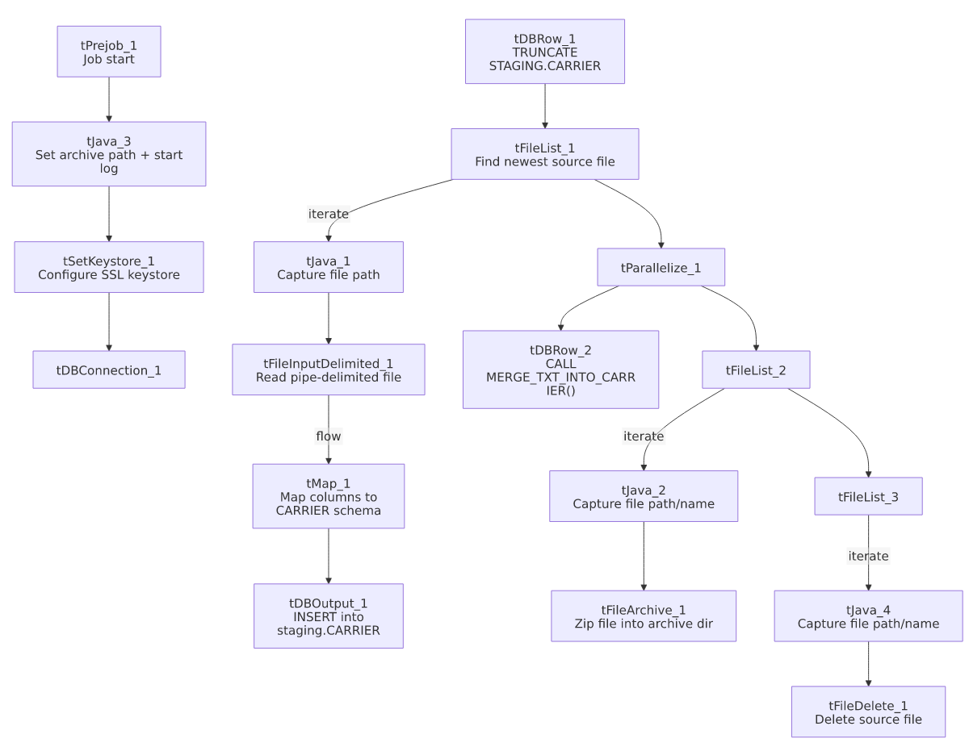

Settings tables

Source: `tFileInputDelimited_1`
Setting | Value | What it means
FILENAME | context.filePath | Reads whichever file tFileList_1 just found.
FIELDSEPARATOR | `\ | ~\
ROWSEPARATOR | `\ | $\
CSVROWSEPARATOR | \r\n | Fallback row separator if CSV mode is used (CSV_OPTION is false here, so this is largely inert).
HEADER | 1 | First line is a header row.
ENCODING | US-ASCII | Plain ASCII — same as cmi_Hermes_Recommendations_Load, unlike Address_Text_Load's ISO-8859-15.
SCHEMA_REJECT | repository schema "customer" | The reject-row schema reference points at a schema named "customer", not "carrier" — likely a copy-paste leftover from a template job (see Issues observed).
EXCLUDEFILEMASK (on tFileList_1) | *.txt | .txt files are skipped.

Target: `tDBOutput_1` (loads the Snowflake staging table)
Setting | Value | What it means
Table | CARRIER | Writes into a table named CARRIER.
Output action | INSERT | Adds rows only.
Table action | NONE | Doesn't create/drop/truncate the table — that's done separately by tDBRow_1.

Truncate step: `tDBRow_1`
Setting | Value | What it means
Query | TRUNCATE TABLE STAGING.CARRIER; | Empties the staging table before loading. Note the schema qualifier is STAGING, not LIQUID_STAGING as in most peer jobs — see Issues observed.

Merge step: `tDBRow_2`
Setting | Value | What it means
Query | CALL MERGE_TXT_INTO_CARRIER(); | Runs a Snowflake stored procedure (defined outside Talend) that folds the staged rows into the permanent table.

Dependencies & configuration
- Triggers/depends on other jobs: none found — no tRunJob links to or from any other job in the extracted metadata.
- Context variables used: context.sourceDir, context.archiveDir, context.filePath, context.fileName, context.logDir, context.keystorePath (all from the Directories_0.1 context group). It does not reference LEGACY_DW_0.1 variables directly — its Snowflake connection is the shared, repository-linked connection object (tDBConnection_1 / tSnowflakeConnection).
- Hardcoded values found: tFileInputDelimited_1.TEMP_DIR, tFileArchive_1.SOURCE_FILE, tFileDelete_1.DIRECTORY/PATH, and tSetKeystore_1.SSL_TRUSTSERVER_TRUSTSTORE are all fixed C:/... Windows paths rather than context variables — the same project-wide pattern seen in Address_Text_Load.

Glossary
Component type | Plain-English meaning
tPrejob / tParallelize | Job-flow control (see job_Address_Text_Load.md).
tFileList | Lists files in a folder for the job to loop over (see job_Address_Text_Load.md).
tFileInputDelimited | Reads a delimited text file row by row (see job_Address_Text_Load.md).
tMap | Maps/transforms columns (see job_Address_Text_Load.md).
tDBOutput / tSnowflakeOutput | Writes rows into a Snowflake table (see job_Address_Text_Load.md).
tDBRow / tSnowflakeRow | Runs a single SQL statement against Snowflake — here, TRUNCATE and CALL <procedure> (see job_Address_Text_Load.md).
tJava | Small custom Java code blocks for string/date/logging work (see job_Address_Text_Load.md).
tFileArchive | Zips a file into an archive location (see job_Address_Text_Load.md).
tFileDelete | Deletes a file from disk (see job_Address_Text_Load.md).
tSetKeystore | Configures the SSL keystore for the Snowflake connection (see job_Address_Text_Load.md).

Issues observed
- The truncate step targets a different schema than the load/merge steps imply. tDBRow_1 truncates STAGING.CARRIER, whereas the equivalent step in most peer jobs (e.g. Address_Text_Load, Insurance_Text_Load, DeskChangeHistory_Text_Load) truncates LIQUID_STAGING.<table>. It's not clear from this metadata whether STAGING is an alias/synonym for LIQUID_STAGING or a genuinely different schema — worth confirming with whoever owns the Snowflake schema layout, since a mismatch here would mean the truncate and the subsequent tDBOutput_1 insert are not necessarily hitting the same table.
- Reject-schema mismatch. tFileInputDelimited_1's SCHEMA_REJECT:REPOSITORY_SCHEMA_TYPE points at a repository schema named "customer" rather than a carrier-specific one — the same mismatched reference appears in Result_Table_Text_Load, cmi_Dialer_Plan_History_Table_Text_Load, and cmi_renkim_ReturnHistory_Text_Load, suggesting all four were built from the same copy-paste template and the reject schema was never updated. Low risk in practice (it only affects the shape of rejected-row metadata), but worth a cleanup pass.
- No merge-result checking. Unlike PatientInfo_Text_Load and cmi_Hermes_Recommendations_Load, this job has no tDie/tWarn reacting to whether MERGE_TXT_INTO_CARRIER() succeeded.
- Several hardcoded, machine-specific paths exist alongside the parameterized ones (see Dependencies & configuration) — the same project-wide pattern flagged in Address_Text_Load.

