Talend Job: Debtor_Table_Text_Load

Overview
This job loads debtor (consumer/account-holder) records into Snowflake, following the project's standard truncate → load → merge → archive/delete pattern. It stands out among this project's "text load" jobs because it runs the data through an encryption step (tDataEncrypt_1) before loading it to staging — the only one of this batch of 9 jobs to do so — reflecting that the DEBTOR_TXT table carries sensitive personal data (SSN, date of birth, portal password/salt, etc.).

Detail table
Field | Value
Job name | Debtor_Table_Text_Load
Version | 0.1
Project | LATITUDE
Author | jmach@harriscollect.com
Created | 2024-10-18T11:58:22.215-0700
Last Modified | 2026-05-26T11:52:52.066-0700

Step-by-step data flow
- Set up. tPrejob_1 → tJava_2 (appends today's date to context.archiveDir, opens a log file) → tSetKeystore_1 → tDBConnection_1.
- Empty the staging table. tDBRow_1 runs TRUNCATE TABLE DEBTOR_TXT; — notably without the LIQUID_STAGING. schema prefix that most peer jobs use.
- Find and read the file. tFileList_1 lists files in context.sourceDir (excluding *.txt); tJava_1 captures the path into context.filePath; tFileInputDelimited_1 reads it as a pipe-delimited file (|~| fields, |$| rows, quoted with ", header row, US-ASCII encoding, DIE_ON_ERROR set to false — unlike most peers).
- Copy, then encrypt, then map. tJavaRow_1 does a straight one-to-one copy of every input column to the output row (no transformation — likely just a schema pass-through step ahead of encryption). tDataEncrypt_1 then encrypts the row using AES (algorithm version 2) via a job-specific key file at context.cryptoPath; the exact column(s) encrypted are not visible in this metadata (see Issues observed). tMap_1 then adds LOAD_DT and maps everything onto the DEBTOR_TXT schema.
- Load staging. The mapped rows flow straight into tDBOutput_1, which inserts them into the staging table (no tFlowMeter row counter in this branch, unlike most peers).
- Merge and clean up — in parallel. tParallelize_1 splits into:
- Merge branch: tDBRow_2 runs CALL MERGE_TXT_INTO_DEBTORS(); — note the procedure name (DEBTORS, plural) doesn't match the staging table name (DEBTOR_TXT) or the job name (Debtor_Table_Text_Load).
- Cleanup branch: tFileList_2 → tJava_3 (captures path + name) → tFileArchive_1 (zips into context.archiveDir); and separately tFileList_3 → tJava_4 (captures path + name) → tFileDelete_1 (deletes the source file).
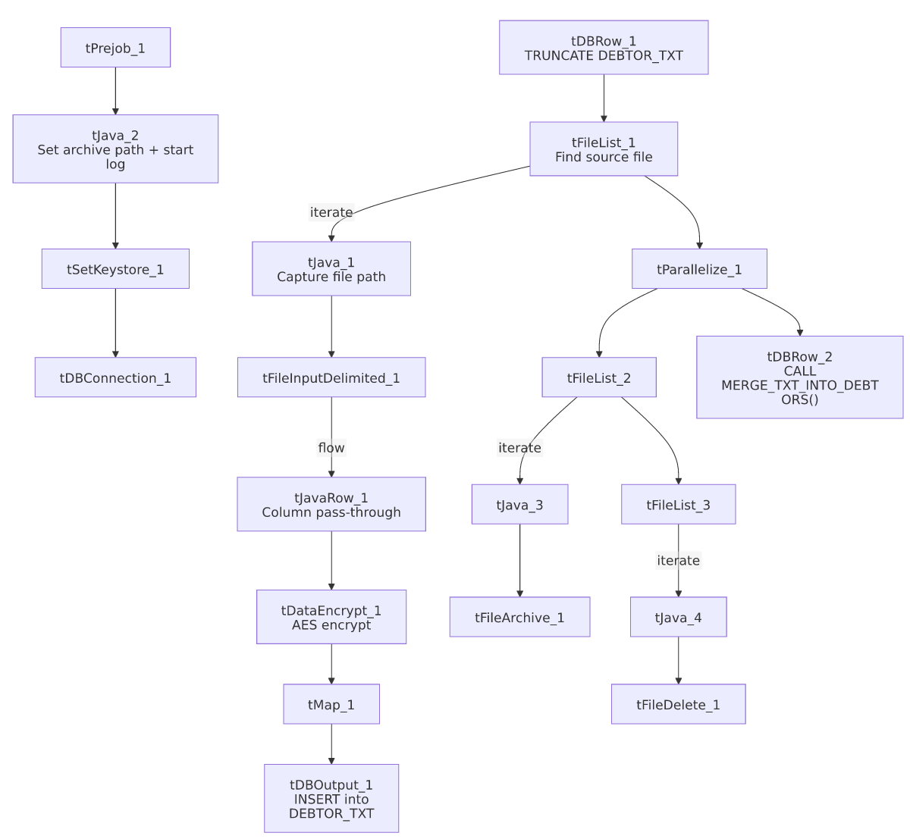

Settings tables

Source: `tFileInputDelimited_1`
Setting | Value | What it means
FILENAME | context.filePath | Reads whichever file tFileList_1 just found.
FIELDSEPARATOR / ROWSEPARATOR | `\ | ~\
ESCAPE_CHAR / TEXT_ENCLOSURE | " | Values may be quoted with double quotes (useful for fields like names/addresses that could contain the delimiter).
ENCODING | US-ASCII | Plain ASCII.
DIE_ON_ERROR | false | A malformed row is skipped/logged rather than failing the whole job — unlike Bankruptcy_Text_Load and cmi_CustomerGrouping_Text_Load, which set this to true.
TEMP_DIR | "C:/Talend-Studio-.../workspace" | Hardcoded Windows path.

Encryption step: `tDataEncrypt_1`
Setting | Value | What it means
CRYPTO_METHOD | AES | Symmetric encryption algorithm.
ALGO_VERSION | 2 | Talend's internal encryption-algorithm version.
CRYPTO_FILE_PATH | context.cryptoPath | Path to a key file used for encryption — this context variable does not appear in the Directories_0.1 group captured in _shared_context.json, so its actual value/location is unknown from this metadata (see Issues observed).
SECRET_KEY / PASSWORD_M1 / SECRET_TYPE | *(redacted)* | Encryption key material — not visible in this metadata.

Target: `tDBOutput_1`
Setting | Value | What it means
Table | DEBTOR_TXT | Loads into the staging copy of the debtor table.
Output action | INSERT | Adds rows only.
Table action | NONE | Table structure untouched.

Merge step: `tDBRow_2`
Setting | Value | What it means
Query | CALL MERGE_TXT_INTO_DEBTORS(); | Runs the Snowflake merge procedure — note the name mismatch with the table/job name (see Issues observed).

Dependencies & configuration
- Triggers/depends on other jobs: none found — no tRunJob links.
- Context variables used: context.sourceDir, context.archiveDir, context.filePath, context.fileName, context.logDir, context.keystorePath (all Directories_0.1), plus context.cryptoPath, which is not one of the variables captured in the Directories_0.1 group in _shared_context.json — its value can't be confirmed from the provided metadata. Uses the shared Snowflake connection object, not LEGACY_DW_0.1 variables directly.

Glossary
Component type | Plain-English meaning
tPrejob / tParallelize | Job-flow control (see job_Address_Text_Load.md).
tSnowflakeConnection (tDBConnection) | Opens the shared Snowflake connection (see job_Bankruptcy_Text_Load.md).
tFileList | Lists files for iteration (see job_Address_Text_Load.md).
tFileInputDelimited | Reads a delimited text file (see job_Address_Text_Load.md).
tJavaRow | Custom code that runs once per row (see job_cmi_Hermes_Recommendations_Load.md) — here used for a straight column-to-column copy ahead of encryption.
tDataEncrypt | Not covered in the reference docs. Encrypts the value of one or more columns in each row using a chosen algorithm (here AES) and a key sourced from an external file, before the row continues downstream. The specific column(s) it encrypts aren't visible in this metadata — the component's input and output schemas list the identical set of column names, so there's no way to tell from this extract which fields (most likely SSN, DOB, PORTALPASSWORD/PORTALPASSWORDSALT, or similar) are actually transformed versus passed through unchanged.
tMap | Maps/transforms columns (see job_Address_Text_Load.md).
tDBOutput / tSnowflakeOutput | Writes rows to Snowflake (see job_Address_Text_Load.md).
tDBRow / tSnowflakeRow | Runs a single SQL statement (see job_Address_Text_Load.md).
tJava | Custom Java code block (see job_Address_Text_Load.md).
tFileArchive | Zips a file into an archive location (see job_Address_Text_Load.md).
tFileDelete | Deletes a file (see job_Address_Text_Load.md).
tSetKeystore | Configures the SSL keystore (see job_Address_Text_Load.md).

Issues observed
- Which columns `tDataEncrypt_1` actually encrypts cannot be determined from this metadata. Given DEBTOR_TXT's schema includes SSN, DOB, PORTALPASSWORD, and PORTALPASSWORDSALT, it is plausible one or more of these are the encryption target, but this is an inference, not a confirmed fact — verify with the team or in Talend Studio directly.
- `context.cryptoPath` is referenced but not defined in the `Directories_0.1` context group captured in _shared_context.json — unlike every other context variable this job uses. Its actual dev/prod values are unknown from the provided metadata.
- Merge procedure name (`MERGE_TXT_INTO_DEBTORS`) doesn't match the staging table (`DEBTOR_TXT`) or the job name (`Debtor_Table_Text_Load`) — a naming inconsistency compared to peers where the procedure name mirrors the table name closely (e.g. MERGE_TXT_INTO_ADDRESS for the ADDRESS table).
- `TRUNCATE TABLE DEBTOR_TXT;` omits the `LIQUID_STAGING.` schema prefix that most peer jobs use explicitly — likely resolves the same way if the connection's default schema is LIQUID_STAGING, but worth confirming.
- No `tFlowMeter` row-count component in the load path, unlike most other Text_Load jobs in this project.
- Hardcoded, machine-specific paths on tSetKeystore_1, tFileInputDelimited_1.TEMP_DIR, tFileArchive_1.SOURCE_FILE, and tFileDelete_1.DIRECTORY/PATH — the same project-wide pattern seen elsewhere.

