Talend Job: Deceased_Text_Load

Overview
This job loads deceased-debtor records (SSNs, dates of death, executor/court/probate details) from a shared folder into Snowflake, following the project's standard truncate-load-merge-archive-delete pattern. It differs from most peers in one important way: before the rows reach Snowflake, they pass through an encryption step (tDataEncrypt_1) — appropriate given the sensitive SSN and probate data involved. It has no tDie/tWarn reacting to the merge outcome.

Detail table
Field | Value
Job name | Deceased_Text_Load
Version | 0.1
Project | LATITUDE
Author | *(blank in metadata — not recorded)*
Created | 2026-06-25T16:01:26.740-0700
Last Modified | 2026-06-25T16:25:55.828-0700

Step-by-step data flow
- Set up. tJava_1 appends today's date to context.archiveDir and starts a log file; tSetKeystore_1 configures the SSL keystore; tDBConnection_1 opens the Snowflake connection.
- Empty the staging table. tDBRow_1 runs TRUNCATE TABLE LIQUID_STAGING.DECEASED;.
- Find and read the file. tFileList_1 finds the newest matching file in context.sourceDir (skipping .txt files); tFileInputDelimited_1 reads it as a pipe-delimited (|~|/|$|), US-ASCII-encoded file with a header row. Unlike some peers, DIE_ON_ERROR is set to true here — a malformed row fails the job immediately rather than being routed to a reject flow.
- Encrypt. tDataEncrypt_1 runs the row set through an AES encryption step (CRYPTO_METHOD=AES, ALGO_VERSION=2) using a key file at context.cryptoPath. Its own secret-key and password settings are redacted in this metadata, and the extractor did not capture which specific column(s) it targets — see Issues observed.
- Transform. tMap_2 maps the (now partly encrypted) columns — SSN, name, DOB/DOD, executor and court/probate details — onto the target schema, adding LOAD_DT.
- Load staging. Mapped rows pass through a row counter (tFlowMeter_4) into tDBOutput_1, which inserts them into DECEASED in Snowflake (INSERT, no table-structure changes).
- Merge and clean up — in parallel. tParallelize_1 splits into two branches:
- Merge branch: tDBRow_2 runs CALL LIQUID_STAGING.MERGE_TXT_INTO_DECEASED(); (schema-qualified, unlike some peer jobs' unqualified merge calls). No tDie/tWarn reacts to the result.
- Cleanup branch: the source file is listed again, archived (tFileArchive_1, zipped into context.archiveDir), and — via a separate file-list/capture — deleted (tFileDelete_1).
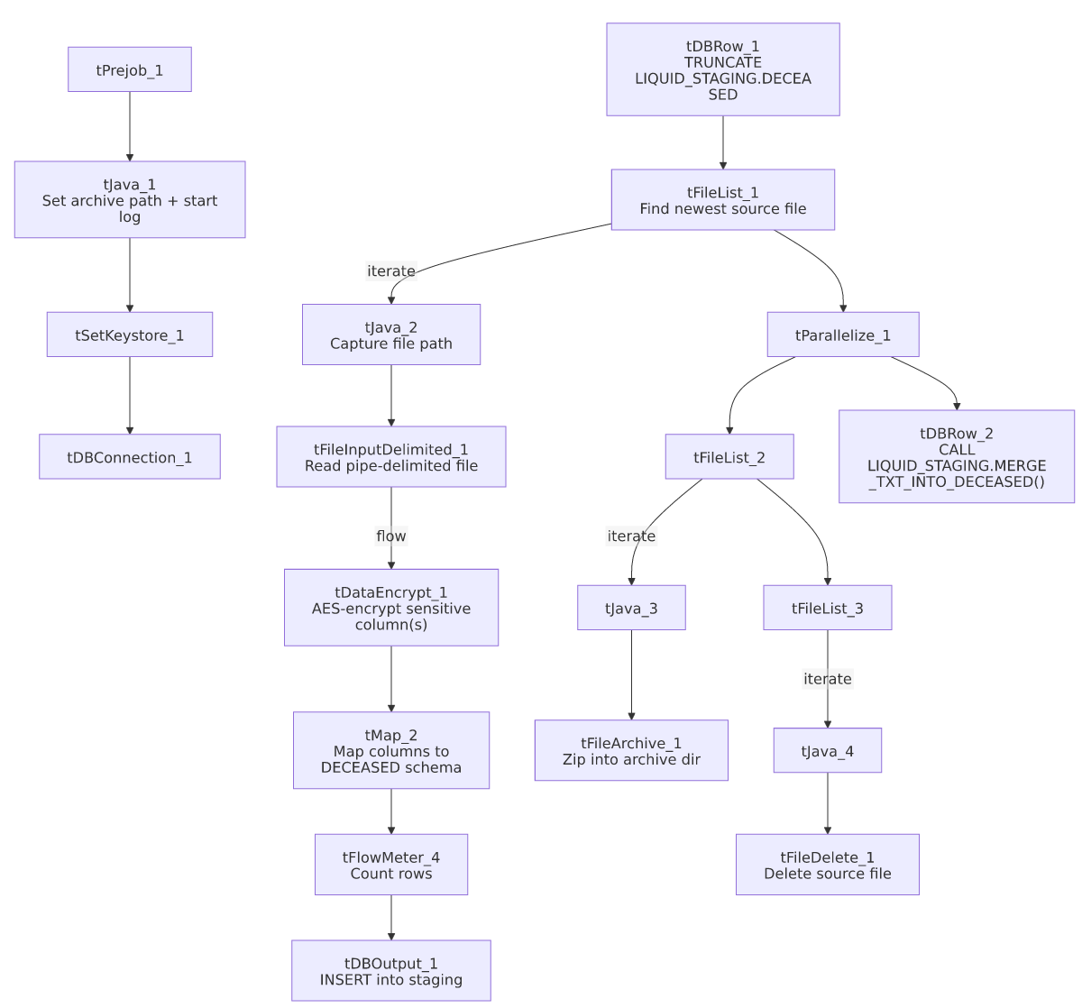

Settings tables

Source: `tFileInputDelimited_1`
Setting | Value | What it means
FILENAME | context.filePath | Reads whichever file tFileList_1 just found.
FIELDSEPARATOR / ROWSEPARATOR | `\ | ~\
HEADER | 1 | First line is a header row.
ENCODING | US-ASCII | Same as several peer jobs; not ISO-8859-15.
DIE_ON_ERROR | true | A malformed row fails the whole job rather than routing to a reject output.

Encryption: `tDataEncrypt_1`
Setting | Value | What it means
CRYPTO_METHOD | AES | Data is encrypted using AES.
ALGO_VERSION | 2 | Talend's internal encryption-algorithm version tag.
CRYPTO_FILE_PATH | context.cryptoPath | Path to the key/config file used for the encryption; this context variable does not appear in the Directories_0.1 group listed in _shared_context.json — see Issues observed.
SECRET_TYPE / SECRET_KEY / PASSWORD_M1 | ***REDACTED*** | The actual key material and password are redacted in this metadata extract and not available for documentation.

Target: `tDBOutput_1`
Setting | Value | What it means
Table | DECEASED | Staging copy of the deceased-debtor table (schema LIQUID_STAGING, per the preceding TRUNCATE).
Output action | INSERT | Adds rows only.
Table action | NONE | No table-structure changes; truncation handled separately.

Merge step: `tDBRow_2`
Setting | Value | What it means
Query | CALL LIQUID_STAGING.MERGE_TXT_INTO_DECEASED(); | Snowflake stored procedure that folds staged rows into the permanent table; its own logic is outside Talend.

Dependencies & configuration
- Triggers/depends on other jobs: none — no tRunJob links found.
- Context variables used: context.sourceDir, context.archiveDir, context.filePath, context.fileName, context.logDir, context.keystorePath (all Directories_0.1), plus context.cryptoPath — this last one is referenced by tDataEncrypt_1 but is not part of the Directories_0.1 group provided in _shared_context.json; its actual value/location could not be confirmed from the metadata given.
- It uses the shared Snowflake connection object (tDBConnection_1), not LEGACY_DW_0.1 variables directly — context_vars_referenced contains no LEGACY_DW_ entries.

Glossary
Component type | Plain-English meaning
tPrejob / tParallelize | Job-flow control (see job_Address_Text_Load.md).
tFileList | Lists files in a folder to loop over (see job_Address_Text_Load.md).
tFileInputDelimited | Reads a delimited text file row by row (see job_Address_Text_Load.md).
tMap | Maps/transforms input columns to output columns (see job_Address_Text_Load.md).
tFlowMeter | Counts rows passing through, for logging (see job_Address_Text_Load.md).
tDBOutput / tSnowflakeOutput | Writes rows into a Snowflake table (see job_Address_Text_Load.md).
tDBRow / tSnowflakeRow | Runs a single SQL statement against Snowflake (see job_Address_Text_Load.md).
tJava / tJavaRow | Custom Java code snippets (see job_Address_Text_Load.md).
tFileArchive | Zips a file into an archive location (see job_Address_Text_Load.md).
tFileDelete | Deletes a file from disk (see job_Address_Text_Load.md).
tSetKeystore | Configures the SSL keystore for the Snowflake connection (see job_Address_Text_Load.md).
tDataEncrypt | Encrypts one or more fields in the row flow using a configured algorithm and key file, before the data reaches its destination — the counterpart to Talend's tDataDecrypt. Not used in any of the 3 reference docs; this is the first job in this set to include it.

Issues observed
- Author field is blank. Unlike every other job documented in this batch, Deceased_Text_Load's metadata has no author recorded — worth checking whether this reflects a different creation process (e.g., copied from a template) or simply a missed field.
- `context.cryptoPath` is used but undocumented. tDataEncrypt_1 depends on context.cryptoPath for its key file, but this variable is not part of the Directories_0.1 context group provided in _shared_context.json (which only lists sourceDir, filePath, archiveDir, fileName, logDir, keystorePath). Its actual dev/prod values are unknown from this metadata — verify with the team.
- Which column(s) get encrypted isn't captured in this metadata. tDataEncrypt_1's schema carries the full row (SSN, names, dates, court/executor fields), but the component's own field-level encryption targeting isn't visible in the extracted parameters — most likely SSN given the sensitivity of the data, but this should be confirmed directly in Talend Studio before relying on it.
- Same standard hardcoded paths as most peer jobs (tFileInputDelimited_1.TEMP_DIR, tFileArchive_1.SOURCE_FILE, tFileDelete_1.DIRECTORY/PATH, tSetKeystore_1.SSL_TRUSTSERVER_TRUSTSTORE).
- No `tDie`/`tWarn` on the merge step — a failed merge surfaces only as a generic Talend error.

