Talend Job: Export_File_Check

Overview
Unlike the other jobs documented so far, this one doesn't load any data itself — it's a gatekeeper. It waits for an upstream process to finish exporting the day's Latitude data (signaled by a specific "done" marker file appearing in the shared source folder) and only then lets whatever runs next proceed. If that marker file never shows up within a set window, it emails a notification and fails the job on purpose, so someone finds out the export never happened.

Detail table
Field | Value
Job name | Export_File_Check
Version | 0.1
Project | LATITUDE
Author | jmach@harriscollect.com
Created | 2025-04-21T10:16:45.638-0700
Last Modified | 2026-07-20T16:18:20.070-0700

Step-by-step data flow
- Set up logging. tJava_1 opens a log file for this run in context.logDir.
- Wait for the marker file. tWaitForFile_1 watches context.sourceDir for a file matching *_zz-done.csv to be created. It checks every 500ms, and gives up after 240 checks of up to 60 seconds each (up to roughly 4 hours total) if nothing appears.
- If the file appears in time: the job continues down the success path.
- If it times out (`COMPONENT_ERROR`): the job continues down the failure path instead.
- Success path: tJava_2 captures the file's name and path from the wait step into context.fileCreated/context.fileName, then tFileCopy_1 copies/renames that file within context.sourceDir, appending .bak to the filename (and removing the original, per its REMOVE_FILE/REPLACE_FILE settings) — effectively marking the marker file as "seen" so it isn't picked up as new again.
- Failure path: tJava_3 captures the wait step's error message into context.errorMsg, tSendMail_1 emails jmach@harriscollect.com with the subject "Latitude export failure to start notification" and a body reading "The Latitude export to Snowflake failed to start: " + context.errorMsg, and then tDie_1 fails the job with exit code 4 and the message "No Latitude export files to load into Snowflake!".
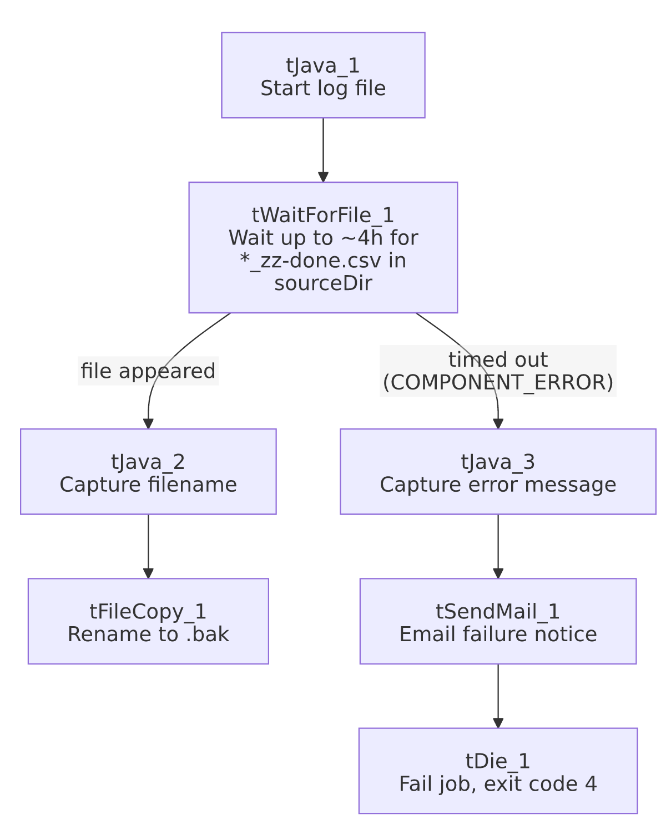

Settings tables

Watcher: `tWaitForFile_1`
Setting | Value | What it means
DIRECTORY | context.sourceDir | Watches the same shared folder every load job reads from.
FILEMASK | *_zz-done.csv | Only a file whose name ends in _zz-done.csv counts as "the export finished" — an explicit completion marker, not the data file itself.
ACTION_ON / THEN | filecreated / exitloop | Stops waiting as soon as a matching file is created (doesn't wait for it to be modified or deleted).
WAIT / MAX_ITERATIONS | 60 (seconds) / 240 | Checks every 60 seconds, up to 240 times — about 4 hours maximum before giving up.
INTERVAL_CHECK | 500 (ms) | Polls the folder every half-second while waiting for the next 60-second check window.

Alert: `tSendMail_1` (failure path only)
Setting | Value | What it means
TO / FROM | jmach@harriscollect.com / svc_analytics@harriscollect.com | Sent to one person's mailbox from a shared service account.
SUBJECT | "Latitude export failure to start notification"
MESSAGE | "The Latitude export to Snowflake failed to start: " + context.errorMsg | Includes the actual error text captured from the timed-out wait step.
DIE_ON_ERROR | true | If sending the email itself fails, that failure stops the job too — there's no "log and continue" fallback if the mail server is unreachable.

Dependencies & configuration
- Triggers/depends on other jobs: none found — no tRunJob links. Whatever schedules the rest of the LATITUDE load jobs to run only after this one succeeds is external to Talend (not visible in this metadata).
- Context variables used: context.sourceDir, context.logDir (from Directories_0.1), plus job-local variables errorMsg, fileCreated, fileName set during the run.
- Alert recipient is a single named individual (jmach@harriscollect.com), not a distribution list or team alias — see Issues observed.

Glossary
Component type | Plain-English meaning
tWaitForFile | Pauses the job, checking a folder repeatedly, until a file matching a given pattern shows up (or a timeout is reached).
tFileCopy | Copies (and optionally renames or removes the original) a file — used here to mark the "done" file as already handled.
tSendMail | Sends an email — used here purely as a failure alert, with no data attached.
tDie | Fails the job immediately with a specific message and exit code.

Issues observed
- The failure alert goes to one named person's mailbox, not a shared team alias or distribution list. If that person is unavailable, a genuine export failure could go unnoticed until someone checks the job log directly.
- The 4-hour wait window is hardcoded (WAIT=60, MAX_ITERATIONS=240) rather than driven by a context variable — if the expected export timing ever changes, this has to be edited directly in the job rather than via configuration.
- No corresponding "everything's fine" notification — the job is silent on the success path (it only emails on failure), so there's no positive confirmation in this job that the gate passed; that has to be inferred from whatever runs next actually starting.

