Talend Job: Hermes_Latitude_Recommendations

Overview
Unlike most jobs in this project, this one runs in reverse: it reads contact-channel recommendation data out of Snowflake (which channel — call, text, VoApps voice message, etc. — to try next for a given account/phone number) and writes it out to a CSV file for an external system (Hermes) to pick up. It is a short, simple job with no file-watching, no staging table, no merge step, and no archiving — just a query and a file write.

Detail table
Field | Value
Job name | Hermes_Latitude_Recommendations
Version | 0.1
Project | LATITUDE
Author | jmach@harriscollect.com
Created | 2025-03-26T09:18:27.296-0700
Last Modified | 2026-02-05T12:12:45.917-0800

Step-by-step data flow
- Set up. tSetKeystore_1 configures the SSL keystore used for the Snowflake connection.
- Query Snowflake. tDBInput_1 runs a SELECT against EDWPRODHH.HERMES.MASTER_PREDICTION_PROPOSAL_LATITUDE, pulling NUMBER, PROPOSED_CHANNEL, TEMPLATE, PHONE_NUMBER, SUBTEAM, TEXT_TYPE, SETTLEMENT_AMT, and several VoApps-specific columns (target date, caller number, message ID, zip code, voice-append flag) plus HERMES_REQUEST_ID. Note the database and schema (EDWPRODHH.HERMES) are written directly into the SQL text rather than built from a context variable — see Issues observed.
- Write the file. tDBInput_1's output flows (MAIN, not FLOW — a labeling detail specific to this job) into tFileOutputDelimited_1, which writes a comma-separated file named master_prediction_proposal_latitude_<CCYYMMDD>.csv into context.outputDir, with a header row, encoded ISO-8859-15.
There is no tPrejob, no file list/watch, no staging table, no merge call, and no archive/delete step — this job simply extracts and writes once per run.
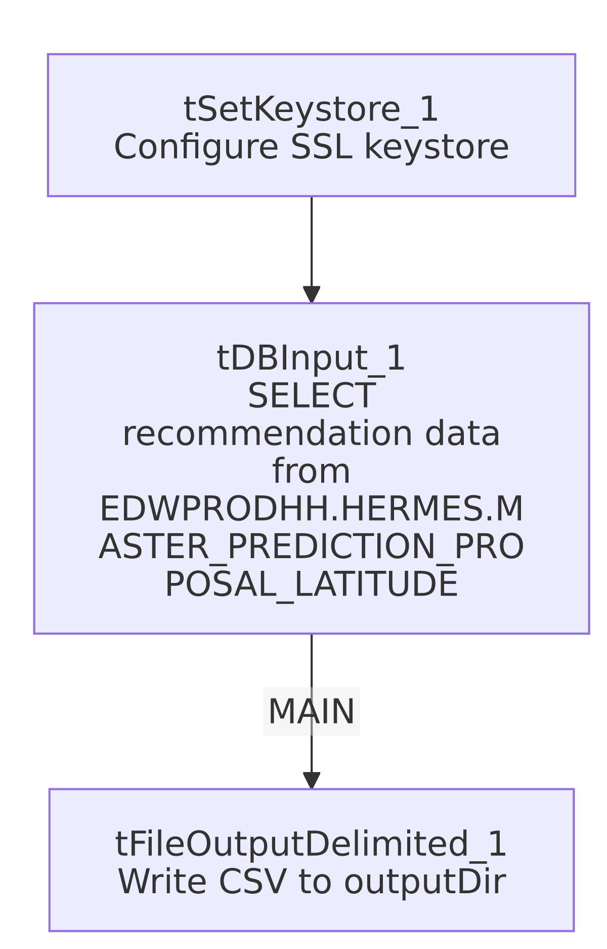

Settings tables

Source: `tDBInput_1` (queries Snowflake)
Setting | Value | What it means
Query | SELECT "NUMBER", PROPOSED_CHANNEL, TEMPLATE, PHONE_NUMBER, SUBTEAM, TEXT_TYPE, SETTLEMENT_AMT, VOAPPS_TARGET_DATE, VOAPPS_CALLER_NUMBER, VOAPPS_MESSAGE_ID, VOAPPS_ZIP_CODE, VOAPPS_VOICE_APPEND, HERMES_REQUEST_ID FROM EDWPRODHH.HERMES.MASTER_PREDICTION_PROPOSAL_LATITUDE; | Reads recommendation rows from a fully-qualified, hardcoded Snowflake table path rather than a repository-mapped table reference.

Target: `tFileOutputDelimited_1` (writes the export file)
Setting | Value | What it means
FILENAME | context.outputDir + "master_prediction_proposal_latitude_" + TalendDate.getDate("CCYYMMDD") + ".csv" | Output file is named with today's date, written to context.outputDir (a context variable not found in the Directories_0.1 group provided — see Issues observed).
FIELDSEPARATOR | , | Plain comma-separated, unlike the pipe-delimited (`\
INCLUDEHEADER | true | The output file has a header row.
ENCODING | ISO-8859-15 | Western European encoding, matching most load jobs' input encoding.
APPEND | false | Each run overwrites rather than appends to the file.

Dependencies & configuration
- Triggers/depends on other jobs: none found — no tRunJob links.
- Context variables used: context.keystorePath, context.outputDir. Neither sourceDir/archiveDir/fileName/logDir (typical of load jobs) nor any LEGACY_DW_ variable is referenced. context.outputDir does not appear in the Directories_0.1 context group supplied in _shared_context.json (which lists sourceDir, filePath, archiveDir, fileName, logDir, keystorePath only) — its dev/prod values could not be confirmed from the provided metadata.
- Snowflake connection: no separate tDBConnection component appears in this job's component list; tDBInput_1 (a tSnowflakeInput) carries its own embedded connection configuration. context_vars_referenced shows no LEGACY_DW_ variables, so it does not appear to reference the legacy data-warehouse context group directly — though the query text itself hardcodes the database/schema name EDWPRODHH.HERMES (see Issues observed).

Glossary
Component type | Plain-English meaning
tSetKeystore | Configures the SSL keystore for the Snowflake connection (see job_Address_Text_Load.md).
tSnowflakeInput (tDBInput) | Runs a SELECT query against Snowflake and streams the results into the job as rows — the mirror image of tSnowflakeOutput/tDBOutput, which writes rows *into* Snowflake. Not used in any of the 3 reference docs; this is the first export-style job in this batch.
tFileOutputDelimited | Writes rows out to a delimited text file (the mirror image of tFileInputDelimited). Not used in any of the 3 reference docs.

Issues observed
- The source database/schema is hardcoded directly in the SQL text (EDWPRODHH.HERMES.MASTER_PREDICTION_PROPOSAL_LATITUDE) rather than built from a context variable, even though LEGACY_DW_db (EDWPRODHH) exists as a context variable in _shared_context.json. If the underlying database is ever renamed or the job is pointed at a different environment, this query has to be edited directly rather than via configuration.
- `context.outputDir` is used but not documented in the Directories_0.1 context group provided — its actual folder path(s) are unknown from this metadata; verify with the team or Talend Studio directly.
- No archiving, deletion, or merge/reconciliation step — this is a pure one-shot extract-and-write job, so none of the usual "Issues" caveats about MERGE_TXT_INTO_* procedures or hardcoded workspace paths apply here.

