Talend Job: LetterRequest_Table_Text_Load

Overview
This job loads letter-request records (collection letters queued or sent for accounts — letter type, due date, amount due, processing status, and related IDs) into Snowflake. It follows the standard LATITUDE text-load pattern exactly: truncate the staging table, read and map the source file, insert into staging, merge into the permanent table, then archive and delete the source file.

Detail table
Field | Value
Job name | LetterRequest_Table_Text_Load
Version | 0.1
Project | LATITUDE
Author | jmach@harriscollect.com
Created | 2024-10-24T08:48:53.448-0700
Last Modified | 2025-09-30T19:55:44.115-0700

Step-by-step data flow
- Set up. tPrejob_1 triggers tJava_2, which appends today's date to context.archiveDir and opens a log file; this chains into tSetKeystore_1 and tDBConnection_1.
- Empty the staging table. tDBRow_1 runs TRUNCATE TABLE LETTERREQUEST_TXT; (again, no explicit schema prefix — see Issues observed).
- Find the file. tFileList_1 lists files in context.sourceDir (skipping *.txt), with no explicit sort order (ORDER_BY_NOTHING: true).
- Read and reshape the file. tFileInputDelimited_1 reads the file as pipe-delimited (|~|/|$|), US-ASCII encoded, with a header row, covering letter request ID, account ID, letter/customer codes, due date, amount due, processing method, 24 "SifPmt" fields (payment-schedule-related), and delivery flags. tMap_1 maps these onto the LETTERREQUEST_TXT schema, adding LOAD_DT.
- Load staging. Mapped rows flow directly into tDBOutput_1 (no row-counter component on this path), inserting into LETTERREQUEST_TXT.
- Merge and clean up — in parallel. Once the file-list subjob completes, tParallelize_1 splits into: tDBRow_2 calling CALL MERGE_TXT_INTO_LETTERREQUEST();, and a file-listing chain (tFileList_2 → archive via tFileArchive_1; then tFileList_3 → delete via tFileDelete_1).
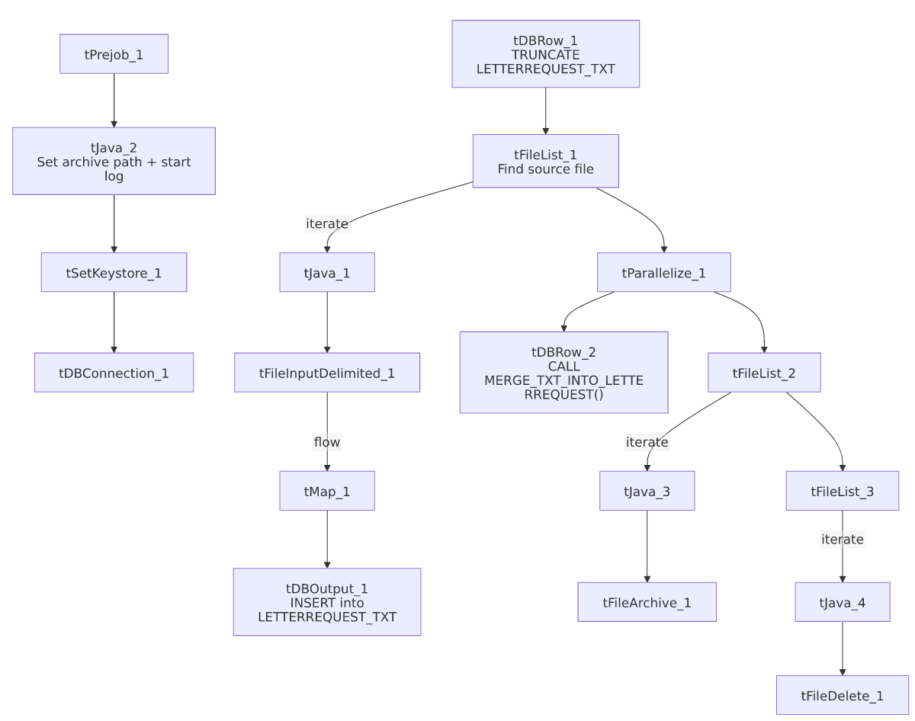

Settings tables

Source: `tFileInputDelimited_1`
Setting | Value | What it means
FILENAME | context.filePath | Reads whichever file tFileList_1 just found.
FIELDSEPARATOR / ROWSEPARATOR | `\ | ~\
HEADER | 1 | First line is a header.
ENCODING | US-ASCII | Plain ASCII text.

Target: `tDBOutput_1`
Setting | Value | What it means
Table | LETTERREQUEST_TXT | Staging table for letter requests.
Output action | INSERT | Adds rows only — the merge step handles updates.
Table action | NONE | Truncation handled separately by tDBRow_1.

Merge step: `tDBRow_2`
Setting | Value | What it means
Query | CALL MERGE_TXT_INTO_LETTERREQUEST(); | Snowflake procedure that folds staged rows into the permanent LETTERREQUEST table.

Dependencies & configuration
- Triggers/depends on other jobs: none found — no tRunJob links.
- Context variables used: context.sourceDir, context.archiveDir, context.filePath, context.fileName, context.logDir, context.keystorePath (all Directories_0.1). Uses the shared Snowflake connection object, not LEGACY_DW_* variables directly.
- Hardcoded values found: tFileInputDelimited_1.TEMP_DIR, tFileArchive_1.SOURCE_FILE, tFileDelete_1.DIRECTORY/PATH, and tSetKeystore_1.SSL_TRUSTSERVER_TRUSTSTORE are fixed Windows/local paths rather than context variables.

Glossary
Component type | Plain-English meaning
tPrejob / tParallelize | Setup-before-main-start, concurrent branches (see job_Address_Text_Load.md).
tFileList | Lists files for the job to loop over (see job_Address_Text_Load.md).
tFileInputDelimited | Reads a delimited text file (see job_Address_Text_Load.md).
tMap | Maps/transforms columns (see job_Address_Text_Load.md).
tDBOutput / tSnowflakeOutput | Writes rows into Snowflake (see job_Address_Text_Load.md).
tDBRow / tSnowflakeRow | Runs a single SQL statement (see job_Address_Text_Load.md).
tJava | Custom Java code block (see job_Address_Text_Load.md).
tFileArchive | Zips a file into an archive location (see job_Address_Text_Load.md).
tFileDelete | Deletes a file from disk (see job_Address_Text_Load.md).
tSetKeystore | Configures the SSL keystore for the Snowflake connection (see job_Address_Text_Load.md).

Issues observed
- The staging truncate doesn't qualify its schema (TRUNCATE TABLE LETTERREQUEST_TXT; with no LIQUID_STAGING. prefix) — same pattern seen in Customer_Table_Text_Load; likely relies on the connection's default schema, but worth confirming.
- No row-count logging — no tFlowMeter component between tMap_1 and tDBOutput_1, unlike some peer jobs.
- `tFileDelete_1.FAILON` is `false` here, meaning a failed delete of the source file won't fail the job — worth being aware of if source files are unexpectedly reprocessed.
- Several hardcoded, machine-specific paths exist — see Dependencies & configuration.
- The merge procedure's own logic is outside Talend and not visible in this metadata.

