Talend Job: Livevox_Daily_Load

Overview
This job loads daily call-detail records from LiveVox (the project's outbound dialer platform) into Snowflake. It shares the project's general shape — truncate staging, load, merge, clear the source file — but deviates from the standard "text load" pattern in several ways: the source file is tab-delimited (not the project's usual |~|/|$| pipe format), it reads from a different context variable (context.sourceRoot instead of context.sourceDir), it has no archive-then-delete two-step (a single tFileCopy does both), and its merge-result check only ever logs a warning — there's no failure path.

Detail table
Field | Value
Job name | Livevox_Daily_Load
Version | 0.1
Project | LATITUDE
Author | jmach@harriscollect.com
Created | 2025-02-10T09:57:45.302-0800
Last Modified | 2025-10-01T10:00:50.577-0700

Step-by-step data flow
- Set up. tPrejob_1 → tJava_3 (opens a log file only — unlike most peers, this job does not append a date to context.archiveDir here) → tSetKeystore_1 → tDBConnection_1.
- Empty the staging table. tDBRow_2 runs TRUNCATE TABLE LIQUID_STAGING.LIVEVOX_CALLS;.
- Find and read the file. tFileList_1 lists files in context.sourceRoot (excluding *.txt); tJava_1 captures the path into context.filePath; tFileInputDelimited_1 reads it — tab-delimited (\t fields, \n rows), header row, US-ASCII encoding, DIE_ON_ERROR=false.
- Load staging. Rows pass through tFlowMeter_3 into tDBOutput_1, which inserts them into LIVEVOX_CALLS (no tMap step in this branch — the file's columns appear to map straight onto the staging schema without an explicit transform component).
- Merge and log the result. Once tFileList_1 completes, tDBRow_3 runs CALL LIQUID_STAGING.MERGE_INTO_LIVEVOX(); — note the procedure name doesn't follow the project's usual MERGE_TXT_INTO_<TABLE> convention. Its single-column result (RETVALUE) flows through tMap_1 to tWarn_1, which logs "Return Code from merge by refnum: " + <RETVALUE> (severity code 42) — there is no `tDie` component reacting to a failed merge, unlike cmi_Hermes_Recommendations_Load's equivalent pattern.
- Clear the source file. tDBRow_3's success also triggers tFileList_2 (again on context.sourceRoot), which for each file found runs tFileCopy_1 — copying it into context.archiveDir and removing the original (REMOVE_FILE=true, REPLACE_FILE=true) in a single step. There is no separate zip/archive component and no separate delete component in this job.
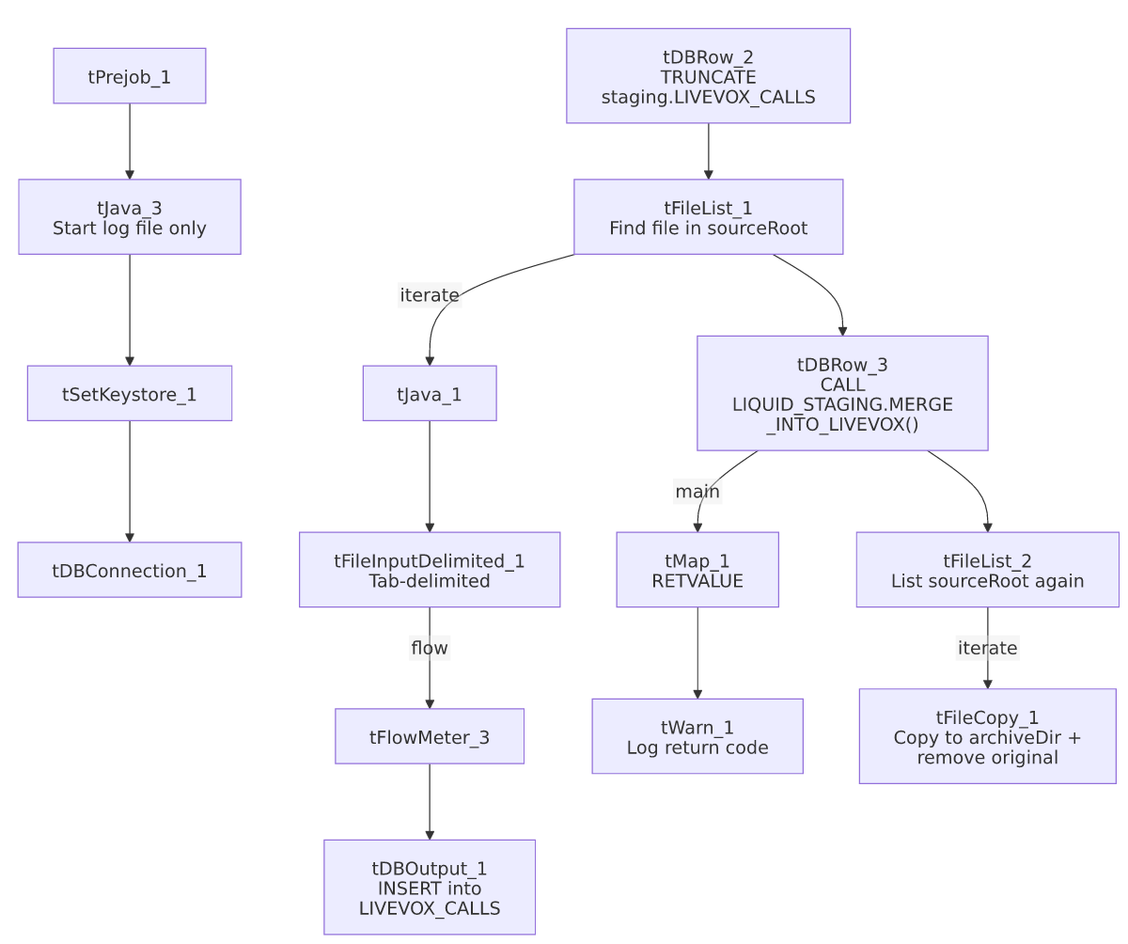

Settings tables

Source: `tFileInputDelimited_1`
Setting | Value | What it means
FILENAME | context.filePath | Reads whichever file tFileList_1 just found.
DIRECTORY (on tFileList_1) | context.sourceRoot | Not context.sourceDir like every other job in this batch — a different, job-specific source folder.
FIELDSEPARATOR / ROWSEPARATOR | \t / \n | Tab-delimited with plain newline rows — the project's only job among these 9 that doesn't use the `\
ENCODING | US-ASCII | Plain ASCII.
DIE_ON_ERROR | false | A malformed row is skipped/logged rather than failing the job.
TEMP_DIR | "C:/Talend-Studio-.../workspace" | Hardcoded Windows path.

Target: `tDBOutput_1`
Setting | Value | What it means
Table | LIVEVOX_CALLS | Loads into the staging copy of the call-log table.
Output action | INSERT | Adds rows only.
Table action | NONE | Table structure untouched.

Merge & result log: `tDBRow_3` → `tMap_1` → `tWarn_1`
Setting | Value | What it means
Query (tDBRow_3) | CALL LIQUID_STAGING.MERGE_INTO_LIVEVOX(); | Runs the Snowflake merge procedure — note the name (MERGE_INTO_LIVEVOX) breaks the project's usual MERGE_TXT_INTO_<TABLE> naming convention (no TXT, and the table itself is LIVEVOX_CALLS, not LIVEVOX).
tWarn_1 message | "Return Code from merge by refnum: " + RETVALUE (severity 42) | Logs whatever value the procedure returns — this happens regardless of whether the merge actually succeeded or failed, since there's no tDie branch.

Cleanup: `tFileCopy_1`
Setting | Value | What it means
DESTINATION | context.archiveDir | Copies the raw (unzipped) source file straight into the archive folder.
REMOVE_FILE / REPLACE_FILE | true / true | The original is deleted from sourceRoot once copied — functioning as a combined archive+delete step.
SOURCE_DERECTORY | *(same value as FILENAME, a full file path)* | This parameter is meant to hold a directory, but is set to the same expression as FILENAME (a full path); it has no effect here because ENABLE_COPY_DIRECTORY is false, but it looks like a copy/paste leftover.

Dependencies & configuration
- Triggers/depends on other jobs: none found — no tRunJob links.
- Context variables used: context.sourceRoot, context.filePath, context.archiveDir, context.logDir, context.keystorePath. Notably, context.sourceRoot is not one of the Directories_0.1 variables captured in _shared_context.json (which only lists sourceDir, filePath, archiveDir, fileName, logDir, keystorePath) — its actual dev/prod values are unknown from the provided metadata. This job also never references context.fileName at all.
- `LEGACY_DW_*` usage: the project-wide background notes for this documentation effort flag Livevox_Daily_Load as one of only three jobs that reference LEGACY_DW_0.1 context variables directly (bypassing the shared connection object). However, this job's own extracted metadata does not show that: tDBConnection_1's parameters are empty, and no LEGACY_DW_ prefixed variable appears anywhere in this job's JSON (checked directly, not just in context_vars_referenced). This may simply mean the connection details aren't captured in this extract format — worth confirming directly in Talend Studio rather than relying on this write-up for that specific question.

Glossary
Component type | Plain-English meaning
tPrejob | Job-flow control marking setup steps (see job_Address_Text_Load.md).
tSnowflakeConnection (tDBConnection) | Opens the shared Snowflake connection (see job_Bankruptcy_Text_Load.md).
tFileList | Lists files for iteration (see job_Address_Text_Load.md).
tFileInputDelimited | Reads a delimited text file (see job_Address_Text_Load.md).
tFlowMeter | Counts rows passing through (see job_Address_Text_Load.md).
tDBOutput / tSnowflakeOutput | Writes rows to Snowflake (see job_Address_Text_Load.md).
tDBRow / tSnowflakeRow | Runs a single SQL statement (see job_Address_Text_Load.md).
tMap | Maps/transforms columns (see job_Address_Text_Load.md) — here used just to carry the procedure's single RETVALUE result column through to the warning log.
tWarn | Logs a warning without failing the job (see job_cmi_Hermes_Recommendations_Load.md).
tJava | Custom Java code block (see job_Address_Text_Load.md).
tFileCopy | Copies (and here, also removes the original of) a file (see job_Export_File_Check.md).
tSetKeystore | Configures the SSL keystore (see job_Address_Text_Load.md).

Issues observed
- No failure path on a failed merge. Unlike cmi_Hermes_Recommendations_Load's tDie/tWarn pair, this job only ever logs the procedure's return value via tWarn_1 — there's no component that fails the job if MERGE_INTO_LIVEVOX() reports an error. A failed merge here could go unnoticed unless someone reads the log.
- Merge procedure name (`MERGE_INTO_LIVEVOX`) breaks the project's naming convention used elsewhere (MERGE_TXT_INTO_<TABLE>), and doesn't match the actual table name (LIVEVOX_CALLS).
- Uses `context.sourceRoot` instead of `context.sourceDir`, and that variable isn't part of the Directories_0.1 context group captured in _shared_context.json — its dev/prod values can't be confirmed here.
- No archive/zip step — the source file is moved to context.archiveDir unzipped via tFileCopy_1, unlike every other Text_Load job reviewed, which zip the file via tFileArchive before deleting it.
- `tFileCopy_1.SOURCE_DERECTORY` is set to a file path expression, not a directory — likely a copy/paste artifact, though it has no effect since directory-copy mode is disabled.
- Does not append a date subfolder to `context.archiveDir` the way most peer jobs do (context.archiveDir = context.archiveDir + <date> + "/") — files of different days may land in the same archive folder without date-based separation.
- File format itself (tab-delimited, not the project's `\|~\|`/`\|$\|` convention) and the `LEGACY_DW_*` connection question noted above are both worth a quick confirmation with the team, since they diverge from what's assumed elsewhere in this documentation effort.

