Talend Job: Master_Config_Val_Segs_Export

Overview
Like Hermes_Latitude_Recommendations, this job reads data out of Snowflake and writes it to a file, rather than the usual load-into-Snowflake pattern. It exports the MASTER_CONFIG_VALSEGMENTS table (client codes paired with a maximum segment number — likely a collections/valuation-segmentation configuration table) to a dated CSV file. It is a minimal, two-step job with no file-watching, staging, merge, or cleanup logic.

Detail table
Field | Value
Job name | Master_Config_Val_Segs_Export
Version | 0.1
Project | LATITUDE
Author | jmach@harriscollect.com
Created | 2026-05-12T15:33:49.566-0700
Last Modified | 2026-05-12T15:36:37.011-0700

Step-by-step data flow
- Set up. tSetKeystore_1 configures the SSL keystore for the Snowflake connection.
- Read the table. tDBInput_1 (a tSnowflakeInput) is configured to read directly from the MASTER_CONFIG_VALSEGMENTS table (via the component's table selector, not a hand-written query), returning just two columns: CLIENT and MAX_SEGMENT.
- Write the file. The result flows (MAIN) into tFileOutputDelimited_1, which writes a comma-separated file named master_config_valsegments_<CCYY-MM-DD>.csv into context.outputDir. Unlike Hermes_Latitude_Recommendations's export file, this one is written without a header row (INCLUDEHEADER = false).
There is no tPrejob, file-watching, staging table, merge call, or archive/delete step.
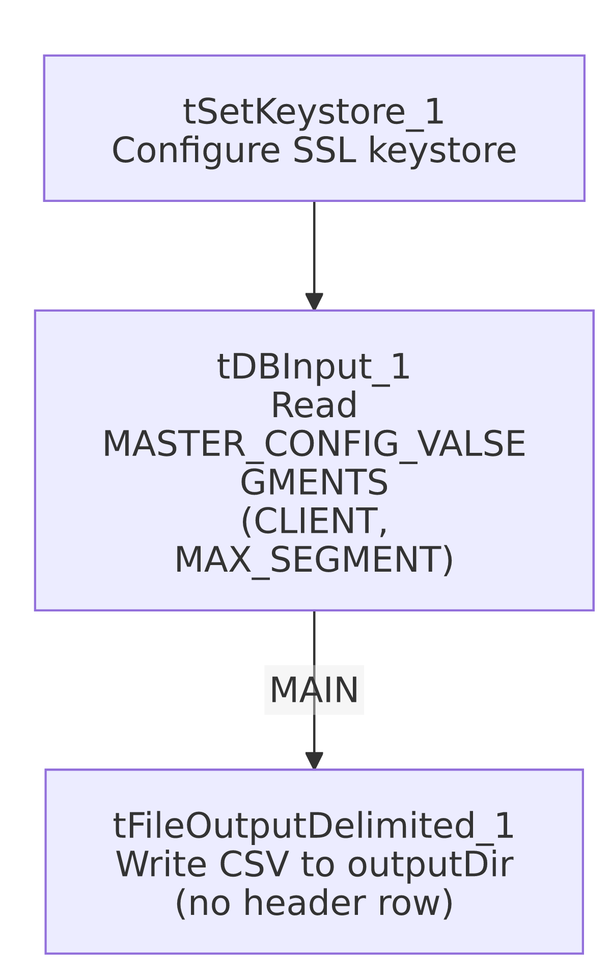

Settings tables

Source: `tDBInput_1` (reads Snowflake)
Setting | Value | What it means
Table | MASTER_CONFIG_VALSEGMENTS | Read via the component's table selector rather than a custom SELECT statement (contrast with Hermes_Latitude_Recommendations, which uses a hand-written query).
Columns | CLIENT, MAX_SEGMENT | Only two columns are pulled — a client identifier and what appears to be a maximum segment number for that client.

Target: `tFileOutputDelimited_1` (writes the export file)
Setting | Value | What it means
FILENAME | context.outputDir + "master_config_valsegments_" + TalendDate.getDate("CCYY-MM-DD") + ".csv" | Dated output file written to context.outputDir.
FIELDSEPARATOR | , | Plain comma-separated.
INCLUDEHEADER | false | No header row — differs from Hermes_Latitude_Recommendations's export, which does include one. Anything consuming this file needs to know the column order in advance.
ENCODING | ISO-8859-15 | Western European encoding.
APPEND | false | Overwrites rather than appends each run.

Dependencies & configuration
- Triggers/depends on other jobs: none found — no tRunJob links.
- Context variables used: context.keystorePath, context.outputDir only. As with Hermes_Latitude_Recommendations, context.outputDir is not part of the Directories_0.1 group provided in _shared_context.json.
- Shared Snowflake connection vs. `LEGACY_DW_*`: this job is called out in the project-wide background as one of only three jobs (alongside Master_Prediction_Scores_Export and Livevox_Daily_Load) expected to reference the LEGACY_DW_0.1 context group directly rather than using the shared connection object. However, the `context_vars_referenced` list actually extracted for this job is only `['keystorePath', 'outputDir']` — it contains no `LEGACY_DW_`-prefixed variable. A full-text search of this job's JSON likewise turns up no LEGACY_DW references. The tDBInput_1 component's own parameters dictionary is empty in this extract (its connection-level settings appear to have been filtered out as technical noise), so it's possible the underlying connection does reference LEGACY_DW_* fields (e.g., account/warehouse/database) in a way this extraction didn't surface as a textual context.LEGACY_DW_* reference. This could not be confirmed from the provided metadata — verify directly in Talend Studio.

Glossary
Component type | Plain-English meaning
tSetKeystore | Configures the SSL keystore for the Snowflake connection (see job_Address_Text_Load.md).
tSnowflakeInput (tDBInput) | Runs a query (or, as here, a direct table read) against Snowflake and streams the results into the job as rows. See job_Hermes_Latitude_Recommendations.md for a fuller explanation.
tFileOutputDelimited | Writes rows out to a delimited text file. See job_Hermes_Latitude_Recommendations.md.

Issues observed
- The expected `LEGACY_DW_*` reference isn't visible in this job's extracted metadata, contrary to the project-wide note that this is one of three jobs that reference it directly. Since tDBInput_1's own connection parameters were filtered out of this extract, this discrepancy is most likely an artifact of the extraction rather than a real absence — but it should be confirmed directly against the job in Talend Studio before treating this job as either "uses shared connection" or "uses LEGACY_DW_* directly" with confidence.
- No header row on the output file (INCLUDEHEADER = false), unlike the otherwise-similar Hermes_Latitude_Recommendations export — anything consuming master_config_valsegments_*.csv must already know the two-column order (CLIENT, MAX_SEGMENT).
- `context.outputDir` is used but not documented in the Directories_0.1 context group provided — its actual folder path(s) are unknown from this metadata.
- No archiving, deletion, or merge step — this is a pure extract-and-write job.

