Talend Job: Master_Prediction_Scores_Export

Overview
Unlike the "text load" jobs, this one runs in reverse: it reads a small result set (a debtor number and a segment/letter-scoring value) out of a Snowflake table and writes it out to a CSV file on disk. There's no source-folder watching, no staging-table truncate/merge, and no archive/delete step — it's a straight query-to-file export, and one of the simplest jobs in the project (just three components).

Detail table
Field | Value
Job name | Master_Prediction_Scores_Export
Version | 0.1
Project | LATITUDE
Author | jmach@harriscollect.com
Created | 2026-05-12T14:48:07.119-0700
Last Modified | 2026-05-12T15:36:55.630-0700

Step-by-step data flow
- Configure SSL. tSetKeystore_1 sets up the SSL client keystore (context.keystorePath) used to reach Snowflake.
- Read from Snowflake. tDBInput_1 (a tSnowflakeInput) queries the MASTER_PREDICTION_SCORES_TRANSFORMATION_LATITUDE_EXPORT table, pulling two columns: DEBTORNUMBER and SEGMENT_LETTERS_VAL.
- Write to file. The rows flow straight into tFileOutputDelimited_1, which writes a comma-separated file to context.outputDir + "master_prediction_scores_transformation_latitude_export_" + <CCYY-MM-DD> + ".csv" — no header row, ISO-8859-15 encoding.
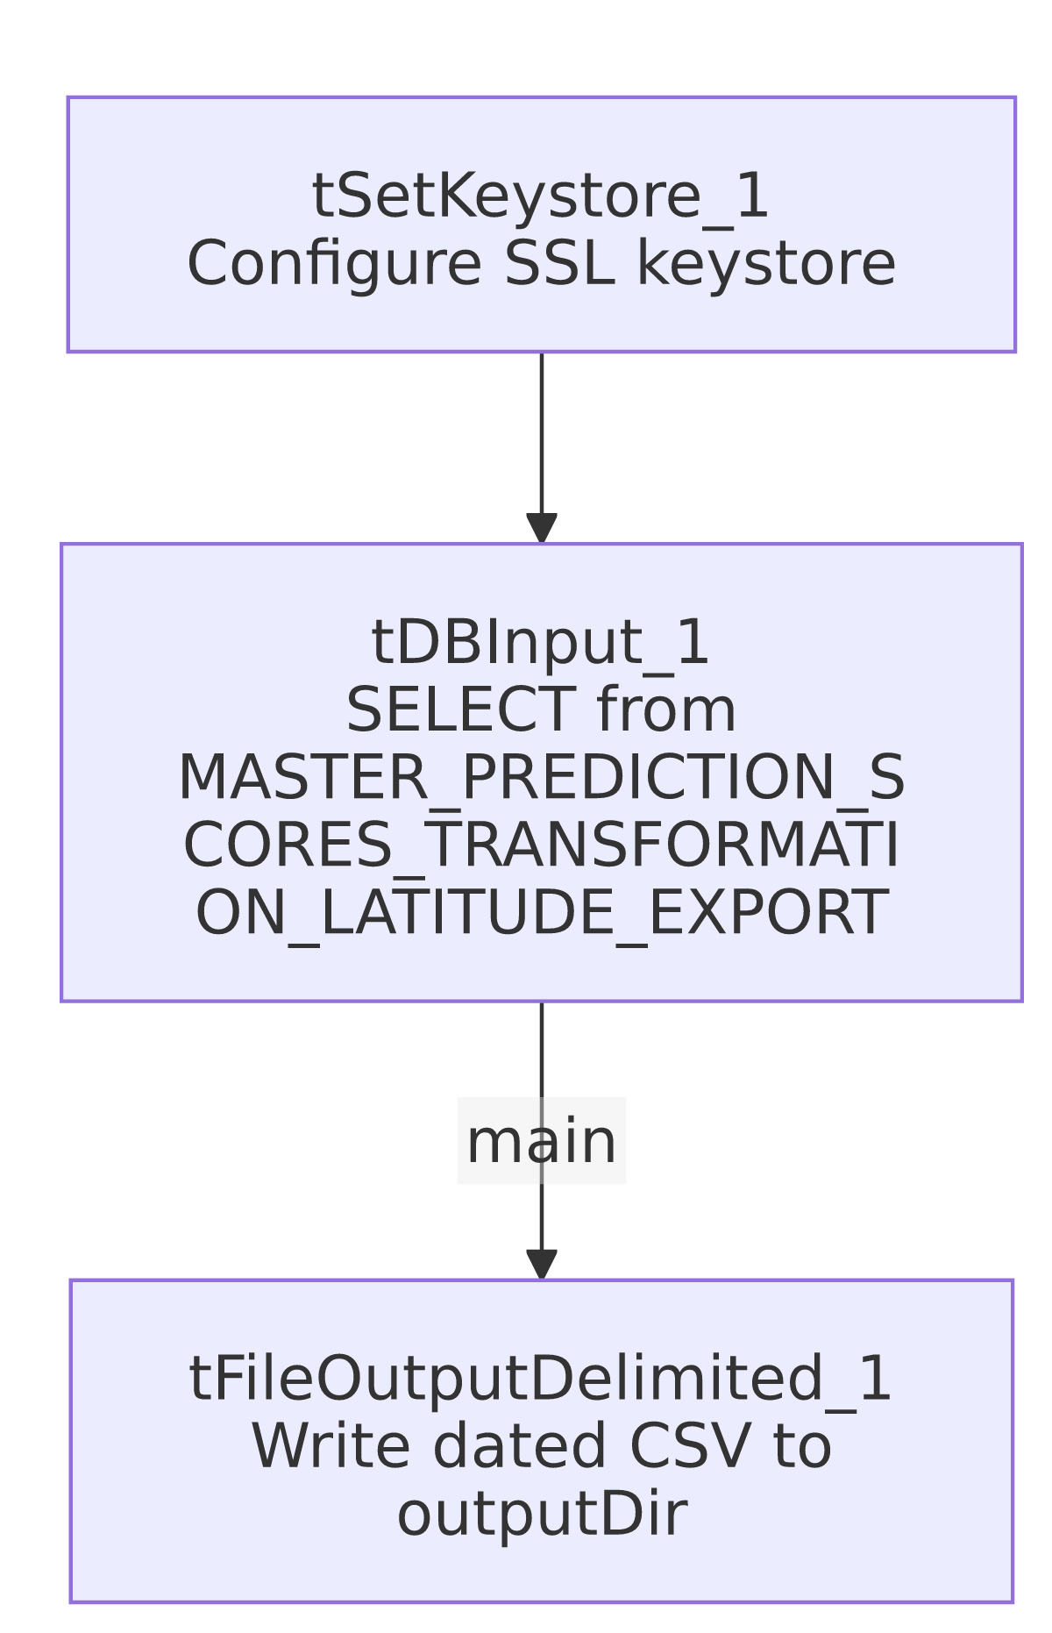

Settings tables

Source: `tDBInput_1` (`tSnowflakeInput`)
Setting | Value | What it means
Table | MASTER_PREDICTION_SCORES_TRANSFORMATION_LATITUDE_EXPORT | The Snowflake table/view being read. No custom query text is recorded — it's a straight table read.
Columns | DEBTORNUMBER, SEGMENT_LETTERS_VAL | Just two columns come out of this table for this export.

Target: `tFileOutputDelimited_1`
Setting | Value | What it means
FILENAME | context.outputDir + "master_prediction_scores_transformation_latitude_export_" + TalendDate.getDate("CCYY-MM-DD") + ".csv" | The output filename is date-stamped with the run date, so each day's export lands in its own file rather than overwriting the last one.
FIELDSEPARATOR | , | Plain comma-separated, unlike the `\
INCLUDEHEADER | false | No column-name header row is written.
ENCODING | ISO-8859-15 | Western European encoding, matching several of the load jobs' file encoding.
APPEND | false | Each run creates a fresh file rather than appending to an existing one (consistent with the date-stamped filename).

Dependencies & configuration
- Triggers/depends on other jobs: none found — no tRunJob links.
- Context variables used: context.keystorePath and context.outputDir. keystorePath is part of the shared Directories_0.1 context group (see _shared_context.json); outputDir is not one of the Directories_0.1 variables documented there (which only defines sourceDir/filePath/archiveDir/fileName/logDir/keystorePath) — it appears to be a variable added specifically for this export job. Its actual value is not visible in this metadata; verify with the team where it points in dev vs. prod.
- Connection style — this is one of the exceptions. This job has no tDBConnection/tSnowflakeConnection component at all, unlike every load job documented so far (Address_Text_Load, Carrier_Text_Load, etc.), which open the shared, repository-linked Snowflake connection before doing any Snowflake work. Per the project-wide connection audit, Master_Prediction_Scores_Export is one of only three jobs (Master_Config_Val_Segs_Export and Livevox_Daily_Load are the other two) that instead configure Snowflake connectivity directly on the tSnowflakeInput component itself, referencing the LEGACY_DW_0.1 context group's variables (account xca26579.us-east-1, warehouse COMPUTE_WH, database EDWPRODHH, schema DW, per _shared_context.json) rather than the shared connection object. The specific LEGACY_DW_* variable names aren't visible on tDBInput_1 in this trimmed metadata (its parameters are empty aside from the extracted snowflake.table value), so this can't be independently re-verified from this file alone — treat it as confirmed by the broader project audit rather than by this job's JSON in isolation.

Glossary
Component type | Plain-English meaning
tSetKeystore | Configures the SSL keystore for the Snowflake connection (see job_Address_Text_Load.md).
tSnowflakeInput | Runs a query against Snowflake and streams the results into the job as rows — the mirror image of tSnowflakeOutput. Not used in the three reference docs (they all write to Snowflake, not read from it).
tFileOutputDelimited | Writes rows out to a delimited text file — the mirror image of tFileInputDelimited. Also not used in the three reference docs.

Issues observed
- `context.outputDir` is not part of the documented `Directories_0.1` context group. Every other directory-style variable in this project (sourceDir, archiveDir, filePath, fileName, logDir, keystorePath) has a recorded dev/prod pair in _shared_context.json; outputDir does not, meaning its actual configured value(s) are invisible from the shared context metadata provided. Confirm with the team where this points before relying on the export path.
- No archive or cleanup step. Every load job reviewed so far explicitly archives and deletes its source file after processing; this export job has no equivalent for the file it writes — there's nothing in this metadata that manages, rotates, or cleans up the exported CSVs over time, so a downstream process (external to Talend) must be responsible for consuming or clearing them.
- This job's Snowflake connection details are not independently visible in its own metadata — the LEGACY_DW_0.1-direct-reference behavior is asserted by the broader project audit (see Dependencies & configuration) but the specific evidence (e.g. named LEGACY_DW_* parameters on tDBInput_1) was filtered out of this trimmed extract. Flagging so this isn't mistaken for something independently verifiable from this file.

