Talend Job: Master_Special_Info_Text_Load

Overview
This job loads "special info" account flags (mail-return flags, web arrangement flags, last call date, and a couple of IDs) from a shared folder into Snowflake. It follows the project's standard load pattern: truncate the staging table, read the newest matching source file, load into staging, merge into the permanent table via a stored procedure, then archive and delete the source file.

Detail table
Field | Value
Job name | Master_Special_Info_Text_Load
Version | 0.1
Project | LATITUDE
Author | jmach@harriscollect.com
Created | 2024-11-27T09:56:03.432-0800
Last Modified | 2025-10-01T10:09:11.453-0700

Step-by-step data flow
- Set up. tPrejob_1 starts the job; tJava_2 appends today's date to context.archiveDir and opens a log file; tSetKeystore_1 configures the SSL client keystore; tDBConnection_1 opens the Snowflake connection.
- Find the file. tFileList_1 lists files in context.sourceDir (skipping .txt files); the match becomes context.filePath (tJava_1).
- Read and reshape. tFileInputDelimited_1 reads the file using the repository schema "invmgmt" — pipe-delimited (|~|/|$|), US-ASCII encoding, header row present. tMap_1 maps its columns (number, LastMailReturnFlagDate, WEBArrangementFlag, lastcalldate, id) onto the target schema (NUMBER, LASTMAILRETURNFLAGDATE, WEBARRANGEMENTFLAG, LASTCALLDATE, ID, plus LOAD_DT).
- Load staging. The mapped rows flow directly into tDBOutput_1, which inserts them into MASTER_SPECIAL_INFO_TXT (no row counter on this path).
- Merge and clean up — in parallel. tParallelize_1 splits into:
- Merge branch: tDBRow_2 runs CALL MERGE_TXT_INTO_MASTER_SPECIAL_INFO();. No tDie/tWarn check follows it.
- Cleanup branch: the source file is listed again, archived (tFileArchive_1), then separately listed and deleted (tFileDelete_1, FAILON false).
- Staging truncate. tDBRow_1 runs TRUNCATE TABLE MASTER_SPECIAL_INFO_TXT; and, on success, triggers tFileList_1 — this is wired as an independent starting subjob rather than chained explicitly before step 2 in this metadata, but functionally runs the truncate before the file is processed.
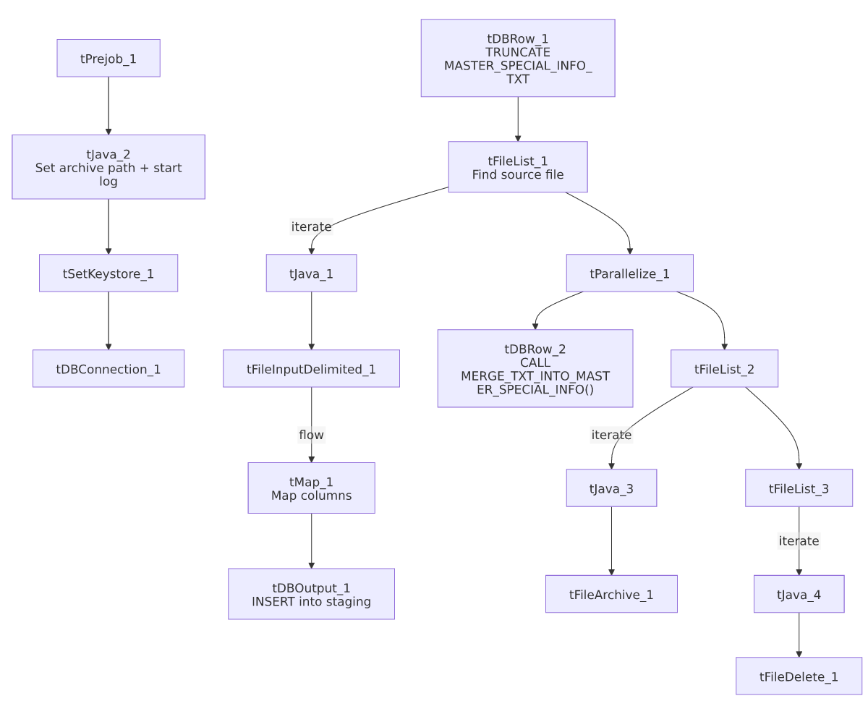

Settings tables

Source: `tFileInputDelimited_1`
Setting | Value | What it means
FILENAME | context.filePath | Reads whichever file tFileList_1 found.
Schema | Repository schema "invmgmt" | Uses a shared, pre-defined column layout.
FIELDSEPARATOR / ROWSEPARATOR | `\ | ~\
CSVROWSEPARATOR | \r\n | Underlying line ending within each row.
ENCODING | US-ASCII | Plain ASCII, not ISO-8859-15.
DIE_ON_ERROR | false | A malformed row is rejected rather than failing the job (rejects captured via the customer reject schema).

Target: `tDBOutput_1`
Setting | Value | What it means
Table | MASTER_SPECIAL_INFO_TXT | Staging table written to.
Output action | INSERT | Adds rows only.
Table action | NONE | Structure untouched — truncation is the separate tDBRow_1 step.

Merge step: `tDBRow_2`
Setting | Value | What it means
Query | CALL MERGE_TXT_INTO_MASTER_SPECIAL_INFO(); | Snowflake stored procedure folding staged rows into the permanent table. Body not visible in this metadata.

Dependencies & configuration
- Triggers/depends on other jobs: none — no tRunJob links found.
- Context variables used: context.sourceDir, context.archiveDir, context.filePath, context.fileName, context.logDir, context.keystorePath (all Directories_0.1).
- Snowflake connection: uses the shared connection object, not LEGACY_DW_* context variables directly.

Glossary
Component type | Plain-English meaning
tPrejob / tParallelize | Setup-before-main-flow, and concurrent branches (see job_Address_Text_Load.md).
tFileList | Lists files in a folder to loop over (see job_Address_Text_Load.md).
tFileInputDelimited | Reads a delimited text file row by row (see job_Address_Text_Load.md).
tMap | Maps/transforms columns (see job_Address_Text_Load.md).
tSnowflakeOutput (tDBOutput) | Writes rows into Snowflake (see job_Address_Text_Load.md).
tSnowflakeRow (tDBRow) | Runs a single SQL statement — TRUNCATE and CALL <procedure> here (see job_Address_Text_Load.md).
tJava | Custom Java code for small tasks (see job_Address_Text_Load.md).
tFileArchive | Zips a file into an archive location (see job_Address_Text_Load.md).
tFileDelete | Deletes a file from disk (see job_Address_Text_Load.md).
tSetKeystore | Configures the SSL keystore for the Snowflake connection (see job_Address_Text_Load.md).

Issues observed
- Hardcoded machine-specific paths: tFileInputDelimited_1.TEMP_DIR, tFileArchive_1.SOURCE_FILE, tFileDelete_1.DIRECTORY/PATH, and tSetKeystore_1.SSL_TRUSTSERVER_TRUSTSTORE are all fixed C:/Talend-Studio-20211109_1610-V8.0.1/... or C:/clientTrustStore.trustStore paths rather than context variables — the same pattern flagged project-wide.
- No row counter (`tFlowMeter`) on the load path — load volume for this job isn't captured in the same monitoring stream as jobs that do have one.
- No explicit error handling on the merge step — no tDie/tWarn reacting to whether MERGE_TXT_INTO_MASTER_SPECIAL_INFO() succeeded.
- The merge procedure's own logic is outside Talend — its body isn't part of this metadata.

