Talend Job: MiscExtra_Text_Load

Overview
This job loads a small, generic "miscellaneous extra data" table (MISCEXTRA — just an ID, a number, a title, and a data blob) into Snowflake. It follows the truncate → load → merge → archive/delete pattern, but is one of the project's exceptions to the "merge via stored procedure" rule: instead of calling a MERGE_TXT_INTO_* procedure, it runs a MERGE INTO ... USING ... statement written directly in the job, which also reveals — unusually for this batch of jobs — the actual name and schema of the permanent target table (LIQUID.MISCEXTRA).

Detail table
Field | Value
Job name | MiscExtra_Text_Load
Version | 0.1
Project | LATITUDE
Author | jmach@harriscollect.com
Created | 2024-11-21T12:12:25.303-0800
Last Modified | 2025-10-01T13:39:24.081-0700

Step-by-step data flow
- Set up. tPrejob_1 → tJava_2 (appends today's date to context.archiveDir, opens a log file) → tSetKeystore_1 → tDBConnection_1.
- Empty the staging table. tDBRow_1 runs TRUNCATE TABLE MISCEXTRA_TXT; (no LIQUID_STAGING. schema prefix).
- Find and read the file. tFileList_1 lists files in context.sourceDir (excluding *.txt), sorted by modified date, oldest first; tJava_1 captures the path; tFileInputDelimited_1 reads it (|~|/|$|, header row, US-ASCII, DIE_ON_ERROR=false).
- The same read also feeds tFileProperties_1 (per file, gets the last-modified time) → tJavaRow_1 (stores it in context.lastModified).
- Transform and load staging. tMap_1 maps the file's four columns (ID, Number, TheData, Title) onto the staging schema, adding LASTMODIFIED and LOAD_DT. Rows flow into tDBOutput_1, which inserts them into MISCEXTRA_TXT.
- Merge and clean up — in parallel. tParallelize_1 splits into:
- Merge branch: tDBRow_2 runs an inline `MERGE INTO` statement (not a stored-procedure call) that folds LIQUID_STAGING.MISCEXTRA_TXT into LIQUID.MISCEXTRA (see Settings tables for the full SQL), keeping only the latest row per ID and updating only when the incoming row is newer.
- Cleanup branch: tFileList_2 → tJava_3 (captures path + name) → tFileArchive_1 (zips into context.archiveDir); and tFileList_3 → tJava_4 (captures path + name) → tFileDelete_1 (deletes the source file).
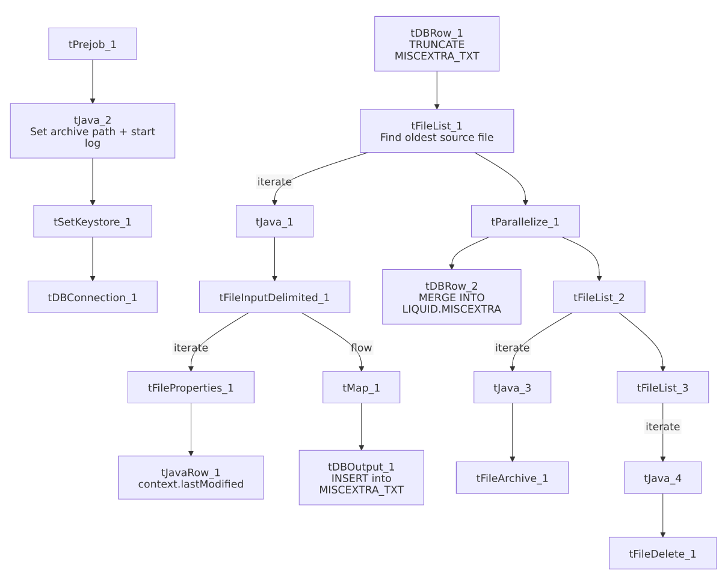

Settings tables

Source: `tFileInputDelimited_1`
Setting | Value | What it means
FILENAME | context.filePath | Reads whichever file tFileList_1 just found.
FIELDSEPARATOR / ROWSEPARATOR | `\ | ~\
ENCODING | US-ASCII | Plain ASCII.
DIE_ON_ERROR | false | Malformed rows are skipped/logged rather than failing the job.
ORDER_BY_MODIFIEDDATE (on tFileList_1) | true, ascending | Oldest unprocessed file is picked up first.
TEMP_DIR | "C:/Talend-Studio-.../workspace" | Hardcoded Windows path.

Target: `tDBOutput_1`
Setting | Value | What it means
Table | MISCEXTRA_TXT | Loads into the staging copy of the table.
Output action | INSERT | Adds rows only.
Table action | NONE | Table structure untouched.

Merge step: `tDBRow_2` (inline SQL, not a stored procedure)
Setting | Value | What it means
Query | MERGE INTO LIQUID.MISCEXTRA AS tgt USING (SELECT ID, LOAD_DT, NUMBER, TITLE, THEDATA, LASTMODIFIED FROM LIQUID_STAGING.MISCEXTRA_TXT QUALIFY ROW_NUMBER() OVER (PARTITION BY ID ORDER BY LASTMODIFIED DESC) = 1) AS src ON (tgt.ID=src.ID) WHEN MATCHED AND ((src.LASTMODIFIED > tgt.LASTMODIFIED) OR (tgt.LASTMODIFIED IS NULL)) THEN UPDATE SET ... WHEN NOT MATCHED THEN INSERT (...) | Rather than calling an opaque stored procedure like most peer jobs, this merge is written directly in the job: it de-duplicates staged rows by ID (keeping only the most recently modified one via QUALIFY ROW_NUMBER()...=1), then updates the permanent LIQUID.MISCEXTRA table only if the incoming row is newer (or the target has no LASTMODIFIED yet), and inserts brand-new IDs. This is one of the few places in this documentation set where the actual permanent-table name and schema (LIQUID.MISCEXTRA, as opposed to the staging schema LIQUID_STAGING) is directly visible.

Dependencies & configuration
- Triggers/depends on other jobs: none found — no tRunJob links.
- Context variables used: context.sourceDir, context.archiveDir, context.filePath, context.fileName, context.logDir, context.keystorePath, context.lastModified (all Directories_0.1 or job-local). Uses the shared Snowflake connection object, not LEGACY_DW_0.1 variables directly.

Glossary
Component type | Plain-English meaning
tPrejob / tParallelize | Job-flow control (see job_Address_Text_Load.md).
tSnowflakeConnection (tDBConnection) | Opens the shared Snowflake connection (see job_Bankruptcy_Text_Load.md).
tFileList | Lists files for iteration (see job_Address_Text_Load.md).
tFileInputDelimited | Reads a delimited text file (see job_Address_Text_Load.md).
tFileProperties | Reads file-system metadata (see job_Address_Text_Load.md).
tJavaRow | Custom code that runs once per row (see job_cmi_Hermes_Recommendations_Load.md).
tMap | Maps/transforms columns (see job_Address_Text_Load.md).
tDBOutput / tSnowflakeOutput | Writes rows to Snowflake (see job_Address_Text_Load.md).
tDBRow / tSnowflakeRow | Runs a single SQL statement (see job_Address_Text_Load.md) — here running a full MERGE INTO statement rather than a CALL to a stored procedure.
tJava | Custom Java code block (see job_Address_Text_Load.md).
tFileArchive | Zips a file into an archive location (see job_Address_Text_Load.md).
tFileDelete | Deletes a file (see job_Address_Text_Load.md).
tSetKeystore | Configures the SSL keystore (see job_Address_Text_Load.md).

Issues observed
- This is one of the project's exceptions to the "merge via stored procedure" convention — the merge logic (de-dup by latest LASTMODIFIED, conditional update, insert-if-new) is written directly into the job as a MERGE INTO statement rather than calling a MERGE_TXT_INTO_* procedure. This is not a defect, but it means this job's merge logic is fully auditable from Talend, unlike its peers.
- `TRUNCATE TABLE MISCEXTRA_TXT;` omits the `LIQUID_STAGING.` schema prefix used explicitly elsewhere — likely resolves correctly if the connection's default schema is already LIQUID_STAGING, but worth confirming.
- Hardcoded, machine-specific paths on tFileInputDelimited_1.TEMP_DIR, tFileArchive_1.SOURCE_FILE, tFileDelete_1.DIRECTORY/PATH, and tSetKeystore_1.SSL_TRUSTSERVER_TRUSTSTORE — the same project-wide pattern seen elsewhere.

